Council AGENDA

Planning and Related Matters

Wednesday 25 August 2021

Commencing 6.30 pm

The meeting will be livestreamed



Acknowledgement of the traditional custodians of the City of Moreland
Moreland City Council acknowledges the Wurundjeri Woi Wurrung people as the Traditional Custodians of the lands and waterways in the area now known as Moreland, and pays respect to their elders past, present, and emerging, as well as to all First Nations communities who significantly contribute to the life of the area.

1. WELCOME
2. APOLOGIES
Leave of absence has been granted to:
Cr Carli Hannan - 5 July 2021 to 25 August 2021 inclusive.
3. DISCLOSURES OF CONFLICTS OF INTEREST
4. MINUTE CONFIRMATION
The minutes of the Planning and Related Matters Meeting held on 28 July 2021 be confirmed.
5. Council Reports
5.1 City Development Activity Report - June Quarter 2021 4
5.2 108A Nicholson Street, Brunswick East - MPS/2020/619 8
6. URGENT BUSINESS
5. Council Reports
5.1 City Development Activity Report - June Quarter 2021
Director City Futures, Kirsten Coster
City Development

Officer Recommendation
That Council:
1. Notes the City Development Activity Report – June Quarter 2021

REPORT

Executive Summary
The City Development Urban Planning and Planning Enforcement teams are managing to produce reasonably good results in the face of high numbers of incoming applications, increased compliance requests, and a high outstanding caseload. The planning application outstanding caseload, and the planning compliance caseloads are areas to continue to monitor closely.
Planning applications lodged with Council increased again in the June quarter with the highest number of applications lodged for some years. Decision making improved but could not keep pace with the number of incoming applications resulting in an increased backlog of applications awaiting a decision. The data clearly indicates that planning activity levels are once again increasing after remaining steady throughout the majority of the COVID 19 pandemic.
Timeframes to determine most planning applications were below the metropolitan average largely due to staff vacancies however VicSmart applications improved. 80 per cent of Vic Smart applications were determined within a timeframe of 10 days nearly on par with the metropolitan average as new staff have started in this area.
Planning compliance had new case numbers more around the average expected for the quarter. The 125 cases closed in the quarter represents the largest number of cases closed in a quarter for many years. This has had a positive impact on the outstanding caseload which is starting to drop but is still not at a manageable level.
VCAT activity was slightly higher in the June 2021 quarter compared to the previous year but is still not back to pre-COVID-19 levels.

Previous Council Decisions
5.1 City Development Activity Report - March Quarter 2021 (D21/203167) – 26/05/2021
Council resolved that Council notes the City Development Activity Report – March Quarter 2021

1. Policy Context
The City Development Branch administers Council’s town planning, building and environmental health decision making and compliance responsibilities under the Planning and Environment Act 1987, Building Act 1993, Moreland Planning Scheme, Building Regulations 2018, Building Code of Australia 2006, Food Act 1984, and Public Health and Wellbeing Regulations 2009.

2. Background
This report shows the key operational performance and activity of the Urban Planning Unit within the City Development Branch, from VCAT decisions to how many planning applications were determined and the timeframe for decision making. It also details performance within the Planning Enforcement Unit. The report contains comparisons of the June 2021 quarter of activity compared to the June 2020 quarter.

3. Issues
The report at Attachment 1 details:
• Analysis of planning applications received, determined and outstanding;
• Analysis of planning application decision making;
• Analysis of streamlined services;
• Planning enforcement caseload;
• VCAT analysis;
• Analysis of planning investment.
The key findings of the data are discussed in this report.
Planning permit activity
A total of 359 planning applications were received for the June quarter. This is compared with 312 for the same quarter in 2020 up 15 per cent. 314 planning applications were decided in the June quarter compared to 293 for the same quarter in 2020, up 7 per cent as shown in figure 1 at Attachment 1. The majority of applications lodged for the quarter were multi dwellings (31%) followed by building alterations (25%) and subdivisions (19%) as shown in figure 2 at Attachment 1. Overall for the financial year planning applications were up by 10 per cent while decisions made stayed steady.
The current backlog of applications awaiting a decision stands at 527 which has jumped up 23 per cent from the same quarter in 2020. Figure 3 at Attachment 1 shows how the backlog has changed over time. The current backlog requires considerable work to ensure workloads for staff return to more manageable levels. This quarter the backlog has been impacted by high numbers of incoming applications combined with staff vacancies that have only just been filled.
The percentage of applications determined within statutory timeframes for all inner metropolitan Councils averaged at 64 per cent in the June quarter. Moreland’s average sat below this at 57 per cent and was affected by a number of staff vacancies (see figure 4 at Attachment 1).
Councils streamlined planning services include Vic Smart, Fast Track (minor permit applications that are not classified as Vic Smart) and Commercial Priority, which is a service to assist businesses setting up or expanding in Moreland. Figure 5 in Attachment 1 shows the performance of the Vic Smart part of streamlined services and pleasingly shows that Moreland’s performance has improved considerably with Moreland determining an average of 80 per cent of Vic Smart applications within 10 days compared to the inner metropolitan average of 82 per cent. Since last quarter a new Vic Smart planner has started, and results have improved.

Planning enforcement
The number of complaints from the community in respect to compliance with either planning permits or the planning scheme increased in the June quarter up 16 per cent in comparison to the same quarter in 2020. Figure 6 in Attachment 1 shows 88 cases lodged in the June 2021 quarter, compared to 76 in the June 2020 quarter, but significantly lower than the March quarter which showed the highest number of cases lodged in many years.
Despite high numbers of incoming cases the closure rate in the June quarter was outstanding with 125 cases closed, the highest in many years. As a result, the backlog of older cases waiting to be resolved fell from the previous quarter which was an excellent result for the team. Figure 7 in Attachment 1 shows the outstanding caseload at 185 which is now only 8 per cent higher than during June 2020.
Of the cases closed during the June 2021 quarter nearly 50 per cent were investigated but no breaches were detected. A further 35 per cent did have breaches but were brought into compliance, a smaller number were referred to other areas or Council for action or had a breach that was so minor that no formal action was undertaken as shown in Figure 8 in Attachment 1
The proactive planning enforcement system targets planning permits issued by Council, decisions overturned by VCAT and around 90 multi dwelling residential developments annually for proactive enforcement. Figure 9 in Attachment 1 shows the continued trend that the main issues being identified and then rectified relate to ESD, landscaping and privacy screening.
Council’s performance at VCAT
In the June quarter 11 applications for review of decisions were lodged at VCAT, which was higher than for the same quarter in 2020 but still well below average for the years prior to the pandemic as shown in Figure 10 in Attachment 1.
Figure 11 in Attachment 1 shows of the 11 appeals lodged, 3 were by objectors and 8 appeals were lodged by applicants against decisions.
Only 6 VCAT decisions were handed down in the June quarter 2021 as shown in Figure 12 in Attachment 1.
VCAT success is defined as the number of Council decisions that were upheld by VCAT (not set aside) or that were negotiated to an outcome satisfactory to Council (consented). In the June quarter, Council won or successfully mediated,100 per cent or 5 out of the 5 appeals against decisions. The other appeal was withdrawn. Figure 14, Attachment 1 shows the win/loss ratio for the June 2021 quarter compared to the June 2020 quarter.

Human Rights Consideration
The implications of this report have been assessed in accordance with the requirements of the Charter of Human Rights and Responsibilities and it was found that it does not contravene any of these sections and supports the following rights:
• Section 18: Taking part in public life
• Section 13: Privacy and Reputation
• Section 20: Property rights

4. Community consultation and engagement
No consultation is required to inform the preparation of this report.

5. Officer Declaration of Conflict of Interest
Council officers involved in the preparation of this report have no conflict of interest in this matter.

6. Financial and Resources Implications
In terms of overall development in Moreland during the June quarter, developments to the value of $152 million have been approved by planning permits issued by the City Development Branch compared to $68.3 million during the same quarter in 2020, up 122 per cent.

7. Implementation
The performance of Council’s City Development Branch will continue to be monitored with the activity report for the next quarter to be presented to the November Planning and Related Matters meeting.

Attachment/s
1 | City Development Activity Report June quarter 2021 | D21/312474

5.2 108A Nicholson Street, Brunswick East - MPS/2020/619
Director City Futures, Kirsten Coster
City Development

Executive Summary
Property: | 108A Nicholson Street, Brunswick East
Proposal: | Building and works to construct a four-storey building that comprises a shop at ground floor and five dwellings, a reduction to the statutory car parking rate and to alter access to a road in a Road Zone, (Category 1).
Zoning and Overlay/s: | • Mixed Use Zone (MUZ)  • Development Contributions Plan Overlay (DCPO)  • Design and Development Overlay (DDO20)  • Parking Overlay (PO1)
Strategic setting: | 
Objections: | A total of 13 objections. The key issues raised include:  • Off-site amenity impacts (overshadowing and overlooking)  • Building height and visual bulk.  • Car parking impacts.
Planning Information and Discussion (PID) Meeting: | Date: 6 July 2021  Attendees: 3 objectors, the applicant, 2 Council officers, and Deputy Mayor Cr Mark Riley, Cr James Conlan and Cr Helen Pavlidis-Mihalakos.  The permit applicant prepared sketch plans showing the deletion of the fourth level and increased setbacks from the south boundary to reduce amenity impacts to neighbours.
ESD: | • Minimum average NatHERS rating of 6.6 stars.  • 10-15kW solar PV on the roof space.  • 6,000L rainwater tank
Accessibility: | Adaptable apartments comprise 50 percent of the proposal.
Key reasons for support | • Design response that complies with the objectives of DDO20, subject to conditions.  • Amenity impacts reduced to a reasonable level, subject to conditions.  • Good quality façade detailing.  • Car parking reduction of one space justified in this location.
Recommendation: | Notice of Decision to Grant a Planning Permit be issued for the proposal subject to conditions.

Officer Recommendation
That a Notice of Decision to Grant a Planning Permit No. MPS/2020/619 be issued for Building and works to construct a three storey building comprising a shop and dwellings, a reduction to the statutory car parking rate and to alter access to a road in a Road Zone, Category 1 at 108A Nicholson Street, Brunswick East, subject to the following conditions:
Amended Plans
1. Before the development commences, amended plans to the satisfaction of the Responsible Authority must be submitted to and approved by the Responsible Authority. When approved, the plans will be endorsed and will then form part of the permit. The plans must be drawn to scale with dimensions and must be generally in accordance with the plans advertised on 21 April 2021, but modified to show:
a) The changes (including the deletion of one level and increased setbacks) as detailed on the plans lodged with Council on 6 July 2021 and referenced as TP04 to TP11 and TP15a to TP17, Revision D, dated 02 July 2021, and TP12 to TP15, Revision E, dated 2 July 2021 and prepared by Peter Brown Architects Pty Ltd with the following additional changes:
i. The wall on the south boundary shortened at first and second floor levels (associated with Apartments 1.01 and 2.01) so that it does not extend past the western-most north facing ground floor window at 108 Nicholson Street to the south.
ii. the south elevation walls of Apartments 1.02 and 2.02 modified to fully comply with Standard B20 at Clause 55.04-4 (North facing windows objective).
iii. Provision of planter boxes to the balcony areas of Apartments 1.01 and 2.01.
b) A Landscape Plan as required by condition 3.
c) The environmentally Sustainable Design initiatives that are required to be shown plans, as contained within Condition 6 of this permit.
d) Any modifications arising from the amended Acoustic Report as required by Condition 8 of this permit clearly annotated on the plans.
e) Any modification arising from the Waste Management Plan as required by Condition 13 of this permit clearly annotated on the plans.
f) A 7.0 metre separation between the Nicholson Street carriageway and the garage door, as required by Transport for Victoria under Condition 33 of this permit.
g) Each bicycle parking device dimensioned with all spaces 500mm wide and the horizontal and vertical bicycle spaces 1800mm and 1200mm long respectively, with every space accessed from a 1500mm wide access aisle as required by the Australian Standard for Parking Facilities – Bicycle Parking (AS2890.3).
h) The verandah above the commercial tenancy modified to become a continuous form with the same design detail as the verandah proposed above the residential entry. The must be off-set from the kerb by at least 750mm and not less than 3.0 metres in height.
i) The bedroom windows shown on section B-B and section C-C, to have a minimum sill height of 1.7 metres from finished floor level, to limit overlooking, and delete the notation on the floor plans stating that these windows are “opaque to 1.7 metres”.
j) The north and south edge of the rear balconies associated with Apartments 1.02 and 2.02 screened up to 1.7 metre-high. A screen diagram drawn at a scale of 1:50 must be prepared that details the screens and includes:
i. All dimensions, including the width of slats and the gap between slats.
ii. Confirmation that no more than 25 per cent transparency is provided.
Compliance with Endorsed Plans
2. The use and development as shown on the endorsed plans must not be altered without the written consent of the Responsible Authority. This does not apply to any exemption specified in Clauses 62.02-1 and 62.02-2 of the Moreland Planning Scheme unless specifically noted as a permit condition.
Landscaping
3. Prior to the endorsement of plans, a Landscape Plan must be submitted to the Responsible Authority. The landscape plan must be generally in accordance with the plan prepared by People Landscape Architecture Pty Ltd, Revision B, dated 31 July 2021 with the following inclusions:
a) Addition of planter boxes to the balcony areas to Apartments 1.01 and 1.02.
b) Full details of plant species and irrigation provided to planter boxes.
When submitted and approved to the satisfaction of the Responsible Authority, the landscape plan will be endorsed to form part of this permit. No alterations to the plan may occur without the written consent of the Responsible Authority.
4. Prior to the issue of an Occupancy Permit or issue of a Statement of Compliance, whichever comes first, all landscaping works, including installation of automatic irrigation, must be completed in accordance with the endorsed landscape plan to the satisfaction of the Responsible Authority.
5. All landscaping and irrigation systems must be maintained to the satisfaction of the Responsible Authority in accordance with the endorsed landscape plans. Any dead, diseased or damaged plants must be replaced with a suitable species to the satisfaction of the Responsible Authority.
Environmentally Sustainable Design (ESD)
6. Prior to the endorsement of plans, an amended Sustainable Design Assessment (SDA) and plans must be submitted to the satisfaction by the Responsible Authority. The Sustainable Design Assessment must demonstrate a best practice standard of environmentally sustainable design and be generally in accordance with the SDA by LID advertised 21/04/2021 but modified to include the following changes:
a) Provide preliminary NatHERS ratings assessments for at least all thermally dissimilar dwellings; 1.01, 1.02, 2.02 and 3.01 demonstrating a minimum 6.5 NatHERS star rating average across all dwellings
b) An improved response to the ‘IEQ objectives of Clause 15.02-1L Environmentally sustainable development which includes:
i. A daylight modelling report which demonstrates that the living areas achieve a daylight factor greater than 1 per cent to 90 per cent of the floor area of each living area, including kitchens and bedrooms achieve a daylight factor greater than 0.5 per cent to 90 per cent of the floor area in each room; the daylight modelling must include all daylight obstructions and future equitable development and include clear daylight maps and complaint area calculations.
c) Amend the SDA and BESS report (and any other corresponding documentation) to:
i. Enter the preliminary NatHERS data into the Dwelling Energy Profiles
ii. The SDA updated to include the increased PV system capacity as per the maximised number of PV panels shown in the roof plans
iii. Amend the BESS report and SDA to include all apartments.
iv. Reference WSUD initiatives that are consistent with plans, STORM and stormwater catchment plan.
v. Optimise the west façade glazing for both thermal performance and daylight penetration, which can include a combination of optimised glazing specifications (U-value SHGC) and external adjustable shading to minimise peak summer radiant heat gain and improve passive winter heat gain whilst not diminishing daylight penetration.
d) Show the following ESD initiatives on the development plans:
i. A minimum 10 KW proposed photovoltaic system including the location, approximate size and number of individual panels, orientation and tilt angle
ii. Double glazing or better to all habitable/conditioned spaces to be annotated on each individual glazing unit on elevation plans and specified on the material/colour schedule.
iii. Materials & colour schedule to include the materials discussion as per the SDA
e) A STORM report and stormwater management response that maintains a minimum STORM score of 100 per cent but is modified so that:
i. The rainwater tank size increased to 6000L;
ii. All impervious areas included
f) An amended stormwater catchment plan that is consistent with the STORM report, clearly showing:
i. The entire site area based on the roof plan;
ii. All stormwater catchment areas (impervious areas and roofs) clearly marked and dimensioned and connected to corresponding Water Sensitive Urban Design (WSUD) treatment measures;
iii. Any untreated roofs/balconies/impervious surfaces clearly identified.
Where alternative ESD initiatives are proposed to those specified in this condition, the Responsible Authority may vary the requirements of this condition at its discretion, subject to the development achieving equivalent (or greater) ESD outcomes in association with the development.
When submitted and approved to the satisfaction of the Responsible Authority, the amended SDA and associated notated plans will be endorsed to form part of this permit. No alterations to the SDA may occur without the written consent of the Responsible Authority.
7. Prior to the issue of a Statement of Compliance or Certificate(s) of Occupancy whichever occurs first, all works must be undertaken in accordance with the endorsed Sustainable Design Assessment report to the satisfaction of the Responsible Authority. No alterations to these plans may occur without the written consent of the Responsible Authority
Acoustic Attenuation
8. Prior to the endorsement of plans, an amended Acoustic Report prepared by a qualified Acoustic Engineer must be submitted to the satisfaction of the Responsible Authority. The Report must be generally in accordance with the Acoustic Report prepared by SLR Consulting Australia Pty Ltd (dated August 2020) but updated to address the current regulations under the EPA Act 2021. The report must consider the following matters specifically:
a) Noise impacts from the proposed car stacker as specified for this development.
b) Whether any noise will pass through the car park area and ventilation vents at the rear of the building.
c) Noise impacts from Nicholson Street traffic.
d) Noise impacts between walls and floors associated with mechanical plant and equipment, including the lift and car stackers.
When submitted and approved to the satisfaction of the Responsible Authority, the Acoustic Report will be endorsed to form part of this permit. No alterations to the Acoustic Report may occur without the written consent of the Responsible Authority.
9. The building must be constructed and thereafter maintained in accordance with the recommendations contained within the approved Acoustic Report to the satisfaction of the Responsible Authority, unless with the further written approval of the Responsible Authority.
10. Prior to the issue of an Occupancy Permit or issue of a Statement of Compliance, whichever comes first, a report from the author of the Acoustic Report approved pursuant to this permit or similarly qualified person or company must be submitted to the Responsible Authority. The report must be to the satisfaction of the Responsible Authority and must confirm that all measures specified in the Acoustic Report have been implemented in accordance with the approved Acoustic Report.
11. If the testing required by Condition 10 concludes that the nominated decibel levels cannot be met, the acoustic expert must recommend further noise attenuation measures to ensure compliance with the condition. These additional measures must be implemented prior to the occupation of the building.
12. That upon request an acoustic review will be undertaken at the land owner’s cost to verifying ongoing compliance with the endorsed acoustic report. In the event that the nominated decibel levels are not being met, the acoustic expert must recommend further noise attenuation measures to ensure compliance with the condition. These additional measures must be implemented within a three month period.
Waste Management
13. Prior to the endorsement of plans, a Waste Management Plan (WMP) must be submitted to the satisfaction of the Responsible Authority. The plan must be generally in accordance with the report prepared by Peter Brown Architects Pty Ltd and dated February 2021. Revision 1, but modified to:
a) specify the separation of garbage waste and FOGO (Food and Garden Organics) waste.
14. When submitted and approved to the satisfaction of the Responsible Authority, the WMP will be endorsed to form part of this permit. No alterations to the WMP may occur without the written consent of the Responsible Authority.
15. The Waste Management Plan approved under this permit must be implemented and complied with at all times to the satisfaction of the Responsible Authority unless with the further written approval of the Responsible Authority.
Development Contributions
16. Prior to the issue of a Building Permit in relation to the development approved by this permit, a Development Infrastructure Levy must be paid to Moreland City Council in accordance with the approved Development Contributions Plan. The Development Infrastructure Levy is charged per 100 square metres of leasable floor space.
If an application for subdivision of the land in accordance with the development approved by this permit is submitted to Council, payment of the Development Infrastructure Levy can be delayed to a date being whichever is the sooner of the following:
a) a maximum of 12 months from the date of issue of the Building Permit; or
b) prior to the issue of a Statement of Compliance for the subdivision;
When a staged subdivision is sought, the Development Infrastructure Levy must be paid prior to the issue of a Statement of Compliance for each stage of subdivision in accordance with a Schedule of Development Contributions approved as part of the subdivision.
Engineering Matters
17. Prior to the issue of an Occupancy Permit or issue of a Statement of Compliance, whichever comes first, access to the site, any ancillary road and road drainage works must be constructed in accordance with any requirement of the Responsible Authority (Moreland City Council, City Infrastructure Department).
18. Prior to the issue of an Occupancy Permit or issue of a Statement of Compliance, whichever comes first, all telecommunications and power connections (where by means of a cable) and associated infrastructure to the land must be underground to the satisfaction of the Responsible Authority.
19. Prior to the issue of an Occupancy Permit or issue of a Statement of Compliance, whichever comes first, the car park garage roller door must be automatic and remote controlled.
20. Prior to the issue of an Occupancy Permit or issue of a Statement of Compliance, whichever comes first, bicycle signage that directs the cyclists to the bicycle facilities must be provided to the satisfaction of the Responsible Authority. Bicycle signage should be at least 0.3 metres wide and 0.45 metres high; display a white bicycle on a blue background on the top half of the sign and display information about the direction of facilities on the bottom half of the sign.
21. The public footpath is to be reinstated with the standard crossfall slope of 1 in 40 from the top of roadside kerb to the property boundary, with any level difference made up within the site.
Stormwater
22. All stormwater from the land, where it is not collected in rainwater tanks for re-use, must be collected by an underground pipe drain approved by and to the satisfaction of the Responsible Authority (Note: Please contact Moreland City Council, City Infrastructure Department).
23. The surface of all balconies are to be sloped to collect the stormwater run-off into stormwater drainage pipes that connect into the underground drainage system of the development to the satisfaction of the Responsible Authority.
Car Parking
24. The area set aside for the parking of vehicles and access lanes shown on the endorsed plan must, to the satisfaction of the Responsible Authority:
a) Be completed prior to issue of an Occupancy Permit or issue of a Statement of Compliance, whichever occurs first.
b) Be maintained.
c) Be properly formed to such levels that it can be used according to the endorsed plan.
d) Have the boundaries of all vehicle parking spaces clearly marked on the ground to accord with the endorsed plan.
e) Not be used for any other purpose other than the parking of vehicles, unless with the prior written consent of the Responsible Authority.
f) Be numbered to facilitate management of the car park.

General
25. Prior to the issue of an Occupancy Permit or issue of a Statement of Compliance, whichever comes first, all boundary walls must be constructed, cleaned and finished to the satisfaction of the Responsible Authority.
26. Unless with the prior written consent of the Responsible Authority, any plumbing pipe, ducting and plant equipment must be concealed from external views. This does not include external guttering or associated rainwater down pipes.
27. The shopfront window must not be painted or blocked out in any way to the satisfaction of the Responsible Authority.
28. All lighting of external areas (including balconies) must be designed not to emit direct light onto adjoining property to the satisfaction of the Responsible Authority.
29. Prior to the issue of an Occupancy Permit or issue of a Statement of Compliance, whichever comes first, all visual screening measures shown on the endorsed plans must be installed to the satisfaction of the Responsible Authority. All visual screening and measures to prevent overlooking must be maintained to the satisfaction of the Responsible Authority. Any screening measure that is removed or unsatisfactorily maintained must be replaced to the satisfaction of the Responsible Authority.
Head, Transport for Victoria
30. Prior to the commencement of use, all disused or redundant vehicle crossings must be removed, and the area reinstated kerb and channel to the satisfaction of the Responsible Authority and at no cost to the Head, Transport for Victoria.
31. Prior to the commencement of use, the crossover and driveway are to be constructed to the satisfaction of the Responsible Authority and at no cost to the Head, Transport for Victoria.
32. Vehicles must enter and exit the site in a forward direction.
33. The garage door must be installed by providing 7m gap between the Nicholson Street carriageway and the garage door.
Permit Expiry
34. This permit will expire if one of the following circumstances applies:
a) the development is not commenced within three (3) years from the date of issue of this permit;
b) the development is not completed within five (5) years from the date of issue of this permit.
The Responsible Authority may extend the period referred to if a request is made in writing before the permit expires or;
i. within six months after the permit expires to extend the commencement date.
ii. within 12 months after the permit expires to extend the completion date of the development if the development has lawfully commenced.
Notes
These notes are for information only and do not constitute part of this notice of decision or conditions of this notice of decision
Note 1: This permit contains a condition requiring payment of Development Contributions. The applicable development contribution levies are indexed annually. To calculate the approximate once off levy amount, please https://www.moreland.vic.gov.au/building-and-business/planning-and-building/planning/development-contributions/ and click on ‘Moreland Development Contributions Plan (DCP)’. Alternatively, please contact Moreland City Council on 9240 1111 and ask to speak to the DCP Officer.
Note 2: Should Council impose car parking restrictions in this street, the owners and/or occupiers of the dwellings would not be eligible for resident parking permits to park on the street. Occupiers are eligible for the resident A parking permit which only permits parking in limited areas. The resident parking permits and Resident A parking permit are subject to future reviews and change. See Council’s website for more information: https://www.moreland.vic.gov.au/living-in-moreland/parking-and-roads/parking-permits-and-fines/residential-parking-permits/

Note 4: Moreland City Council is committed to increasing the amount of affordable housing in the municipality. One way to do this, is through Homes for Homes, a social enterprise founded by the Big Issue that aims to raise new funds via voluntary tax-deductible donations on property transactions and invest those funds in building and managing new social and affordable dwellings. If you would like to help build homes for those in need, visit Homes for Homes and register your commitment to donate 0.1 per cent of the sale price of your dwelling.

REPORT

1. Background

Subject site
The subject site is located on the east side of Nicholson Street, between Victoria and Blyth Streets in Brunswick East. Regularly dimensioned, the site has a frontage of 10.08 metres, a depth of 30.48 metres and a total site area of 307.23 square metres. The site has a slight slope, with fall of 1.05 metres across the site from east to west.
The site currently contains a single storey, inter-war brick dwelling, with a tiled, hipped roof (see figure 1, below). Vehicle access is provided from the southern side of the Nicholson Street frontage and a low brick retaining wall forms a front fence. The rear yard is relatively open and contains one small-scale outbuilding and no tree planting.
There is an electricity pole and parking restriction sign located within the foot path along the site’s frontage.
There are no restrictive covenants indicated on the Certificate of Title.

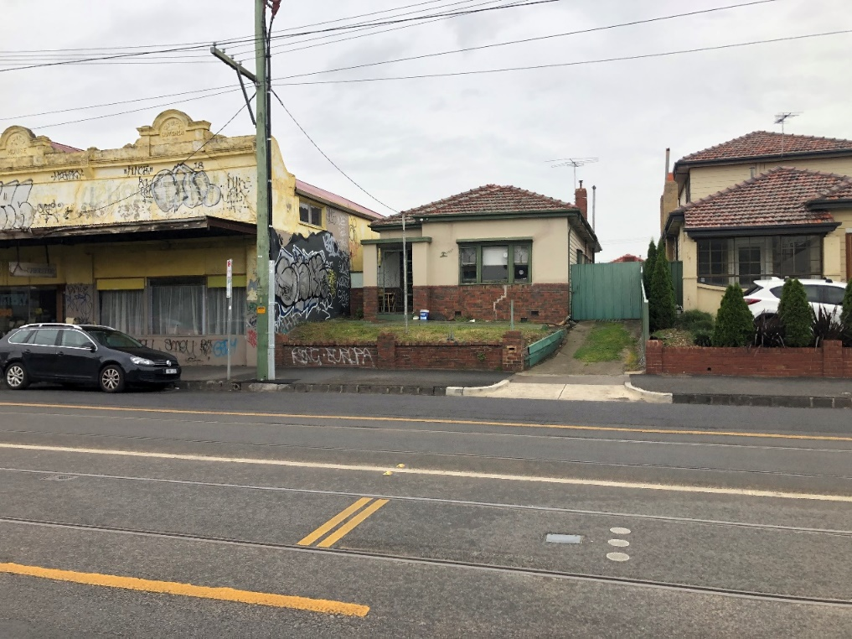

Figure 1: The subject site, 108A Nicholson Street. Source: M, Alexander. 2021.

Surrounds
The site is located along the Nicholson Street Corridor of the Brunswick Activity Centre, which extends to the north and south and is located approximately:
• Within 100 metres south of Blyth Street and the Route 96 accessible tram stop.
• Within walking distance of Fleming Park and Merri Creek.
• Within walking distance of Brunswick East Village (to the south).
This section of Nicholson Street comprises three different zones: Residential Growth Zone, Commercial 1 Zone and the Mixed Use Zone. As a result, there is an eclectic mix of architectural styles, land uses and building heights with an emerging character of contemporary mixed-use apartment buildings establishing in the area.
To the north, the site adjoins a Victorian-era, single storey commercial shopfront at 110-112 Nicholson Street. The building has a zero-lot-line to Nicholson Street and an awning that extends over the footpath.
To the south, the site adjoins a detached, double storey dwelling at 108 Nicholson Street. The rear yard contains several low-scale outbuildings but is otherwise open.
The land to the east contains single storey, detached dwellings that have rear yards and low scale outbuildings that interface with the subject site.
A location plan forms Attachment 1.

Proposal
The proposal is for the construction of a four storey building that comprises a shop at ground floor and five apartments with a reduction to the statutory car parking rate by two spaces and to alter access to a road in a Road Zone (Category 1).
The proposed building will have an overall height of 11.9 metres.
At ground floor, the building is constructed boundary-to-boundary and contains a small commercial tenancy (42.3 square metres), the residential entry and lobby, a garage that comprises four car spaces (including two in a stacker), a bin and waste store area.
Two apartments are proposed on levels one and two with a fifth apartment located on level three.
The advertised development plans form Attachment 2.

Statutory Controls – why is a planning permit required?
Control | Permit Requirement
Mixed Use Zone (MUZ) | Clause 32.04-6: a planning permit is required to construct two or more dwellings on a lot.  A planning permit is not required for the use of the land for dwellings or a shop (commercial tenancy).
Design and Development Overlay (DDO20) | Clause 43.02-2: a planning permit is required to construct a building or to construct or carry out works.
Particular Provisions | Clause 52.06-3: a planning permit is required to reduce the number of car parking spaces required under Clause 52.06-5.  Clause 52.29-2: a permit is required to alter access to a road in a Road Zone, Category 1.
The following Particular Provisions of the Moreland Planning Scheme are also relevant to the consideration of the proposal:
• Clause 45.06: Development Contributions Plan Overlay. A condition is included in the recommendation requiring the payment of the DCP levy prior to the issue of a Building Permit for the development.
• Clause 45.09: Parking Overlay.
• Clause 55: Two or more dwellings on a lot.

2. Internal/External Consultation

Public notification
Notification of the application has been undertaken pursuant to Section 52 of the Planning and Environment Act 1987 by:
• Sending notices to the owners and occupiers of adjoining and nearby land.
• Placing a sign on the frontage of the site
Council has received 13 objections to date. A map identifying the location of objector’s forms Attachment 3.
The key issues raised in objections are:
• Off-site amenity impacts through overlooking, overshadowing and loss of daylight to existing windows
• Overdevelopment
• Building height
• Visual amenity and bulk impacts
• Non-compliances with setback requirements
• Noise impacts
• Car parking and traffic impacts
• Complications and nuisance during construction phase
• Impact to adjoining properties through the proposed excavation works
• Contribution to the urban heat island effect
• Boundary dispute
A Planning Information and Discussion meeting was held on 6 July 2021. All objectors were invited to participate. The meeting provided an opportunity to explain the application, for the objectors to elaborate on their concerns and for the applicant to respond.
In response to the concerns raised by objectors, the applicant circulated a set of proposed amended “sketch” plans to the attendees of the Planning and Information Discussion meeting, being the owners and/or representatives of 108 Nicholson Street to the south and 9 Ryan Street to the east.
A copy of the sketch plans circulated on 6 July 2021 forms Attachment 4.
The changes contained within the sketch plans include:
• The deletion of the third level and a reduction in building height to 9.65 metres.
• An increase to the floor to ceiling level height at each level.
• A reduced length to the wall on the south boundary at the front half of building allowing for a widened central light court on the south side.
• Raked walls/ceilings implemented to the rear half of the building to achieve compliance with Standard B17 from the south side boundary.

Internal/external referrals
The proposal was referred to the following external agencies or internal branches/business units:
External Agency | Objection/No objection
Transport for Victoria | No objection subject to conditions included in the recommendation.

Internal Branch/Business Unit | Comments
Urban Design Unit | Support the proposal, subject to the changes contained within the ‘sketch’ plans lodged with Council that delete the upper level.
Sustainable Built Environment - Development Engineering Team | Supports the proposal, subject to modifications, which are addressed by conditions detailed in the recommendation and are considered further in Section 4 of this report.
Sustainable Built Environment - ESD Team | Supports the proposal subject to modifications. The recommended changes are addressed by conditions of the recommendation and are considered further in Section 4 of this report.

3. Policy Implications

Planning Policy Framework (PPF):
The following policies are of most relevance to this application:
• Municipal Planning Strategy (Clause 2)
• Settlement (Clause 11)
• Environmental Risks and Amenity (Clause 13):
− Noise Abatement (Clause 13.05-1S and 13.05-1L)
• Built Environment (Clause 15.01), including:
− Urban Design (Clause 15.01-1S, 15.01-1R & 15.01-1L)
− Vehicle Access Design in Moreland (Clause 15.01-1L)
− Building Design (Clause 15.01-2S & 15.01-2L)
− Building Design in Neighbourhood and Local Centres (Clause 15.01-2L)
− Healthy Neighbourhoods (Clause 15.01-4S and 15.01-4R)
− Neighbourhood Character (Clause 15.01-5S)
• Sustainable Development (Clause 15.02)
• Residential Development (Clause 16.01), including:
− Housing Supply (Clause 16.01-1S and 16.01-1R)
− Homes in Moreland (Clause 16.01-2L)
− Housing for people with limited mobility (Clause 16.01-1L)
− Housing affordability (Clause 16.01-2S)
• Economic Development (Clause 17), including:
− Employment Areas (Clause 17.01-1L)
− Business (Clause 17.02-1S)
• Transport (Clause 18), including:
− Sustainable Personal Transport (Clause 18.02-1S & 18.08-1R)
− Sustainable Transport in Moreland (Clause 18.02-1L)
− Car parking (Clause 18.02-4S & 18.02-4L)

Human Rights Consideration
This application has been processed in accordance with the requirements of the Planning and Environment Act 1987 (including the Moreland Planning Scheme) reviewed by the State Government and which complies with the Victorian Charter of Human Rights and Responsibilities Act 2006, including Section 18 (Taking part in public life). In addition, the assessment of the application has had particular regard to:
• Section 12: Freedom of movement
• Section 13: Privacy and Reputation
• Section 20: Property rights
An assessment of whether there is any potential for unreasonable overlooking has been undertaken in section 4 of this report. The proposed redevelopment of private land does not present any physical barrier preventing freedom of movement. The right of the landowner to develop and use their land has been considered in accordance with the Moreland Planning Scheme.

4. Issues
In considering this application, regard has been given to the Planning Policy Framework, the provisions of the Moreland Planning Scheme, objections received and the merits of the application.

Does the proposal have strategic policy support?
The proposal meets the objectives and strategies of the Planning Policy Framework (PPF) by providing increased housing growth in an area with excellent access to public transport and other services. The proposal enjoys strategic support at both State and Local level.
The broad support for increased density is tempered by planning controls that also require new development to respond to the existing built form context and to allow for reasonable levels of amenity to be maintained to existing residential properties. Subject to the recommended conditions, the proposal will strike an appropriate balance between these two objectives.

Does the proposal respond to neighbourhood character, positively contribute to the local context and enhance the public realm?
This section of the report considers the neighbourhood character and built form outcomes as outlined within Schedule 20 of the Design and development Overlay (DDO20).

Building height
As advertised, the proposal will have an overall building height of 11.9 metres and comprises four storeys, which exceeds the preferred height of 11 metres as set out in the DDO20.
Objectives of DDO20 include:
• To create a new mid-rise built form character that provides a built form transition from the Nicholson Street Activity Corridor to adjoining low rise residential areas.
• To maintain reasonable amenity for residential properties adjacent to and within the activity centre.
A key concern by Council’s Urban Design Unit is that the proposed building height at four storeys will dominate the streetscape and disrupt the scale of built form envisaged by DDO20. The Urban Design Unit also noted that the building is poorly designed with low ceiling heights, implemented to minimise the overall building height but reducing the functionality of the commercial space and internal amenity for the dwellings. The proposed four storey building will also impose unreasonable amenity impacts to the adjoining dwellings through the significant reductions to daylight and sunlight access to habitable room windows.
The permit applicant circulated ‘sketch’ plans (outlined in Section 2) that seeks to ameliorate these key concerns. By incorporating the changes in the ‘sketch plans’ via a condition of the recommendation, the proposal will:
• Comply with the preferred building height under the DDO20 and sit comfortably within the emerging character of mid-rise built form along Nicholson Street.
• Maintain reasonable amenity to adjacent residential land.
• Provide for adequate internal amenity of apartments and create a functional commercial space at ground floor through increased ceiling heights.
Council’s Urban Design Unit have reviewed the ‘sketch plans’ circulated at the PID and support the changes proposed.

Setbacks to residential land outside the activity centre
The DDO20 contains a specific setback requirement to create an appropriate transition between built form within the Brunswick Activity Centre and adjoining residential land outside the activity centre boundary.
To the east, the subject site adjoins the residential land at 9 and 11 Ryan Street, Brunswick East. These adjoining properties are outside the Activity Centre boundary and contain single storey dwellings with rear yards that interface with the subject site.
The design response proposes a wall along the east boundary less than 2 metres in height and upper level setbacks well within the allowances of DDO20. The rear boundary building envelope outline under the DDO20 is shown in the context of the development as amended by the 6 July sketch plans in figure 2, below: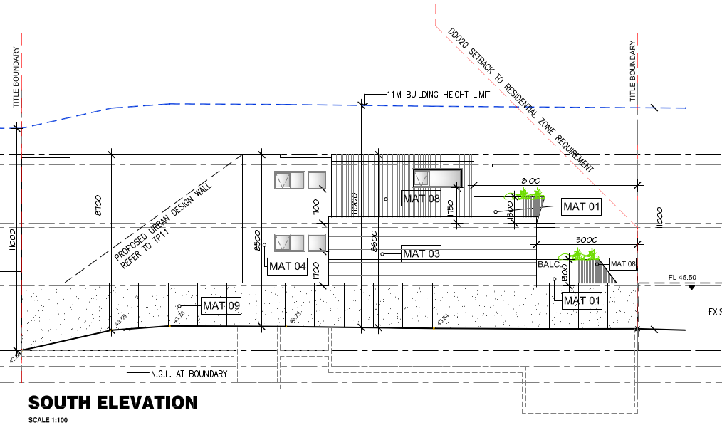Figure 2: rear boundary building envelope outline under the DDO20 (sketch plans, 6 July 2021).

Layout and design detail
The proposal, as shown in the 6 July 2021 sketch plans provides an appropriate response to the layout and design detail requirements of DDO20 in the following ways:
• Activation to the public realm (Nicholson Street) is achieved with a commercial space with extensive clear glazing at ground level and balconies at first and second floor allowing passive surveillance of the street.
• All service cabinets are concealed from view from the street.
• The vertical articulation associated with the extension of aluminium cladding from the first floor balcony to the top parapet and the patterned concrete at the north and south side elevation will create visual interest.
• A canopy extends across the façade providing shelter for pedestrians.
• Car parking facilities are concealed from view from the street.
To create an improved residential entry space, a condition is included in the recommendation to require the verandah above the commercial shopfront to adopt the same design as the verandah above the residential entry to provide additional weather protection and a cohesive presentation to the street.
The maximum site coverage proposed is an acceptable outcome in the activity centre, however the landscaping opportunities should be increased where possible. Planter boxes are currently proposed along the edges of the rear balconies. Conditions in the recommendation require the provision of additional landscaping including more greening across the façade as seen from Nicholson Street.
The Brunswick Structure Plan 2018, which is a reference document in the planning scheme, seeks to encourage development along the east side of Nicholson Street to create a residential frontage (‘Frontage – Type C’). The proposed commercial frontage with a zero-lot building line is supported in this case as it responds to the site’s context and the commercial language of the adjoining development to the immediate north.

Does the proposal satisfy the requirements of Clause 55?
A detailed assessment of the proposal against the objectives at Clause 55 has been undertaken. The proposed development complies with the objectives of Clause 55 including those relating to neighbourhood character, infrastructure, on-site amenity and facilities, detailed design and apartment developments. Areas of non-compliance with Clause 55 are discussed in detail below.
Side and rear boundary setbacks objective
The proposed rear boundary setback complies with Standard B17, however the setback of Apartment 1.02 and 2.02 (rear half of the building) will result in a non-compliance from the southern side boundary.
With respect to the south boundary setback, the proposed changes within the ‘sketch’ plans will result in compliance with Standard B17 and will be secured through condition 1 a) of the recommendation.

Walls on boundaries
At ground floor level, a boundary wall is proposed along the full length of the side and rear boundaries. Due to the ‘sunken’ design of the ground level car park, the boundary wall will adopt a similar height to standard boundary fencing (approximately 2 metres in height). The proposed ground level boundary wall is not compliant with Standard B20 in relation to length but does comply in relation to height. This is a reasonable outcome in an activity centre context and where wall height is minimized to reduce potential amenity and visual bulk impacts.
The development includes three sections of wall that exceed the height requirement for boundary walls.
Along the south boundary, a 12.2 metre long and four-storey high boundary wall is proposed to the front half of the building located adjacent to the dwelling at 108 Nicholson Street. Along the north boundary, a part three and part four storey wall is proposed.
Boundary wall development is relatively common along Nicholson Street. In an activity centre context, strict compliance with the requirements of Standard B18 is not necessarily required. Boundary wall construction appropriately affords the right for an adjoining property to equally build to the same extent allowing the vision for the Activity Centre to be realised with higher density development. However, these strategic development aspirations need to be tempered with considerations for amenity protection to existing sensitive interfaces, in this case, the impacts to the dwelling at 108 Nicholson Street to the immediate south of the subject site.
With the proposed changes implemented through the amended ‘sketch’ plans, the fourth level has been deleted thereby reducing the overall maximum building and wall height to 9.7 metres and generally 8.7 metres opposite the dwelling at 108 Nicholson Street. The length of the wall on the south boundary is also proposed to be reduced by 1.25 metres. However, as this wall is adjacent to north-facing windows, an assessment against Standard B20 is required to determine the acceptability of this boundary wall (provided below).
As there are minimal impacts to the property to the north, the extent of wall on the north boundary is acceptable and does not require change.

North-facing windows
There are four north-facing habitable room windows at ground level at 108 Nicholson Street facing the subject site. The ground floor windows are setback a minimum of 1.15 metres from the common boundary.
As advertised, the proposal is not compliant with Standard B20 and will cause a significant reduction in solar access to the habitable rooms at 108 Nicholson Street.
The advertised shadow diagrams are included at Attachment 2.
The ‘sketch’ plans submitted through the PID meeting have improved the access to sunlight into the north-facing windows to 108 Nicholson Street, however full compliance with Standard B20 is still not achieved. Updated 3D shadow diagrams have been supplied and were provided to the owners of 108 Nicholson Street.
The shadow diagrams associated with the ‘sketch’ plans are included at Attachment 4.
In balancing the objectives to ensure amenity impacts to neighbouring properties is reduced to a reasonable level whilst still achieving the higher-density development aspirations of the Activity Centre, it is recommended that full compliance with Standard B20 be imposed on the rear half of the proposed building, whilst compliance with Standard B19 (Daylight to existing windows) be achieved as a minimum for the front half of the building. This will mean that the living room windows have solar access in compliance with Clause 55.
The section C-C diagram of the sketch plans has been marked-up to illustrate the recommended change (see solid red line in Figure 4 below) to the rear half of the building.
Accordingly, the recommendation requires the following further changes in addition to those provided for in the ‘sketch’ plans:
• The wall on the south boundary shortened at first and second floor levels (associated with Apartments 1.01 and 2.01) so that it does not extend past the western-most north facing ground floor window at 108 Nicholson Street to the south.
• The south elevation walls of Apartments 1.02 and 2.02 modified to fully comply with Standard B20 at Clause 55.04-4 (North facing windows objective).
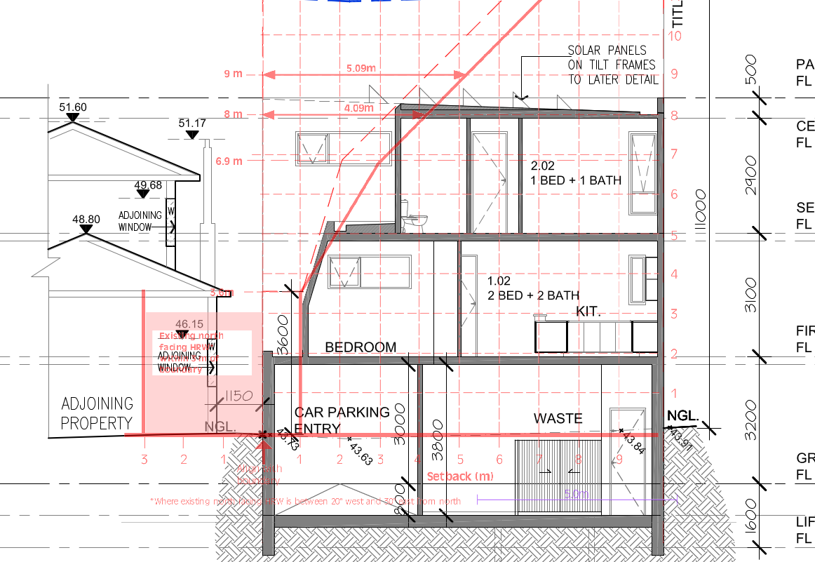Figure 4: Mark-up plan of the required setbacks to the rear half of the building to comply with Standard B20.
The sketch plans lodged with Council on 6 July 2021 reduce the extent of the wall on the south boundary associated with Apartments 1.01 and 2.01 (front half of the building) by 1.25 metres, meaning that Standard B19 Daylight to Existing Windows has been satisfied by providing the required light court to the impacted dining room windows. Solar access will still be achievable into the dining room area of 108 Nicholson Street up until midday, and daylight access will be provided in the afternoon. The result is one that achieves a reasonable level of amenity protection to an existing dwelling in an Activity Centre where significant change and density is encouraged.

Overshadowing open space
As advertised, the development slightly increases the shadow cast to the secluded private open space (SPOS) of 108 Nicholson Street to the south and 9 Ryan Street to the east. Due to the relatively small sizes of the adjoining SPOS and the location of existing built form, including outbuildings, any additional overshadowing cast by the proposed development will result in a non-compliance with Standard B21.
Specifically, in relation to 108 Nicholson Street, the proposal will result in an increase in shadow to the SPOS at every hour, from 9am to 3pm (at the equinox). As advertised, the extent of the increase in shadow varies from 0.6 square metres at 9am to a maximum of 8.2 square metres at 1pm. The sketch plans show a reduction in shadow at each hour, with overshadowing reduced by 0.6 square meters (to 7.6 square metres) at 1pm.
The shadow impact to 9 Ryan Street is confined to 2pm and 3pm (at the equinox). The sketch plans show additional overshadowing of 1 square metre and 1.2 square metres at 2pm and 3pm, respectively as a result of the proposed development.
Whilst full compliance with Standard B21 is not achieved, the development will result in only a marginal increase in overshadowing. This outcome is commensurate with the amenity expectations for land within and adjoining the Brunswick Activity Centre and is not unreasonable in this context.

Overlooking
As advertised, the proposal uses a combination of high window sills (to 1.7 metres) and planter-box screening to the eastern edge of the east facing balconies to address the issue of overlooking. To achieve full compliance with the requirements of Standard B22, the following changes will be required via conditions of the recommendation:
• The north and south edge of the balconies at the east elevation are to be screened up to a height of 1.7 metres.
With respect to the use of the planter-box, this initiative limits direct views through a combination of its height and depth that allows horizontal views east but limit views downward towards to SPOS of adjoining dwellings. The planter-box design does not rely on vegetation and planting to be effective in limiting views; however, appropriate planting can soften the balcony edge, provide additional screening and improve the internal amenity of the proposed apartment.
For these reasons, the planter-box design is considered to be a positive solution to limit overlooking and complies with the objective of Clause 55.04-6.
To remove inconsistent information on how overlooking is addressed, a condition of the recommendation will require that windows shown on section B-B and section C-C to have a minimum sill height of 1.7 metres from finished floor level, to limit overlooking, and the notation on the floor plans stating that these windows are “opaque to 1.7 metres” is to be deleted.

Energy Efficiency
The proposal includes a number of environmentally sustainable design features. The key initiatives include:
• Minimum average NatHERS rating of 6.6 stars.
• 10-15kW solar PV on the roof space.
• Harvesting of stormwater with 6,000L capacity for re-use on site.
Council’s ESD Unit confirmed that, subject to conditions included in the recommendation, the proposal will achieve best practice in accordance with the requirements of Clause 15.03-1L.

Noise impacts
The layout of the proposed development seeks to minimise noise transmission within the site. Noise sensitive spaces have been appropriately located to avoid noise impact from mechanical equipment, including air conditioners, lifts and car parking.
An acoustic assessment of the proposal was prepared by SLR Consulting Australia Pty Ltd (dated August 2020). A condition of the recommendation will require the acoustic report to be updated to respond to the current requirements of the EPA Act as introduced on 1 July 2021. The Acoustic report will be endorsed once approved and all recommendations of the report implemented and maintained.
A concern was raised by an objector relating to noise potentially escaping through air/exhaust vents to the rear of the building. The updated acoustic report will be required to assess this situation together with the noise associated by the specified car stacker to ensure these matters have been properly addressed.

Accessibility
The objective of Clause 55.07-7 is to ensure the design of dwellings meets the needs of people with limited mobility.
The proposal complies with the requirements of Standard B41 with at least 50 percent of the dwellings appropriately designed to comply with the requirements of Table B7 at Clause 55.07-7 of the Planning Scheme.

Has adequate car parking been provided?
The proposed development provides a total of 4 car parking spaces on-site, including two within the car stacker.
The sketch plans reduce the number of apartments to four. This change reduces the car parking requirement associated with the residential component of the development to 4 car spaces. These spaces are provided.
The proposed shop has a total leasable floor area of 42.3 square metres and requires one car space in accordance with Clause 52.06. The proposal seeks a reduction of one car space, associated with the shop.
Clause 18.02-4L (Car parking in Moreland) supports reduced car parking rates in developments:
• Within and close to activity centres.
• With excellent access based on frequency and location to a range of public transport options.
• With increased provision of bicycle parking above the rates specified in Clause 52.34.
The proposal is located within the Brunswick Activity Centre and has excellent access to public transport including the route 96 tram, which operates along Nicholson Street. The development also incorporates 5 dedicated bicycle parking spaces where none are required by the planning scheme.
Council’s Development Engineers are satisfied that the car parking requirement can be reduced for this application.

Are the vehicle access arrangements and traffic impacts in the local area acceptable?
Council’s Development Engineers have reviewed the application, including the submitted traffic impact report prepared by TTM Consulting, and confirm that the proposal represents an acceptable outcome.
As a determining referral authority, the application was also referred to Transport for Victoria, who didn’t object to the proposed development, subject to conditions contained within the recommendation.

What impact does the proposal have on cycling, bike paths and pedestrian safety, amenity and access in the surrounding area?
The proposal provides an acceptable response to the Planning Policy Framework and will not have an unreasonable impact on cycling, bike paths and pedestrian safety, amenity and access for the following reasons:
• The development creates an active frontage allowing for passive surveillance.
• The number of vehicle crossings is limited to one for the site frontage.
• Vehicles can enter and exit the site in a forward direction.
• There is provision for 5 wall mounted bicycle racks secured within the car park area.

5. Response to Objector Concerns
The following issues raised by objectors are addressed in section 4 of this report:
• Off-site amenity impacts.
• Building height.
• Visual amenity and bulk impacts.
• Non-compliances with setback requirements
• Noise impacts (mechanical equipment)
• Car Parking and Traffic impacts.
Other issues raised by objectors are addressed below.

Noise impacts (residential)
Concerns have been raised regarding the potential noise generated from the dwellings after occupancy. The consideration of this planning application is confined only to the construction of the dwellings. The residential use of the dwellings does not require a planning permit. Residential noise associated with a dwelling is considered normal and reasonable in an urban setting.

Overdevelopment
Planning Policy envisages an increase in housing density in well serviced areas. Clause 16.01 of the Moreland Planning Scheme encourages higher density housing development on sites that are well located in relation to activity centres, employment corridors and public transport. The increase in population and density at this site is considered an appropriate response given its location in an Activity Centre and the proximity to public transport, shops and other services.
The planning assessment and issues in Section 4 of this report has confirmed that subject to the conditions in the recommendation, the proposed mixed use development will not be an overdevelopment of the site.

Contribution to the urban heat island (UHI) effect
It is accepted that land within an activity centre will be developed more intensely. The proposal results in 100 percent site coverage and cannot accommodate any tree planting but does incorporate landscaping within planter-boxes along balcony edges. In addition, no existing trees are being removed.
Council’s ESD team support the application subject to conditions that will ensure the development achieves a best practice ESD outcome.
Complications and nuisance during construction phase
Noise and truck movements during the construction phase of development are a temporary and unavoidable consequence of development and not justification to withhold development of the site.
Construction techniques and effects are not a consideration under the Planning and Environment Act or Moreland Planning Scheme. The Moreland City Council General Local Law 2018 seeks to prevent nuisances, protect the amenity of the municipality and control vehicles during construction. The Environmental Protect Act 2021 also provides for the protection of residential amenity by controlling noise from construction sites.
Impact to adjoining properties through the proposed excavation works
An owner who is proposing building work has obligations under the Building Act 1993 to protect adjoining property from potential damage from their work. If building work is close to or adjacent to adjoining property boundaries, then the relevant building surveyor may require the owner to carry out protection work in respect of that adjoining property. This is to ensure that the adjoining property is not affected or damaged by the proposed building work.
This process is not controlled or overseen via the planning process and regulations. It is a matter addressed at the building permit stage.
Boundary dispute
As part of the assessment of this planning permit application, Council has had regard to the property title in determining the location, dimension and orientation of property boundaries. The property boundaries shown on the property title may differ from the location of existing boundary fencing.
Adverse possession law allows a person to claim land under particular circumstances. Adverse possession is not covered by the Planning and Environment Act (1987) and has not been considered as part of Council’s consideration of the planning permit application. Should a planning permit issue and an adverse possession claim be granted, the development plans endorsed under the permit would need to be amended to reflect the updated title boundary.

6. Officer Declaration of Conflict of Interest
Council Officers involved in the preparation of this report do not have a conflict of interest in this matter.

7. Financial and Resources Implications
There are no financial or resource implications.

8. Conclusion
It is considered that the proposed development at 108A Nicholson Street, Brunswick East, is consistent with the purpose of the Mixed Use Zone and the Planning Policy Framework including Council’s Municipal Planning Strategy.
Subject to conditions of the recommendation, namely the reduction of the building to three storeys, the proposal is an acceptable response to the preferred character of the area and the relevant provisions of the Planning Policy Framework. The proposal strikes a balance between providing housing growth and maintaining a reasonable level of amenity of adjoining dwellings.
On the balance of policies and controls within the Moreland Planning Scheme and objections received, it is considered that a Notice of Decision to Grant a Planning Permit No MPS/2020/619 should be issued.

Attachment/s
1 | Location and zone plan - 108A Nicholson Street, Brunswick East | D21/332518
2 | Advertised Development plans - 108A Nicholson Street, Brunswick East. | D21/332595
3 | Objector map - 108A Nicholson Street, Brunswick East | D21/332676
4 | PID sketch plans - 108A Nicholson Street, Brunswick East | D21/332705

