…..

UPDATE No. 55

December 2020
Building Strong Communities in Timor-Leste and Australia

For your diary:

- To start off 2021

Friends of Aileu’s first Community Committee meeting for 2021

6:00 - 7.30 pm
Tuesday 9 Feb 2021 (TBC)

CERES Gathering for Aileu – an afternoon and evening of music and much more …….

CERES Pavilion
Sunday 28 February 2021

- Future activities

Getting together to celebrate 21 years of friendship with Aileu

First week in May 2021, more details to come

The return of the Trivia Quiz night for the Aileu University Scholarship Program

Friday 27 August 2021, Coburg Town Hall,
more details to come

- For more about these activities, or other enquiries about Friends of Aileu:

See:

friends-of-aileu-news-events

facebook.com/friendsofaileu

Send a Message:

moreland.vic.gov.au/send-message

Contact Friends of Aileu Project Officer:
by email
or
by phone/mobile:
Tel: 9240 1111
Mob: 0475 954 068

Vale Mr Martinho Matos
Condolences to the family of Mr Martinho Matos, Aileu District Administrator (2004-2016), who passed away in November.
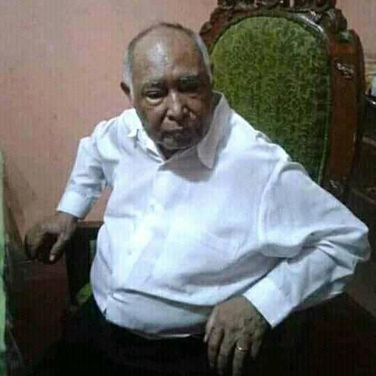
Mr Martinho was a strong supporter of the friendship relationship over his 12-year tenure. He did much to help strengthen our mutual bonds, warmly welcoming many friendship delegations to Aileu and visiting Moreland and Hume in 2005 and 2010. He will be sadly missed.
CERES Gathering for Aileu, Sunday 28 February 2021
In collaboration with Grassroots Gatherings and CERES, Friends of Aileu invites you to join us at the 5th annual CERES Gathering for Aileu.
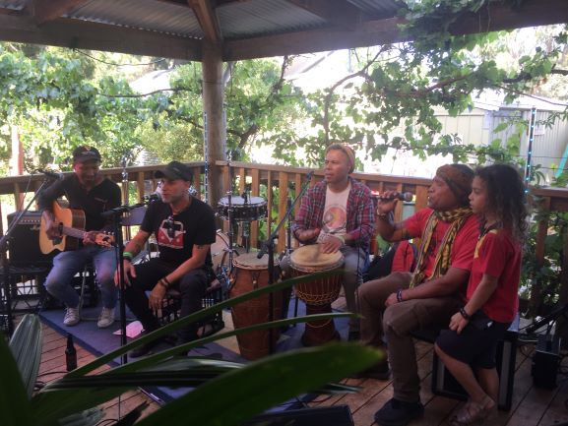
This will be a COVID-safe, all-ages afternoon and evening of friendship, with music, activities and much more.
Lunch, snacks and drinks will be available for purchase. Funds raised from the event will help us continue our engagement with the youth of Aileu.

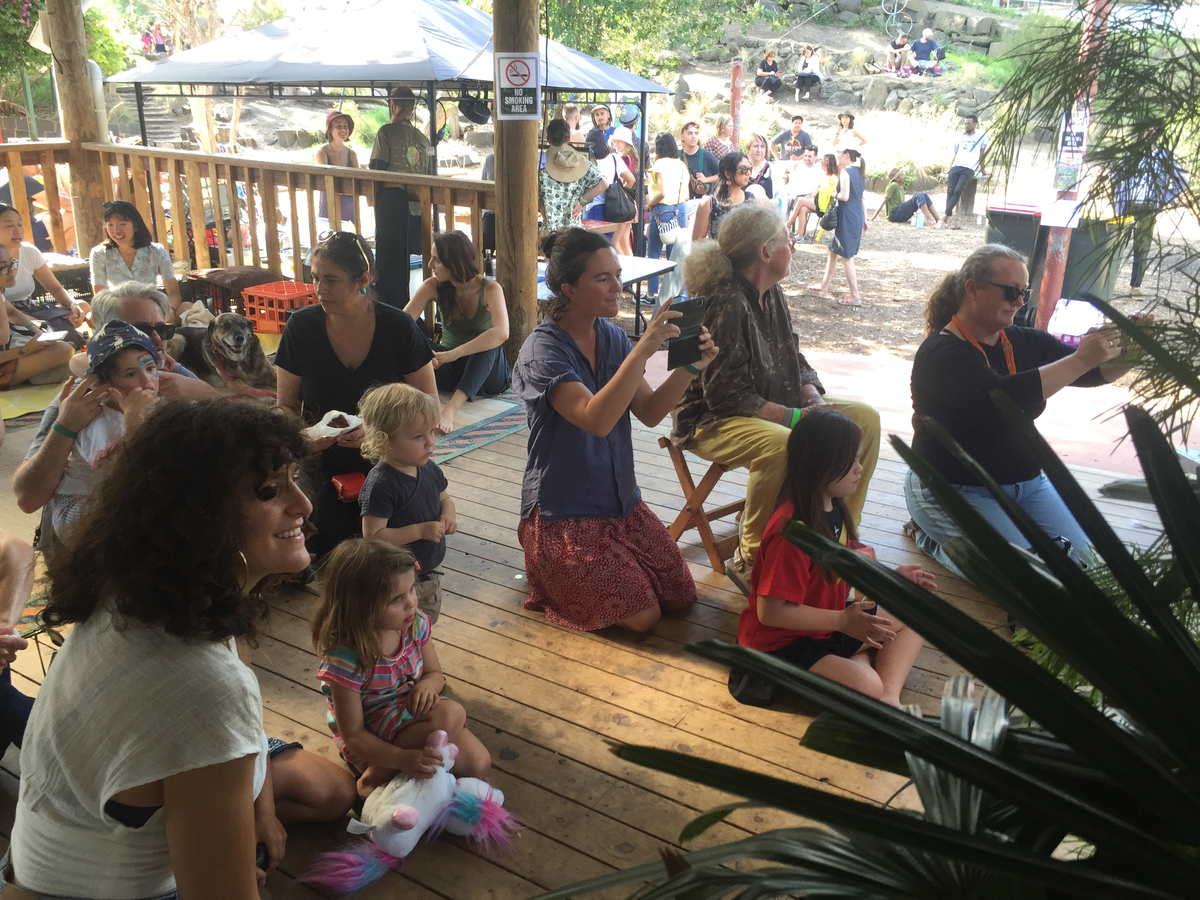
Your contribution on 28 February will help support the youth-led activities in sustainable agriculture & permaculture, environmental protection & waste management, and art, music & culture.
Water conservation training put into practice
28 young people (14 males and 14 females) from seven villages were sponsored to participate in a 4-day hands-on water conservation training conducted by PERMATIL in early October, with funds from Merri Health’s 2020 donation and a GoFundMe appeal.
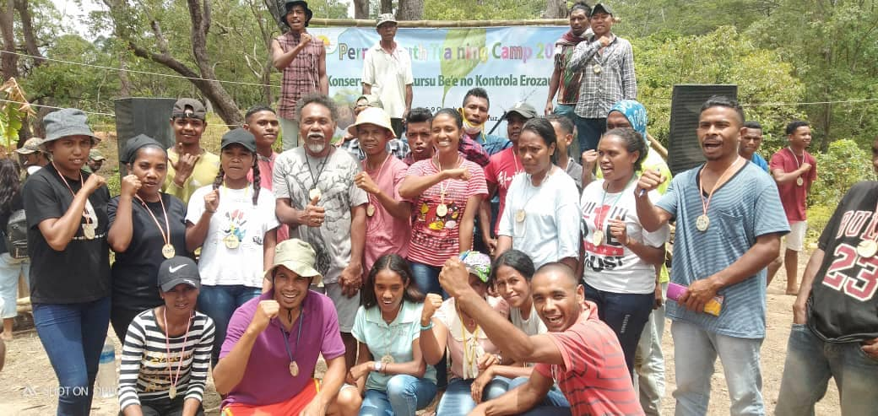
The participants have since been busy applying their learnings back home, constructing water retention and groundwater recharge ponds in the headwaters of local streams.
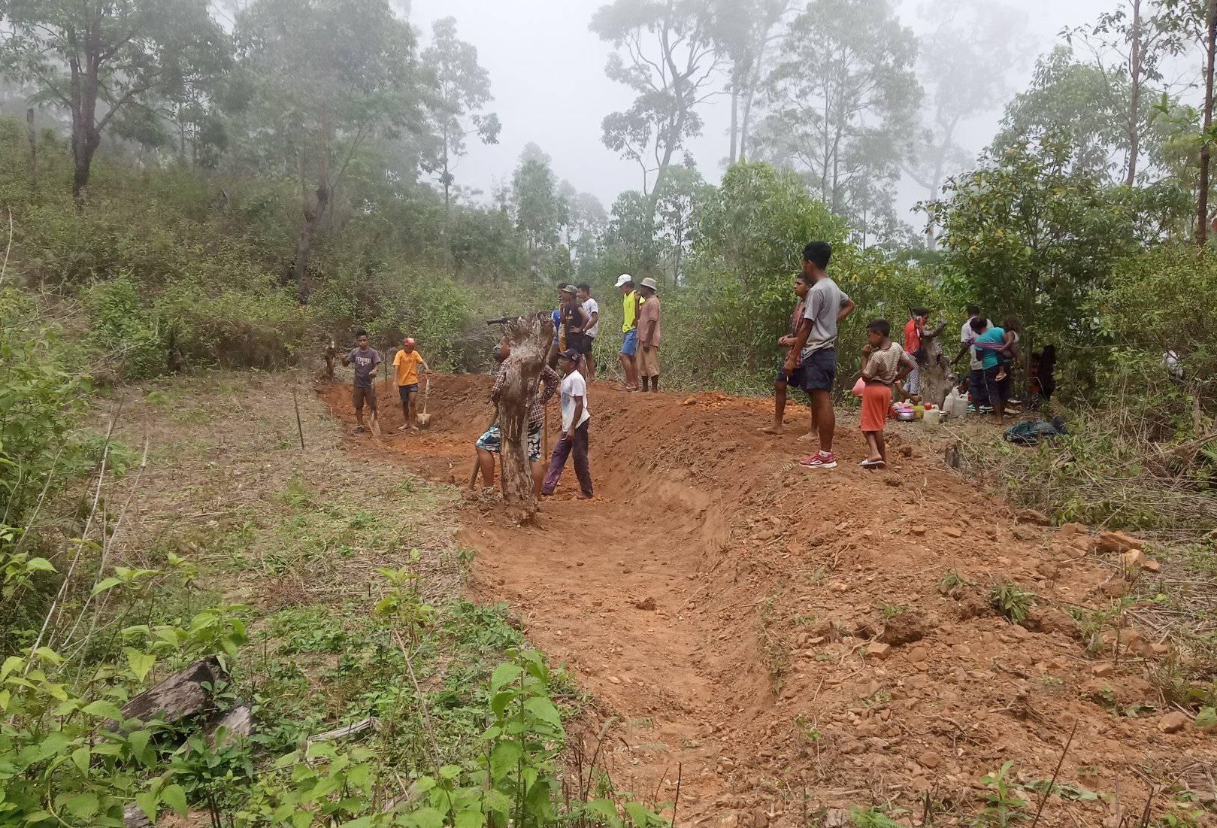
This practical work is being monitored by members of the Aileu Anan Association, four of whom also took part in the training, and by PERMATIL staff and volunteers.


Building strong communities in Timor-Leste and Austral

Supporting the efforts of rural communities to address the poor water quality & reliability is an ongoing priority for Friends of Aileu. Implementing local water resource management, reforestation and agricultural improvement activities will help increase agricultural productivity & diversity and improve people’s health, nutrition and social and economic opportunities.
15th annual Aileu Expo
The 15th annual Aileu Expo of traditional culture and local products, coordinated by the Aileu Resource and Training Centre (ARTC) and held over 26-28 November, was again a great success, involving 26 exhibitors and attracting 950 visitors over the three days.
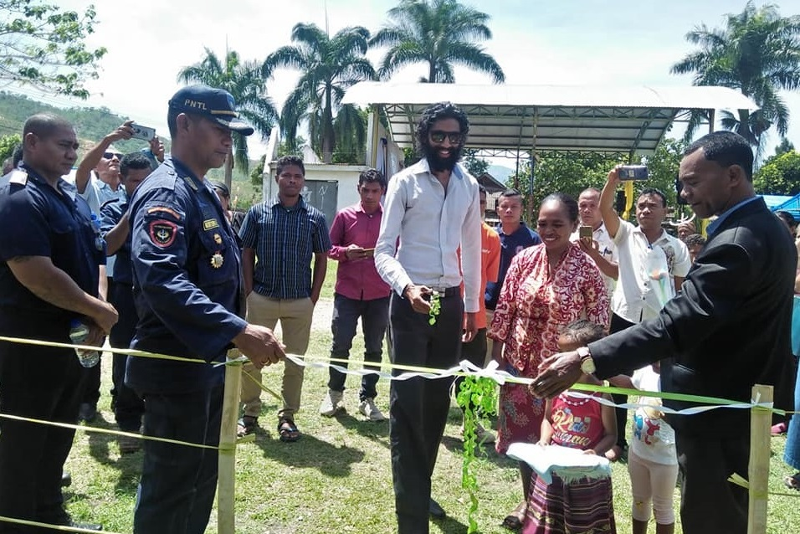
This year there was a special focus on coffee and tourism. The Expo was supported by The Asia Foundation, whose representative opened the event with local officials (above), and by the Coffee Association of Timor and the Portuguese Cooperation’s Kinta Portugal project.
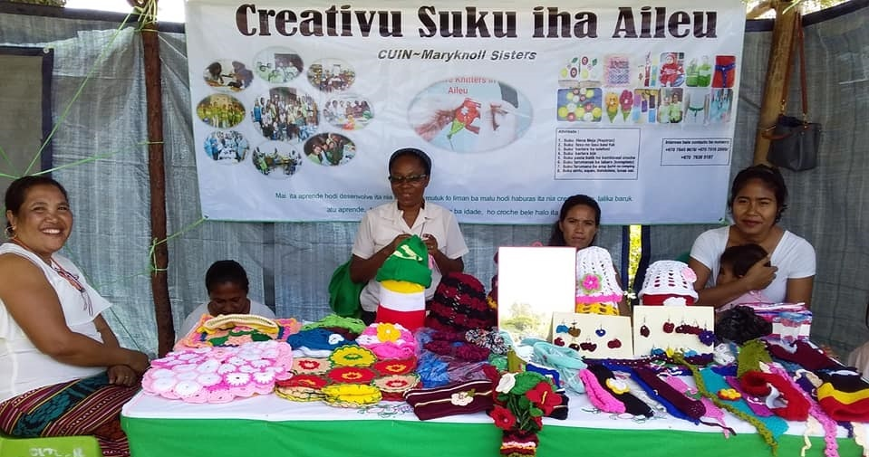
Exhibitors included Friends of Aileu partners the Maryknoll Sisters Uma Itaú Nian Clinic sewing group (above) and Arte Mambai Rai Husar youth art group (below).
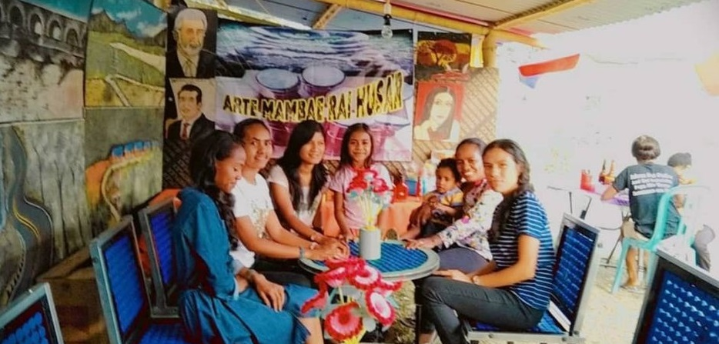
Farmers from the Manu Casa community in Lequidoe also attended the Expo, learning more about coffee quality and marketing.
Refresher training for Aileu health workers
Dr Gustodio Alves, Head of the Emergency Department at the Dili National Hospital, has now assembled a team of other Aileu-born doctors to continue supporting knowledge and skills development amongst Aileu’s health workers.
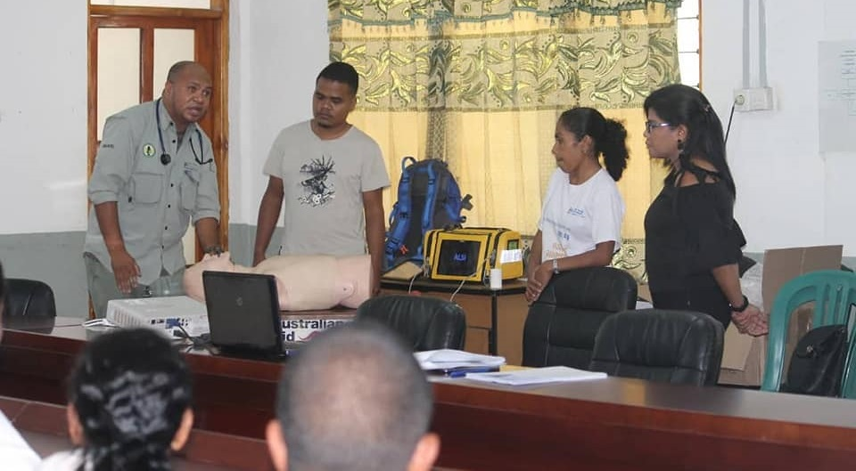
In November, Dr Todi, with Dr Pascoal, Dr Dulce and Dr Julia, provided a one-day refresher on the science and management of medical emergencies and severe illnesses for 25 staff of the Aileu Hospital and Health Centre.
The training was well received, and an evaluation indicated significant learning by most participants.
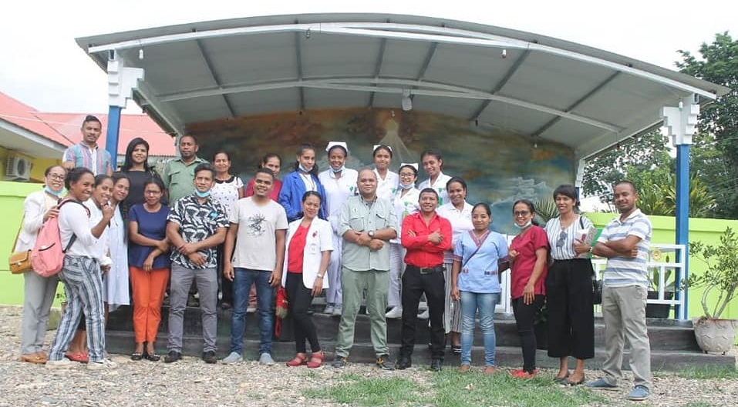
In consultation with Aileu Health authorities, Dr Todi is preparing a plan for a program of training for 2021, with opportunities for staff located in Aileu’s rural Health Posts to participate.
Friends of Aileu looks forward to further supporting this ‘Aileu Helps Aileu’ initiative with a contribution towards the costs including the out of pocket expenses of the volunteer trainers and participating health workers.
Congratulations
Friends of Aileu wishes to congratulate all our Aileu partners, and others across Timor-Leste, on their success in addressing the challenges of the COVID-19 pandemic.
While there was no opportunity for travel between Australia and Timor-Leste this year, we have been able to maintain our close links, enabling the sharing of ideas and resources and accomplishing quite a bit in a most difficult year.
With our local partners, we look forward to continuing to work together in friendship and cooperation, and to more joint successes in the year ahead.

