SINGLE-USE PLASTIC BAN
Supplier List: alternatives to single-use plastics items
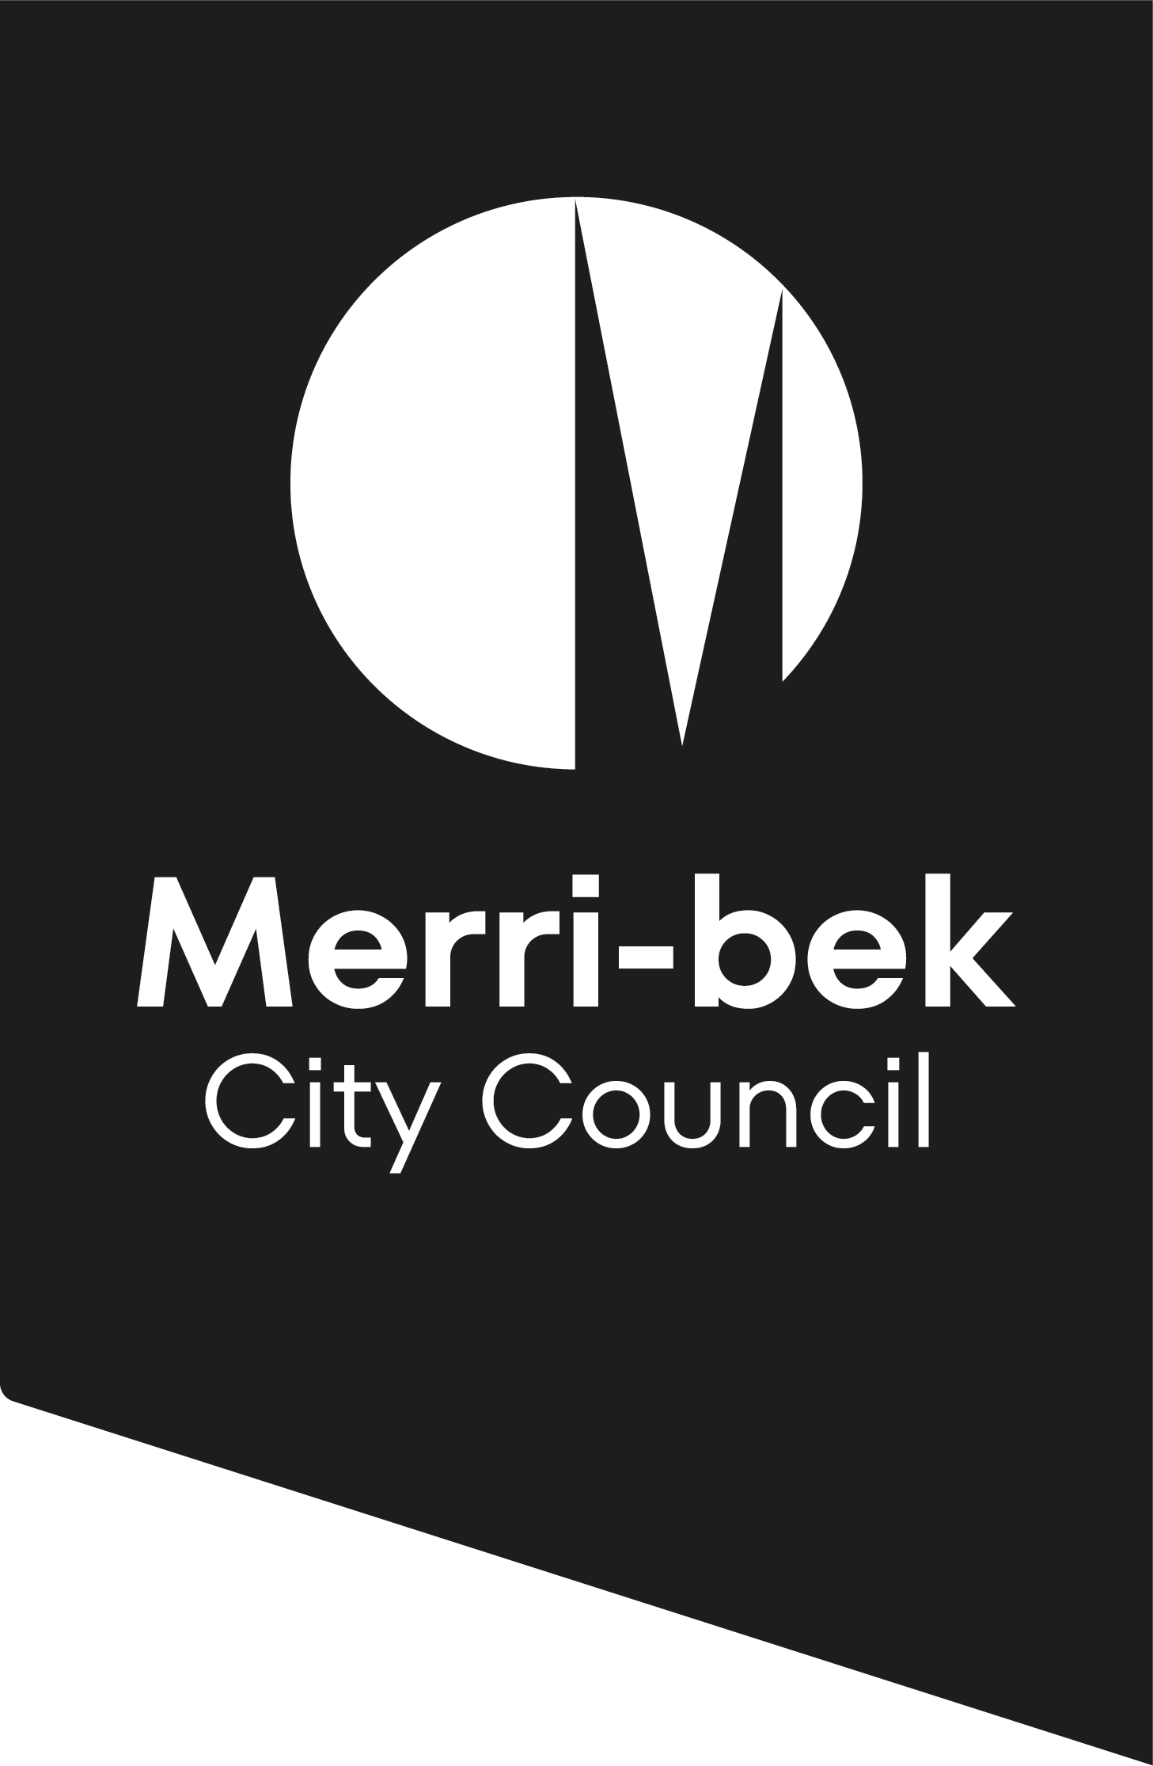

The Victorian Government is banning the sale and supply of some single-use plastic items from February 2023. Plastic pollution harms our health, wildlife and environment. By banning these items, we will reduce plastic pollution, creating a healthier environment now and for years to come.
To help your business find alternatives to single-use items we have developed a supplier list. Please note, this is not a Council endorsed supplier list. It is simply a list of suppliers that Council is aware of. It is intended only to be a useful document to help you get started. It is not extensive and may not include all suppliers operating.
Please ensure you conduct your own research and that your business is satisfied that any alternatives you proceed with will be able to meet both your business and customer needs. Council accepts no responsibility for any problems that arise as a result of using any of the suppliers identified in the list below.
Minimise single-use if you can
- Before purchasing items, always consider whether you can avoid the item first. Then consider whether reusable options could be used.
- Boomerang Alliance have a useful resource, with tips on reducing usage to keep costs down. See the section on ‘Reducing to save money and waste, in their compostable take-away packaging guide
Single-use items
- The following list is predominantly for single-use items.
- Boomerang Alliance have a useful resource on compostable take-away packaging, which may help you determine which packaging items will suits your various food needs.
Reusable items
- For reusable items to sell at your business to encourage re-use, see the list below
- For re-use systems, including reusable cup swaps schemes and container swap schemes, see Sustainability Victoria’s Reusable Business Solutions list. For guidance about accepting reusable items see Sustainability Victoria’s guidance and our BYO containers Guide.
Thanks for helping to keep our streets and waterways clean

This document will be updated as needed. If you have any feedback relating to this document, email wasteprojects@merri-bek.vic.gov.au or call 9240 1111. Thanks to Yarra City Council for sharing their supplier list, as part of their Proudly Plastic Free program.
SINGLE-USE ITEMS
Supplier name | Items | Website
DRINKING STAWS

Hay straws | - Home compostable straws made from wheat stems | www.haystaws.com.au
Stroh | - Home compostable straws made from wheat stems  - Note, plastic straws will still be made available for medical or disability needs | www.stroh.com.au
What a wheat | - Home compostable straws made from wheat stems | www.whatawheat.com
For paper straws see Packaging Suppliers listed below
PACKAGING RANGE
to replace single-use plastic cutlery, plates, drink stirrers, straws and expanded polystyrene take-away containers
Alpha food packaging | - Wide range of recycled cardboard takeaway containers (Enviro range) | www.alpha-pack.com.au
BioPak | - Small range of 100% recycled certified cardboard containers, certified home compostable plates, takeaway containers (e.g.: sugarcane clamshell, sugarcane compartment trays), wooden cutlery, paper straws and recycled napkins | www.biopak.com.au
Confoil | - Wide range of aluminium foil containers, with optional paperboard coated paper lids | www.confoil.com.au
Detpak | - A range of cardboard takeaway containers (Endura range), sugarcane plates, wood cutlery, paper straws, paper bags and recycled napkins | www.detpak.com
Greenpak | - Wide range of cardboard takeaway containers, 100% recycled paper punnets, home compostable plates, catering trays, wooden cutlery, paper bags and recycled napkins | www.greenpack.com.au
Kent Paper | - Wide range of cardboard takeaway containers, aluminium foil containers, wood cutlery, paper straws, paper bags and recycled napkins | www.kentpaper.com.au
PAC Trading | - Wide range, home compostable sugarcane takeaway containers, paper cardboard takeaway containers, wood cutlery and paper and bamboo straws, | www.pactrading.com.au
The Packaging Place | - Wide range of item specific paperboard takeaway options: snack cups, wrap cups and sleeves, snack cones, bagel/donut sleeves as well as takeaway containers, wood cutlery, paper straws, paper bags and recycled napkins | www.packagingplace.com.au/food-catering/
DRINK CUPS
To replace expanded polystyrene drink cups
BioPak | - Certified commercially compostable disposable paper cups, lined with plant-based plastic* | www.biopak.com.au
Compostable Alternatives | - Certified home compostable coffee cups | www.compostablealternatives.com.au/shop
Good Edi | - Edible coffee cup made from oats and grains | www.goodedi.com.au
I am Not Paper | - Coffee cups made from re-purposed plant by-product. Home and commercially compostable. * | www.iamnotpaper.com
Suppliers of standard disposable paper cups | - Numerous suppliers. Standard paper cups for hot and cold beverages are lined with oil-based plastic.
COTTON BUD STICKS

Your current supplier | - Paper cotton bud sticks, will be available from your current supplier  - Reusable silicon ‘cotton;’ swabs are available through some suppliers.

* Note, commercially compostable coffee cups, cannot be disposed of in Merr-bek’s kerbside Food and Garden Organics bin. To be commercially composted, these need to be disposed of via a by a specific composting service, such as BioPak’s Cup Recycling Service. Alternatively, they can be disposed of in a garbage bin.

REUSABLE ITEMS – to sell to encourage BYO
Supplier name | Items | Website
REUSABLE CUP SUPPLIERS
To sell to encourage BYO
Frank Green | - Reusable cups made from plastic, ceramic, or glass | www.frankgreen.com.au
Huskee | - Reusable cups made from coffee husk, available as dine in option, multiple sizes available, saucer options | www.huskee.co/huskeecup
Joco Cups | - Reusable cups made from glass and silicone. Cobranding option, multiple sizes | www.jococups.com.au
KeepCup | - Reusable cups made from glass and silicone. Cobranding option, multiple sizes | www.keepcup.com.au
RCup | - Reusable cups made from glass and silicone. Cobranding option, multiple sizes | www.simplycups.com.au/rcup
Uppercup | - Reusable cups made from plastic, cobranding option, multiple sizes | www.uppercup.com
REUSABLE PACKAGING SUPPLIERS
To sell to encourage BYO
Biome | - Wide range of reusable options – not a wholesaler | www.biome.com.au
Shop Naturally | - Wide range of reusable options – not a wholesaler | www.shopnaturally.com.au
Flora & Fauna | - Wide range of reusable options – not a wholesaler | www.floraandfauna.com.au
Zero Store | - Wide range of reusable options – not a wholesaler | www.zerostore.com.au

