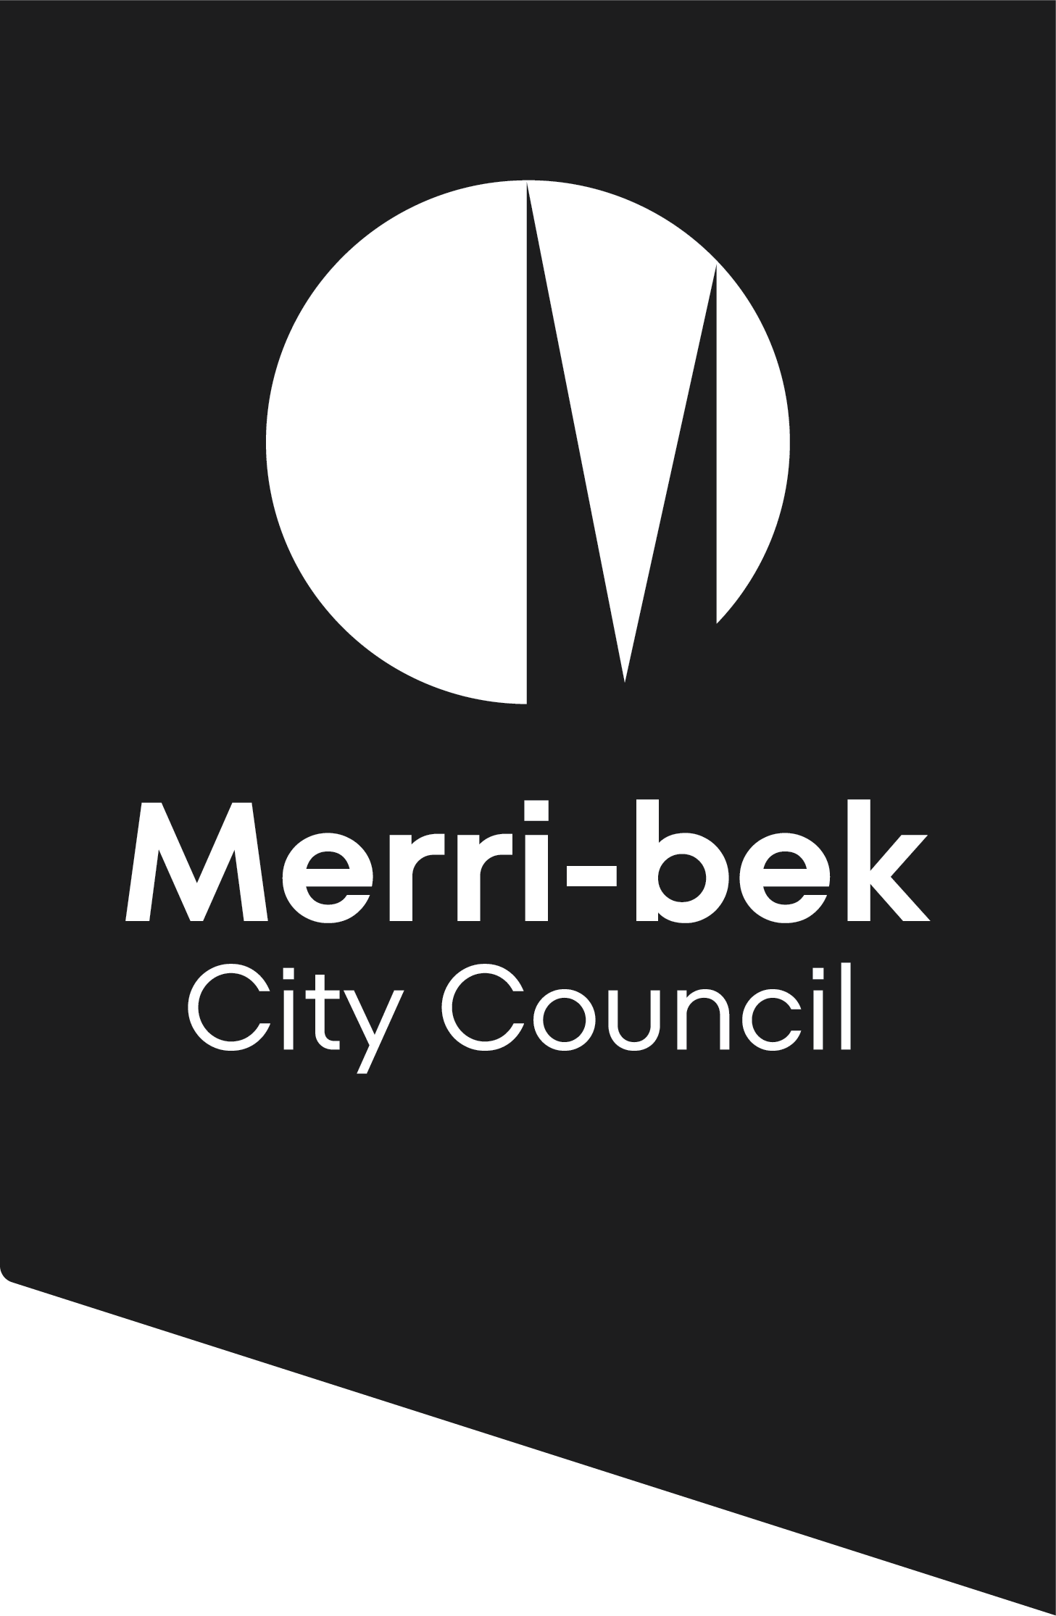

Activity Notification

Groups or individuals registered with one of the following organisations are not required to obtain a permit, however an Activity Notification is required.
This is to ensure that public space is managed in accordance with safety and public amenity requirements and that bookings are fairly and equitably distributed.
- Victorian Electoral Commission / Australian Electoral Commission
- Consumer Affairs (Co-operatives Public Register, Fundraisers Public Register or Incorporated Associations Public Register)
- Australian Charities and Not for Profit Commission
- Victorian Registration and Qualifications Authority

Business Trading Name:
Contact Name:
Address:
Suburb: |  |  | Postcode:
Contact Details: | BH. | Mobile:
 | AH. | Email:
Are you a Not for Profit: | Yes: (if yes, please provide proof) | No:

Approved Locations

ANDER  Anderson Road  FAWKNER | BELLCUM  Bell Street & Cumberland Road  PASCOE VALE SOUTH | BELLELIZ  Bell Street & Elizabeth Streets COBURG | BELLMELV  Bell Street & Melville Road  PASCOE VALE SOUTH
BELLNICH  Bell Street & Nicholson Street COBURG | BELLTURN  Bell Street & Turner Street PASCOE VALE SOUTH | BONW  Bonwick Street & Jukes Road  FAWKNER | CERES  Corner Roberts Street BRUNSWICK (outside CERES Enviro Park)
COBMALL  Victoria Street Mall  COBURG | CUMGAFF  Cumberland Road & Gaffney Street PASCOE VALE | GEUM  Geum Street  HADFIELD | GOWCOMM  Gowanbrae Community Centre  GOWANBRAE
GRANBRUN  Grantham Street & Brunswick Road  BRUNSWICK WEST | LYGBLY  Lygon Street & Blyth Street BRUNSWICK | LYGBRUN  Lygon Street & Brunswick Road  BRUNSWICK EAST | LYGGLEN  Lygon Street & Glenlyon Road  BRUNSWICK EAST
LYTTON  Lytton Street  GLENROY | MORGAN  Morgan Court (next to Coles)  GLENROY | MORMEL  Moreland Road & Melville Road  PASCOE VALE SOUTH | MRLYMC  Merlynston Street Shops COBURG NORTH
NICHBRU  Nicholson Street & Brunswick Road  BRUNSWICK EAST | NICHMORE  Nicholson Street & Moreland Road BRUNSWICK EAST | OHESUS  O’Hea St & Sussex Street COBURG (near Bakery) | PASGLEN  Pascoe Vale Road & Glenroy Road GLENROY
POSTOFF  Post Office Place  GLENROY | SNELL  Snell Grove  OAK PARK | SYDBNDRY  Sydney Road & Boundary Road FAWKNER | SYDBOX  Sydney Road & Box Forest Road FAWKNER
SYDBRU  Sydney Road & Brunswick Road BRUNSWICK | SYDDAW  Sydney Road & Dawson Street  BRUNSWICK | SYDGAFF  Sydney Road & Gaffney Street COBURG | SYDHRDNG  Sydney Road & Harding Street COBURG
SYDPARK  Sydney Road & Park Street BRUNSWICK | SYDURQ  Sydney Road & Urquhart Street COBURG

COLLECTION NOTICE
Merri-bek City Council is committed to protecting your privacy in accordance with the Privacy and Data Protection Act 2014 (Vic) and the Health Records Act 2001 (Vic). The personal information requested on this form is being collected by Merri-bek City Council for the purpose of assessing your eligibility for a street trading or special events permit or any other directly related purpose under the Local Government Act 1989 or other relevant legislation and may also be used to update your personal information otherwise held by Council (for example, contact details including email address, phone number).
It will not be disclosed to any other external party without your consent, unless required or authorised by law. If the personal information is not provided your application cannot be processed or a permit issued. You can gain access to your personal information you have provided to Merri-bek City Council and if you wish to alter it, please contact Council’s Privacy Officer via telephone on 9240 1111 or e-mail at Privacyofficer@merri-bek.vic.gov.au.

Proposed Activity

- Fundraising
- Information/Awareness
- Performance
- Political
- Highway/Intersection Collection
- Other: (please specify) _____________________________________

Proposed location, date and times

- No more than two days per week per location
- Bookings may be made up to six months in advance

Location | Date | Time | Number of people attending

Please note: Public Liability Insurance of $10 million is required when undertaking any activity on public streets in Merri-bek.

Code of Conduct requirements

When undertaking activities in Merri-bek please ensure:

- activities are undertaken in approved locations only;
- the activity does not interfere with the use or enjoyment of that public place or the personal comfort of another person;
- public safety and amenity are not compromised;
- the activity and those engaged to participate in the activity do not annoy, pester, assault, abuse or obstruct the mobility access of any other person;
- activities are respectful of the public;
- instructions issued by Council Authorised Officers are followed;
- collectors do not disrupt business trading including retail and dining establishments, affect workplace performance or detract from or negatively impact public amenity;
- the activity does not obstruct or interfere with vehicle or pedestrian traffic; or
- at the conclusion of the activity the area is left clean and tidy.

If any details change prior to the event, please notify Merri-bek City Council by emailing csaenquiries@merri-bek.vic.gov.au.

Following receipt of this advice, Merri-bek Council will confirm the requested space is available.

Applicant Name: ___________________________________________________________________________

Signature: _______________________________________ Date: _____________________________

Please allow 14 days for processing of your application

