Moreland Council Parking Permits
Resident parking & visitor’s ePermits
Application process and FAQs

October 2021
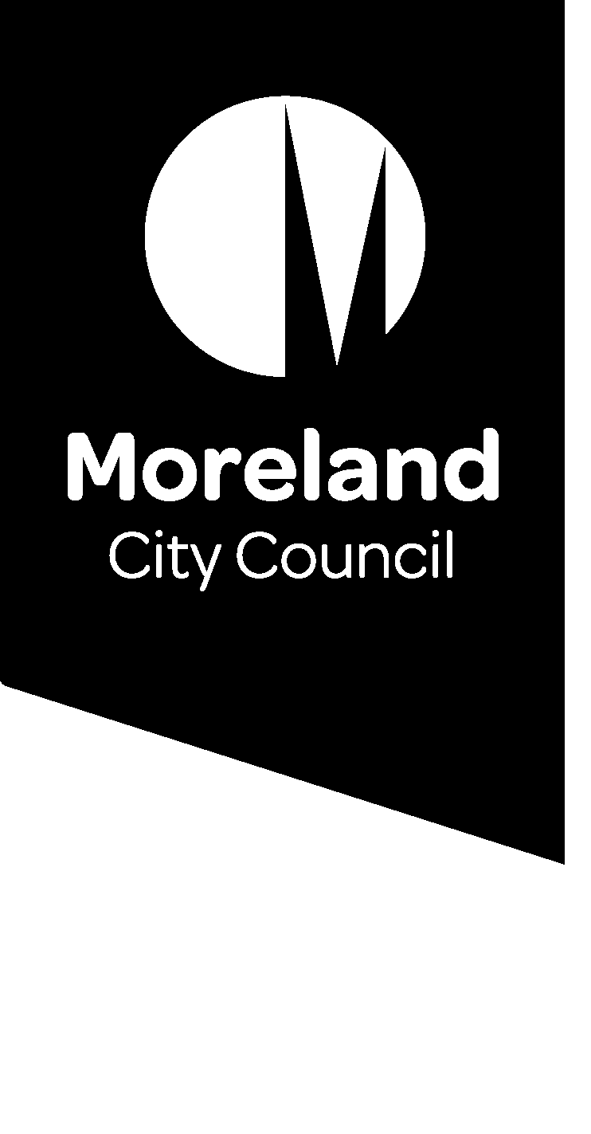
Contents
Overview 3
Resident Parking ePermit 4
Before you start 4
How to apply for a Resident Parking ePermit 5
ePermit Registration Update via Web Browser 14
ePermit Registration Update via PayStay App 17
How to Renew Your Resident Parking ePermit 22
Resident Parking ePermit FAQ’S 25
Resident Parking ePermit processing timeframes 25
Are my personal information and PayStay payments secure? 25
Why do parking officers mark tyres in time restricted parking areas? 25
Where can I park with a resident parking permit? 25
How many resident parking permits can I apply for? 26
How much do resident parking permits cost? 26
When can I expect to receive my resident parking ePermit? 26
I have bought a new car; how do I update the registration on my permit? 26
My property doesn't appear to be eligible. What do I do? 26
Visitor Parking ePermit Book 27
How to apply for Visitor ePermit Book 28
How to use a Single Use Visitor ePermit 31
Visitor ePermit Book – processing timeframes 33
Visitor ePermit Book FAQs 33
Who can apply for visitor parking permits? 33
Where can I park with a visitor parking permit? 34
Visitor ePermit Book processing timeframes 34
Can I apply for a Visitor ePermit for a future date? 34
Can I select multiple dates if I have guests that plan to stay-over? 34
Can I can cancel an approved Single Use Visitor ePermit if my plans change? 35
Can I transfer the Single Use Visitor ePermit to a different vehicle? 35

Overview

Moreland City Council has a new digital parking permit system called ePermits.
The ePermits system is an easy way to apply for a Resident Parking Permit and Single Use Permit (previously known as Scratchy Permits).
ePermits is powered by PayStay – an electronic system that manages resident accounts online and links the digital ePermit to the registration plate of the registered vehicle. Permits are no longer displayed on the vehicle.
This guide has been created for Moreland residents to help you understand the online application process and ePermit system.
The online portal allows Moreland Council staff to quickly review, approve and activate resident parking ePermits.
Signing up to the online portal and applying for an ePermit will take approximately 10mins.

Resident Parking ePermit

Before you start
Check your eligibility
Current Resident Parking and Single Use ePermits (previously known as Scratchy permits) are available for eligible Moreland residents.
To check your eligibility for a resident ePermit:

- Enter your address in the eligibility section on our website: www.moreland.vic.gov.au/residential-parking-permits
- If you live in a unit, apartment or townhouse enter the address in the following format: Unit 1 20 Sample Street.

- If your property has a driveway/crossover, you are only eligible for 1 resident parking permit
- If your property does not appear as eligible but you believe that you are eligible because you have previously had a resident permit or your property has not been subdivided after 30 August 2011, please contact us: please email csaenquiries@moreland.vic.gov.au and provide your name, address and contact number and we will respond to your enquiry within 3 business days.

What you need for your application
As part of the online application process for a Resident Parking Permit, you will need to upload a photo or scanned copies of these supporting documents:
- Proof of residency. This can be a rates notice, drivers licence, rental agreement or utility bill (excluding mobile phone bills).
- Vehicle registration number.
All documentation must be in the applicant’s name and for an address within the restricted parking area.

How to apply for a Resident Parking ePermit

Visit Resident parking permits (moreland.vic.gov.au) to apply
To apply for an ePermit you will need:
- An email address
- A credit/debit card (VISA or Mastercard)
- 1 Proof of residency document. This can be a rates notice, drivers licence, rental agreement, utility bill (excluding mobile phone bills).

Step 1 - Check if you are eligible for a parking permit by typing in your property address
This search function checks whether your property was or was not subdivided after August 2011.

Step 2 - If your property is eligible, the address will auto populate in the dropdown menu. Select your address. and click ‘Apply’ on the permit type (Resident 1 or Resident 2).
Note - If your property came up as not eligible but you previously had a resident parking permit or believe that you are eligible for one (because your property has not been subdivided after 30 August 2011), please email us at CSAenquiries@moreland.vic.gov.au. Please provide your name, address and contact number and we will call you within 3 business days.

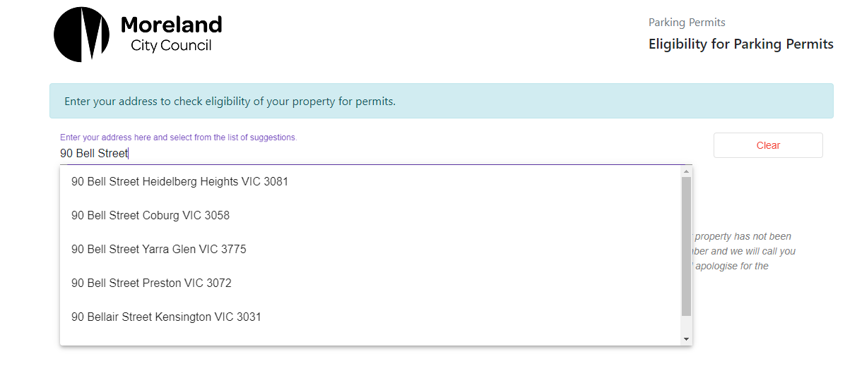
Start typing your address and select from drop-down menu.

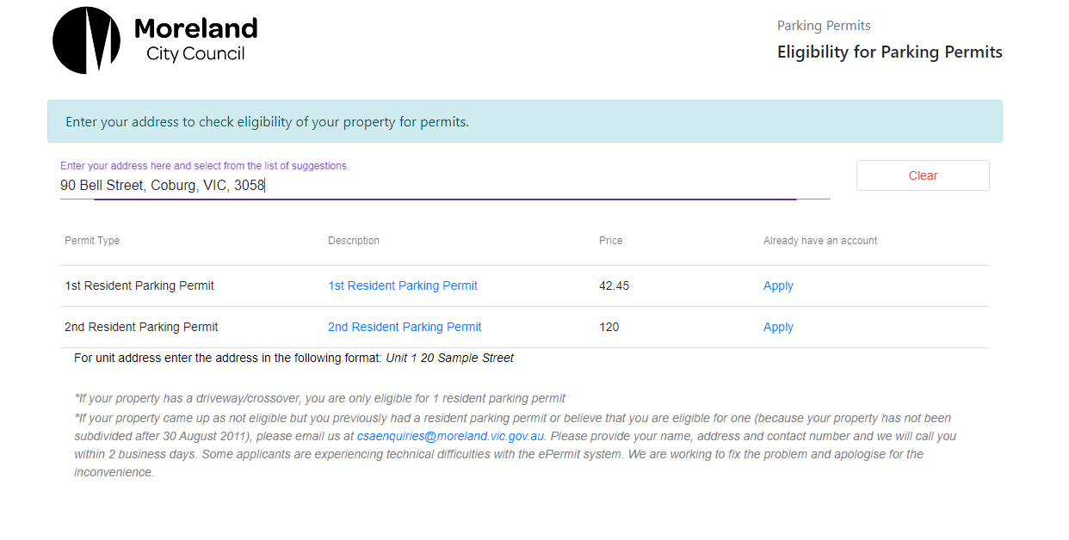
Permit/s eligible for your property
Click APPLY to apply for Resident 1 and/or Resident 2.
Step 3 - Sign up for a PayStay account by clicking on ‘Sign up’ on the next page. If you already have a PayStay account, login using your current PayStay username and password.

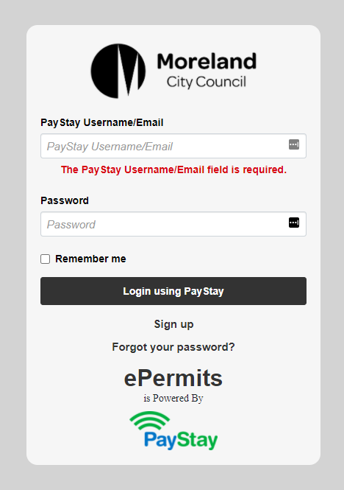
If you are new to PayStay sign up for an account by clicking on ‘Sign up’

If you already have a PayStay account, login using your PayStay username/email and password

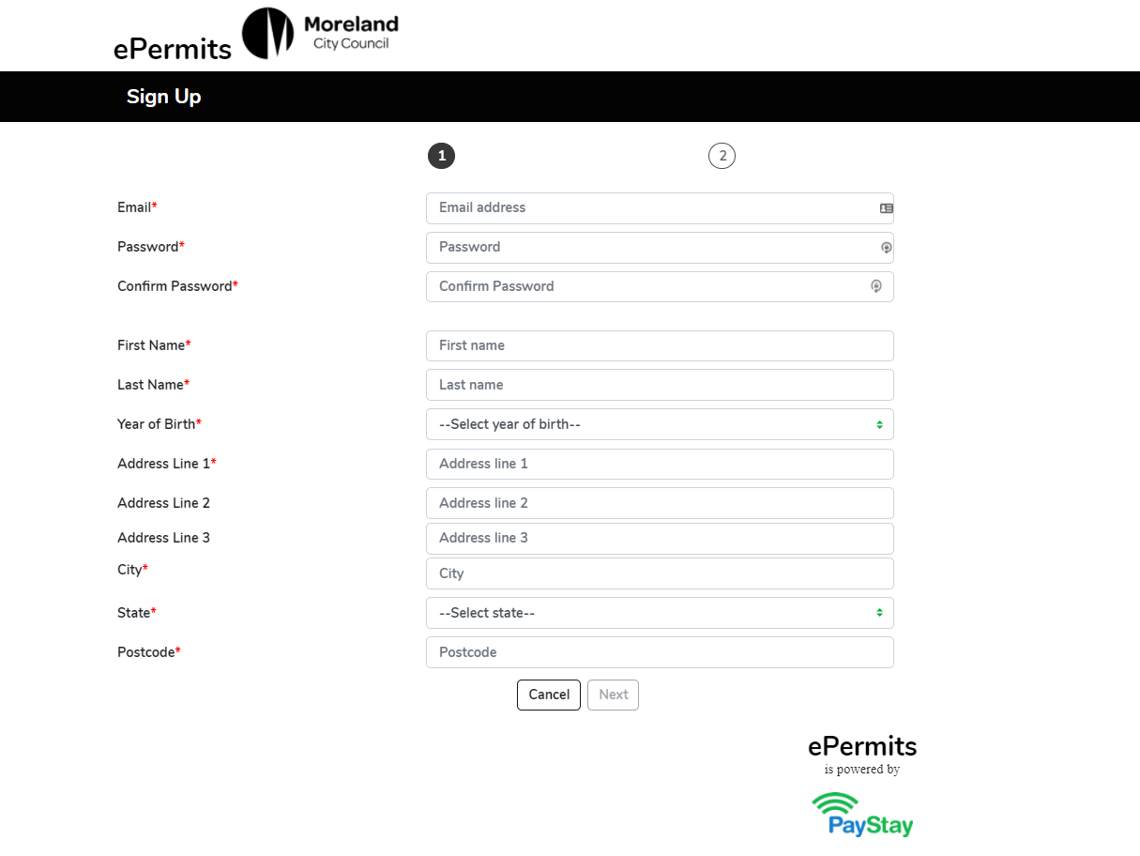
Fill out the application form and click Next

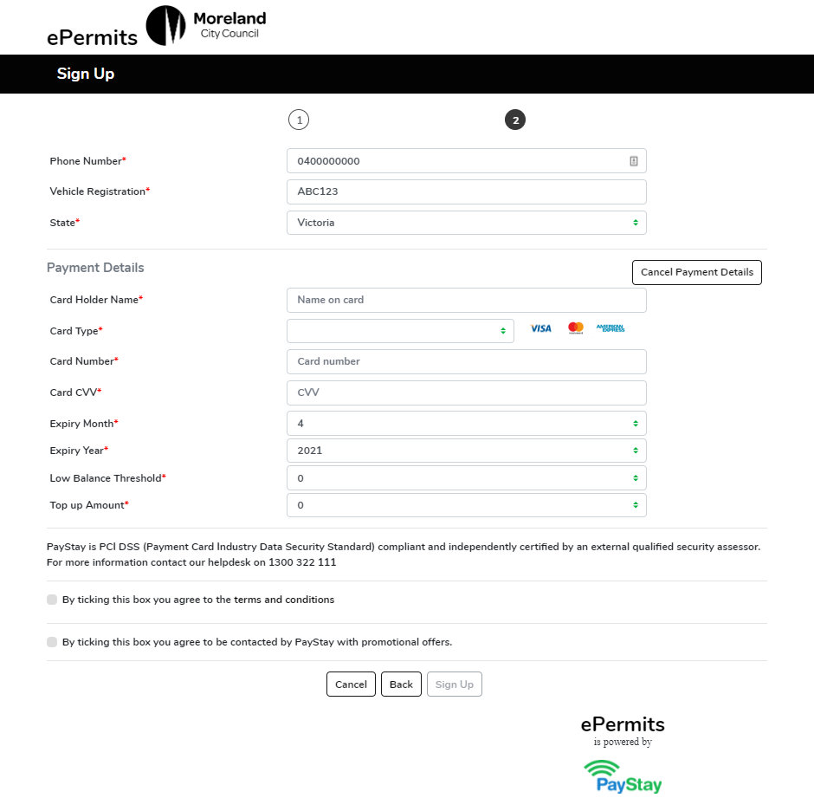
Enter your mobile phone number, vehicle registration number and select State.
Click the Add Payment Details button and fill in your Credit Card/Debit card details.
Select ‘0’ for Low Balance Threshold.
Select ‘0’ for Top-up Amount.
You may choose to select a different Low Balance amount and Top up amount. This may come handy if you use PayStay to pay for parking meters
For ePermits, both the balance and top-up amounts can remain 0 (zero) as only the permit fee is deducted when the permit is approved
Read the terms and condition and tick the box if you agree.
Click Sign Up to create your PayStay account

Step 4 – Verify Contact Details. You will receive an email from PayStay. Click the VERIFY EMAIL button to verify your contact details.

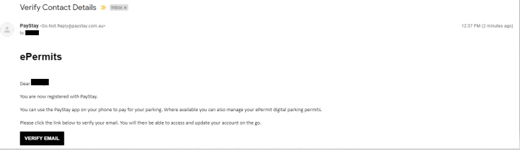

Once your account is verified, you will be asked to login using your email and password.

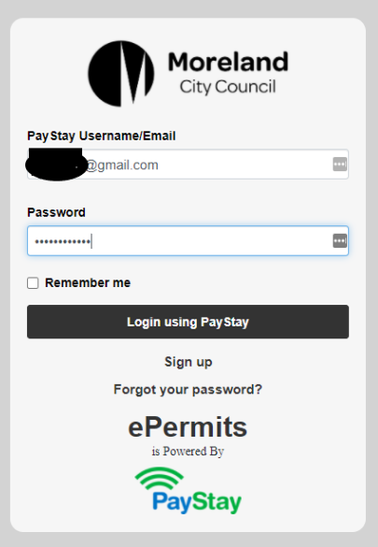

When signing up for a PayStay account for the first time, please ensure your address is updated on the User Profile (top right corner). Please add your property and choose your address from the drop-down menu.

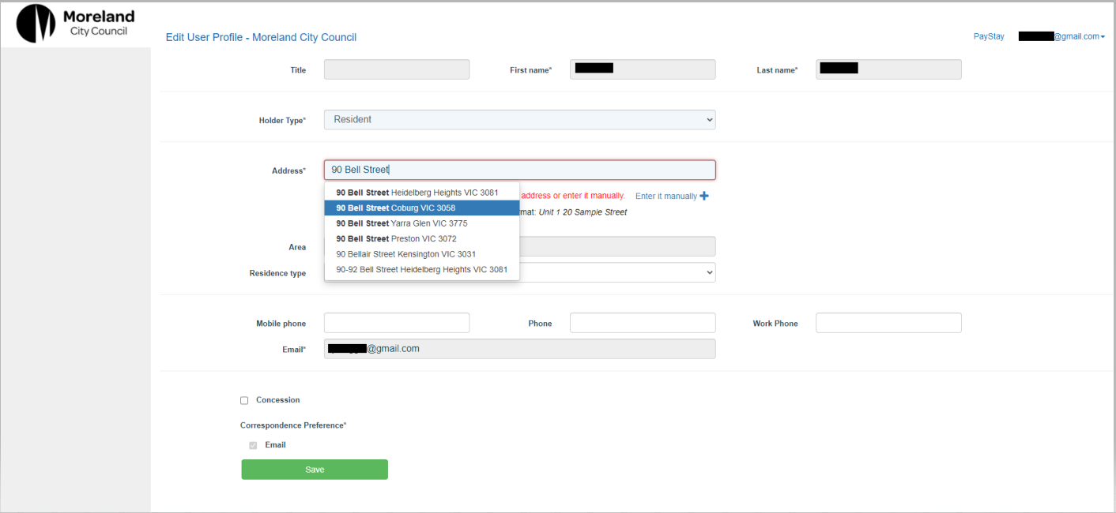
Add your address.
IMPORTANT - Start typing your address and then select the correct address from the drop-down box.

Select the Holder type – Resident or Business, fill the rest of the user profile and click SAVE.

Select Concession, if you hold a valid concession card.

When you click Save, the Confirmation window will pop-up (see next page).

Tick ‘I have read and understood above mentioned points’ and click YES button.
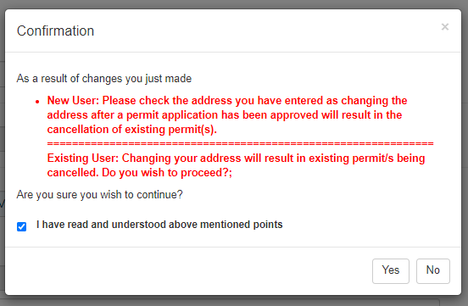

This will take you to the Applications Page.

Step 5 - Click on ‘My Applications’ in the top left corner and then click ‘Residential’ to fill out the Resident Parking application form.

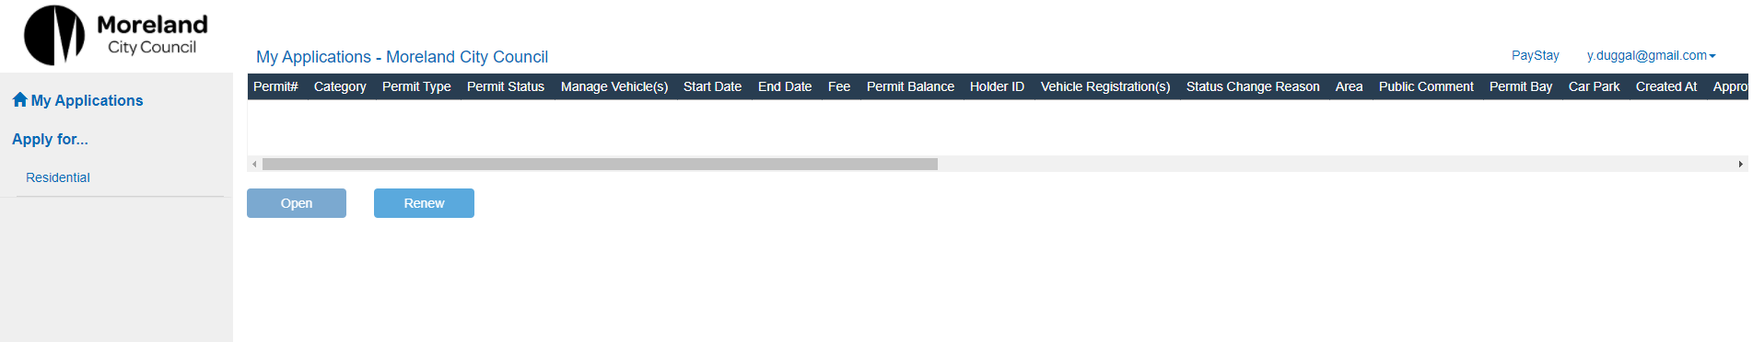

Click RESIDENTIAL and start your Resident ePermit application process.

Step 6 – Fill in the application form and attach your Proof of Residency. Accept the Terms and Conditions and click the Submit button.

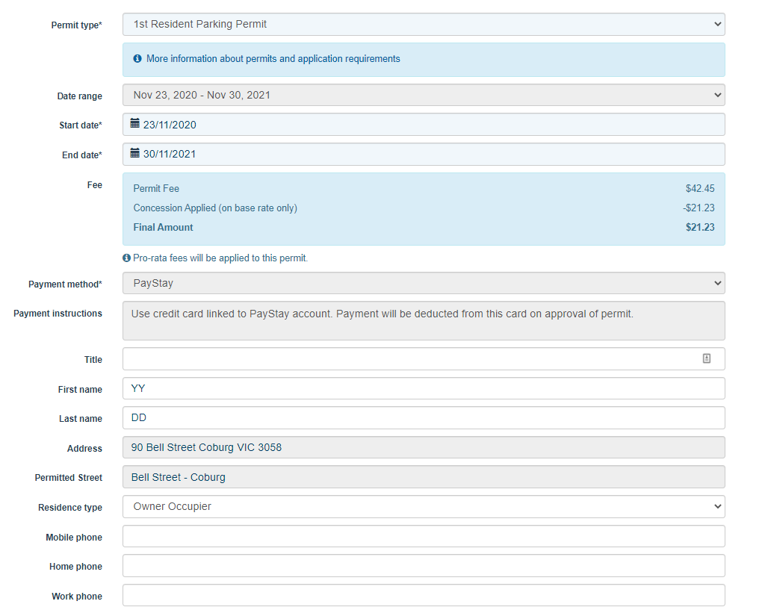
Ensure PayStay is the preferred payment option.

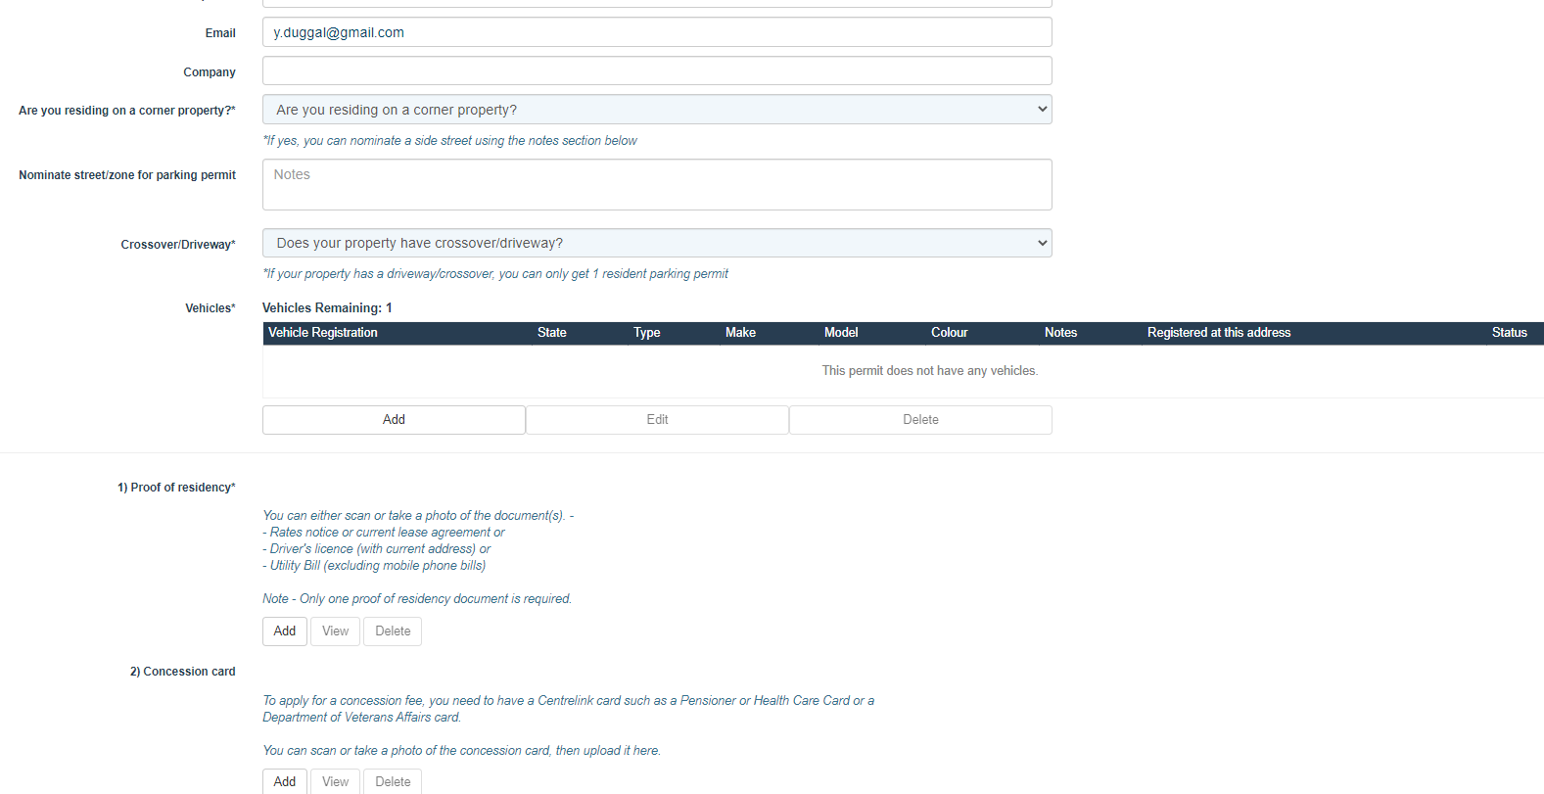
Add vehicle registration details
Attach proof of residency documents.
Attach proof of Concession card.
Attach any additional documents.
Read T&C. Tick the box to confirm you understand T&C and click Save to apply for your ePermit!
If you require a 2nd Resident ePermit, Repeat Step 6 only.

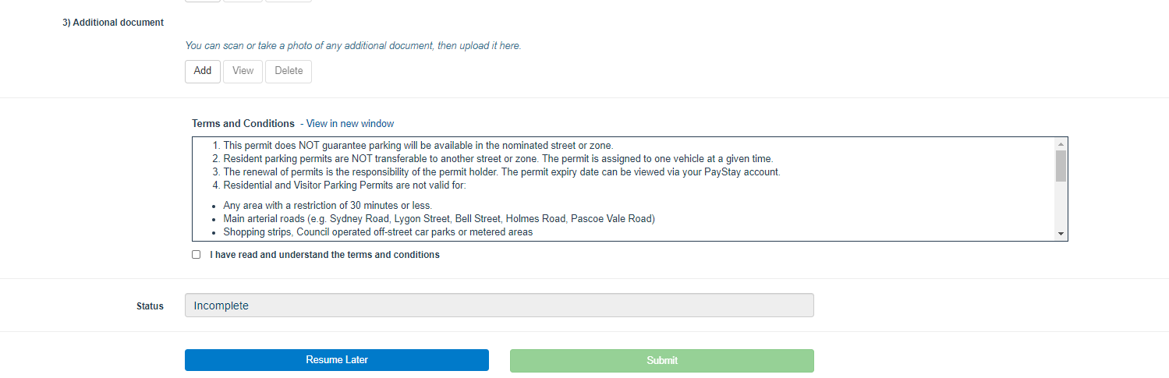

ePermit Registration Update via Web Browser

Permit holder can update vehicle registration details of their active permits via a Web Browser.

Pre-Requisites
- Permit holders have to login into PayStay using same login credentials from which they have applied for permits via Moreland ePermit webpage.
Step 1 - Login to your PayStay account: https://mcc.data.com.au/SSP/Home

Step 2: On the permit that you want to change the registration, click Update Vehicle:

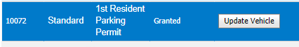

Step 3: On the drop-down box that will show, Select the Option Edit Vehicle

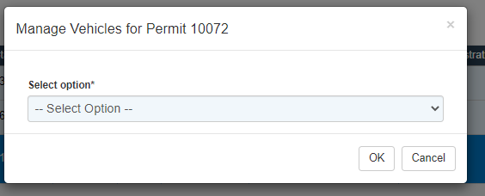

Step 4: Select the vehicle on the drop-down option:

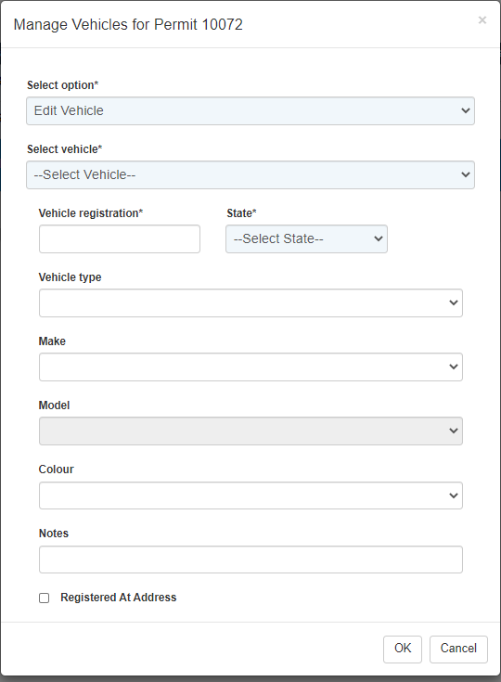

Step 4: Change the vehicle registration on the Vehicle Registration field and choose the State on the State field. Click OK.

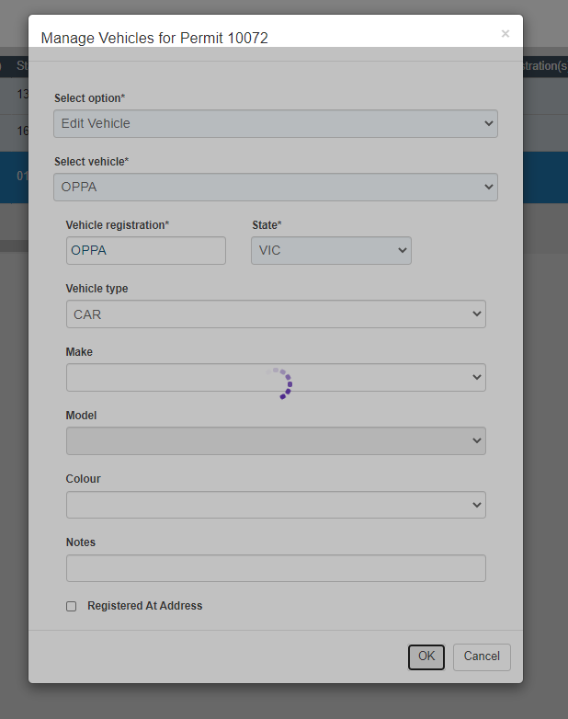

The window will automatically close once one it is saved and you will find that the updated vehicle registration number is showing on the Vehicle Registration field on the My Applications page.

ePermit Registration Update via PayStay App

Permit holder can update vehicle registration details of their active permits via PayStay

Pre-Requisites
- Permit holders can download the PayStay app via the App Store (iOS) or Play Store (Andriod).
- Permit holders have to login into PayStay using same login credentials from which they have applied for permits via Moreland ePermit webpage.
- Only active permits will be visible in PayStay. Pending or Approved or over the counter issued permits will not be visible in PayStay.
Registration Update Process
- Click PayStay icon on the mobile phone.
- Wait for default screen to open
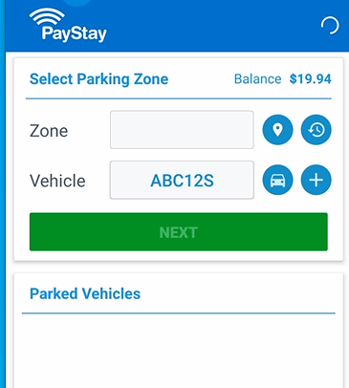

- Click Permits Icon from bottom bar for PayStay to load the active permits.


- Active permits will be displayed.
- Click Pencil icon to update the Vehicle Registration.

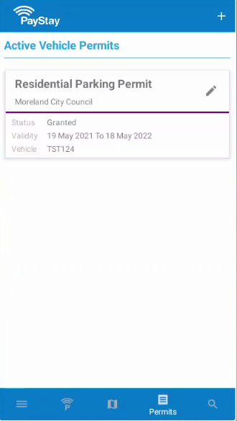

- Click EDIT option to update the Vehicle Registration details.
- Click ADD VEHICLE option only if the permit allows to add more vehicles in it.

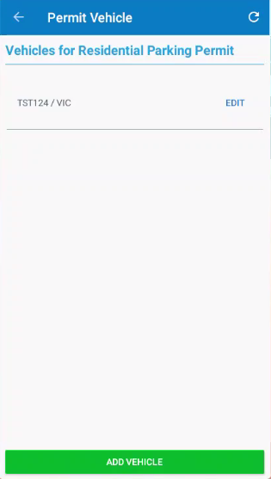

- Update the Vehicle Registration details and State if applicable.
- Click UPDATE button once completed.
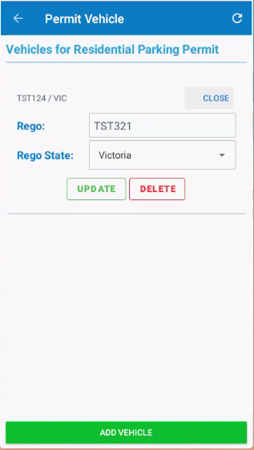

- Message will appear to confirm the Vehicle registration details are updated.

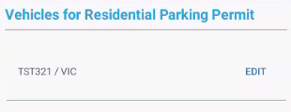

- The Vehicle details are updated and reflecting in the permit.
- The update will happen in real time.

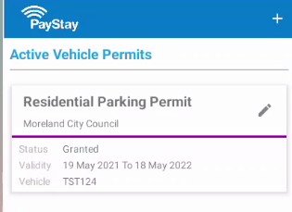

How to Renew Your Resident Parking ePermit

Please note: if you elected for your permit to expire prior to 30 November and still require a permit, you need to submit a new permit.

Step 1 - Login to your PayStay account: https://mcc.data.com.au/SSP/Home

Step 2 – Click on the 1st or 2nd resident permit you wish to renew from your list of permits and select the renew button.
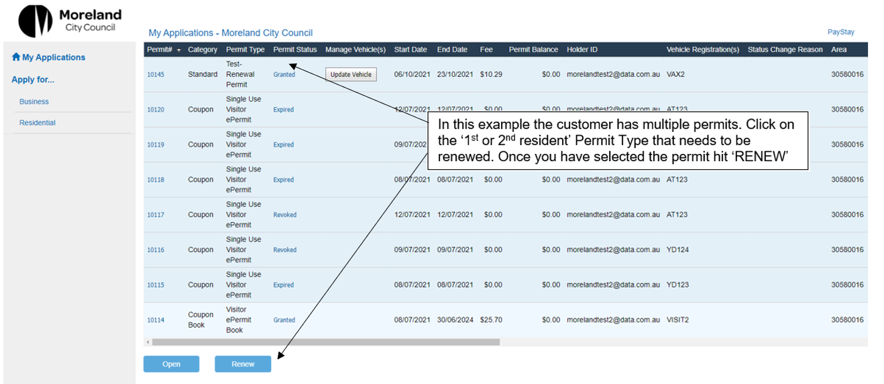

Step 3 – Check the details of the permit you are renewing. All permits commence 1 December to 30 November.
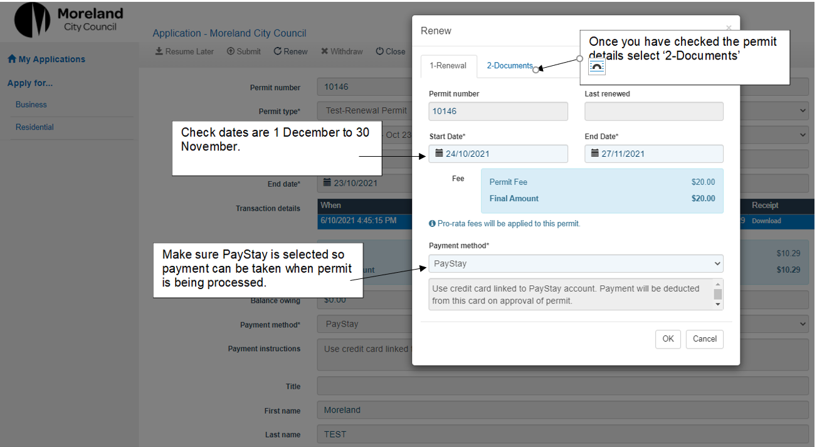

Step 4 – In the 2-Documents tab attach your proof of residency and concession card if applicable. Then select ok to submit your renewal application.
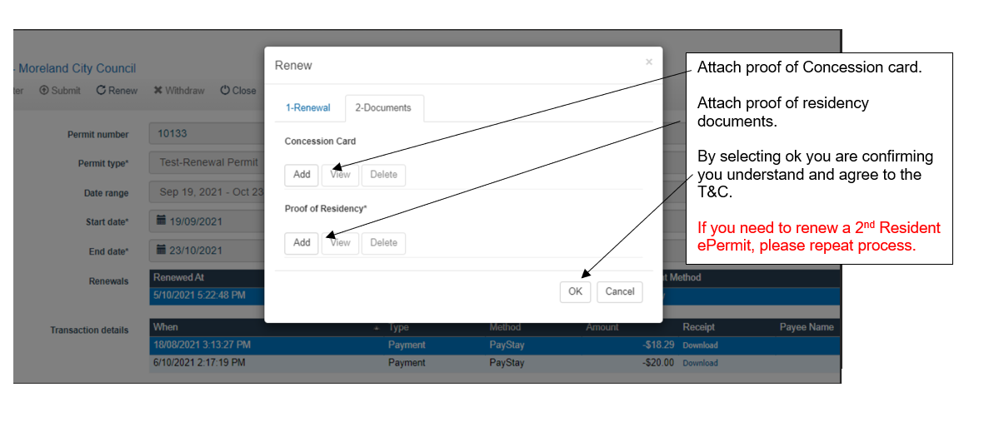
Step 5 – Once you have completed your application you will return to your permit home screen and this is what you will see.
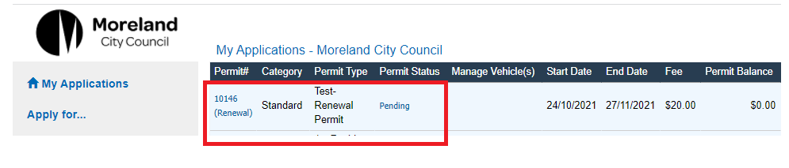
Please note you will receive a confirmation email that your renewal is pending and then again once your renewal has been granted (approved and paid).

Resident Parking ePermit FAQ’S

Resident Parking ePermit processing timeframes
ePermits submitted on will be assessed by our Business Support Team within 3 business days. You will receive email updates about your application progress.
A Business Support Officer will contact you by email if we require further information. This might be for additional proof of residency or if we are unable to deduct payment from your PayStay account.
Once your ePermit has been granted, you will get a confirmation email.
ePermits are digital permits. You no longer need to display a physical permit on your vehicle.
For visitor parking permits, please apply for a digital Coupon ePermit. Instructions begin on page 28. You can also apply for a physical scratchy permit.

Are my personal information and PayStay payments secure?
The personal information you provided when registering with PayStay is handled in accordance with current industry standards. Your details can only be accessed by securely logging in with your username and password. All personal information is stored in an encrypted secure database and handled in accordance with current industry standards.
Your payments made via PayStay are processed in line with Payment Card Industry Data Security Standards. The PayStay website (and mobile application) is protected by a digital certificate which can be verified by viewing the certificate details in your browser. PayStay is Payment Card Industry Data Security Standard compliant and independently certified by an external security assessor.

Why do parking officers mark tyres in time restricted parking areas?
Parking officers mark-up tyres of all vehicles when patrolling a street with time restricted parking.
Parking officers return to the street once the allowed parking time has passed (for example, 2 hours later if the area has 2P parking). If a vehicle with a marked-up tyre is still in the street, the parking officer will check if the vehicle has an ePermit.
If the vehicle has an ePermit, they will not issue a parking infringement. Only vehicles that are parked for longer than the time allowed without a parking permit will receive a parking infringement.

Where can I park with a resident parking permit?
With a resident parking permit, you can park all-day in timed parking in your street except where restrictions are under 30 minutes and in prohibited areas such as ‘no stopping’ and ‘loading zones’. This permit also allows you to park in areas on your street marked as resident permit zones.
If you live on a corner property, a permit can be issued for either the front street or side street. If you have 2 permits, both permits must be issued to the same street.
A permit does not guarantee there will be a parking space available in your street.
A permit is only valid for the street of issue on your parking permit and in your application form.
For more information, see our Parking Management Policy

How many resident parking permits can I apply for?
You can have either 1 or 2 resident parking permits depending on your property.
If your property has a driveway crossover, you can only get 1 resident parking permit.
If your property does not have a driveway crossover, you can get 2 resident parking permits.
A driveway crossover is an access point where cars can travel from a road, usually across a nature strip and/or footpath, to a property. If you have a private driveway, it usually indicates you have a driveway crossover.
Properties with more than one driveway crossover are not eligible for any resident parking permits.
If you are unsure whether you have a driveway crossover or not, please contact us.
For more information, see our Parking Management Policy

How much do resident parking permits cost?
For permit fees, please visit our website: www.moreland.vic.gov.au/residential-parking-permits

When can I expect to receive my resident parking ePermit?
Resident Parking ePermits are linked to your vehicle’s registration number. Our officers will see your valid resident parking permit when they enter your vehicle registration number into our system.
Your Resident Parking ePermit becomes valid and active as soon as it is processed by our Business Support Team. You will receive an email when you’re application is complete.
You do not need to display your permit on your dashboard to park in time restricted areas.
Please apply for your permit before the date that you need it.

I have bought a new car; how do I update the registration on my permit?
You can change the vehicle registration on your ePermit by logging into your PayStay account. Select the Resident 1 or 2 permit and click on Update Vehicle Registration. Type new Registration number and click Save. Instructions begin on page 14.

My property doesn't appear to be eligible. What do I do?
If your property has been sub-divided after August 2011, you are not eligible for a Resident Parking Permit
If your property does not appear as eligible but you believe that you are eligible because you have previously had a resident permit or your property has not been subdivided after 30 August 2011, please contact us: please email csaenquiries@moreland.vic.gov.au and provide your name, address and contact number and we will call you within 3 business days.

Visitor Parking ePermit Book

A Single Use Visitor ePermit is a single use permit that can be linked to a vehicle. Single Use Visitor ePermit (Visitors ePermit) come in a “book” or set of 10 ePermits known as Visitor ePermit Book. This Visitors ePermit is a digital version of Scratchy Permits.

Eligibility
Visitors ePermits may only be purchased by residents who are eligible for a Residential Parking ePermit (this does not Include residents of a property subdivided after August 2011). You do not need to hold a current residential parking permit to purchase visitor permits, but you will need an ePermit Account and a PayStay Account.

What you need for your application
As part of the Visitor ePermit Book online application process, you need to provide a photo or scanned copies of:
- Proof of residency (rates, drivers licence, rental agreement, utility bill excluding mobile phone bills).
- Proof of concession (if you are receiving concession and for the concession fee to apply)

All documentation must be in the applicant’s name and for an address within the restricted parking area.

How to apply for Visitor ePermit Book

Single use Digital Coupons must be purchased in a "book" of 10.
Step 1 - Login to your PayStay account: https://mcc.data.com.au/SSP/Home

Step 2 – On the left-hand side, click on Apply for Residential
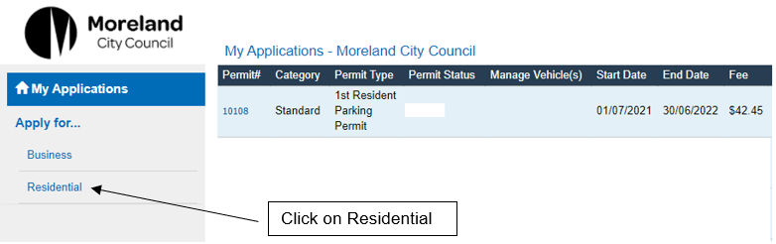

Step 3 – Click on the drop-down Menu and select Visitor ePermit Book.
Note: The Singe Use Visitor ePermit option will not appear until you have purchased a Visitor ePermit Book.

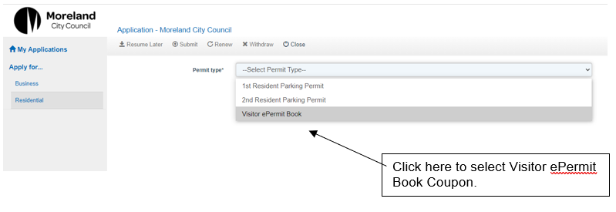

Step 4 – Complete all the required information on the application.
Note - The date and fees displayed in the example form are a sample only.
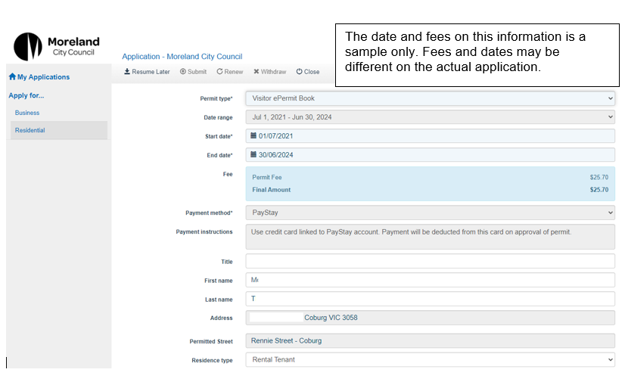

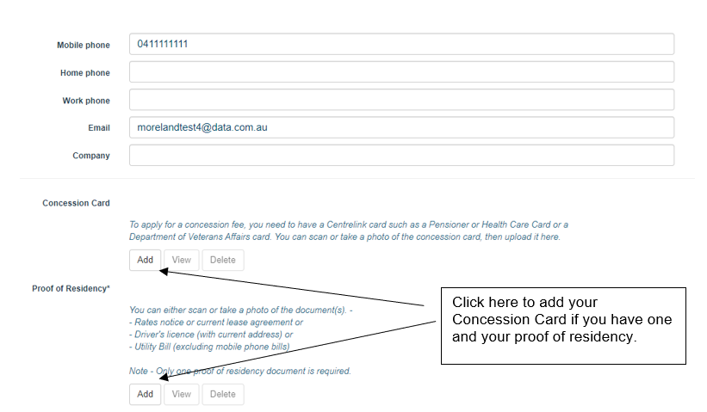

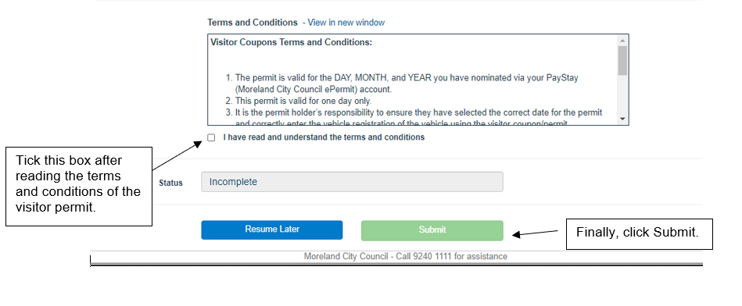

Your application will then appear on My Applications and it looks like the below:
Your application will be reviewed, and a response will be emailed to you within 3 business days. Once approved, you can start using Singe Use Visitor ePermit and assigning different registrations numbers to them. Instructions on how to use a Single Use Visitor ePermit is on the following pages.

How to use a Single Use Visitor ePermit

Step 1 – Return to My Applications but this time, select Singe Use Visitor ePermit from the drop-down menu:
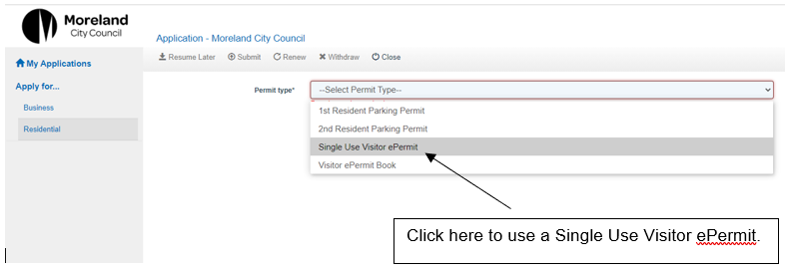
Step 2 – Complete the form as shown below:
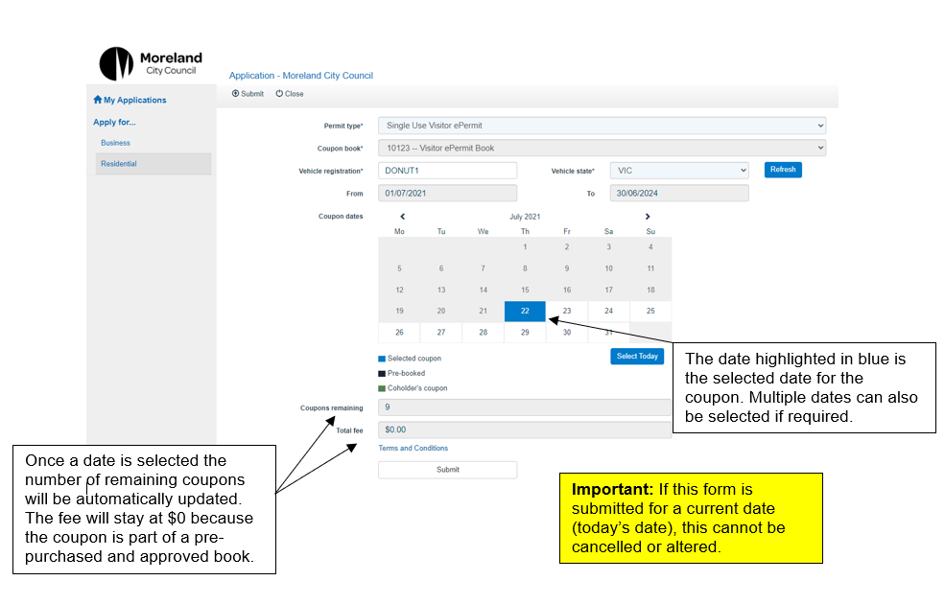
If you need to deselect a date (marked with blue), just click on the date again and it will be selected. You will know the date has been deselected is it is not marked blue.
The date highlighted in blue is the selected date for the coupon. Multiple dates can also be selected if required.
Important: If this form is submitted for a current date (today’s date), this cannot be cancelled or altered.

Once the form is submitted, a summary like this will be shown:
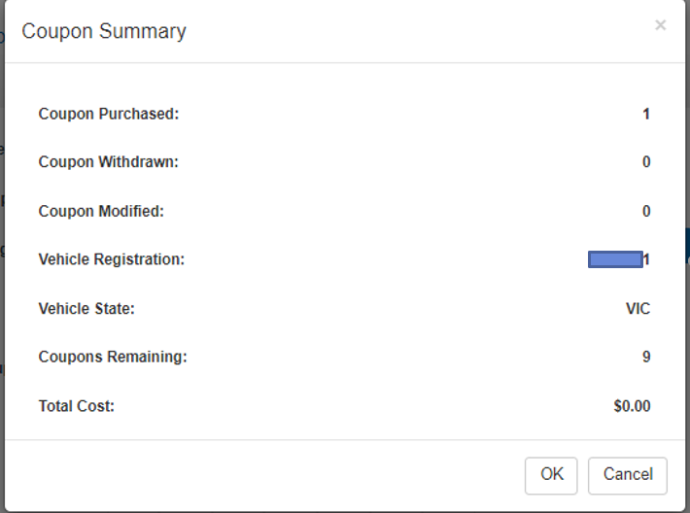

The Single Use Visitor ePermit is approved immediately, and the details of the coupon will be available on the home page of your account. Here is an example:

If a Single Use Visitor ePermit has been created for a future date, the vehicle registration and the date of use can still be updated. To do this, click on the permit number to open the details.

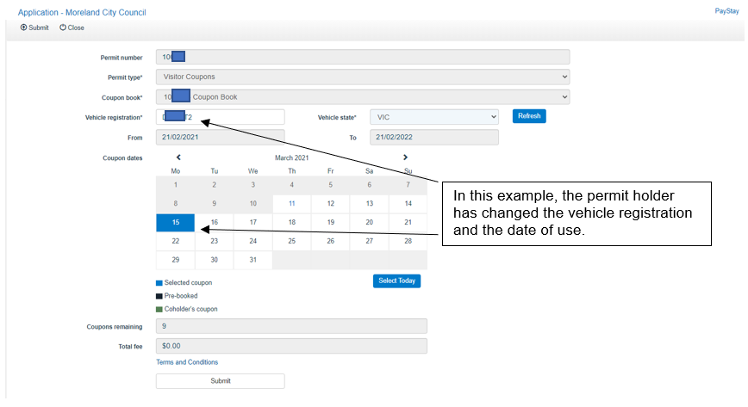

Please note that multiple dates can be selected which means multiple coupons are going to be used. For example, if 2 dates are selected, 2 Single Use Visitor ePermit will be used.

Visitor ePermit Book – processing timeframes
Visitor ePermit Books submitted on weekdays will be assessed by our Business Support Team within 3 business working days. Applications submitted over the weekend will be assessed the following business working day.
You will receive email updates about your application progress.
A Business Support Officer will contact you by email if we require further information. This might be for additional proof of residency or if we are unable to deduct payment from your PayStay account.
Once your ePermit has been approved, you will get a confirmation email.
ePermits are digital permits. You no longer need to display a physical permit on your vehicle.

Visitor ePermit Book FAQs

Who can apply for visitor parking permits?
Residents can apply for visitor parking permits (book of 10 Digital Coupons) if:
- They live in a street with timed parking restrictions; and
- They live in a property which has not been subdivided after August 2011
(Including newer townhouses and apartments).
This is due to the Parking Management Policy adopted by Council in 2011, which sought to provide protection for existing residents in older properties who rely on on-street parking. Find out more about our Parking Management Policy.

Where can I park with a visitor parking permit?
With a visitor parking permit, you can park in timed parking areas in your street except where restrictions are under 30 minutes and in prohibited areas such as ‘no stopping’ and ‘loading zones’.
If you live on a corner property, a permit can be issued for either the front street or side street.
A permit does not guarantee there will be a parking space available in your street.
A permit is only valid for the street of issue on your parking permit and in your application form.
For more information, see our Parking Management Policy.

Visitor ePermit Book processing timeframes
Visitor ePermits Book submitted will be assessed by our Business Support Team within 3 business days. You will receive email updates about your application progress.
A Business Support Officer will contact you by email if we require further information. This might be for additional proof of residency or if we are unable to deduct payment from your PayStay account.
Once your Visitor ePermit Book has been granted, you will get a confirmation email.

Can I apply for a Visitor ePermit for a future date?
Yes. To apply for a Visitor ePermit for a future date, select the date you need it for in the Coupon Dates calendar.

Can I select multiple dates if I have guests that plan to stay-over?
Yes. When applying for a Visitor Coupon, you can choose multiple dates in the Coupon dates calendar.
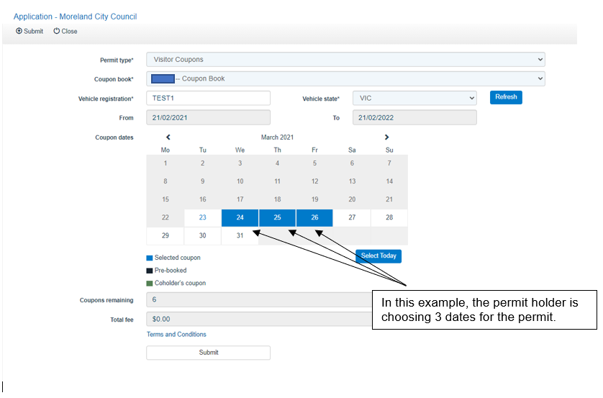

Can I can cancel an approved Single Use Visitor ePermit if my plans change?
Yes, if it is for a future date. For example, if a permit holder entered details for a Visitor ePermit today for tomorrow’s date, it can still be cancelled or updated if it is done today.
You will be unable to cancel a visitor coupon on the day it is issued for. This prevents any misuse of a permit or changing the date of the permit when it has already been used by a vehicle.

Can I transfer the Single Use Visitor ePermit to a different vehicle?
Yes. A Visitor ePermit can be transferred to a different vehicle if the date it will be used is a future date. You will be unable to transfer a visitor permit on the day it is issued for.

