Council AGENDA

Monday 22 August 2022

Commencing 6 pm

Online via video conferencing

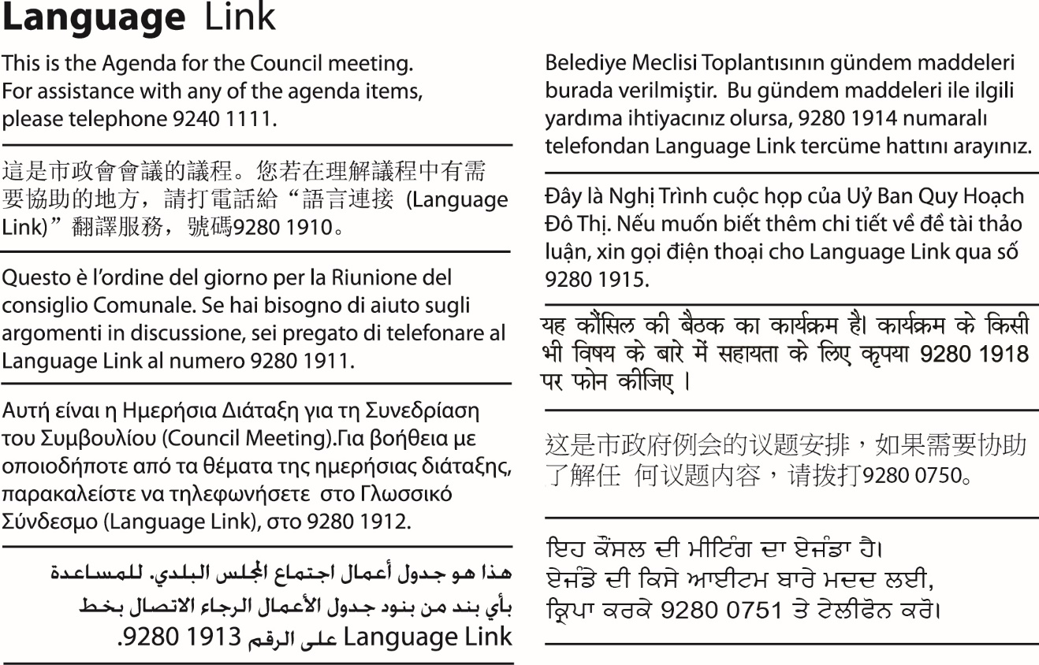

1. WELCOME
2. APOLOGIES/LEAVE OF ABSENCE
3. DECLARATIONS OF CONFLICTS OF INTERESTS
4. COUNCIL REPORTS
Nil
5. Confidential Business
5.1 Bin Purchase - Kerbside Waste Reform
Pursuant to section 3(1)(g(i))(g(ii)), and of the Local Government Act 2020, this report has been designated as confidential because it relates to private commercial information, being information provided by a business, commercial or financial undertaking that relates to trade secrets, and private commercial information, being information provided by a business, commercial or financial undertaking that if released, would unreasonably expose the business, commercial or financial undertaking to disadvantage.

