SPECIAL Council AGENDA

Saturday 14 May 2022

Commencing 12 noon

Council Chamber, Moreland Civic Centre
90 Bell Street, Coburg

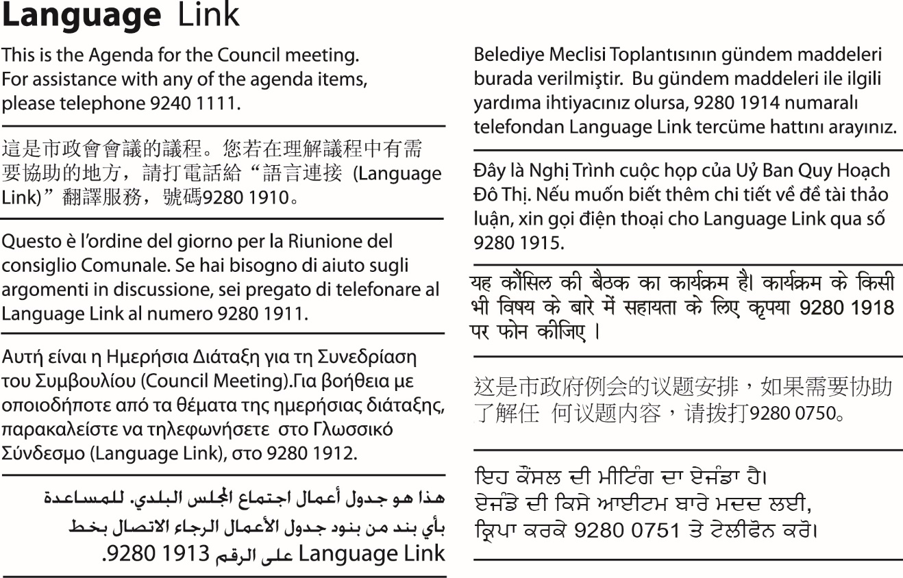

1. WELCOME
2. APOLOGIES/LEAVE OF ABSENCE
3. DECLARATIONS OF CONFLICTS OF INTERESTS
4. Introductory address
Uncle Andrew Gardiner, Wurundjeri Woi-wurrung Elder and representative of the Traditional Owner Community, has been invited to address the meeting.
5. Council Report
5.1 Renaming of Moreland City Council - receiving options for new names from the Wurundjeri Woi-wurrung Cultural Heritage Aboriginal Corporation 3

5. Council Report
5.1 Renaming of Moreland City Council - receiving options for new names from the Wurundjeri Woi-wurrung Cultural Heritage Aboriginal Corporation
Director, Community Eamonn Fennessy
Community Wellbeing

Officer Recommendation
That Council:
1. Thanks the Wurundjeri Woi-wurrung Cultural Heritage Aboriginal Corporation for providing three Woi-wurrung words for municipal name options on Saturday 14 May 2022.
2. Acknowledges the cultural significance of this occasion for the Wurundjeri Woi-wurrung people, its importance for the local community and for broader reconciliation and healing with First Nations people.
3. Endorses the three name options to proceed to municipal-wide community engagement.
4. Notes the community engagement approach as previously approved in March 2022 and the updated engagement details.
5. Receives a report in July 2022 setting out feedback received through the community engagement process and the panel’s recommendation for a new municipal name.
6. Determines at a July 2022 Council meeting the recommended new name for the municipality.

REPORT

Executive Summary
Council decided in December 2021 to in principle support the renaming of Moreland City Council. In line with the Council resolution, Council representatives then worked closely with the Traditional Owners, Wurundjeri Woi-wurrung Cultural Heritage Aboriginal Corporation, to design a community consultative process around options for new names.
Council adopted the community engagement process in March 2022.
On 14 May 2022, Council will receive three Woi-wurrung language words from the Traditional Owners for consideration as options for new name. On this day, a special cultural ceremony is to be held, preceding the Special Council Meeting. The ceremony includes a Welcome to Country, Cleansing Ceremony and Scroll Handover. Council buildings will be cleansed in a smoking ceremony to address past injustices and signify a step forward together in reconciliation. Three Woi-wurrung words will be ceremonially handed to the Mayor and Councillors in an address made by Wurundjeri Wo-wurrung Elders.
This report recommends formally endorsing the names received at the ceremony, for the purposes of community consultation.
Once endorsed by Council, a broad community engagement process will start, seeking community feedback on the options for names.
The community engagement process was endorsed by Council in March 2022, involving residents, ratepayers and business owners and other community members in this important decision. The process is, in summary:
- After receiving naming options from the Wurundjeri Woi-wurrung Cultural Heritage Aboriginal Corporation, Council will facilitate wide engagement across the municipality to ensure all residents and stakeholders can share their feedback on proposed names and the reasons for their preference.
- A program of online and face-to-face education and engagement activities will run via a range of methods to gather a broad representation of community feedback. A community education and truth telling program will also take place.
- A panel of representatives from the Wurundjeri Woi-wurrung Cultural Heritage Aboriginal Corporation, the Mayor and Deputy Mayor will deliberate community feedback received to inform a final recommendation on a new name in May 2022.
- In early July 2022 Council will consider the recommendation of the panel and all community feedback. At that meeting Council will determine the preferred new name for recommendation to the Minister for Local Government.

Previous Council Decisions
Renaming of Moreland City Council - Community Engagement, Education and Truth Telling – 9 March 2022
That Council:
1. Endorses the proposed community engagement approach and the community education and cultural program to inform and support the renaming of the municipality which includes:
a) Receiving options for new names proposed by the Wurundjeri Woi Wurrung Cultural Heritage Aboriginal Corporation and inviting community consultation on the options.
b) Municipal-wide engagement with the community from March to May 2022 including a printed and online feedback survey on proposed names, translated information, distribution of surveys and information to households, and an optional submissions process for community members who wish to provide additional comment.
c) Supporting municipal-wide community education and truth-telling around local Wurundjeri Woi Wurrung history, and why renaming Moreland is an important step towards reconciliation and healing.
d) At completion of the consultation period, a panel consisting of Wurundjeri Woi Wurrung Cultural Heritage Aboriginal Corporation representatives, the Mayor and Deputy Mayor will deliberate on community feedback and recommend a final name for endorsement by Council.
2. Notes that an additional Special Council Meeting will be called to receive options for new names proposed by the Wurundjeri Woi Wurrung Cultural Heritage Aboriginal Corporation and to provide further details of the engagement.
3. Receives a report in June 2022 setting out feedback received through the community engagement process and the panel’s recommendation for a new municipal name.
4. Determines at the June 2022 Council meeting the recommended new name for the municipality, for recommendation to the Minister for Local Government.

Proposed Renaming of Moreland City Council - 13 December 2021
That Council:
1. Supports in principle changing the name of the municipality.
2. Partners with stakeholders, including the Wurundjeri Woi-wurrung Cultural Heritage Aboriginal Corporation, to co-design a process to select a new name during 2022 including consideration of arrangements such as community nominations and a consultative survey.
3. Plans and commences in 2022 a community information and education program that acknowledges the impacts and consequences of dispossession and racism and encourages respectful understanding through truth telling and reconciliation.
4. Receives a report in February 2022 detailing the proposed community information and education campaign, and recommendations from the name selection process co-design activity, including plans for community engagement with such matters as nominations, shortlisting processes and surveys.
5. Following community and stakeholder engagement, which includes consideration of matters such as nominations, and surveys, receives a further report with survey results and other considerations, and selects a preferred suitable name for the municipality to present to the Minister for Local Government for consideration in 2022.
6. Notes and refers to the budget process an additional $250,000 per year for two financial years ($500,000 total) to update Council’s digital platforms, signs at significant Council buildings and facilities and municipal entry signs and notes updating Council assets such as street and park signs, smaller facilities signage, staff uniforms and vehicles will be addressed incrementally within existing budget allocations and asset renewal programs over a 10-year timeframe.

Statement of Commitment to Wurundjeri Woi-wurrung People and Aboriginal and Torres Strait Islander Communities of the City of Moreland –12 May 2021
That Council:

1. Endorses the Statement of Commitment to Wurundjeri Woi-wurrung People and Aboriginal and Torres Strait Islander Communities of the City of Moreland as approved by the Wurundjeri Woi-wurrung Board of Management on 4 March 2021

2. Supports a public signing ceremony that will be livestreamed from Council Chambers at an appropriate time hosted by the Mayor, Councilllors, Wurundjeri Woi-wurrung Elders and members of the Moreland Reconciliation Working Group.

1. Policy Context
Receiving the three Woi-wurrung name and the imminent community engagement on the names are aligned with these key Council plans and policies:
Council Plan 2021-2025: Theme 3: A healthy and caring Moreland
Statement of Commitment to Wurundjeri Woi-wurrung People and Aboriginal and Torres Strait Islander Communities of the City of Moreland (Attachment 2)
Extract:
Council recognises that:
- The Wurundjeri Woi-wurrung people are the Traditional Owners of these lands and waterways in Moreland.
Council supports:
- A process towards self-determination and local, regional, or national Treaty or Treaties that enshrine the rights of Wurundjeri Woi-wurrung people and Aboriginal and Torres Strait Islander Australians
Council commits itself to:
- Undertake cultural consultations with the Wurundjeri Woi-wurrung people and seek to include Woi-wurrung names in the process of naming and renaming spaces, places, roads and parks in the City of Moreland.
Moreland Human Rights Policy 2016 – 2026 - Theme 4: Advocacy and Leadership
Social Cohesion Plan (2020–2025): Theme 4: Diversity and Discrimination.
Community Engagement Policy 2020
In accordance with Moreland City Council’s Community Engagement Policy, this engagement as endorsed by Council in March 2022 will be at the level of “Consult”. Community members will be invited to provide feedback about the future name for Moreland City Council.

2. Background
Historic naming of Moreland City Council
In 1994 the local government areas of the City of Brunswick, the City of Coburg and part of Broadmeadows were amalgamated and the Victorian Government named the new council Moreland. The name Moreland City Council is therefore 28 years old.
In November 2021, information was presented to Council by Elders from the Traditional Owner community and other community representatives, showing that Moreland City Council was named after land, between Moonee Ponds Creek and Sydney Road, that Farquhar McCrae acquired in 1839. He named the land ‘Moreland’ after a Jamaican slave estate his forebears had operated.
The land which forms part of the Moreland local government area was sold to Farquhar McCrae without the permission of the Traditional Owners, who were suddenly dispossessed from their land.
In 2022, Dr James Lesh completed a commissioned paper titled Report on the place name: Moreland which provides additional historical background on the links between the name and eighteenth and nineteenth century Caribbean slave plantations. The report is available via Moreland’s community engagement website at https://conversations.moreland.vic.gov.au/renaming .
Decision to change name
Council has a long history of proactive leadership on issues of racism, inclusion and reconciliation and has for many years used the description of ‘one community, proudly diverse’. In 2021 Council signed a Statement of Commitment to Wurundjeri Woi-wurrung People and Aboriginal and Torres Strait Islander Communities, updating and renewing a Statement of Commitment previously in place. Council also supports a process towards self-determination and local, regional, or national Treaty or Treaties that enshrine the rights of Wurundjeri Woi-wurrung people and Aboriginal and Torres Strait Islander Australians.
In the light of this, retaining the name “Moreland” as the Council’s corporate name conflicts with the Council’s history and aspirations.
Council resolved on 13 December 2021 to support in principle changing the name of the municipality, that is, changing Moreland City Council’s corporate name. Council decided a community engagement process would be designed to invite community feedback on the future name of the municipality.
Process
Ultimately the decision to change Council’s corporate name rests with the Victorian Government via an Order in Council under s 235(g) of the Local Government Act 2020 (the Act). The Minister for Local Government confirmed in December 2021 his support for renaming of the Council in accordance with the requirements of the Act, if the proposal is supported by Council and the local community.
The Minister for Local Government also encouraged Council to work closely with the Wurundjeri Woi-wurrung Cultural Heritage Aboriginal Corporation throughout the proposed renaming process.
At the December 2021 Council meeting, Council resolved to work with the Traditional Owners, the Wurundjeri Woi-wurrung Cultural Heritage Aboriginal Corporation, to co-design a community engagement process and education and truth telling program.
The proposed community engagement process that came out of this collaborative co-design work was considered by Council in March 2022 and endorsed.
With the receipt of options for names from the Traditional Owners, following Council consideration, community engagement on the future name can now begin.

3. Issues
Ceremonially receiving Wurundjeri Woi-wurrung names
Three Woi-wurrung names will be ceremonially handed to the Mayor and Councillors by Wurundjeri Woi-wurrung Elders at a ceremony on Saturday 14 May.
This will precede the Special Council Meeting on Saturday 14 May for Council to consider endorsement of the proposed names for community engagement and consideration.
This ceremony will be livestreamed on Council’s Facebook for community audiences.
These Woi-wurrung names have been provided through detailed research and careful consideration by the Wurundjeri Woi-wurrung Cultural Heritage Aboriginal Corporation. They reflect the significance of Country and culture as well as honour the opportunity this name change represents as part of the reconciliation and healing journey.
Community impact
The proposal to change the name of the municipality is a matter of significant interest for the Moreland community and beyond. The recommendation is to engage the community widely to enable them to have their say on the deliberation and selection of a new name for the municipality.
Climate emergency and environmental sustainability implications
There are no direct climate emergency or environmental sustainability implications associated with this report.
Legal and risk considerations including official name change process
Council was constituted by an Order of Council made on 21 June 1994, and published in the Victorian Government Gazette the following day. This named the newly amalgamated municipality Moreland City Council..
Only the Victorian Government can change Council’s corporate name. It can do so by making an Order in Council under s 235(g) of the Local Government Act 2020 (the LGA), which would occur on the recommendation of the Minister for Local Government.
The Minister has encouraged Council to work closely with the Wurundjeri Woi-wurrung Cultural Heritage Aboriginal Corporation throughout the proposed renaming process, and seek community support.
Broad community engagement will occur in order to seek community feedback on the options for new names. Consultation should be focused on Moreland residents, Moreland ratepayers and other members of the Moreland community. The survey will be in the form of a survey or poll, available in hard copy or online. Where possible, participants filling out the survey will be asked to provide their name and address and to confirm they have not previously filled out the same survey.
Human Rights Consideration
The implications of this report have been considered in accordance with the requirement of the Charter of Human Rights and Responsibilities. The report supports Charter Section 19 (2) Aboriginal Cultural Rights and Responsibilities which say that Aboriginal People hold distinct cultural rights and must not be denied the right to:
- Enjoy their identity and culture.
- Maintain their distinctive spiritual, material and economic relationship with the land and waters and other resources they have a connection under traditional laws and customs.

4. Community consultation and engagement
Outline of Community Engagement Approach
The community consultation and engagement approach was carefully considered and designed to maximise community participation within the scope of community influence based on the recommended naming process.
Considerations have been made to address common barriers to participation including digital access, low-level English and certain age demographics including older citizens and young people, to ensure all community members have the opportunity to have a say. This includes:
- Information and engagement will be facilitated via mailouts, online and face-to-face activities with tailored options for residents who require translations or other support.
- Our youth team are working with schools and young people.
- Information that supports engagement and goes to every household will be in plain English and include translated content and promotion of interpreter service.
- Culturally and linguistically diverse Community Connectors will be supported to reach people who might not otherwise engage with Council communications.
- Education resource packs will support this proactive engagement.
Community feedback process
All residents, ratepayers, business owners and other community members will be invited to share their feedback on the new name options over a period of up to 5 weeks via a range of methods including:
- digital engagement (via Conversations Moreland)
- hardcopy surveys to be mailed out to all residents and business owners, which can be returned by reply-paid post or returned to libraries or customer service centres; and
- face-to-face activities.
An engagement report will be made public including quantitative results, categorised qualitative feedback, summarised submissions and key findings. This report will be considered by Council.
Additional submission process
Some community members may wish to make a submission in favour of or in objection to the options for names and the renaming process. Submissions should include the person’s or group’s interest in the naming proposal and/or reasons for the proposed name/s being either suitable/unsuitable or supported/unsupported. Submissions need to be made in writing by email, or letter.
Council will acknowledge receipt of individual submissions. A report will be prepared which summarises submissions and responds to key themes of submissions received. The report will be publicly available and will inform Council’s final decision.
Community education and truth telling
Council has an important role to play in creating a diverse, inclusive and connected city. We must promote a community in which people from all backgrounds are treated fairly and equally, feel welcome and have a strong sense of belonging in Moreland.
The community engagement process to inform the decision for a new name for Moreland will be implemented in conjunction with a community information and education program. This program has been developed with guidance from the Wurundjeri Woi-wurrung Cultural Heritage Aboriginal Corporation, including identifying matters for truth telling.
Council recognises that this is by no means a comprehensive retelling of the Aboriginal history of the local area, and renaming Moreland is just one aspect of reconnecting to Wurundjeri Woi-wurrung history.
The education and truth telling components of this proposal are critical to raise awareness and guide respectful and informed participation in the renaming process. The proposal supports Moreland’s Social Cohesion Plan by creating opportunities for social connection and cultural exchange.
Public events
- Week 1: Public webinar presenting project information and rationale, including responding to pre-registered questions from community members.
- Weeks 2 & 3: Public information sessions hosted at Brunswick and Coburg Library.
- Week 4: Public screening event of First Australians documentary with discussion and reflection activity held at Brunswick Town Hall.
All events will seek to include Welcome to Country by Wurundjeri Elders dependent on availability.
All events will be promoted to the community via a range of communication channels.
Education and truth telling
An overview of the engagement approach is outlined above and some elements of this as part of Council’s annual program of events commenced in January 2022.
This includes information and resources made available to the community online on Conversations Moreland since early March, and via our municipal-wide print publication Inside Moreland.

5. Officer Declaration of Conflict of Interest
Council officers involved in the preparation of this report have no conflict of interest in this matter.

6. Financial and Resources Implications
Resources required to support the community engagement, information and education programs can be met within current budget allocations.
Community engagement costs
The community consultation process to choose a new name will occur in the current financial year 2021-22 and does not require additional funding - it is met within existing budgets for Council’s ongoing community consultation and communications programs. The program is expected to cost approximately $67,000.
The bulk of these estimated costs are towards communications expenses related to renaming including print materials mailed to all residents and business owners. This includes translation of information into languages other than English, and reply paid post for residents mailing back their feedback.
Implementation costs
As previously advised to Council, an additional estimated $250,000 per year for two financial years starting 2022/23 would be required to update Council’s digital platforms, signs at significant Council buildings and facilities and municipal entry signs. This has been included in the draft budget 2022/23 and 2023/24 which is currently on exhibition.
Updating Council assets such as street and park signs, smaller facilities signage, staff uniforms and vehicles will be addressed incrementally within existing budget allocations and asset renewal programs over a 10-year timeframe.

7. Implementation
In summary, the engagement and education programs will take place with the following timelines:

Program/event | Timing
Community education and truth telling program | From March onwards
Community consultation on options for names | Begins 16 or 17 May 2022
Deadline for hard copy surveys, online feedback and submissions | 20 June 2022
Panel considers community feedback | Late June 2022
Council considers community feedback and panel recommendation and determines preferred name for recommendation to Minister | Early July 2022
Informing the community of the outcome of the proposed renaming | July onwards

Attachment/s
There are no attachments for this report.

