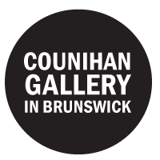

Counihan Gallery
  - Internship application pack
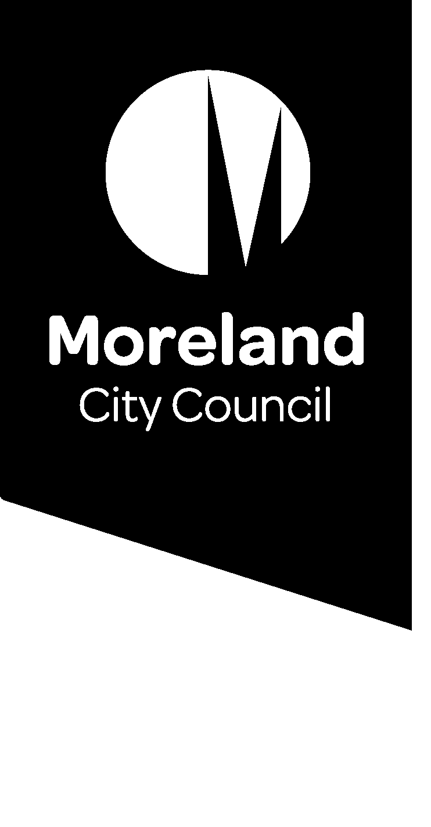
Contents
Acknowledgement of Country 2
About the Counihan Gallery 2
Internship eligibility 2
What we are looking for 3
What you can expect while interning with us 3
How to apply 3
Submit your application via our online form: 3
Key dates 3
Outlining your project 4
Example projects: 4
Contact information 4

Acknowledgement of Country
The Counihan Gallery acknowledges the Wurundjeri Woi Wurrung people as the Traditional Custodians of the lands and waterways in the area now known as Moreland. We pay respect to their Elders past, present, and emerging, as well as to all First Nations people who are part of the community today.

About the Counihan Gallery
The Counihan Gallery is the municipal gallery for Moreland City Council and operates within the Arts and Culture Unit.
We are named after Noel Counihan, an artist and activist who fought for social justice issues and the right to free speech. Our exhibition program reflects our commitment to political activation, sustainability and creative expression.
To learn more about the Gallery’s vision and mission, you can read our 2020-25 Gallery Strategic Plan.

Internship eligibility
To participate in our internship program, you must be:
- Over 18 years of age
- Enrolled in a graduate or postgraduate degree in visual arts, curatorship, arts management, museum studies or equivalent, with a demonstrated commitment to the arts sector
- Completing your internship placement to satisfy the requirements of a subject/course you are enrolled in. If successful in your application, you will need to provide documentation confirming this
- Covered by appropriate insurance for the duration of your placement. If successful in your application, you will need to provide documentation confirming you are covered by your education provider’s insurance. Please contact your course coordinator if you have questions regarding your insurance cover

What we are looking for
The ideal candidate will:
- Be familiar with the Gallery’s exhibition program, vision and mission
- Know what skills and experience they hope to get out of their internship
- Be self-driven with the capacity to work autonomously and in a professional manner
- Be open to feedback and willing to work closely with Gallery staff on an agreed project
- Be a good communicator

We encourage applications from the Aboriginal and Torres Strait Islander community, members of the disability community, and people from every culture, gender, sexuality identity and ethnic background.

What you can expect while interning with us
You can expect to:
- Learn about and participate in the daily operations of the Gallery, including but not limited to:
  - Front of house duties
  - Gallery set up and pack down
  - Exhibition install
  - Marketing and events delivery
- Coordinate and deliver a project designed in consultation with Gallery staff
- Receive support from Gallery staff to achieve the aims of your project
- Meet members of the Moreland City Council Arts and Culture Unit and other Gallery stakeholders
- Understand the role of a municipal gallery and how it sits within the landscape of the arts industry

How to apply

Submit your application via our online form:
https://morelandcitycouncil.snapforms.com.au/form/counihan-gallery-internship-application-form
If you would prefer to submit a hardcopy application, please contact the Gallery.

Key dates
Applications are open for the following dates:
Semester 2
- Applications close 5pm, June 15
- Interviews will be conducted in the last week of June
- All applicants will be notified of their application outcome in July

We do not currently offer a Summer Term or Semester 1 internship placement.

Outlining your project
Pitch us a project!
The internship application form will ask you to outline a project you would like to work on while interning with us.
While the project you end up working on may differ from what you propose in your application, your project description will help us understand what you are hoping to get out of your internship. We are looking for interns who are clear about what professional experience they need to further their careers and are willing to take ownership of a project of their choosing. We will support you to get the most out of your time with us.
We are particularly interested in projects that meet the aims and outcomes outlined in our Gallery strategy. Your project description is an opportunity to show us you are familiar with our Gallery and keen to contribute to our mission.
Good project outlines will:
- Be specific; tell us what you would like to work on and how you think you will achieve the aims of your project
- Show that you are familiar with the Gallery’s exhibition program, vision and mission
- Show us how the project would be a good fit for the Gallery
- Be achievable; please keep in mind that we are a tiny team with a limited budget and our exhibitions are scheduled a year in advance

Example projects:
- Manage a marketing and publicity campaign for an exhibition
- Develop and produce a series of public or education programs to engage audiences with an exhibition
- Produce an exhibition catalogue
- Create a Moreland artist directory and artist networking meet-up

Contact information
Counihan Gallery contact information
Address: | 233 Sydney Road, Brunswick VIC 3056 (Inside Brunswick Town Hall)
Open hours | Wednesday to Saturday, 11am to 5pm and Sunday, 1pm to 5pm
Phone | 9389 8622
Email | CounihanGallery@moreland.vic.gov.au

