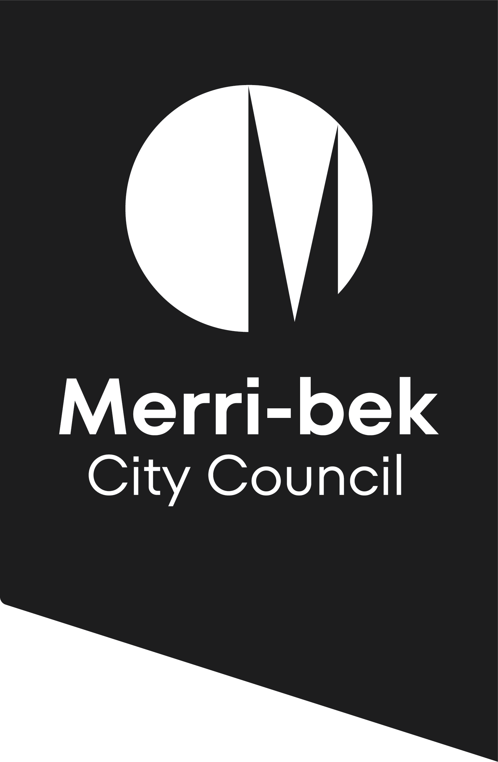

Geotechnical declaration
and certification

November 2012

This form is to be used for the purposes of complying with a condition on a planning permit for the development of land (which Council has identified is at risk of landslip) where the condition requires the impact of the final design of the buildings and/or works on slope stability to be assessed and certified by a suitably qualified geotechnical engineer. This form must be completed by a suitably qualified geotechnical engineer and lodged with the Urban Development Branch of the Merri-bek City Council prior to the commencement of the permitted buildings and/or works.

Tell us about the planning permit
Planning permit number |  |  |  |  |  |  |  |  |  | Date of issue
Condition number
Address of land
Approved use or development
Permit holder/applicant

Tell us about the geotechnical engineer and the assessment
 |  | For the purposes of this Certification a “qualified geotechnical engineer with experience in slope stability” is defined as:  - a degree qualified geotechnical engineer or engineering geologist; who is  - a member of a professional institute; and  - has achieved chartered professional status, being a Chartered Professional Engineer (CPEng), a Chartered Professional Geologist (CPGeo) or a Registered Professional Geologist (RPGeo); and  - has experience in the identification and management of slope stability problems and landslide as a core competence.
Given name |  |  |  |  |  |  |  |  | Family name
Company (optional)
Professional qualifications
Professional status |  |  |  |  |  |  |  | Chartered Professional Engineer (CPEng)
 |  |  |  |  |  |  |  | Chartered Professional Geologist (CPGeo)
 |  |  |  |  |  |  |  | Registered Professional Geologist (RPGeo)
Geotechnical report reference (if any) |  |  |  |  |  |  |  |  |  | Date of report

Submission checklist
 |  |  | Your application must include the following:
 |  |  | A copy of the planning permit.
 |  |  | A copy of the drawings of the proposed development and other relevant documents (if any) which form part of this certification. Drawings must incorporate any changes required as stated above (if any). List drawing numbers and state other relevant documents:

Signature and declaration
 | Yes |  |  |  | I declare that I am a “qualified geotechnical engineer with experience in slope stability” and am qualified to make the certification required by the above-named Planning Permit Condition.
 | Yes |  |  |  | I declare that I have considered and assessed the slope stability of the land at the above named Site Address and the Development approved by the above named Planning Permit in accordance with the procedure for landslide risk assessment established by the Australian Geomechanics Society (Australian Geomechanics Society Landslide Taskforce, Landslide Practice Note Working Group) ‘Practice Note Guidelines for Landslide Risk Management 2007’, Journal and News of the Australian Geomechanics Society, Volume 42 No 1, March 2007, including completion of the “Checklist for Landslide Risk Assessment and Management”.
 | Yes |  |  |  | I certify that the land at the Site Address will achieve a slope stability level of “Acceptable  (10⁻⁶)” taking into account the approved Development and total site disturbances proposed, subject to any required changes being made to the design or ongoing maintenance regime being implemented.
 | Yes |  |  |  | I require changes to the proposed design of the Development and/or ongoing maintenance to achieve or maintain a slope stability level of “Acceptable (10⁻⁶)”. The design changes and/or ongoing maintenance requirements are attached to this certification and included in the plans certified by me for the purposes of Section 4.
 | No
 | Yes |  |  |  | I am aware that this declaration and certification, the attached plans and any other relevant documents attached are to be submitted in satisfaction of the Planning Permit Condition and will be relied upon by the Permit Holder and the Responsible Authority.
Signature
Name |  |  |  |  |  |  |  |  |  |  |  | Date
For more information & lodgement
 | Email your declaration and certification to info@merri-bek.vic.gov.au.
 | Mail your declaration and certification to Merri-bek City Council, Locked Bag 10, Brunswick, Vic 3056.
 | Online visit www.merri-bek.vic.gov.au/building-and-business/planning-and-building/planning/when-you-need-a-planning-permit for more information.
 | Visit the Merri-bek Civic Centre at 90 Bell Street, Coburg, Vic 3058.
 | Call Merri-bek City Council on 9240 1111.
Privacy notice
Merri-bek City Council is committed to protecting your privacy in accordance with the Privacy and Data Protection Act 2014 (Vic) and the Health Records Act 2001 (Vic). The personal information requested on this form is being collected by Merri-bek City Council to consider and determine this application and may also be used to update your personal information otherwise held by Council (for example, contact details including email address, phone number). Personal information disclosed in this application may be made available for public inspection including on Council’s public website whilst the application is being determined, in accordance with the Planning & Environment Act 1987. If a planning permit is granted, the permit and any endorsed plans or documents under the permit continue to be available for public inspection including on Council’s website permanently and may also be used by Council for related purposes. It will not be disclosed to any other external party without your consent, unless required or authorised by law. If the personal information is not provided in your application, this may result in the application not being accepted, lapsing or being refused. You can gain access to your personal information you have provided to Merri-bek City Council and if you wish to alter it, please contact Council’s Privacy Officer via telephone on 9240 1111 or e-mail at Privacyofficer@merri-bek.vic.gov.au.
PLEASE NOTE: Information associated with this application might be provided electronically and unless otherwise stated, Council takes the completion of this form as consent to use electronic communication. Further Council may use your electronic details for other Council communication.

