Moreland Nature Plan
Enhancing biodiversity and celebrating nature in our City


Contents

Executive summary 3
Introduction 5
PART 1 – Background and technical report 7
1. History of our natural environment 7
2 Moreland’s natural landscape today 9
3 Why is a Nature Plan important in Moreland? 19
4 Natural Resource Management (NRM) in Moreland today 25
5 Challenges and opportunities for nature in Moreland 27

PART 2 - ACTION PLAN 49
6 Strategic context 51
7 Implementation Plan 55
8 Annual performance indicators 70
9 Bibliography: 71
Appendix 1: Vegetation types 73
Appendix 2: Community ‘Nature’ groups in Moreland 76

Acknowledgments:
This Plan was developed by officers from Councils Open Space Design and Development Unit with input from internal and external stakeholders.
Photos: Anna Lanigan, Merri Creek Management Committee (MCMC), Vince Andreana, Lori Arthur, Sam Neidra, Hussain Hameed, Kaye Oddie and Stephen McKenzie Photography.

Executive summary

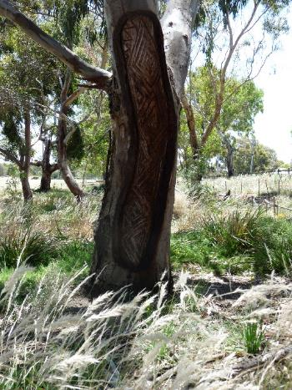
The City of Moreland offers wonderful nature experiences, despite many years of urbanisation which resulted in significant land transformation and vegetation loss. Stands of highly significant original (remnant) vegetation, such as grassland areas in Fawkner, and large tracts of revegetated areas, particularly along the creek corridors, provide important habitat for a range of native birds and animals. In addition to their important biodiversity value, these areas offer treasured opportunities for community to recreate and seek respite from the busyness of the City.
Moreland City Council and our partners, such as Friends and community groups and Melbourne Water, have been investing in land restoration and revegetation programs since the late 1970s and have created the valuable natural landscapes we have today. The Moreland Nature Plan provides a heightened strategic direction to enhance biodiversity and celebrate nature in our City for the next four years and beyond. It sets out a vision of:
Moreland will have a more diverse, connected and resilient natural environment where indigenous plant and animals thrive in a challenging and changing environment. Through fostering strong partnerships, Council supports its community to treasure the local environment by providing opportunities to discover, connect and care for nature.
The Moreland Nature Plan is the first dedicated plan towards the protection and enhancement of biodiversity in Moreland. It highlights the challenges for nature in the City including climate change, habitat fragmentation, loss of diversity and impacts from increasing urban development. It also identifies many opportunities, particularly for supporting greater community connection to nature such as potential for inclusion of nature in parks, schools, nature-strips and private backyards and other private outdoor spaces. These programs will not only have biodiversity benefits but are increasingly being recognised as having significant health and well-being benefits for community.
The Nature Plan is separated into two parts. Part 1 includes a Background and Technical Report discussing the history or Moreland’s landscape, how it has transformed over time and a summary of our natural environmental today. It recognises the importance of nature in the City which provides a range of ecosystem services having significant environmental, social, ecological and economic benefits. The report outlines Councils current approaches to natural resource management in the City and discusses the challenges and opportunities for future management.
Part 2 provides the strategic context behind the Plan and details a 4 year implementation plan which identifies clear projects for establishment and / or delivery within a four-year period and ongoing actions which are considered to be part of Council’s core service in open space / natural resource management with expectations to be delivered for the next 10 years and beyond.
The implementation plan is based on four themes:
- Protecting and enhancing biodiversity on Council managed land
- Seeking opportunities for the private realm to contribute positively to biodiversity
- Connecting people to nature
- Improving governance and collaboration in natural resource management
Eleven annual performance indicators have been determined for tracking progress towards the vision and delivery of this Plan.
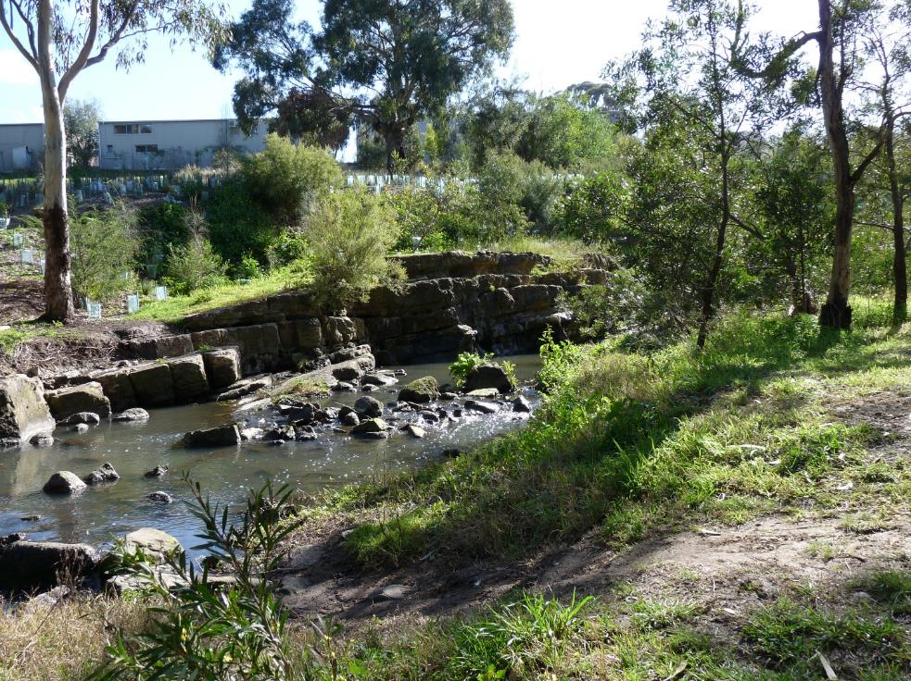
Moreland City Council acknowledges that we are in a state of climate emergency; that the world is facing an unprecedented environmental crisis and urgent action is required. Global temperatures continue to rise and huge numbers of species are now on the brink of extinction. The time for action is now and this Nature Plan, along with strategies such as Zero Carbon Moreland, highlight Councils commitment to this call for action.

Introduction
The term‘Biophilia’ has been around since the 1970s referring to the idea that humans possess an innate tendency to seek connections with nature and other forms of life. Whilst many would readily acknowledge a tendency to seek natural locations to spend a holiday, say at the beach or going to a National Park, the importance of people’s local environment is often less well-recognised.
There is strong evidence that spending time and connecting with nature is good for both physical and mental health and that ready access to nature in cities is particularly important, given our increased time spent indoors often doing sedentary activities.
Despite years of urbanisation, the City of Moreland still retains some stands of original and highly significant vegetation. Community-led restoration programs and advocacy since the late 1970s have created the valuable natural landscapes we have today, particularly along our waterways. These areas provide important habitat for a range of animals and the return of species clearly highlights the value of revegetation work to our City.
Across the globe, thousands of species are threatened with extinction as a result of climate change. Moreland City Council declared that we are in a state of climate emergency in September 2018 acknowledging that the world is facing an unprecedented environmental crisis and urgent action is required. The need for this Nature Plan, and the protection of our local species, has never been more pressing.
This Nature Plan is the first dedicated plan towards the protection and enhancement of biodiversity in the City. Its timing is paramount, particularly as we experience a growing population, urban consolidation, constrained budgets and climate change, such as extreme heat and extended drought, are all placing additional stress on our ecology and wildlife.
Focus is placed on the protection and rehabilitation of indigenous vegetation and ecosystems, as this provides our greatest opportunity to protect local species, but all vegetation, native and exotic, can have biodiversity value.
Moreland’s population is expected to grow from 170,000 in 2016 to 228,000 in 2036. Additional housing and services will be required to cater to this population. This urban consolidation exerts greater pressures on our natural environment, not only as a space for animals and plants to live, but also as places for people to seek respite from the busyness of the City; to recreate and restore. This Plan acknowledges the importance of local connection to nature for the health and well-being of our community and the value of interactive nature engagement programs.
This Nature Plan has been developed in line with the Council Plan’s Strategic Objectives for a Connected Community, Progressive City and Responsible Council (Council Plan 2017-21). It identifies priority actions to encourage greater connection to nature which will provide significant health and well-being benefits for our community.
Council will be progressive and collaborative in our approach to natural resource management, working with the community and key stakeholders to meet the needs of our people and the environment. The development and delivery of this Plan demonstrates Moreland’s commitment to our environmental responsibilities, to not only protect, but enhance the unique natural environment we have in our City.

PART 1 – Background and technical report

1. History of our natural environment
Two centuries of urbanisation have transformed our local environment but stands of original (remnant) vegetation still exist and have high significance, particularly along our waterways. Planting programs since the late 1970’s have been revegetating significants stands of vegetation and restoring habitat to create the valuable natural landscapes we have today.

The original landscape and underlying geology
Moreland is located in between the Moonee Ponds and Merri Creeks and intersects with the great lava plains formed by ancient volcanoes which erupted millions of years ago. The flows created great beds of basalt, and as time progressed the rock weathered and broke down to create the plains of shallow soils, which typify much of Moreland. The underlying basalt geology supported expansive areas of volcanic plains grassland and stands of open woodland. These grasslands extended over much of western Victoria and into South Australia and are now referred to as the Temperate Grasslands of the Victorian Volcanic Plains bioregion.
A range of riparian and aquatic ecosystems, such as Stream Bank Shrubland, occurred along the creek and drainage lines where the extra soil moisture supported more tree and shrub vegetation.
Several areas in the municipality were not covered by lava flows and provide examples of much older sedimentary soil profiles, dating over 400 million years. The Silurian cliff escarpments at Union Street, West Brunswick and along the Edgars Creek in North Coburg are dramatic examples of this.
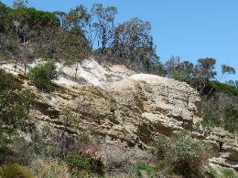
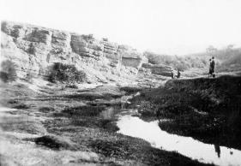
Sedimentary stone and sands of the Moonee Ponds Creek, Brunswick West, photographed in 1922 (left). Source: Moreland City Libraries and Picture Victoria. And today (right).

Traditional land management
The northern region of Melbourne, encompassing the City of Moreland, is the traditional land of the Wurundjeri-willam people, a clan of the Woiwurrung language group. The Wurundjeri people had, and continue to have, a strong spiritual and physical connection to the land. Over their long association with the land, they developed land management and survival practices specific to the area. Large trees provided bark for canoes and fibrous reeds could be made into ropes, nets and baskets. Grasslands were managed through fire stick farming and digging to support new growth and diversity, including large populations of Murnong (Yam daisy), a large staple in the diet of the Wurundjeri people (Moreland City Council, 2010).

Colonisation and land use change
Given the open, grassy landscape, areas north and west of Melbourne were quickly colonised by Europeans in the 1800s for housing and farming. The (now) Moreland area was one of the earliest parts of Melbourne to be surveyed for sale by the colonial government. Larger allotments to the north were used for farming whilst the southern part of the municipality quickly grew dense with industry and housing (Moreland City Council, 2010).
As a result of this early colonisation, the Wurundjeri people were displaced, their land management techniques replaced with European styles, resulting in significant modification of the landscape. Temperate Grassland and Grassy Eucalypt Woodlands of the Victorian Volcanic Plains which covered much of western Victoria and into South Australia (including the Moreland area) are now considered amongst the most under-represented and threatened ecosystems in Australia and were listed for Federal protection under the Environment Protection and Biodiversity Conservation Act 1999 (EPBC) in 2008-09. Less than five per cent of the original extent of both communities remains, although patches in good condition are likely to constitute less than one per cent.
Two centuries of farming and, later, urban development has dramatically changed Moreland’s natural landscape: much of the original vegetation has been lost, and what remains, exists mostly on public land and is heavily fragmented; traditional land management practices have ceased through the dislocation of the Wurundjeri people; exotic flora and fauna introduced; creek alignments have been significantly modified, such as concrete channelisation of the Moonee Ponds Creek; and urban drainage systems changed with major impacts on the natural ecosystem function.
Land restoration programs in urban areas are challenged by the legacies of this earlier (post colonisation) land management. Spatial and urban infrastructure confines (such as transmission lines and underground sewers) also provide limitations on revegetation opportunities and design. Understanding the history of our landscape and the vegetation types that existed are useful for guidance in revegetation, however, the reality is a more modified urban landscape with planting and regeneration of landscapes design responding to the particular context, with plants and trees selected based on the role and function that fits best with that location within the urban ecosystem, and their likelihood of healthy growth.

Moreland’s natural landscape today
Given its urban context, some may consider the natural landscape a lost cause, but this is far from the truth. Around 46% of Australia’s endangered wildlife can be found in towns and cities, including Melbourne, which highlights the importance of protection and conservation efforts in cities (Ives et al 2015).
The Moreland Indigenous Vegetation Assessment 2011 (MIVA) provides the most recent detailed assessment of both remnant and revegetated areas across a mixture of land tenures in the municipality. Much of our indigenous vegetation is on public land along waterways, but significant vegetation has also been identified on private land at the Northern Golf Course and within the Fawkner Cemetery and Northern Memorial Park.
As of February 2020, Moreland (and partners including Merri Creek Management Committee and community groups) manage in excess of 53 hectares specifically for conservation. This includes land that is Council owned as well as several parcels of Crown Land where Moreland has been appointed as Committee of Management, including the highly significant Bababi Djinanang (Mother’s Foot) grassland reserve which would otherwise go relatively unmanaged.
Vegetation types (Ecological Vegetation Classes – EVCs) range from mostly treeless grassland vegetation (such as Bababi Djinanang grasslands) to riparian and grassy woodlands. More detail on the vegetation types can be found in Appendix 1 and MIVA (2011).
Key sites and areas of significance are discussed below and shown spatially in Figure 1.0.
This map also includes key sites adjacent to Moreland, such as Royal Park and Ngarri-djarrang grassland, which play a crucial part in the wider connected habitat network through large, hollow bearing trees, wetlands and rare grassland habitats.
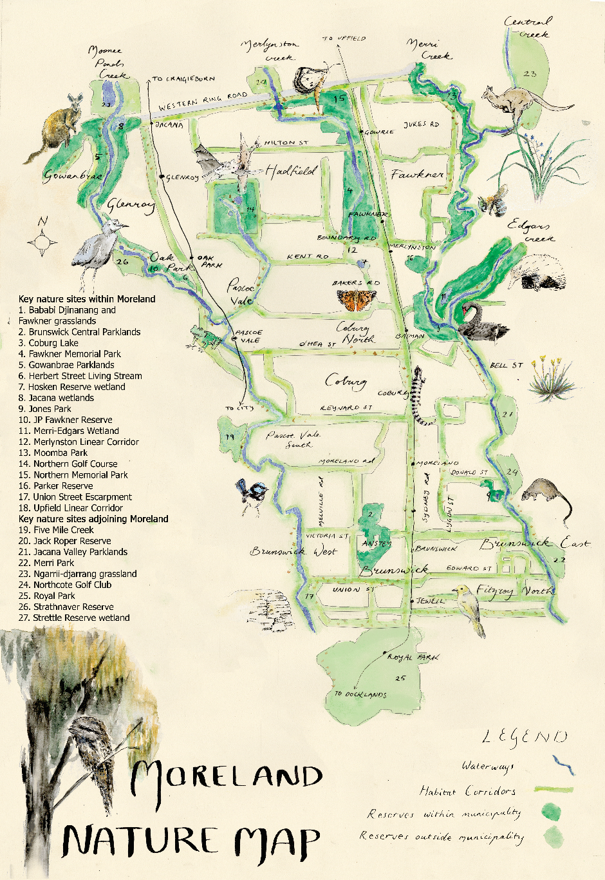
Figure 1.0 Nature map of Moreland identifying key sites. Artwork: Sofia Sabbagh (Note: Westbreen Creek, CERES and Community gardens to be added to Nature Map)

Creek Corridors
As noted above, the majority of natural vegetation is located along the city’s waterway corridors, the Moonee Ponds, Merri and Edgars Creeks. Much of the land along the Merri and Edgars Creeks had been reserved for freeway reservation and strong advocacy from community protected the biodiversity and open space values along these corridors. Other smaller creeks, such as the Westbreen, Melville, Campbellfield and Merlynston Creeks have been barrel drained for part or all of their length; however, where they are open and/or revegetated, they provide important wildlife refuge.
The creek corridors have been the focus of environmental restoration programs for over 40 years in Moreland. Advocacy from groups such as the Pascoe Vale Naturalists and Brunswick Merri Action Group in the late 1970’s started a movement towards restoring waterways for both environmental and recreational purposes. This saw the establishment of groups such as the Friends of Merri Creek, Merri Creek Management Committee (MCMC) and the Moonee Ponds Creek Association, now the Chain of Ponds Collaboration (CoP) after some reiterations over the years.
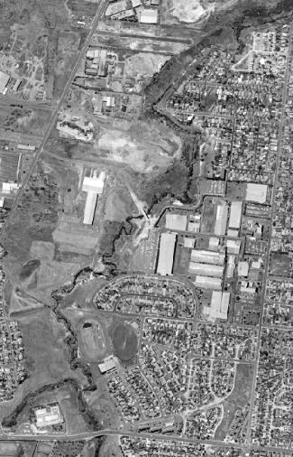
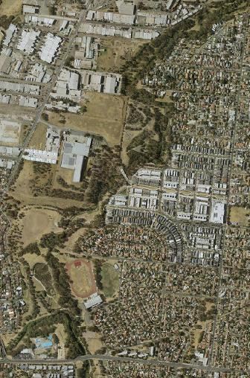
Council has partnered with these organisations, new and emerging community groups and other key stakeholders, such as Melbourne Water, in undertaking activities such as weed control, revegetation and ecological burning to rehabilitate parklands along the creek corridors to what they are today. The above images of the Edgars Creek corridor between Elizabeth Street and the confluence with the Merri Creek in Coburg North from 1979 and again in 2018 show the significant land transformation in this time through revegetation efforts.
Edgars Creek 1979
Edgars Creek 2018
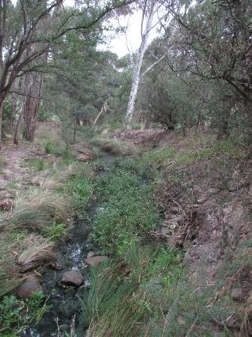
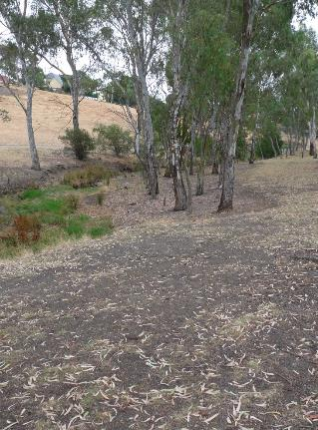
The focus of early restoration programs saw the planting of mostly tree species and recent aerial imagery shows a now near continuous tree canopy along the corridor. Understorey planting (mid and ground layer planting) has been the focus of more recent plantings but much of the understorey along the creek corridors is still largely modified. The photos below of Westbreen Creek from 2009 and again in 2018 show the diversity achieved through understorey, riparian and in-stream planting programs, establishing a more natural and structurally diverse systems.
Westbreen Creek 2009
Westbreen Creek 2018

Linear Corridors and stepping stone habitats
Stepping stone habitats and linear corridors are designed to create links between the creek corridors and key natural areas both within and outside the municipality. These links are critical for the safe passage of fauna and sharing of genetic material between populations.
The Upfield Linear Corridor creates an important north-south link between Royal Park and Fawkner Cemetery and Memorial Park which contains high natural values (see 2.4 below). Work undertaken by the Upfield Urban Forest group over recent years has greatly increased both the habitat and amenity value of this link. Level crossing removal works have impacted on this corridor, particularly through the loss of large trees, and it will considerable take time to restore these values.
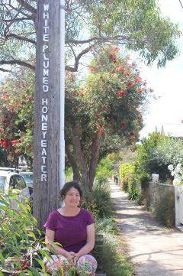
Council’s Urban Forest Strategy identifies priority streetscapes as habitat corridors throughout the municipality. The majority of these streets run east-west, creating linkages between the creek corridors. Some of these links are more developed than others, mostly because of community involvement and groups such as Brunswick Communities for Nature. Union, Edward, Talbot and King Streets in East Brunswick have very diverse nature strip plantings developed and maintained by residents supporting both local fauna and creating important community and nature engagement experiences within an urban setting.
Urban parks, schools and wetland areas away from the main habitat corridors provide important stepping stone habitats and refugia for fauna movement across the landscape. Wetlands such as those at Jones Park (Brunswick) and Hosken Reserve (Coburg North) and native plantings in parks, schools and private gardens all contribute to the wider habitat network.
Image: Lizzie Bickmore from Friends of Edward Street amongst the diverse nature strip planting with local EcoArt on powerpole referring to bird species seen in the area created by Brunswick Bird Observertors.

Fawkner grasslands
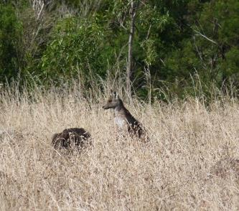
Large open areas along the western banks of the Merri Creek in Fawkner, which were initially set aside as a freeway reservation, now contain some of the best quality examples of grassland vegetation in the municipality.
A four hectare grassland at Bababi Djinanang has been protected and intensively managed for conservation since 1995 by MCMC on behalf of Council. Some smaller grassland areas at Emma and Hare Streets Fawkner have also been actively managed for two decades.
Many of these grassland parcels are of national significance, either representing EPBC listed communities and/or containing the EPBC listed species, Matted Flax Lilly (Dianella amonena) and a diverse range of ground storey species of interest and significance.
In 2019, Council purchased several parcels of ‘surplus’ land from VicRoads which still retain grassland values despite being neglected for some time. Plans are now underway to improve their management and further enhance connectivity, diversity and resilience of this highly important network of grasslands in Fawkner.

Northern Memorial Park and Fawkner Cemetery
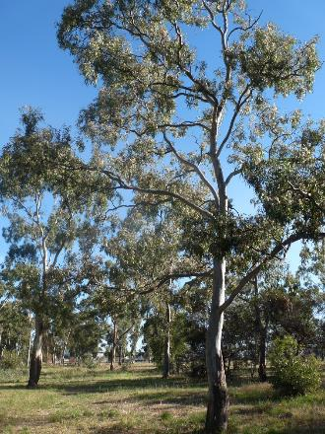
Managed by the Greater Metropolitan Cemeteries Trust (GMCT), the two cemetery sites in Fawkner greatly contribute to Moreland’s biodiversity. The Merlynston and Campbellfield Creeks both travel through the cemeteries which also contain pockets of remnant woodland vegetation and stands of large old trees..
When the vegetation at the sites was assessed (MIVA 2011), the northern area of the Memorial Park (approximately 29 hectares) still contained a relatively natural landscape of open Grassy Woodland, potentially meeting the definition ‘Grassy Eucalypt Woodland of the Victorian Volcanic Plain’ community under the EPBC Act. Expansive areas of this type are likely habitat for the Golden Sun Moth (Synemon plana) which is also listed under the EPBC Act as a threatened species and has been observed at the site on one occasion. Whistling Kite and Brown Falcon, both characteristic grassland raptors which require extensive, relatively secluded areas to hunt have been observed at the site.
Unfortunately, the recent expansion of the developed area of the Northern Memorial Park has led to a decline in ground-storey and habitat through the construction of roads, services, soil dumping and the removal of grazing. The use of the site as an active cemetery is resulting in further decline, if not full loss of the site’s significant habitat values without urgent protection and remediation. There is still potential for more sympathetic planning, retaining areas of open space, vegetation and especially habitat trees, which will protect some environmental values at the site.

Northern Golf Course
The Northern Golf Course is a privately owned 50-hectare course in Glenroy. It contains stands of highly significant vegetation around the fairways from different vegetation communities, some of which are otherwise poorly represented within the municipality. The Westbreen Creek traverses through the course and several wetlands and ponds provide further habitat.
Red Gum Woodlands mostly dominate the course containing approximately 800 mature River Red Gums (Eucalyptus camaldulensis) and approximately 40 Yellow Gums (Eucalyptus leucoxylon). Many of these are very large, having circumferences of over 3m, and contain tree hollows providing valuable shelter and breeding habitat for parrots, owls, bats and other native wildlife. Vegetation along the Westbreen Creek and around dams on the site add to the diversity of habitat at the course, supporting a range of waterfowl and frog species.
Various ground works around the course, particularly as a result of course changes, have had an impact on native vegetation, particularly understorey in the roughs between greens, but its environmental significance is still very high, particularly due to the presence of large, old trees.
Council has been developing supportive relationships with golf course managers on sympathetic practices to retain these values with some success. However, funding and incentive to implement conservation programs is supplementary to core business. Further practical and funding support by Council may assist the uptake of such programs at this critically important site.
Protecting tree hollows at the Northern Golf Course
In recognition of the habitat importance of the site, Council Officers have been developing supportive relationships with managers of the Northern Golf Course who are adopting sympathetic land management practices. In 2019, the club sought advice on the treatment of some large old trees that had become a safety hazard for course users. The result was habitat pruning of the said trees as stag trees, retaining existing hollows and perching habitat at the site. Log hollows removed during pruning were also relocated to other areas on-site or provided to Council for use in conservation areas.
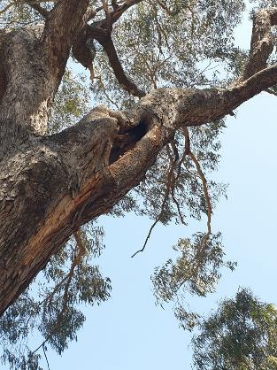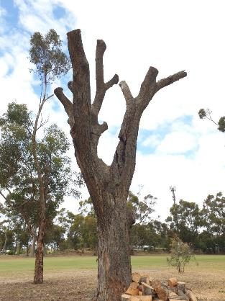

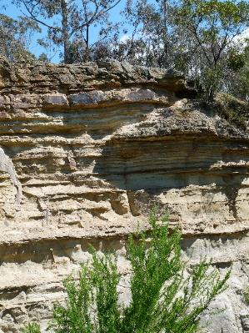
Silurian escarpments
Some areas of Moreland escaped the flow of volcanic lava that spread through the area many millions of years ago. These Silurian escarpments can be seen along the Moonee Ponds Creek in West Brunswick (Union Street), Glenroy (Outlook Drive) and at Edgars Creek in Coburg North (Spectrum Way).
These areas present opportunities to experience rarer sedimentary soils, striking topography and vegetation types, particularly Escarpment Shrubland, not found elsewhere in the municipality. These sites provide their own set of management challenges, often requiring highly skilled rope-work contractors, to undertake conservation work.

Wetlands
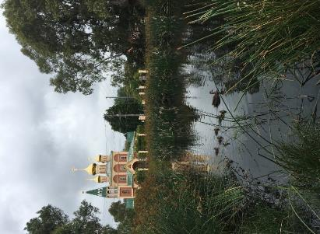
Wetlands are a critical part of our natural environment. They help to reduce the impacts of floods, absorb pollutants and improve water quality and provide habitat for plants and animals.
The wetland at Jones Park was upgraded to improve its biodiversity value and treat stormwater before reaching Merri Creek.
Wetlands can be permanent, holding water all the time, or ephemeral, wetting and drying in response to rainfall. Given the land form change in Moreland, the majority of wetlands in the City are now constructed, built over the past 20 years with the exception of Coburg Lake which was constructed in the early 1900s. Wetlands are found at Jacana, Merri-Edgars creek confluence, Jones Park and Hosken Reserve. The Herbert Street Living Stream in Oak Park includes a small permanent water body flowing into an ephemeral stream.
Off-stream wetland habitats, such as these, are of growing importance as refuges for aquatic species. They provide safe respite from fast moving flood waters during high flow events in the main creek channels, predicted to become stronger and more common with climate change and increased urbanisation.

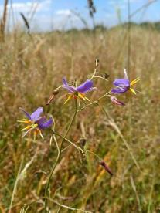
Significant plant species
Matted Flax-lily (Dianella amoena) in flower
MIVA (2011) identified 255 indigenous plant species, two of these, Matted Flax-lily (Dianella amoena) and Swamp Everlasting (Xerochrysum palustre) are considered nationally significant. The former was found occurring naturally in grassland areas whilst the latter was only recorded in planted sites. MIVA (2011) considered only 28% of the 255 species are secure as remnants in Moreland, highlighting the importance of protecting these populations and connecting habitats to allow genetic transfer. A full list of species is available in MIVA (2011).

2.9 Large old trees
Large old trees are very important for habitat, mostly for the ability to develop nesting hollows but also for feeding and perching. Due to early land clearing, there are very little large old, hollow bearing trees remaining in the Moreland landscape. The most significant stands exist within the Northern Golf Course and the Northern Memorial Park. In the absence of remnant trees, established non-indigenous trees (especially established eucalypts but including exotic trees) provide important habitat and food sources for fauna.
Protecting large trees is critically important due to the time it takes for others to grow and develop suitable nesting hollows. Hollows are considered essential for 16 mammal species and 44 bird species in Victoria. Hollows are also used by at least another 17 mammal species, 17 bird species and a number of reptiles (DSE 2003).
Council is in the process of establishing a ‘Significant Tree Register’ of a limited number of identified significant trees (indigenous, native or exotic) to be protected in the Moreland Planning Scheme on privately owned land. Ensuring any particularly important indigenous and/or habitat trees are listed in this register will help secure their protection.
Providing habitat linkages (biolinks) through the landscape to sites with large trees is also important to support safe fauna movement and breeding between populations.

Fauna
An in-depth study or collation of data of fauna living in Moreland has never been undertaken. However, records of sightings are kept by the Merri Creek Management Committee, Friends groups and community members and provide some evidence of the changes both in species composition and numbers, particularly bird species. Limited information is also available on the Atlas of Living Australia’s online database.
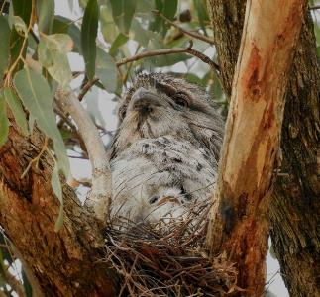
The number and diversity of birds in the City has greatly increased as a direct result of habitat restoration works. The Friends of Merri Creek have been undertaking quarterly bird surveys along the Merri Creek for over 20 years. Early surveys identified only seven ‘woodland‘ bird species between Mahoneys Road in Fawkner and Murray Road in Coburg (the term ‘woodland birds’ referring to those that require tree canopy, understorey shrubs, native groundcover and sparse leaf-litter strewn ground as habitat). After 25 years of establishing diverse woodlands along the creek, 33 woodland bird species are now being recorded in surveys of the same area, highlighting the importance of this type of work (MCMC, 2019).
Nesting Tawny Frogmouths along the Moonee Ponds Creek camouflage themselves amongst the branches.
The table below identifies the number of bird species recorded through Friends of Merri Creek surveys from October 2008 – February 2020 at various sections/sites of the corridor.
Survey site | Number of species
Bababi Djinanang (Jukes Rd grasslands) Fawkner | 88
Coburg Lake Reserve | 72
Merri Creek corridor - Harding St to Moreland Rd, East Coburg/ West Preston | 67
Merri Creek corridor – Blyth St to Moreland Rd, East Brunswick | 77
Merri Creek corridor – Kirkdale Park to Merri Park, East Brunswick/ Northcote | 77
Source: eBird.org/myebird
Creek and wetland habitats are important for a range of aquatic species such as eels, long necked tortoises, yabbies, native fish and a range of frog species. Growling Grass Frogs, which are considered a nationally threatened species, have been identified in Moreland at various locations, including JP Fawkner Reserve, Jacana Wetlands and suspected in areas along the Westbreen Creek.
The large tracts of natural grassy woodland and grassland areas, particularly in the northern part of the municipality provide critical habitat for larger mammals such as Eastern Grey Kangaroos and Swamp Wallabies. There have been a number of sightings of Echidnas and Platypus along the Merri and Edgars Creeks suggesting they are making good use of restored habitat. Nocturnal animals such as possums, bat and predatory bird species are also present throughout the municipality. The Grey-Headed Flying-Fox, which, although not endemic to Moreland, foragers in Moreland from camps along the Yarra River and is listed as a vulnerable species under the EPBC Act 1999.

Often least considered are the smaller animal life such as insects. These play a critical role in the pollination of both indigenous and non-indigenous (such as food) plant species and are an important food source for larger animals such as birds and bats. Indigenous vegetation, particularly flowering species, provide important food and habitat for a large range of insects from butterflies to bees and beetles.
The Australian Butterfly Conservation group identify over a quarter of Australia’s butterfly species use native grasses as their hosts and at least 13 species use Kangaroo Grass (Themeda triandra), a key constituent of the grasslands which once covered much of Moreland’s landscape. The endangered Golden Sun Moth (Synemon plana) requires extensive grassland area for foraging and has been spotted within the Moreland area, including at the Northern Memorial Park.

Why is a Nature Plan important in Moreland?

Natural areas in the City provide a number of environmental, social, ecological and economic services which are critically important. With our population expected to continue to grow, the way in which we manage our natural assets will impact on these services now, and for future generations. Whilst other Council strategies, such as the Open Space Strategy 2012-22 refer to the importance of nature, this is the first dedicated plan committed to protecting, enhancing and celebrating our biodiversity assets and demonstrates Council’s commitment as an environmental leader.
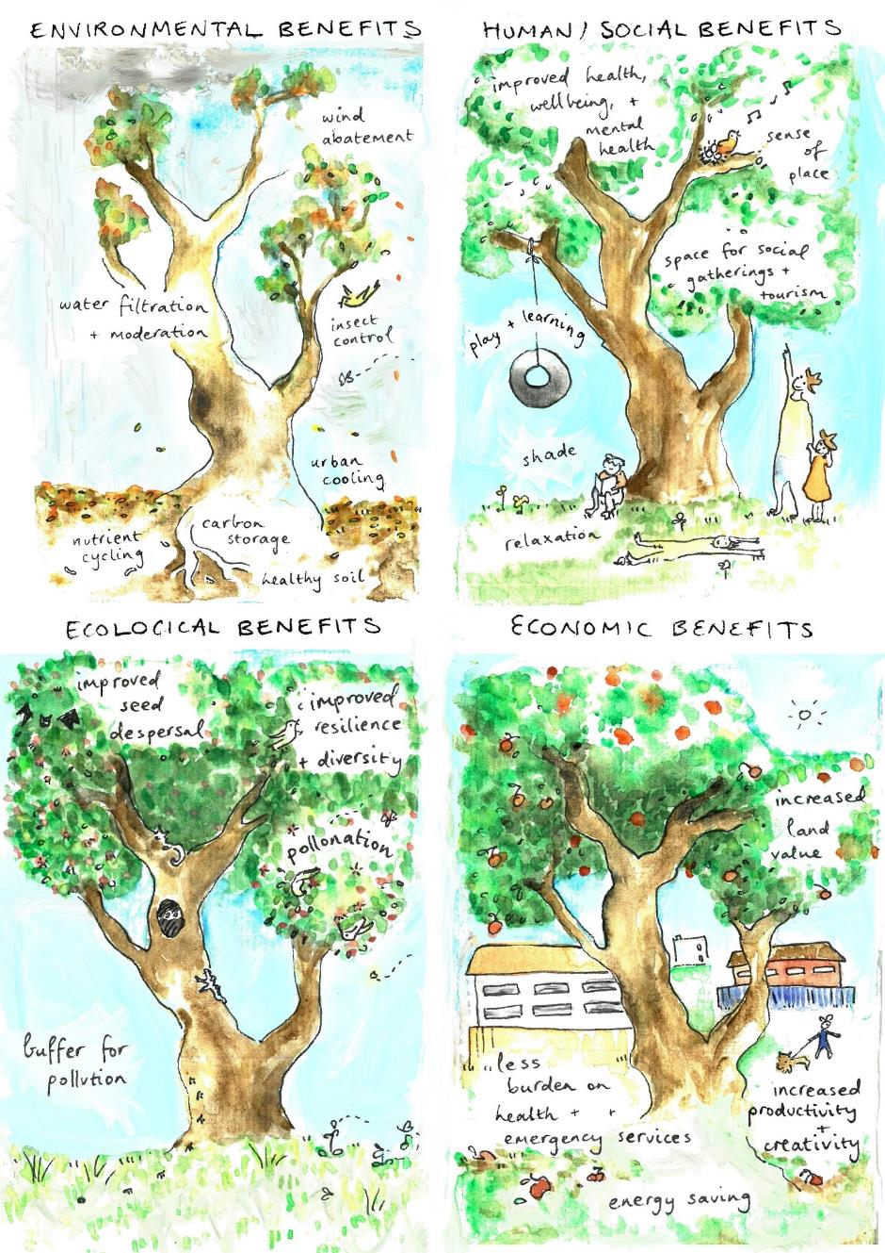
Ecosystems services provided by nature (Artwork Sofia Sabbagh)

Environmental services
Environmental services are ecological processes that benefit people by affecting their environment such as air and water purification, cooling, carbon sequestration and pollination.
Through the uptake of carbon dioxide and other pollutants, trees and vegetation improve air quality and reduce the impacts of greenhouse gases contributing to climate change. Vegetation and particularly water in the landscape (wetlands, waterways) significantly lowers temperatures reducing urban heat island effects.
Healthy soils provide the base to a well-functioning urban ecosystem and are reliant on effective nutrient recycling processes. Vegetation and organisms living in and above the soil are critical to the development of healthy soils. Ants, slaters, millipedes and other small insects work above ground to shred dead plant material after which a variety of microbes, invertebrates and fungi underground decompose it, making it ready for use again by plants. A healthy ecosystem contains all these elements, reducing the reliance on supplemental fertilisers and avoiding the build-up of dead organic matter and animal waste in the environment.
Parks and vegetation help to improve the water quality in our wetlands and waterways. Roots of plants help to stabilise soils and filter nutrients and sediments before entering streams. Wetlands and riparian (streamside) vegetation in particular play a large part in improving the health of our waterways and in turn, Port Phillip Bay.
Our natural areas provide important habitat for a large range of animal species that help with natural pest control. Insectivorous birds, bats and frogs all play a part in controlling the number of adult mosquitoes and other insects, whilst fish and tadpoles can reduce numbers at the larval stage. Reptiles such as the Blue Tongue Lizard will feed on snails and a range of native spiders catch flies and other household pests.
Our waterways serve important water quality and habitat functions
(Westbreen Creek)
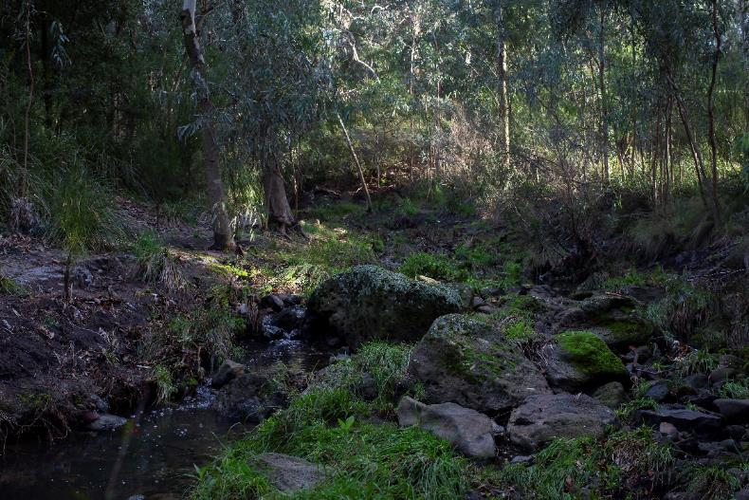

Human/social services

Our natural areas offer wonderful places for recreation and restoration. They are incredibly important for children as wild places for free play and discovery which has significant benefits for physical, emotional and academic development (Children & Nature Network 2016).
There is strong evidence recognising the health and well-being benefits of a connection to nature. The report Adding Trees – A prescription for health, happiness and fulfilment (Planet Ark 2016) identified:
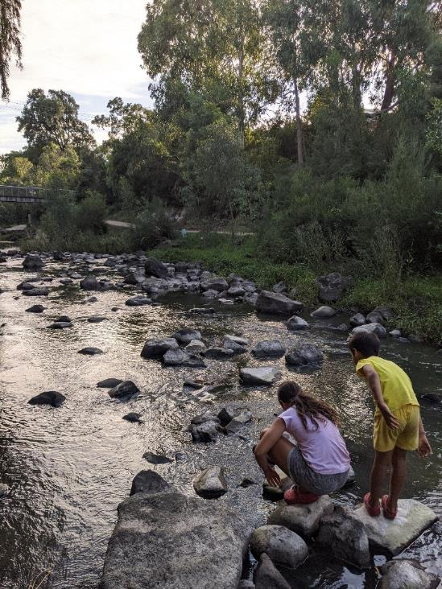
- Just 10 minutes' relaxing outside is enough to significantly reduce blood pressure.
- Time in nature reduces a person’s chance of developing a range of diseases, including diabetes by 43%, cardiovascular disease and stroke by 37% and depression by 25%.
- Nature induces positive feelings through a number of physiological mechanisms, including activating the brain’s dopamine reward system.
- Students who take part in outdoor learning programs perform better in reading, writing, maths and science, with 77% of teachers reporting student improvement in standardised tests.
- A strong connection to nature makes people more likely to feel passionate about relationships with their friends and family.
Our natural areas are wonderful places for free play and wild discovery

Research shows that ‘green nature’, such as parks, can reduce crime, foster psychological wellbeing, reduce stress, boost immunity, enhance productivity, and promote healing. In fact, the positive effects on human health, particularly in urban environments, cannot be over-stated. As a result, urban planning should ensure that the communities have adequate access to nature (C. Maller et al 2008).
Mental health issues are on the rise and research is showing the positive impacts of spending time in nature on restoring mental health. Particularly biodiverse nature, with multi-sensory elements, such as bird and frog sounds and wildflower smells, helps with mental restoration, calm and creativity (Myers 2020). Acknowledging this role of the senses supports a shift of the focus from solely visual aesthetics and functional activity to the experiences gained from natural spaces.
Healthy soils in ecologically restored sites contain a range of fungi and microbes serving a range of functions, including decomposition and recycling. Humans are exposed to these microbes whenever we enter these sites through both air and skin contact and the diversity of these microbes can have a significant impact on physical health. Changes to the microbes in the gut of urban people are responsible for higher rates of allergies and other autoimmune disorders than those living in rural areas with more exposure to natural soils (da Silva 2019).
World-first research in 2009 specifically investigated the social importance of Victoria’s waterways, ie rivers, creeks, wetlands and estuaries. The research, (Department of Sustainability and Environment 2011), was considered vital to fill a gap in waterway health management as, although a lot of work was being done to understand and better manage the physical health of our waterways, not much had been done to understand their social importance and to manage for these values. Whilst the study found people valued waterways for a range of reasons, a highlight of the research was the importance of recreational access to local waterways with the vast majority of respondents (83%) feeling most personally connected to a waterway that is local to them. Of particular interest is the standout recognition of Merri Creek as Victoria’s most popular urban creek in the study.
Community volunteers who participate in conservation activities, such as planting and weeding days and monitoring activities, gain benefits of social connection, a sense of community contribution and health benefits. Members of Friends of Edwards Street recently commented that they felt much more connected to their community since being involved in the program, that it has given them opportunity for a shared conversation with their neighbours.
With people spending more time indoors and on screens, supporting local opportunities to connect people with the environment will provide long term and wide-reaching community health and social benefits. This provides a solid base for Councils investment in programs that enhance local environmental values and which offer meaningful engagement with nature.

Ecological services
Councils natural areas support endangered remnant vegetation and valuable habitat for a range of animal species. It is widely recognised that nature has intrinsic value – that biodiversity (the diversity of all life forms that comprise natural ecosystems) has value, in its own right, beyond the services or usefulness it provides to humans and it should be protected.
Many people are familiar with the importance of conservation in rural areas but are less aware of the importance of nature protection in cities. Australian cities support substantially more nationally threatened animal and plant species than non-urban areas on a unit-area basis, highlighting the importance of conservation programs in cities. Around 46% of Australia’s endangered wildlife can be found in towns and cities, including Melbourne, which highlights the importance of protection and conservation efforts in cities (Ives et al 2015).
The community’s perception of general environmental health is strongly influenced by their personal experience of their closest waterway (Department of Sustainability and Environment 2011). People who have seen environmental restoration work undertaken on their closest creek favourably judge the necessity and quality of the work in general. This finding highlights the importance of engaging communities in local conservation programs to support an increased understanding and appreciation of the importance of conservation and conservation protection works in broader contexts.
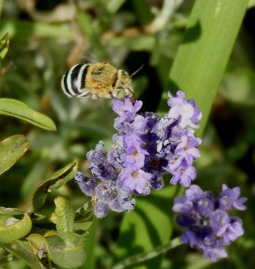
The importance of urban-specific conservation programs, particularly those focused on habitat for insect pollinators, is now more recognised. Diverse urban landscapes offer a greater variety of forage and nesting sites in comparison to more homogenous rural/agricultural landscapes. In the midst of a pollination crisis, where insect pollinator populations are experiencing significant decline, studies of native bee richness and abundance indicate that diverse communities of wild bees persist in cities in many parts of the world, including Melbourne.
Enhancing habitat of insect pollinators is a legitimate conservation practice and offers opportunities for impactful, yet sometimes, small scale interventions. Such programs offer benefits across a diversity of pollinator populations and provide ecosystem services for humans (e.g., pollination of vegetables and fruit and cultural services associated with an interest in natural history, plants (e.g., increased reproductive success), and animals (prey for species from higher trophic levels such as birds).
Blue banded bee on lavendar
(photo credit: A. Lanigan).

Another argument for the importance of nature protection in cities, is that many migratory and nomadic birds cross the Melbourne metropolitan area seasonally, and as Melbourne expands northwards towards Wallan, the need for resting and foraging habitat in Moreland will increase. Melbourne has the largest footprint of any Australian city (covering 2,705 sq. km) and is the 34th largest for any city in the world, according to the Demographia World Urban Areas survey. Being relatively well-watered (domestic gardens and irrigated parks/sportsfields), Melbourne also becomes a refuge for birds in times of drought (pers.comm A McGregor 26 June 2020).

Economic services
While there is general agreement on the use of open spaces and their benefits to human beings, these benefits typically do not have a market to reflect their monetary value and as such, the economic value of open spaces, and of investments within them, is not well understood.
An investigation into the economic benefits of open space in Moreland was undertaken in 2019 (Natural Capital Economics 2019) to better understand this connection. The study used an ecosystem services valuation approach and quantified the following key benefits from open spaces in Moreland for which data is readily available:
- Property price premiums
- Recreation
- Avoided health costs due to physical inactivity
- Traffic decongestion from bicycle commute
Based on the four benefits, the investigation identified Moreland’s open spaces have an estimated value of $94 million per annum and indicated annual benefits of $152,000 per hectare.
The report recognised several other ecosystem services that also contribute to their economic value, such as carbon sequestration and climate mitigation (reduced heat island effect), however data was not readily available to contribute to the study. This suggests that the value provided is conservative and could be considerably higher as discovered by a 2015 Planet Ark report. This report found Australians would be willing to pay an average of $35,000 more for a home in a green neighbourhood than for the same kind of home in an area with little surrounding nature (about 7% of base cost on a $500,000 home).

Natural Resource Management (NRM) in Moreland today
Council has been investing in natural resource management (NRM) programs now for over three decades.
Council currently has one full time position for the delivery of natural resource management (NRM) programs in the City and also provides annual funding to Merri Creek Management Committee (MCMC) and the Chain of Ponds Collaboration (aka Moonee Ponds Creek Collaboration Group) to support collaboration, planning and on-ground programs along waterways.
Much of the on-ground delivery of NRM programs is delivered through specialised bushland contractors and many revegetation programs are delivered in partnership with community groups. Since 2010, Council provides annual capital funding towards the delivery of improvement programs along waterways such as improved path networks and access, upgrades to fencing and revegetation and weed control programs.
In addition to direct NRM programs, Council also supports nature enhancement and engagement programs through a range of other services, such as park upgrades, land acquisitions and integrated water management programs.
For example, in 2018-19, Council:
- Planted 27,490 indigenous plants
- Revegetated 3.5 hectares including extensive works on steep terrain at Gowanbrae
- Implemented controlled burning on 1.5hectares of grassland and an additional 0.9hectares of cultural burn at Bababi Djinanang with the Wurundjeri Tribe Council
- Completed an upgrade to the Jones Park wetland and surrounds to enhance its biodiversity value and treat stormwater before it enters the Merri Creek
- Commenced a grassy woodland restoration project on (0.7 ha) at JP Fawkner Reserve removing mowing and direct seeding with indigenous grass species
- Constructed a nature themed park upgrade at Sheils Reserve, West Brunswick including blue wren habitat and nature pods in response to community feedback
- Completed the Chain of Ponds Plan for Moonee Ponds Creek in partnership with Moonee Valley Council, stakeholders and Melbourne Water
- Completed the Westbreen Creek Conservation and Development Plan
- Purchased land along the waterways to retain public open space and waterway corridor function at Spry Street (Coburg North), Kernan Street (Pascoe Vale), Queens Parade, Leonard Street) and McBryde Street (Fawkner) and Outlook Drive (Glenroy).
- Upgraded 5 connections to waterways (drainage) to improve water quality and amenity at Coburg North and Oak Park
- Conducted amenity improvements such as new nature paths, fencing and seating along creek corridors at various locations
- Attracted over $100,000 in grant funding towards programs in Moreland either directly through Council or supported through our community partners.
- Supported community greening activities (planting, weeding, mulching) which contributed to over $75,000 in volunteer hours (based on $30/hr rate)
- Participated in National Tree Day through hosting a community event at Gowanbrae, 2 schools events and supporting a number of schools with planting events through provision of mulch, tools and/or plants.
- Supported the inaugural Birds Australia ‘Birds in Schools’ program with Oak Park and Coburg Primary Schools
- Commenced a longitudinal study with RMIT University looking at insect and bird behaviour change through greening activities.
This Nature Plan aims to build on the great work achieved thus far with our partners.

Challenges and opportunities for nature in Moreland

Climate change
Climate change modelling predicts a long-term shift to a warmer and drier climate in south-east Australia with an increase in the frequency and severity of extreme weather events (fire, storms, heavy rain and strong winds).
Climate change is likely to amplify existing threats to biodiversity such as habitat loss and invasive species, making their impacts considerably worse. Especially vulnerable are species with restricted or specialised habitat requirements, poor dispersal abilities or small populations. There is already evidence of a shift in the timing of flowering or seed production and insect emergence, bird arrival and breeding to optimise reproduction and success as a result of climate change.
Loss of biodiversity is a real concern in a changing climate, but its impact can be softened through addressing key threats, as outlined in more detail below, to support stronger, more resilient ecosystems. Resilience to climate change can be enhanced by improving the quality and diversity (inter-species and genetic), establishing good connectivity and developing strong buffers around significant vegetation and habitats.
Adaptations to revegetation programs will also consider the future drier climate, such as the incorporation of more drought tolerant species and/or sourcing from drier provenances in revegetation plant lists, founded on advice from research organisations.

Vegetation loss and habitat fragmentation
Habitat loss and fragmentation is the biggest threat to biodiversity worldwide. Habitat fragmentation is the breaking up of once continuous native ecosystems into small and often
isolated patches following land-use change. The impact of fragmentation is that habitat patches no longer provide enough suitable habitat or suitable environmental conditions to support viable populations of species.

As outlined above, the Moreland area has undergone significant land-use change since European Settlement and much of our remnant vegetation has been lost or heavily fragmented. Revegetation programs since the late 1970s have restored large tracts of vegetation, and we are now enjoying the return of species in the landscape as a result of this work, particularly in bird species and numbers (see Fauna section above). Important land acquisitions, including several land parcels along the Merri and Moonee Ponds Creek in recent years, have protected significant vegetation and open space linkages from further development and encroachment.

Whilst these programs have been effective, works have been undertaken in a relatively opportunistic way, responding to grant funding criteria and/or community interest. The opportunities for revegetation in the municipality, including public and private open space, are somewhat endless and being more strategic in this space will help to target resource allocations.

The development of a Connectivity Plan which identifies key corridors and habitat requirements for select representative species will help to prioritise locations and design of revegetation programs for most effect. This includes identifying priorities for focussed conservation efforts (biodiversity hot spots), buffer and connectivity planting and key opportunities for ‘stepping stone’ habitats to create a more diverse, connected and resilient ecological landscape overall.

Urban stream degradation and loss of water in the landscape
One of the biggest environmental impacts of urban development results from the loss of soil permeability and changes to the way water is managed in the landscape. Conventional drainage systems are designed to move rainfall as quickly as possible to local waterways. This is exacerbated by the irreversible loss of permeable soils as building footprints expand.
This has a significant impact on natural values as all flora and fauna species require access to water to survive. It also has downstream impacts: exacerbating flooding, decreasing water quality, litter pollution and erosion of creek banks from increased volumes and velocities of stormwater.
The benefits of stormwater retention, reuse and treatment in the landscape are now well understood and the principles of Water Sensitive Urban Design (WSUD) are implemented in many Council projects from streetscape upgrades to building infrastructure projects, particularly since the adoption of Moreland’s Watermap 2020. These projects, particularly those which retain stands of open water in the landscape, often have biodiversity value but are not necessarily designed with this intent.
Council has recently refreshed Watermap 2020, now titled the Moreland Integrated Water Management (IWM) Strategy 2040 with the aim to create a water sensitive city resilient to future population growth and climate change. It outlines a number of actions in relation to improving waterway health, particularly in Outcome Area 4: Healthy Waterways, including the design and delivery of Water Sensitive Urban Design (WSUD) projects, wetlands and litter management programs. There are clear actions around reducing litter pollution, such as the implementation of a Litter and Gross Pollutant Action Plan and increased support for community initiatives to reduce plastic pollution in the environment.
The Herbert Street Living Stream and the Merri-Edgars wetland are both recent IWM projects which prioritised biodiversity and habitat in their design. Continued implementation of green-blue infrastructure and IWM projects will greatly contribute to Moreland’s natural environment.
Herbert Street Living Stream
This 2017project re-established a “living stream” in the former creek line of Moonee Ponds Creek. Stormwater from an underground drain was redirected through a gross pollutant trap into a small constructed wetland and vegetated swale before returning to the creek. The project provides many benefits including enhanced habitat, improved water quality and reduced pollution going into Moonee Ponds Creek and an opportunity for community to connect with nature.
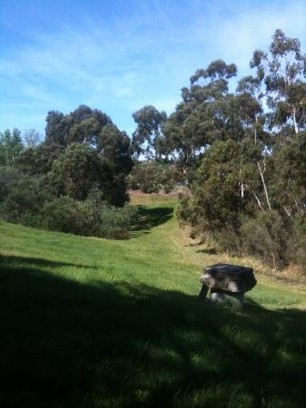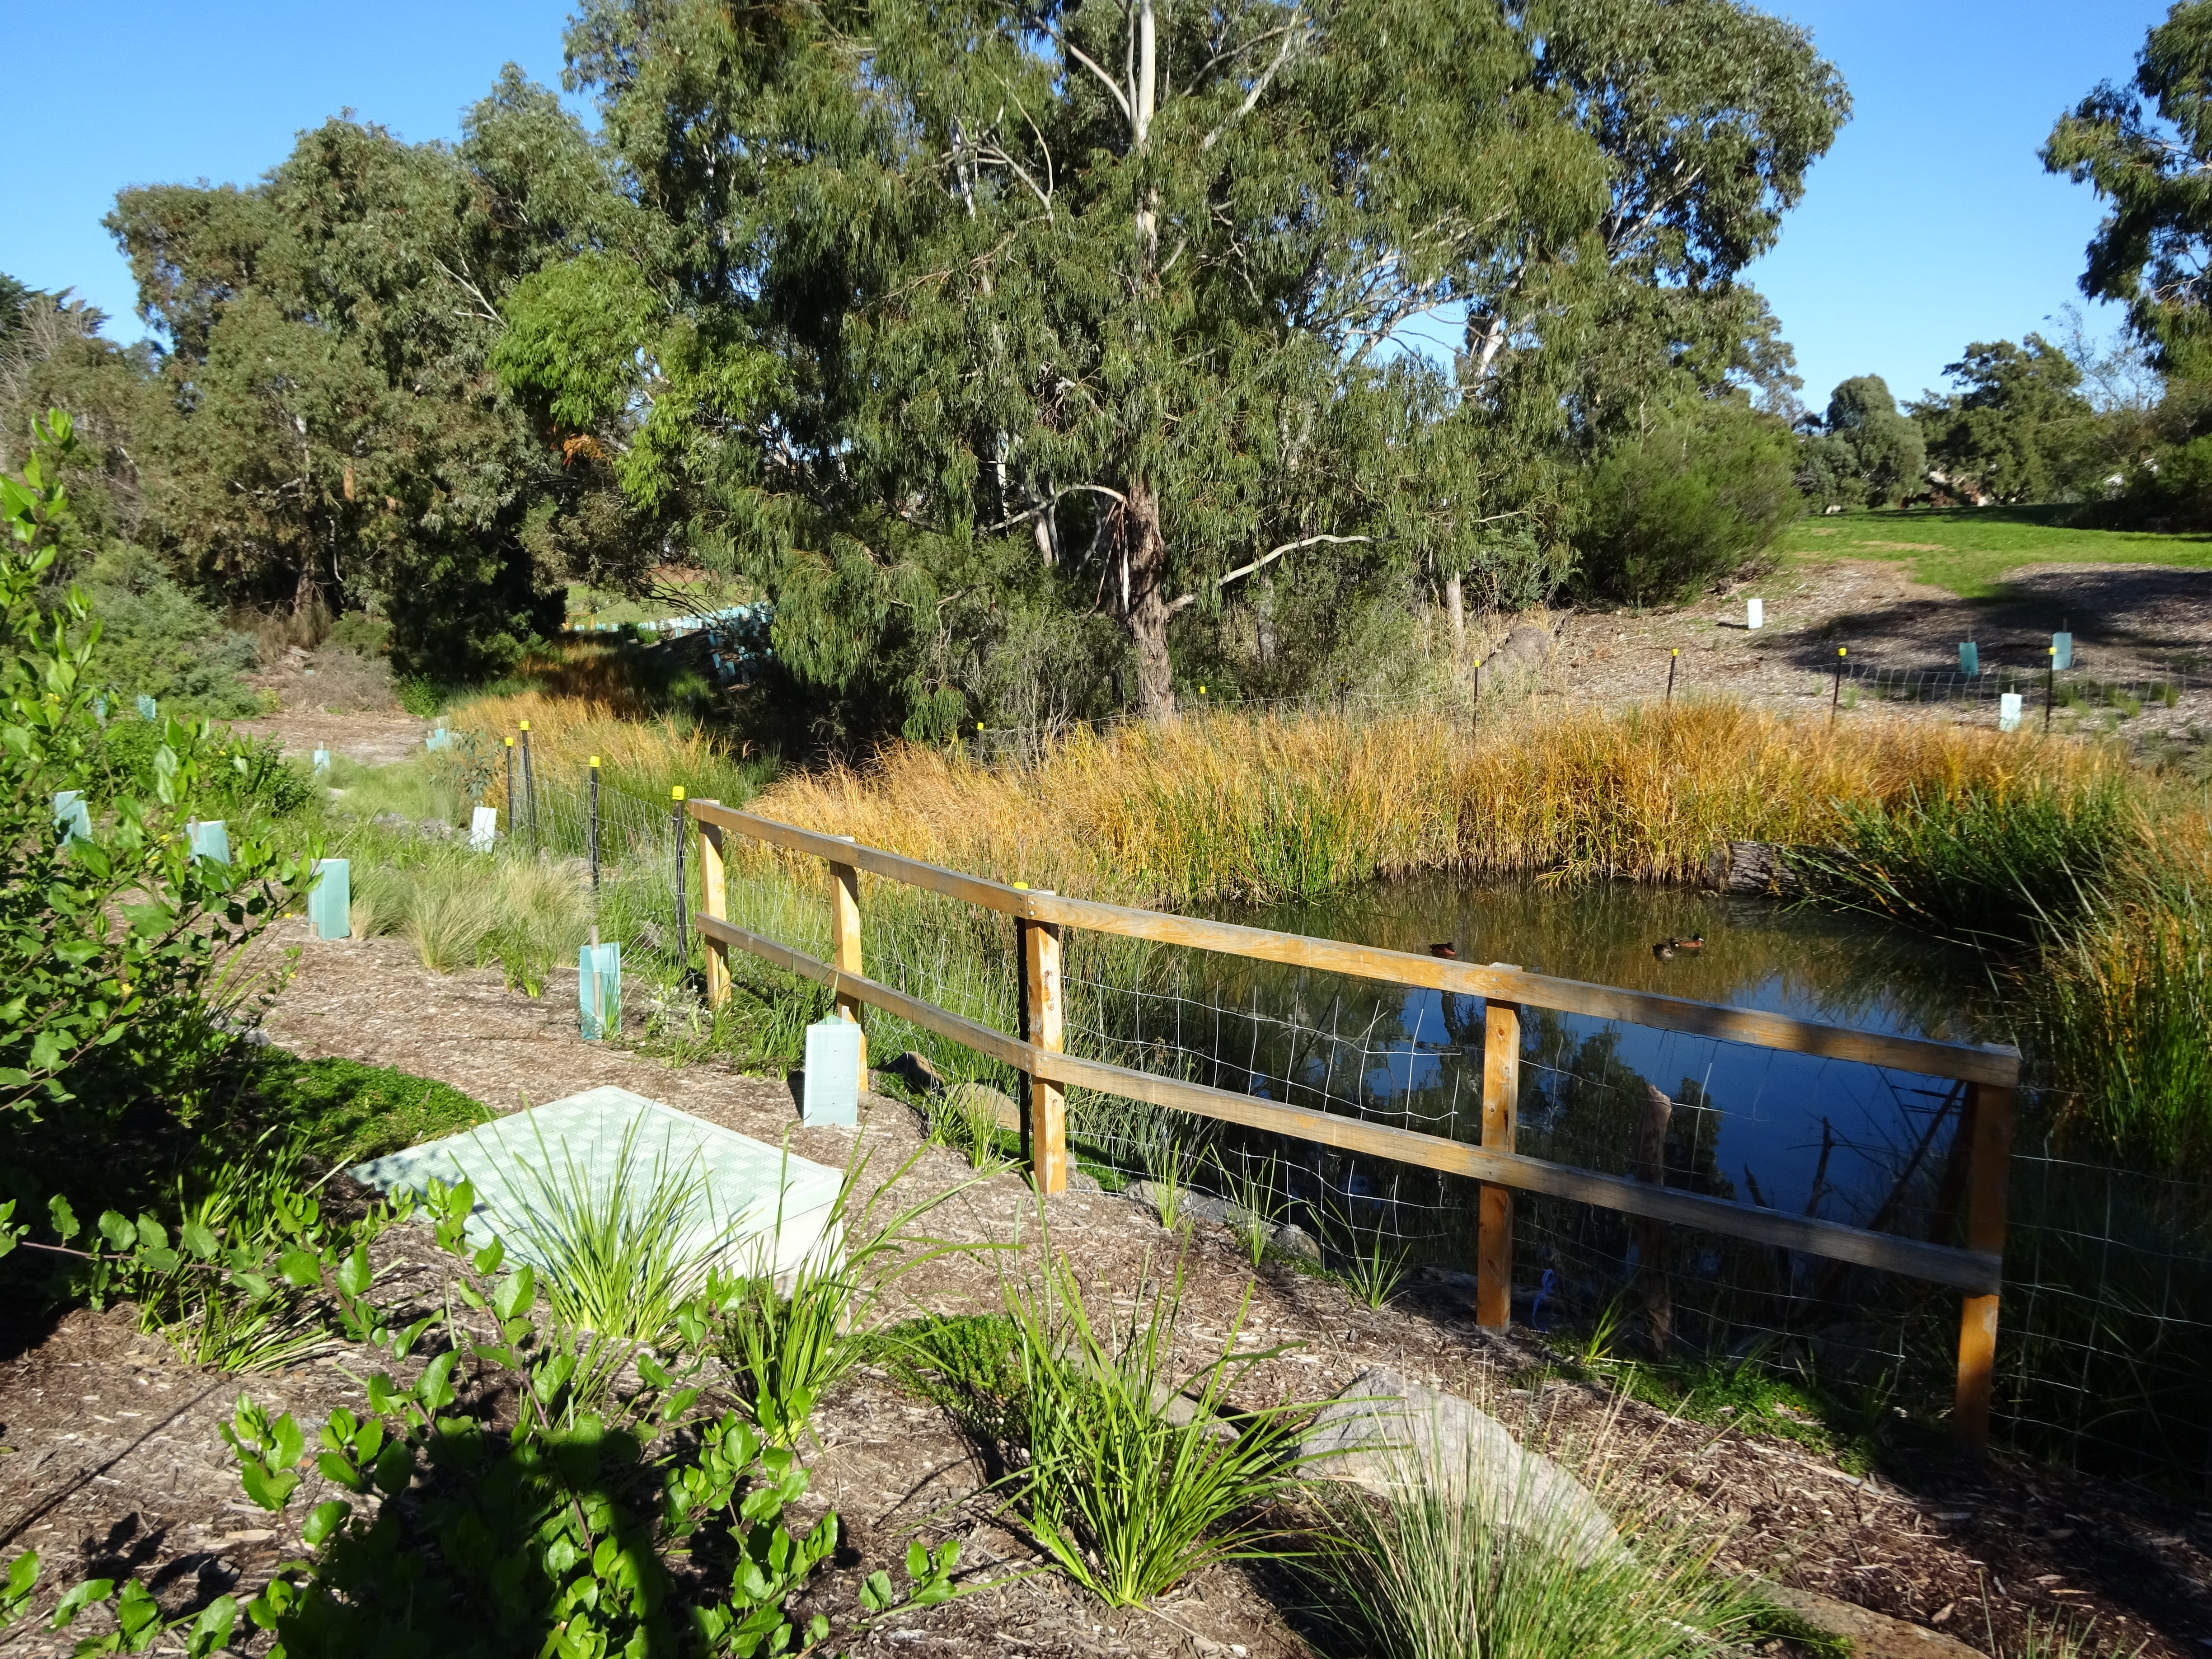
Herbert Street before and after ‘living stream’ development works

Environmental weeds
The Moreland Indigenous Vegetation Assessment (MIVA - MCMC 2011) identified 381 introduced plant species in the survey areas, 351 considered occurring as weeds, the remainder as planted for amenity or other purposes.
Weeds can out-compete indigenous plants, prevent germination, generally make habitat less suitable for native fauna and provide better conditions for introduced species by creating shade or concentrating nutrients.
Infestations are largely a result of past land practices and the ability of weeds to quickly colonise post land clearing. However, dumped garden waste and garden escapees lead to new weed infestations and take up valuable Council resources in removal.
On the flip side, in the absence of other vegetation, large stands of woody weeds can provide safe harbour and habitat for fauna species and wide-scale clearing needs careful consideration. Some exotic trees, such as Poplar and Willow trees along the Merri Creek have been retained during weed removal programs as they were known nesting sites for birds, such as Tawny Frog Mouths and Sacred Kingfishers, in the absence of suitably sized native trees at the time.
Effective weed management is complex and can be especially challenging in the urban environment. In conservation areas, Council engages skilled bushland contractors to undertake weed control. They use a range of best practice land management techniques, including brush cutting, hand weeding, herbicide spraying, flame-weeding and ecological burning.
In line with the Victorian Government Invasive Pest Plant and Animal Policy Framework, weed control is implemented using a biosecurity approach. Priority for investment is on those areas where weeds post the most threat, such as at high conservation significant sites eg remnant and revegetated areas, rather than implemented on a targeted species approach.

Chemical use in natural areas and parks
The use of herbicides for weed control is currently common practice in Council parks and streetscapes, providing an efficient and targeted method of weed control. Council, both in its internal operations and through the engagement of specialised bushland contractors, uses herbicides in conjunction with other techniques such as hand weeding, brush cutting, mulching, flame-weeding and ecological burning to manage weeds in conservation areas to both reduce competition for indigenous plants and for amenity purposes.
In response to community concerns about the effects of toxicity of some herbicides, such as glyphosate based products, Council committed to review its chemical use and has been investigating and trialling other methodologies, such as physical removal, steam-weeding, hot water and organic chemicals. The impacts of these technologies/chemicals on biodiversity, appropriateness for use in conservation areas and cost implications forms part of these investigations.

Impact of urban development on environmental and landscape values
Moreland continues to experience significant development, with increases in dwelling numbers as well as replacement houses and home extensions. These changes have the potential to impact on environmental and landscape values both during and post construction, particularly when located along waterways, parks and habitat corridors.
Typical impacts include:
- Greater site coverage and loss of pervious surfaces
- clearing of vegetation (including canopy trees) on private land
- damage from construction vehicles accessing sites via public land and reserves
- run off from building sites adding sediment and pollutants to waterways
- poorly designed interfaces with open space impacting on amenity values and people’s enjoyment of natural spaces
- loss of connectivity, both for access and biolinks
- Increased presence and pressure from domestic cats and dogs
- impacts on fauna activity and behaviour in response to urban features (eg light spill)
- use of waterway corridors for services, such as transmission powerlines and sewer, and the access and maintenance requirements around these services.
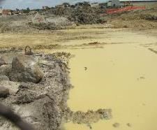
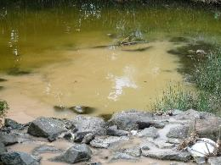
Poor site management results in sediment laden stormwater making its way into creeks impacting on riparian habitats.

Existing planning controls primarily consider the neighbourhood character value of vegetation, while local laws currently provide assistance in protecting larger trees and managing construction impacts on Council land.
Given the majority of Council’s natural areas exist along waterways, where Council is often also the land owner, these areas provide our greatest opportunity for influence. Whilst the Environmental Significance Overlay (ESO) within the Moreland Planning Scheme has the potential to improve biodiversity on private land along these waterways, the need for a review is recognised in the actions to this Nature Plan. The Discussion Paper Protecting the Waterways of the West (2018) highlights the role of planning controls to protect landscape character and amenity along waterways and identifies a need to review provisions along the Moonee Ponds Creek (amongst other waterways). In addition, while there are ESOs along most of the waterways in Moreland, they have generally been in place for over 30 years, and a review of their objectives and effectiveness is warranted.
Clause 22.08 Environmental Sustainable Development (ESD) in the Moreland Planning Scheme provides a framework for consideration of environmental sustainability at the building design stage. It includes objectives for a range of environmental considerations including stormwater management and urban ecology. However, it has been found that stated urban ecology objectives have not been overly effective in achieving habitat and biodiversity outcomes. Clause 22.08 is currently being reviewed and Council is actively preparing a justification and research basis to progress towards a Planning Scheme Amendment for a new local ESD Policy in the next two years. New ‘Urban Ecology’ objectives are part of this review.

Traditional owners – Caring for country
‘Country’ is the term used by Aboriginal people to describe their home – the land, water, air, natural systems, living things and stories that make up a place (City of Melbourne 2017). The relationship between people and Country is one of symbiosis, if people care for the environment, the country will in turn care for them. Unlike western notions, Country is not ‘owned’ but rather it is cared for by its people as custodians. Through ‘Caring for Country’ for thousands of years, Aboriginal communities have been meeting the needs of the present whilst ensuring future generations can also meet their own needs. Contemporary land managers can learn from this approach.
An important first step in successfully integrating ‘Caring for Country’ in Moreland is to develop appropriate and meaningful partnerships with Traditional Owners, the Wurundjeri Tribe Council as the Registered Aboriginal Party in Moreland.
Council is developing a Statement of Commitment to Traditional Custodians as a way of formalising such a partnership. This includes (amongst others) commitments to work more collaboratively, protect cultural heritage sites,lead and promote community awareness raising and education initiatives which celebrate Aboriginal history, culture and achievements.
Engaging in cultural practices, such as traditional land management, on Country enables Wurundjeri people to maintain cultural connection and wellbeing. Cultural programs that involve the wider community, such as the annual Murnong Gathering Harvest Festival on the Merri Creek, are important opportunities to learn and celebrate Wurundjeri culture, lore, language and history.
A key aspiration of the Wurundjeri Council is to provide a holistic approach to working on Country. A Natural Resource Management (NRM) team, the Narrap Team, has been established to support this aspiration. Council, particularly through the MCMC, has been developing partnerships with the Narrap Team since the early stages of establishment, sharing information and undertaking activities, such as cultural burns in Councils reserves. Formalising the Statement of Commitment and developing morecollaborative relationships with the Wurundjeri Tribe Council, particularly the Narrap Team, are examples of opportunities that will be explored in the Nature Plan.
Murnong Gathering Harvest Festival
The traditional staple food of Aboriginal people of South East Australia, the Murnong (or Yam-Daisy) is now close to extinction on much of the grassy plains that spread across the northern and western districts. Murnong and other plants that are important to the Wurundjeri people, are part of a cultural land restoration project on the Merri Creek near Connolly Avenue, Coburg by the Merri-Murnong Group (local volunteers) in collaboration with the Wurundjeri Tribe Council.
Every year in November, the community celebrates the Murnong Gathering Harvest Festival and learns about and engages in Wurundjeri culture. Activities include a Welcome to Country by a Wurundjeri elder and other cultural practices, for example dance performance and stories. Of course, Murnong and other tubers cook-up and tasting are part of the experience.
The annual Murnong Harvest Festival is a good example of celebrating place, cultural traditions and traditional plants which also acknowledges the strength and significance of ongoing access to, and celebration of, land and country.
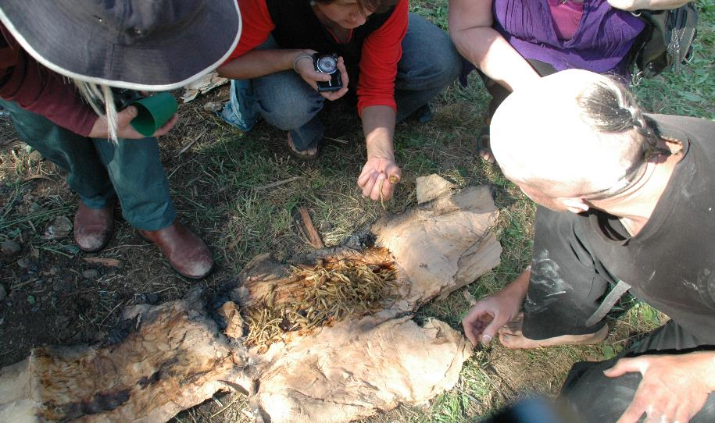
Cooking Murnong tubers in paperbark

From Moreland Urban Forest Strategy

Simplified landscapes – lack of diversity
Animals use landscapes in different ways. Some maybe so-called migrants, coming into the landscape at certain times of the year and others may spend their entire life on one plant. Some may seek the nectar of flowering plants whilst others require safe roosting areas in order to shelter and prey for food. Landscapes that provide a diversity in composition and structure therefore offer the greatest ecological value. Unfortunately, past management practices have seen our parks simplified, often trees over a mown grass layer following the desire for a clean, European style park landscape and ease of maintenance. These simplified landscapes have significant, usually detrimental, implications for biodiversity.
Landscapes that include tree, shrub and ground cover layers and a diverse range of species have the greatest potential to support habitat and restore natural processes. Dead trees, fallen branches, natural mulch and rocks are also important elements providing refuge habitat for reptiles and insects and supporting natural decay and nutrient recycling.
In recognition of this, revegetation programs, particularly over the past 15 years, have moved from simply planting trees to encompassing full ecological restoration incorporating a range of structural elements. As tree canopy is becoming more established in the City, it is through understorey planting and habitat replacement (rocks, logs, mulch) that offers the most opportunity. Artificial habitat, such as nest boxes and bee hotels, can be used to provide supplementary habitat in the absence of natural elements, and can provide an avenue for community involvement through their construction and monitoring.
The development of local seed plots (concentrated plantings for seed collection) and propagation programs for key species within Moreland will help establish a good supply of local provenance plant and genetic material, particularly for difficult to obtain or significant species.
Restoring understorey habitat at JP Fawkner Reserve, Oak Park
An area of parkland (approximately 0.7ha) along the Moonee Ponds Creek at the rear of JP Fawkner Reserve, Oak Park lay relatively unused. Whilst a good range of native trees had been established, it offered little understorey habitat value as a result of intensive mowing. Restoration works at the site offered significant potential particularly with its connection to Strathnaver Reserve grasslands just north of the site in the City of Moonee Valley.
In 2017 a change in management saw an end to mowing and commencement of targeted,seasonal weed control of problem weeds such as Chilean Needle Grass. Revegetation, particularly along the creek corridor, has been undertaken. Large scale direct seeding with indigenous grasses was completed in late 2019 to restore grassy woodland across much of the site.
Council has partnered with RMIT University to monitor insect and bird populations and behaviour changes resulting from the works.
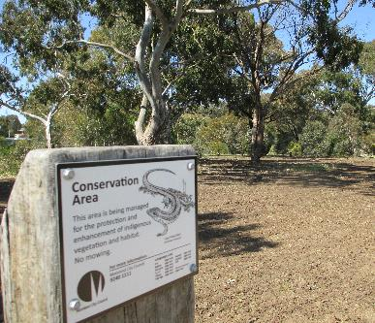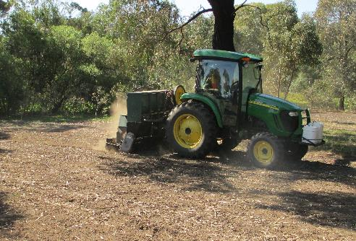

Looking small – making homes for pollinators
As discussed above in Section 3.3, conservation programs which focus on habitat for insects, particularly pollinator species, are key opportunities in urban areas such as Moreland. Due to insect pollinators’ relatively small functional requirements—habitat range, life cycle, and nesting behaviour—relative to larger mammals, pollinators put high‐priority and high‐impact urban conservation within reach (Hall et al 2016).
The greatest correlation to the health of pollinator populations is the presence of foraging sites, ie. the presence and diversity of flowers. The planting of pockets of diverse foraging species, flowering at different times of year, in conservation areas, nature strips, gardens and schools will contribute to conservation benefits both within the municipality and beyond.
The Friends of Merri Creeks/MCMC Lilies and Bees project in 2016-17 is a great example of a program targeted towards enhancing habitat for a pollinator species (in this case the Blue Banded Bee) to support conservation efforts of the critically endangered Matted Flax Lily (Dianella amoena) see inset below.
Increased flowering for foraging can also be achieved through modifications to mowing regimes. Research has shown strong evidence that intense mowing of urban lawns has negative ecological effects and that even modest modifications such as moving from a weekly to 3 weekly mow regime increases flowering in grassed areas by 250% (Lermann et al 2018). Differential mowing in parks, where mowing is reduced to allow flowering and seeding, could be applied in less utilised grass areas as supplementary habitat.
‘Lilies and Bees’: Matted Flax Lily Conservation project by Friends of Merri Creek and MCMC
This project aimed to increase the numbers and reproductive potential of the Matted Flax-lily, Dianella amoena, a Critically Endangered species found along the Merri Creek in Fawkner and Reservoir. Remnant plants are threatened by competition from weeds and population isolation, leading to genetic decline and low fertility.
Cross-pollination between the Matted Flax-lily plants requires a specialised ‘buzz-pollination’ that is carried out by native bees, in particular, the Blue-banded Bee, Amegilla sp. The foraging distance for these bees is estimated at approximately 300 metres. Based on this distance, the Matted Flax-lilies in Fawkner and Reservoir are fragmented into several much smaller disconnected populations. Habitat quality for the Blue-banded Bee was considered poor due to the lack of density and diversity of co-occurring wildflowers that the bee needs for nectar.
The ‘Lilies and Bees’ project targeted a number of on-ground actions to support the Blue Banded Bee population which, in turn, will assist the long-term sustainability of Matted Flax-lily. These included weed control, propagation and planting of Dianella and other wildflowers, trialling artificially made bee hotels and citizen science monitoring.
The unique project also gained the attention of the community, involving a crowd-funding campaign supported by 441 people, raising over $25,000 towards the project.
Source: MCMC website https://www.mcmc.org.au/29-front-page/front-page-blurb/547-help-the-blue-banded-bee
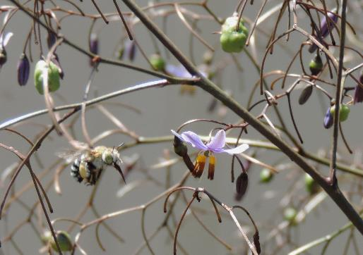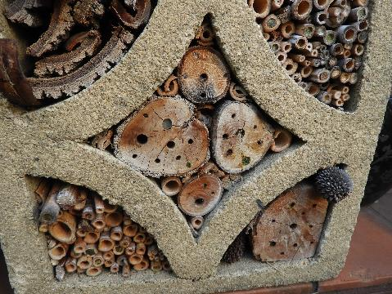
Combining research into insect presence and behaviour change as a result of greening programs, in partnership with community and research organisations, will improve understanding on this emerging topic and help shape future conservation programs.
Blue banded bee flying into inspect a Dianella flower and an example of a bee hotel (photos. A. Lanigan)

Community partnerships
Moreland is fortunate to have a long history of active community groups undertaking greening activities. The Friends of Merri Creek and (then) Pascoe Vale Naturalists Group were early pioneers in planting trees and restoring waterway landscapes in Melbourne. The legacy of four decades of tree plantings have provided the backbone to today’s restoration programs and many people who are new to the area would not recognise the majority of vegetation as planted.
Over the years, new groups have emerged, each with their own focus. There are now 24 highly active groups working in Moreland (see Appendix 2). The types of activities these groups undertake range from revegetation along habitat corridors, supporting home gardeners to establish wildlife friendly spaces, establishing local productive community gardens and ecoart initiatives. The contribution of these groups and their many volunteers to the local environment and social cohesion cannot be overstated.
Community groups foster custodianship and care for the local environment. They also offer opportunities for increased investment into conservation programs through accessing grants, volunteer labour, corporate partnerships and community donations (eg Merri Creek Environment Fund).
For example, over their 14 year life, Friends of Edgars Creek has attracted and expended over $360,000 in external grant funding plus enabled other organisations, such as Greening Australia and Satterley Property Group, to contribute equivalent additional funds into the development of the Edgars Creek Corridor. This has equated to the delivery of environmental improvement projects along Edgars Creek valued at over $1.4 million, in addition to and over and above the Council’s open space budget (pers comm S. Northey 2020).
A key action of Councils Urban Forest Strategy (UFS) 2017-2027 is to work closely with community groups and residents to support greening initiatives while fostering positive community attitudes towards the urban forest. Council currently provides support through:
- Materials support: plants, tools, tree guards, weed mats, mulch etc.
- Site preparation and weed control
- Professional advice
- Promotion on-line
- Use of venues
- Coordination of events
- Networking opportunities
- Grant application support
- Auspicing through Council-funded programs eg Neighbourhood Houses

With the increase in groups and activity, particularly over the past 10 years, the demand on Councils resources currently outstrips availability and expansion of this program is warranted.

Community nature engagement activities
People value what they know and understand. To foster positive community attitudes towards nature, further investment in nature education and connection programs, particularly targeting new and diverse audiences will have both environmental and wellbeing outcomes.
Immersive and interactive activities that support a greater understanding of the local environment, such as wild ‘safaris’, wildlife demonstrations, adult education programs such as Nature Stewards, and EcoArt programs, offer an opportunity to engage with wider audiences beyond traditional planting days and to support a number of the social benefits outlined in section 3.2.
Locally focussed education material, including web-based information and printed materials, such as the Friends of Merri Creek , brochure on common birds of Merri Creek and northern Melbourne, are great resources for residents, schools and community groups in getting to know their local environment. These engagement programs also lead to greater participation in community group activities and citizen science programs, such as iNaturalist, which contribute to a wider knowledge of the local and wider environments.

Habitat streets and gardens
Encouraging residents to establish and maintain indigenous plantings in private gardens and in nature strips offers a significant opportunity to increase biodiversity in the City and showcase indigenous plants.
Council currently provides a number of support programs including the provision of the Sustainable Gardening in Moreland booklet, free mulch collection point at the Hadfield Operations Centre, nature-strip guidelines which encourage the use of indigenous plants and assistance for some community groups.
Council supported a community driven ‘Adopt a tree’ pilot program in 2011-12 which was largely funded by a State Government grant. The program converted grassed nature strips and green spaces into native gardens to create a biodiversity corridor from Merri to Moonee Ponds Creek in Brunswick. The successful program engaged with a large number of volunteers and led to the establishment of the Brunswick Communities for Nature (BC4N) group. BC4N continue to undertake planting, propagation, and educational activities and have an informative website.
A number of Councils across Victoria have established a Gardens for Wildlife program in their municipality to support residents, schools and businesses in caring for the local environment. The Gardens for Wildlife program is designed to be a flexible model which is developed by local Councils in partnership with community and tailored to that community.
An online Facebook group, ‘Creating Gardens for Wildlife in Moreland’ established in 2019 and now has over 500 followers. There is opportunity for Council to build upon the great work and success of local community groups, such as BC4N and the Gardens for Wildlife Facebook group, to tailor a program for Moreland residents which supports the uptake of wildlife gardening and development of streetscapes for nature, particularly along designated habitat corridors.

Nature in Schools
There is growing scientific evidence that schoolyards which contain nature have significant benefits for children’s development. Research conducted through the Children and Nature Network in 2016 identified ‘green schoolyards’ support enhanced learning, more imaginative and cooperative play, increased physical exercise and ability; and improved feelings of well-being. Longitudinal studies also suggest that nature-rich schools can help improve academic performance and raise standardised test scores.
Many of Moreland’s schools, particularly at the Primary level, engage in environmental and nature-based studies as well as undertake greening activities within school grounds. Schools can provide valuable pockets of greenery to provide important ‘stepping stone’ habitats as part of the wider habitat network.
Our local parks and waterways are also invaluable educational resources and immersive and interactive activities in these spaces can enhance feelings of community belonging as well as encourage an appreciation of the local environment. Programs such as Bush Kinder and Playgroups which immerse young children in nature are becoming more and more popular as parents seek alternatives to the more traditional indoor preschool activities.
Council currently supports a number of educational and support programs:
- Participation in Schools National Tree Day (direct engagement with a small number of schools and provision of plants and mulch for school plantings)
- Funding support to Merri Creek Management Committees Waterwatch and Catchment Education Programs
- Funding support to CERES to facilitate the Resource Smart Schools program
- Supporting Birdlife Australia’s Birds in Schools program
- Resourcing and supporting Early Childhood Education and Care services to implement Bush Kinder programs
- Delivering an annual Nature Play Week event
Requests for these programs will continue to increase as awareness around the benefits are more recognised. Current resource allocations for school programs are already falling short of demand. An expansion of this program would allow a wider range of schools and greater number of students to participate on an annual basis.
The development of programs that can be self-directed/led should also be a priority in upcoming years. The Moonee Ponds Creek Crusaders: Teachers Water Education Manual (produced by MCMC) includes an information and activity pack which is a good example of self-led programs for various age groups that can be better promoted and delivered in Moreland parks.

Productive gardens
Productive gardens, both in the home and community gardens, are another important avenue for connecting people to nature.
CERES Environment Park and Joes Community Garden along the Merri Creek are evidence that community gardens have the capacity to activate spaces, connect communities to nature, promote biodiversity and empower individuals in the home. These places also recognise part of Merri Creeks history which included expansive market gardens post colonisation, utilising the rich basalt soils for fruit and vegetable crops.
Urban food-growing and biodiversity conservation and enhancement can be complementary, not competing, objectives. Through regenerating under-utilised land, urban food growing spaces can contribute to a diverse, connected and resilient natural environment by improving diversity and quantity of flora, fauna and improved soils with thriving microbiota; and providing ecosystem services such as pollination, natural pest control, and climate regulation (Lin et al 2015).
Food growing on public land is best reserved to places where it can contribute most effectively to increasing biodiversity - such as sites of lower conservation and habitat value. Where there are large expanses of underutilised open space, such as along the Merri Creek in Fawkner, productive/community gardens can help to increase biodiversity and community activation provided they are located and managed to avoid any impact on conservation activity, from weed escapees for example.
The Moreland Food System Strategy is Councils key document in supporting productive gardening and the establishment and management of community gardens. However, there is a key opportunity in edible indigenous gardens where nature and food systems align. Community and productive gardens offer an opportunity to grow and show-case indigenous food plants and have potential to act as seed orchards for wider landscape plantings. This has been raised in discussions with garden managers at both Joes Community Garden and Fawkner Food Bowls as well as the potential to incorporate local wetland projects and alternative water sources for community garden projects.

Activation of natural spaces
Although research provides evidence that time in nature is good for health and well-being, there can be a level of apprehension preventing people enjoying these spaces. There are many aspects of natural areas that can be attributed to this:
- feelings of isolation and seclusion from the urban environment (some value this aspect and others find it scary)
- fear of wildlife, such as snakes and spiders
- lack of lighting at night
- mid-storey vegetation impacting on visibility through the landscape
- fear of the unknown, particularly for new migrants who maybe experiencing the Australian environment for the first time
- historic use of isolated and underutilised areas for crime and vandalism, such as rubbish dumping and physical attacks.
Helping people to feel safe and enjoy natural areas is important for Council as land managers. Crime Prevention Through Environmental Design or "CPTED" (pronounced sep-ted) is an approach to crime prevention that considers the relationship between the physical environment and the users of that environment. The theory behind CPTED is that the design of a physical environment can produce behavioural effects that will reduce both the incidence and fear of crime. These behavioural effects can be accomplished by reducing the susceptibility of the environment to support criminal behaviour (Victoria Police 2015).
There are a range of opportunities for implementing CPTED principles in natural areas, but some key concepts include providing safe opportunities that increase activation (such as path networks), encouraging passive surveillance through development and improved visibility by balancing potential conflicts between sightlines and landscape values. Improved wayfinding signage, the provision of regular access points and emergency markers can help to guide, particularly new park users, to known landmarks and provide a greater sense of place. An audit of the Merri Creek Trail was completed in 2013 with a number of actions, such as new underpasses and bridges, wayfinding signage, vegetation management and emergency markers implemented as a result of the review and are continuing with annual budgets.
Other examples of increasing activation in a sympathetic way include Joe’s Market Garden in East Coburg and Kirkdale playground in East Brunswick. Joe’s Market Garden is the longest continuously operating market garden in Melbourne (over 150 years). It’s location along the Merri Creek provides an attraction point but also offers pollination and pest control benefits from its close location to natural habitats.
Lighting in parks is often suggested as a solution for crime in parks, particularly in somewhat isolated areas such as creek corridors. As outlined in Councils Public Lighting Policy 2018, providing light within these areas does not always solve, and in some cases, increases illegal activity, particularly where there is no or little public surveillance. Lighting such areas can give people a false sense of security rather than actually improving their safety.
Increasing human activity in natural spaces also has the potential to negatively impact on environmental values and conflict can arise between more passive and active uses (eg between fast moving cyclists and pedestrians). Developing ‘activation’ or park master plans, which identify and map areas for development (including new paths, playgrounds, revegetation areas) for key open spaces and balance potentially competing values will help to reduce future conflicts. Newly purchased land, such as sites in Leonard St and McBryde Street (Fawkner), Outlook Drive (Glenroy) and Spry Street (Coburg North) are priority areas for developing such plans for both amenity and conservation improvements.

Fire – friend or foe?
Fire has long been a natural element in Australia’s landscape but its place in the urban environment is complex. Fire regimes implemented by Traditional Owners maintained plant diversity in the vast grasslands across much of Victoria’s south west for tens of thousands of years. In the absence of fire, particular grass species become dominant, out competing less vigorous plants such as wildflowers which are not only attractive but provide vital ecosystem services such as nectar for birds and insects. Fire also removes biomass (dried grass and debris), reducing fuel loads and rejuvenating fresh growth on grassland species.
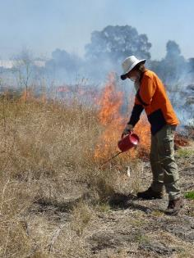
With partners Merri Creek Management Committee, fire has been safely used as a management tool in Moreland’s grasslands both for managing weeds and increasing plant diversity for many years. Through greater partnerships with the Wurundjeri Tribe Council’s Narrap Team in recent years, a greater understanding of cultural burning practices, particularly the implementation of cool burning regimes is being achieved.
With increased pressure to reduce a reliance on chemical weed control, there is opportunity for Council to support partnerships with the Wurundjeri Tribe Council and MCMC and other delivery partners to greater understand and integrate traditional land management practices such as burning. With natural areas abutting residential areas and climate change predicted to increase extreme weather events, the potential and risks associated with uncontrolled fire in the landscape requires careful management. Council commissioned an investigation into fuel hazards along waterway corridors (Terramatrix 2014). Key recommendations included maintenance of designated asset protection zones and clear access for emergency vehicles into and along open space orridors. These findings are incorporated into park planning and maintenance programs and a 10-year review of the investigation is recommended as part of this Plan.
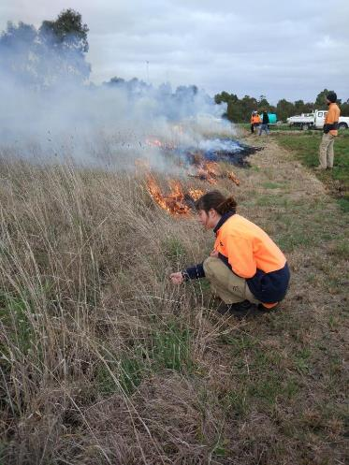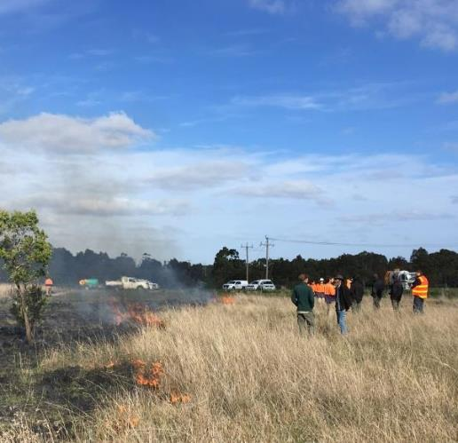
Cultural burning at Bababi Djinanang
Under the guidance of Wurundjeri Elder, Uncle Dave Wandin, the Wurundjeri Woi worrung Narrap Team partnered with Merri Creek Management Committee (MCMC) in a cool burn at Bababi Djinanang Grassland, Fawkner. MCMC is employed as one of Council’s bushland contractors to maintain and restore natural vegetation in Moreland.
Cool burns, also known as cultural burns, are conducted using traditional indigenous land management techniques. They differ from the usual ecological burns, which are commonly done in mid to late autumn and which are hot and fast moving, largely due to dried out vegetation.
In contrast, cool burns are done following heavy rains, when the soil is wet and lots of green vegetation has sprouted. The cool fire moves slowly and burns a patchy mosaic, giving wildlife time to move to safe ground. The low fire intensity and moist ground conditions mean that only dead plant material is burnt leaving the green shoots of plants. Grassland species can then regenerate in the spaces opened by the fire. Cool burning offers a safer method to maintain grassland values close to urban development.

Domestic dogs and cats can threaten wildlife and disturb habitats
Dog walking is a very popular use of parks and creek corridors and many of these areas are designated dog off leash zones. While waterbirds and fledglings leaving the nest are particularly at risk of dog attack, the physical presence and smell that dogs leave can disturb all birds and other animals.
Council’s Local Law prohibits dogs entering waterways, and yet many dogs readily access the creeks and sensitive habitats and are causing erosion issues in high use zones. In the urban context and with an expected warmer environment, it is likely that this demand, and in turn, impact will only increase.
Strict enforcement of the Local Law is likely to be expensive and poorly received by many in the community and finding a balance that supports interaction with water and manages the impact is a preferred option for Council. The designation of ‘dog access areas’ which can be purposely located, designed and managed could help to contain the problem. More sensitive habitats can be protected through pedestrian only fencing, signs and appropriate enforcement to allow safe refuge for birds and animals away from dogs.
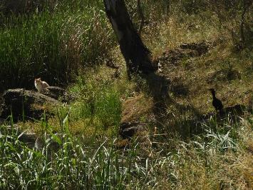
Cats (both stray and registered animals) express their hunting instinct by threatening and killing native birds, lizards and other wildlife. Around 46% of Australia’s endangered wildlife can be found in towns and cities which highlights the importance of protection from predation in these areas (Ives et al 2015).
Council is a supporter of the Safe Cat, Safe Wildlife Campaign, a joint initiative between Zoos Victoria and RSPCA Victoria. Cats should be kept indoors at night and preferably confined to the property at all times both for the cat's welfare, to prevent nuisance problems (for instance, trespassing/spraying on private property) occurring and to protect native wildlife. Some Councils have taken an additional step and established cat curfews as part of Local Laws to require cats to be contained, particularly at night, and this could be investigated in Moreland.
The importance and role of responsible pet ownership in protecting the natural environment can be continually reiterated through Councils annual animal registration program and as part of community education programs.

Pest animals
Pest animals, particularly rabbits, foxes and Indian Mynas, can have a significant impact on biodiversity.
Rabbits cause destruction through burrowing and grazing, particularly on young and sensitive species such as wildflowers. Given its urban context, Moreland is fortunate to have only relatively small populations of rabbits, located mostly in Fawkner and Coburg North. These populations, and the impacts from them on conservation programs, have been manageable using non-chemical approaches such as ferreting, netting and dogging on an annual basis.
Control of Indian Mynas and foxes is much more problematic in the urban environment. Both pests are territorial in nature, with new populations quickly recolonising after any control program and as such, small scale control programs are relatively futile. Control options for foxes are limited as shooting and baiting programs are not permitted in urban areas due to off-target risks. Fumigation of dens is possible, where locatable, but most foxes in cities live under buildings and in neglected areas.
Some Councils have begun supporting community led programs to trap and euthanise Indian Mynas. However, the RSPCA does not currently support these programs (RSPCA website). Preference is given to providing more favourable habitat for native species, such as planting understorey as Indian Mynas prefer open, mown parkland. Foxes and Indian Mynas can further be discouraged through removing food sources, ie closed compost heaps, removing uneaten pet food and not feeding the birds. Educational programs using Councils website and social media can help to increase awareness this issue.

Artificial lighting
Artificial lighting impacts on habitat values, particularly for bats and invertebrate species, disrupting their behaviours of which serve critical ecosystem functions as pollinators and as food sources for larger animals. Many invertebrates depend on the natural rhythms of day-night and seasonal and lunar changes to light levels. As a result, artificial lighting has several negative impacts on a wide range of invertebrates including disrupting their feeding, breeding and movement which may reduce and fragment populations (Bruce-White et al 2011).
Councils Public Lighting Policy (2018) provides for the design, installation, maintenance and application of public lighting throughout the city. It aims to improve public safety, provide equity of lighting across the municipality, and ensure that public lighting meets community expectations for illumination performance, while minimising operating costs and environmental impacts.
The minimum Moreland standard for lighting in streetscapes in the policy is for alignment with Australian Standards AS1158. The policy recognises that artificial lighting can have an impact on wildlife and notes in standards for lighting in open space ‘Where the habitat value of a park is the predominant attribute of the park (often known as habitat open space), the potential impacts on native wildlife are to be considered as the primary reason against the need for lighting. The design, location and level of illumination of new public lighting in parks should be chosen to minimise impacts on trees and wildlife.’
The Lighting Policy was adopted in 2018 but since then, the Commonwealth Government has released a set of guidelines to help reduce the impacts of light pollution. These guidelines should be referred to in the review of the Public Lighting Policy which is due in 2023.

Working better together
In its urban context, Moreland’s natural spaces are more than just areas for conservation. Collaborative management with key stakeholders both within and outside the organisation will be critical to the success of this Nature Plan. These include adjoining municipalities, Melbourne Water, the Department of Environment Water Land and Planning (DELWP) and local community organisations.
Moreland has been a member and funding supporter of both the Merri Creek Management Committee (MCMC) and Moonee Ponds Creek Coordinating Committee, more recently replaced by the Chain of Ponds Collaboration, ) since their foundation. These groups provide an important opportunity for community input into governance of local waterways, provide for continual dialogue and coordination between organisations and offer opportunity for advocacy and action on upstream issues that impact on the Moreland section of waterways.
There is a key opportunity with this Plan to review the services provided by waterway and open space land managers both within Council Operations and with other key land managers, such as Melbourne Water, particularly along waterway corridors to improve efficiencies and identify any gaps in service.
Melbourne Water has begun developing Integrated Service Plans (ISPs) with a number of Councils and advocacy for the development of an ISP for Moreland will be a short-term action of the Nature Plan based on the findings of the review. A business case will be developed for any gaps in Councils service, benchmarked across other Councils and in consideration of future needs.
Working better together also means seeking and being more innovative with other public and private stakeholders, such as Conservation Volunteers Australia, Landcare and Corrections Victoria. Council has, in the past sought these opportunities with considerable success and can be an effective way in increasing resourcing into Councils programs as well as offering educational and employment opportunity.

Sufficient resourcing and preparing for future demand
As we continue to restore the landscape, areas managed for conservation are expanding on an annual basis. The past 10 years have experienced a significant expansion (50%), largely due to the initiation and greater activity of individual Friends groups and the annual investment in capital programs through large scale weed control and revegetation programs by Council and Melbourne Water.
The maintenance and renewal requirements of Council’s grey assets, such as buildings and roads, are currently captured and managed through Council’s Asset Management System. However, our natural or green assets, such as trees and vegetation and natural open spaces are not currently recognised and managed in the same way. A short fall between an expanding asset base and resources continues to grow, impacting on quality of service.
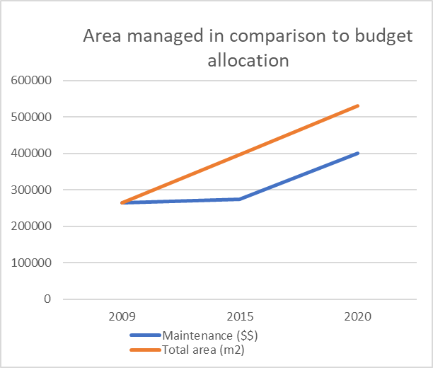
Council has made incremental increases in budget allocation towards maintenance of NRM areas over the past 5 years to help address this gap. This graph shows the trends of NRM area and maintenance funding over the past 10 years and that investment currently trends with the expansion of areas, largely as a result of recent additional investment. Determining a process which recognises green assets as part of Councils Asset Management System and planning for future maintenance needs will help to manage this shortfall.
The demand on staffing resources have also increased with this expansion of area and community interest in nature engagement activities but current staff levels have remained stagnant at 1 Effective Full Time (EFT) position. This includes management of contracts, collaboration with stakeholders, support to community groups, community engagement activities and delivery of capital programs along waterways.
The employment of a second position, a Conservation Programs Officer, will be required if Council is to effectively deliver this Nature Plan with key responsibilities including planning, strategic projects, community support and nature engagement activities allowing the existing Natural Resource Management Officers role to focus on on-ground delivery and contract management.

Monitoring for success
With any Council expenditure, having a program that measures the effectiveness of interventions in achieving the desired targets and which supports adaptive management decisions, makes good business sense. Currently, other than recording the amount of new area revegetated and number of plants installed, little information about the positive changes to our biodiversity is regularly recorded by Council.
Water quality monitoring is undertaken as part of the Waterwatch program with schools and community groups, but this is not necessarily targeted towards understanding the impacts of interventions and/or effectively analysed to influence decision making. This is similar fauna surveys, such as the quarterly birdwatch monitoring undertaken by Friends Groups and frog census whereby data is rarely collated and analysed in any detail.
There are now environmental monitoring programs, such as iNaturalist and Fungimap, which work as mobile Apps and tap into citizen science to collate ecological data and feed into the Victorian Biodiversity Atlas dataset. These create a great platform for Council to establish an effective monitoring program in partnership with community and stakeholders and will be used to establish some baseline data for monitoring outcomes for the natural environment in conjunction with annual output measures outlined in 9.0.

Research and adaptive practice
There are a number of research organisations, such as RMIT’s Clean Air and Urban Landscapes Hub and Melbourne University’s Urban Biodiversity, Ecology and Conservation Research Group whose research aims to better understand the impact of urban environments on biodiversity and to design practical improvements to the way our cities are designed and managed. Working in closer partnership with these organisations will provide Council with the latest evidence base and provide research organisations with meaningful and applied research opportunities.

PART 2 - ACTION PLAN

Implementation of the Action Plan is grouped into four themes:
- Protecting and enhancing biodiversity on Council managed land
- Seeking opportunities for the private realm to contribute positively to biodiversity
- Connecting people to nature
- Improving governance and collaboration in natural resource management
These themes and associated actions have been developed based on a set of guiding principles towards achieving the stated vision below.
The Action Plan identifies clear projects for either the establishment and/or delivery within a four-year period and identifies ongoing actions which are considered to be part of Council’s core service in open space/natural resource management with expectations to be delivered for the next 10 years and beyond.
Projects in the Action Plan are identified as either approved or proposed. Approved projects will be delivered within existing annual capital and operational budget allocations. Proposed projects will require external grants, additional funding or resource commitments.

Moreland Nature Plan Vision
Moreland will have a more diverse, connected and resilient natural environment where indigenous plant and animals thrive in a challenging and changing environment. Through fostering strong partnerships, Council supports its community to treasure the local environment by providing opportunities to discover, connect and care for nature.

Guiding principles
Out of the many matters and issues raised in Part 1 of this Plan – Background and Technical Report, a set of guiding principles has been developed to achieve this vision.
Healthy environments are critical to the health and wellbeing of our community  Natural ecosystems provide a range of environmental services that are critically important to liveability such as air purification, cooling, pollination and pest control and carbon sequestration. There is also growing evidence in the importance of human connection to nature for mental and physical health. | Conservation activity can be integrated with other uses of open space  The demand for and on open space in Moreland is only set to grow as our population increases. Sensitively activating areas around conservation zones can assist in the protection of these spaces through increased appreciation of their values and reduced negative impacts such as vandalism. Conservation activity can also be integrated into other open space, such as in schools and other parks providing multiple benefits.
Biodiversity is worth protecting for its intrinsic value alone  It is widely recognised that biodiversity (the diversity of all life forms that comprise natural ecosystems) has value in its own right, beyond the services or usefulness it provides to humans. Moreland contains some of Australia’s most endangered ecosystems and pro-active protection is required if we are to secure these ecosystems, and the services they provide.  Conservation programs are not short term, they require dedicated long-term commitment. | Quality habitat involves more than just vegetation cover  Healthy ecosystems involve a complex of structural, genetic and species diversity (plant, animal and microbiota) ane their interrelationships serving a range of functions. Revegetation should be more than simply planting trees. Restoring ecosystems involves other factors such as retention of fallen timber, rocks, diverse mid- and understorey planting and re-introduction of key species. The way in which these ecosystems are connected through the landscape, both within the municipality and beyond, also impacts on their success.
People protect what they value  Providing positive opportunities for people to experience, learn about and connect with nature helps to foster an appreciation of the local environment and for the importance of biodiversity protection more broadly. | Prioritise action according to impact  With competing demands on resources and funding, actions must be prioritised according to impact. Weighing up where to expend limited resources requires consideration of a sites biodiversity and/or cultural significance, current condition, connectivity in the landscape, potential for improvement and community commitment and/or expectation.
Council cannot work alone  With creek corridors forming much of the municipality’s boundaries, there is complex land ownership and management in relation to our natural assets. Moreland has a long history of community advocacy and activation in greening activities. Inclusion, empowerment and support for these groups and collaboration with all our stakeholders will help drive the success of this Plan. | Urban conservation programs must consider the impacts of land use change Land use change since European settlement has impacted on the natural environment through land clearing, changed water regimes and introduction of non-native plants and animals to name just a few. It is unrealistic to expect to restore the original landscape but rather to see a modified natural landscape that protects and enhances significant vegetation and builds a network of viable habitats and populations across the municipality.

Strategic context
Whilst this is the first dedicated plan for biodiversity for Moreland, there are a number of existing international, national, state and regional policies and strategies which relate to biodiversity and provide context for this Plan.
International

United Nations Convention on Biological Diversity in 1992 | Australia is one of 150 governments that signed up to the United Nations Convention on Biological Diversity in 1992. The Convention is dedicated to promoting sustainable development and recognizes that biological diversity is about more than plants, animals and micro-organisms and their ecosystems – it is about people and our need for food security, medicines, fresh air and water, shelter, and a clean and healthy environment in which to live.  Under the Convention, governments undertake to conserve and sustainably use biodiversity and are required to develop national biodiversity strategies and action plans, and to integrate these into broader national plans for environment and development.  For Australia, this has led to the development of environmental legislation, the Environment Protection and Biodiversity Conservation Act 1999 (the EPBC Act) and the Strategy for Nature 2019-2030 discussed below.
National
Environment Protection and Biodiversity Conservation Act 1999 (the EPBC Act) | Australian Government’s central piece of environmental legislation and provides a framework for the protection of biodiversity. It identifies species of national significance which includes communities and species that exist within Moreland such as Temperate Grasslands of the Volcanic Plains and legislates their protection.
Australia’s Strategy for Nature 2019-2030 | Overarching framework for all national, state and territory and local strategies, legislation, policies and actions that target nature. It includes three priority goals:  - Connect all Australians with nature  - Care for nature in all its diversity  - Share and build knowledge  which all strongly align with the focus areas in the Moreland Nature Plan.
State and regional
Protecting Victoria’s Environment - Biodiversity 2037 | Victorian Governments plan to stop the decline of Victoria’s biodiversity and achieve overall biodiversity improvement over the next 20 years. Its vision is that ‘Victoria’s biodiversity is health, valued and cared for’ and includes targets for connecting all Victorians with nature and ensuring there is a net improvement in the health of the environment.
Invasive Plants and Animals Framework | The Invasive Plants and Animals Policy Framework (IPAPF) presents the overarching Victorian Government approach to the management of existing and potential invasive species. This framework uses a biosecurity approach to managing pest plant and animal species using a four stepped process: prevent the entry of new high risk invasive species, eradicate those that are at an early stage of establishment, contain where possible species that are beyond eradication, and take an impact reduction approach to managing widespread invasive species.
Melbourne Waters Healthy Waterways Strategy 2018-28 | Identifies a collaborative approach to waterway management with objectives and actions for improving the health of Melbourne waterways shared across state and local government, water corporations and the community. It identifies a number of priorities for sub-catchments such as Merri and Moonee Ponds Creeks including revegetation and amenity improvement targets.
Merri Creek Environs Strategy | Provides an overview of important issues along the waterway corridors of the Merri Creek and its tributaries and documents agreed objectives, targets and actions to achieve their resolution. Moreland Council is a member of the Merri Creek Management Committee who oversees the delivery of this strategy. It includes strategic and site specific actions which provide context for the Nature Plan.
Chain of Ponds Plan | This cross-jurisdictional plan was developed in partnership with Moonee Valley Council and reimagines the Moonee Ponds Creek as a healthy, vibrant destination which supports native plants and animals, provides green space for leisure and recreation, and helps prevent flooding. It includes a range of stormwater management, ecological, social and economical goals for the Moonee Ponds Creek which have been considered in the development of this Nature Plan.

Council Framework for Moreland Nature Plan
Long-term Community Vision
(to be developed)

2017 to 2021 Council Plan
Moreland Planning Scheme
Health and Wellbeing Plan

Open Space Strategy
Urban Forest Strategy
Integrated Water Management Strategy

Parks Close to Home
Nature Plan
Food Systems Strategy

Chain of Ponds Plan
Edgars Creek Conservation & Development Plan
Westbreen Creek Conservation & Development Plan
Merri Creek Environs Strategy
Merlynston Linear Park Plan

Council

Council Plan 2017-21 and Health and Wellbeing Plan | This Nature Plan has been developed in line with the Council’s Strategic Objectives for a Connected Community, Progressive City and Responsible Council (Council Plan 2017-21). It identifies priority actions to encourage greater connection to nature and delivers on the goal for a ‘cooler, greener and more sustainable city’ stated in the Municipal Public Health and Wellbeing Plan 2017-21.
Moreland Planning Scheme | The Moreland Planning Scheme recognises and seeks to protect biodiversity though a number of Clauses:  - Strategic Framework Clause 21.03-6 Open Space Network Objective 16 “To protect the biodiversity, amenity and recreational values of the open space network (identified)’ and a number of particularly relevant strategies, including:  - 16.5 Ensure development protects and enhances areas of remnant vegetation and indigenous revegetation as identified in the Moreland Open Space Strategy 2012-2022.  - 16.5 Ensure development does not compromise the ecological integrity of the Merri, Moonee Ponds, Edgars, Westbreen and Merlynston Creek corridors.  - 16.6 Create a continuous public open space corridor with a minimum of 50 metres on each side along the Moonee Ponds, Merri and Edgars Creeks. A minimum of 30 metres from the edge of the embankment on each side should be a vegetated buffer.  Environmental Significance Overlay Clause 42.01 over waterway corridors - These overlays recognise the environmental, heritage and recreational values of these corridors and identify a number of objectives to be achieved including protection and restoration of natural systems, waterway function, recreation use, landscape character and heritage (aboriginal and geological).Environmental Sustainable Development Clause 22:08: provides a framework for early consideration of environmental sustainability at the building design stage and includes objectives for a range of considerations including stormwater management and urban ecology.
Urban Forest and Open Space Strategies | Council’s Open Space Strategy 2012-22 and Urban Forest Strategy 2017-27 both recognise the importance of biodiversity as a significant element in Council’s open space network and in creating a greener, more liveable city.
Reserve Plans | Reserve plans, such as the Gowanbrae Development and Maintenance Plan and the Westbreen and Edgars Creek Conservation and Development Plans provide localised recommendations for revegetation and biodiversity protection which form part of previous and future planned works.

Implementation Plan

Theme 1: Protect and enhance biodiversity on Council managed land
Context | Strategic Direction
As the largest public land manager, Council will manage its land to not only protect, but enhance, its natural assets to build biodiversity value and to strengthen resilience to climate change. | To strategically plan and deliver natural resource management programs that protect and enhance significant vegetation and habitat, reduce the impact of threatening processes, expand indigenous revegetation and contribute to a stronger, more connected ecological landscape.

Action # | Implementation action | Timeframe | Budget | Once off/  Ongoing | Approved | Proposed | Funding source
1.1 | Develop a habitat connectivity and revegetation plan for the municipality based on the habitat requirements of key representative species and including streetscapes, schools and other open space. | 2020-2021 | $20,000 | Once off | X |  | Existing
1.2 | Continue to implement site management plans for key conservation sites such as Bababi Djinanang grassland, Lynch Road grassland, Newlands Hill Remnant and Union Street escarpment. | Ongoing | $100,000 | ongoing | X |  | Existing
1.3 | Develop and begin implementing a management plan for the newly acquired grassland areas at Leonard Street, Fawkner. | 2020-2021 | $10,000 | Once off | X |  | Existing
1.4 | Continue maintenance, regeneration and renewal of conservation areas through intensive weed management, ecological burning, fencing, pest animal control and enhancement planting. Develop seed lots and propagation programs for significant species as part of these programs. | Ongoing | $450,000 | ongoing | X |  | Existing and grants
1.5 | Expand the staged revegetation/ regeneration of conservation areas to provide buffers and improve connectivity, including those specifically identified in the Gowanbrae, Westbreen Creek and Edgars Creek Conservation and Development Plans. | ongoing | $100,000 | ongoing | X |  | Existing and grants
1.6 | Increase habitat diversity through incorporation of enriched understorey planting (particularly flowering plants) rocks and logs in restoration programs and consider artificial habitat opportunities (eg nest boxes, bee hotels) where appropriate | Ongoing | BAU | Ongoing | X |  | Existing and grants
1.7 | Continue to implement a range of weed control techniques and trial new technologies in maintenance programs to reduce reliance on chemical use. | ongoing | BAU | Ongoing | X |  | Existing
1.8 | Construct Gavin Park wetland as outlined in the Westbreen Creek Conservation and Development Plan. | 2020-2021 | $600,000 | Once-off | X |  | Existing and grants
1.9 | Continue to assess habitat value of trees during arboricultural activities, retaining stag trees and hollows where safe and appropriate to do so, particularly along habitat corridors. | ongoing | BAU | Ongoing | X |  | Existing
1.10 | Re-naturalise the historic Melville Creek corridor in Brunswick West (Fraser Reserve) through delivery of the WSUD opportunity outlined in the Moonee Ponds Creek Improvement Plan - Brunswick West. | 2021-2022 | 50,000 | Once-off | X |  | Existing and grants
1.11 | Design and construct a stormwater wetland within the Merri Creek parklands at Somerlayton Road, Fawkner. | 2022-2024 | $700,000 | Once-off | X |  | Existing and grants
1.12 | Contribute to the naturalisation of a concrete section of the Moonee Ponds Creek in Oak Park in partnership with the Victorian Government, Melbourne Water and Moonee Valley Council | 2021-2023 | $1M | Ongoing |  | X | Future business case
1.13 | Advocacy for the naturalisation of the concrete section of the Edgars Creek in Coburg North | Ongoing | BAU | Ongoing | X |  | Existing
1.14 | Trial the construction of designated dog ‘beaches’ at 3 locations to reduce erosion and water quality impacts from unregulated activity. | 2022-2023 | 30,000 | Once-off | X |  | Existing and grants
1.15 | Trial a differential mowing program regime in 3 parks across the municipality and monitor the effects on insect life and social/recreationalvalues | 2023-2024 | 10,000 | Once-off | X |  | Existing
1.16 | Readily respond to emerging threats to natural values, such as erosion hot spots and weed outbreaks, as they arise | ongoing | BAU | ongoing | X |  | Existing
1.17 | Undertake a review of land ownership and management along waterways and key habitat corridors to identify opportunities to improve connectivity for both habitat and public access. | 2022-2023 | 0* | Once-off |  | X | Future business case
1.18 | Review the Creek Reserves Fire Management Plan 2014 | 2023-2024 | 30,000 | Once-off | X |  | Existing
1.19 | Implement recommendations from Moreland’s Integrated Water Management Strategy (IWM) 2040, particularly Outcome area 4: Healthy Waterways, to reduce stormwater impacts on local waterways. | Ongoing | As per IWM 5 year Action Plan | Ongoing | X | X | As per IWM 5 year Action Plan
1.20 | Undertake a feasibility study and business case for creating an indigenous food garden at Edna Grove Coburg (alongside Joe’s Community Garden as part of a wetland and integrated stormwater project | 2020-2021 | $15,000 | Once-off | X |  | Existing and grants
1.21 | Support the establishment of an indigenous food garden at Fawkner Food Bowls | 2021-2022 | $15,000 | Once-off | X |  | Existing and grants
1.22 | Consider, and make reference to, the National Light Pollution Guidelines for Wildlife including Marine Turtles, Seabirds and Migratory Shorebirds in 2019 in a review of the Public Lighting Policy | 2021-2022 | BAU | Once-off | X |  | Existing
BAU = Business as usual processes

Theme 2: Seek opportunities for the private realm to contribute positively to biodiversity
Context | Strategic Direction
Land use change and urban development has the potential to impact biodiversity values in Moreland through loss of vegetation, changes to water regimes and domestic animal management to name just a few.  Council is responsible for ensuring development outcomes enhance natural values particularly adjacent to waterways and designated habitat corridors. | To implement planning and governance mechanisms that protect and enhance natural values on private land through incentives and other support programs that encourage the uptake of indigenous and wildlife gardening.

Action # | Implementation action | Timeframe | Budget | Once off/  Ongoing | Approved | Proposed
2.1 | Support the further establishment of a ‘Gardens for Wildlife’ program in Moreland in partnership with existing community programs. | 2021-2022 | 5,000* | Ongoing |  | X | Future business case and grants
2.2 | Continue to provide resources that support the uptake of indigenous gardening in Moreland such as the Sustainable Gardening in Moreland and Gardening with Indigenous Plants booklets and free bush mulch depots. | Ongoing | BAU | Ongoing | X |  | Existing
2.3 | Review and reprint the Sustainable Gardening in Moreland booklet (or similar) resource with reference to local fauna (including insect pollinators) and habitat gardening | 2023-2024 | 20,000 | Once off |  | X | Future business case
2.4 | Reinvigorate the ‘Adopt a tree’ (verge program) to support the uptake of nature strip conversions, particularly along designated habitat corridors | 2021-2022 | 10,000* | Ongoing |  | X | Future business case
2.5 | Undertake a review of planning control mechanisms for waterways in the municipality to strengthen the protection of significant vegetation and amenity values of these corridors, including interfaces with urban development. | 2020-2021 | $40,000 | Once-off | X |  | Existing
2.6 | Continue to influence the design of new developments through the Moreland Planning Scheme Clause 28: Environmental Sustainable Development in, particularly in relation to impacts on stormwater and urban ecology. | Ongoing | BAU | Ongoing | X |  | Existing
2.7 | Continue to regulate private use of Council land using Open Space Temporary Occupancy Permits (OSTOP) during construction activities to minimise biodiversity impacts/pressures and reinvest income to improve biodiversity. | Ongoing | BAU | Ongoing | X |  | Existing
2.8 | Update Councils website and responsible pet ownership information to include more information about the impacts on wildlife and protection measures | 2020-  2021 | BAU | ongoing | X |  | Existing
2.9 | Undertake an investigation into the cost implications and effectiveness of a cat curfew in Moreland and consider the adoption of a cat curfew in the 2022/26 Domestic Animal Management Plan. | 2021-  2022 | $10,000* | Once-off |  | X | Future business case
2.10 | Work with the Northern Golf Course and Greater Metropolitan Cemetery Trust (GMCT) to encourage sympathetic management and conservation programs at critical habitat sites identified through MIVA (2012). | Ongoing | $20,000 | Ongoing |  | X | Future business case
2.11 | Register identified significant trees on private land on the Significant Tree Register | 2020-  2021 | 100,000 | Once-off | X |  | Existing
2.12 | Promote and enforce Council’s Tree Protection Local Law | Ongoing | BAU | ongoing | X |  | Existing
2.13 | Education and enforcement of dog on-leash areas and dog poo collection, prioritised in high conservation areas. | Ongoing | BAU | Ongoing | X |  | Existing
2.14 | Strengthen Urban Ecology objectives as part of the wider review of Clause 22.08 Environmental Sustainable Development of the Moreland Planning Scheme | 2021-2022 | BAU | Once-off | X |  | Existing
2.15 | Provide information on Councils website on measures for discouraging pest animals, such as Indian Mynas and foxes. | 2020-  2021 | BAU | Once-off | X |  | Existing
* Relies on the appointment of a Conservation Programs Officer, otherwise works would need to be outsourced at additional cost. Would also impact on ability to deliver as current staff time to manage the project is limited.

Theme 3: Connect people to nature
Context | Strategic Direction
The health and well-being of our community is influenced by our environment and the ways in which we interact with it. We also know that people care for things they know and understand. Delivering programs that support meaningful connection to nature for diverse audiences will have lasting benefits both within our community and in wider contexts. | Promote and deliver a range of nature engagement and education activities for residents, community groups, schools and pre-schools. Implement capital improvements that support public interaction and safety in natural areas such as improved access and path networks, wayfinding and interpretive signage.

Action # | Implementation action | Timeframe | Budget | Once off/  Ongoing | Approved | Proposed | Funding source
3.1 | Engage a Conservation Programs Officer to undertake strategic projects, support and empower community conservation activities and implement nature engagement programs | 2021-2022 | 100,000 | ongoing |  | X | Future business case
3.2 | Expand assistance to schools in undertaking conservation based learning activities such as Waterwatch, Birds in Schools, Schools for Wildlife and biodiversity modules in the Resource Smart Schools program or similar. | Ongoing | 30,000 | ongoing | X |  | Existing
3.3 | Expand assistance to empower Friends Groups and other organisations to undertake conservation activities on public land through the provision of site preparation, materials, plants, tools, grant writing, planning and advice. | Ongoing | Increase from $30,000-$50,000 | Ongoing | X | X | Existing, grants and future business case
3.4 | Deliver an annual program of nature-based activities to engage residents in learning about and valuing the natural environment with a focus on engaging new and diverse audiences. | Ongoing | Increase from $10,000 to $20,000 | Ongoing | X | X | Existing and future business case
3.5 | Support the annual Merri-Murnong Harvest Festival to acknowledge and celebrate Wurundjeri culture and land management in partnership with the Wurundjeri Tribe Council and community groups. | Ongoing | $5,000 | Ongoing | X |  | Existing
3.6 | Compile a list of fauna to be encountered in Moreland and develop interpretive and educational material for residents, schools and community groups. | 2022-2023 | $5,000* | Once-off |  | X | Future business case
3.7 | Develop a set of 'nature play' resources to support Early Years Educators, Bush Kinder and care givers to undertake nature engagement activities, utilising existing resource where available | 2022-2023 | $0* | Once-off |  | X | Future business case
3.8 | Develop a 'nature experiences' map to promote Moreland’s nature experience opportunities, including picnic, play and walking opportunities and key sites. | 2022-2023 | $0* | Once-off |  | X | Future business case
3.9 | Update Councils website and utilise social media to promote the unique biodiversity of Moreland. | Ongoing | $0* | Once-off | X |  | Existing
3.10 | Naming of key sites and newly acquired open space, including Edgars Creek parkland, Merri-Edgars wetland and open space at Outlook Drive, Glenroy using Councils Naming Moreland Places Policy prioritising the use of Wurundjeri Woiwurrung language. | 2020-  2021 | BAU | Once-off | X |  | Existing
3.11 | Develop and begin implementing an activation/master plan for open space areas along the Merri Creek in Fawkner, including recently purchased land at McBryde and Leonard Streets | 2020-  2021 | $30,000 | Once-off  ongoing | X |  | Existing and grants
3.12 | Undertake a review of current access points along the creek corridors with consideration of access every 400m (as per Merri Creek Environs Strategy and Chain of Ponds Plan) with associated wayfinding signage. Refer to the Merri Creek Trail Review 2011 for any incomplete actions in relation to the shared trail | 2020-2021 | BAU | Once -off | X | X | Future business case
3.13 | Develop a 10-year program of capital investment for access and amenity improvements along waterway corridors based on the above review (Action 3.12). | 2020-2021 | BAU | Once-off |  | X | Future business case
3.14 | Implement access and amenity upgrades along the creek corridors as prioritised through the above program (Action 3.13). | 2022-2024 | $100,000 | ongoing | X |  | Existing
3.15 | Delivery of bridge crossing and eastern bank walking path network as part of the Moonee Ponds Creek Corridor Improvement Plan in West Brunswick | 2020-  2021 | $900,000 | Once-off | X |  | Existing and grants
3.16 | Implement path network improvements along Westbreen Creek at KW Joyce Reserve to support an informal circular walking route and shared trail connection. | 2020-  2021 | $150,000 | Once-off | X |  | Existing
3.17 | Construct new DDA compliant path entrance at recently acquired open space at Spry Street, Coburg North and associated revegetation | 2020-  2021 | $850,000 | Once-off | X |  | Existing
3.18 | Upgrade creekside pedestrian linkage between Egan Reserve and Beau Monde Reserve, East Coburg to address erosion concerns | 2020-  2021 | $160,000 | Once-off | X |  | Existing
3.19 | Develop and begin implementing an activation/master plan for open space areas along the Moonee Ponds Creek in Glenroy, including recently purchased land at Outlook Drive. | 2022-2023 | $30,000 | Once-off | X |  | Existing and grants
* Relies on the appointment of a Conservation Programs Officer, otherwise works would need to be outsourced at additional cost. Would also impact on ability to deliver as current staff time to manage the project is limited.

Theme 4: Improving governance and collaboration in natural resource management
Context | Strategic Direction
Moreland has a long history of community activism in nature enhancement that stretches over four decades. We are also still learning about traditional land management techniques and how we can apply these in an urbanised setting. Working closely with Traditional Owners (Wurundjeri Tribe Council), community, other land managers and research experts will continue to assist us to refine our processes to improve efficiencies and likelihood of success. | Council will continue to collaborate with key stakeholders and community in decision making and stewardship in relation to nature enhancement in Moreland and the delivery of actions outlined in this Plan. We will research, review and adapt our processes accordingly to improve efficiencies and on-ground outcomes.

Action # | Implementation action | Timeframe | Business  impact | Once off/  Ongoing | Approved | Proposed | Funding source
4.1 | Develop an up-to-date mapping database as (a) an active inventory of NRM sites (including community group sites and planted streetscape) across the municipality, and (b) clarifying current management responsibilities. Identify any proposed revegetation zones. | 2020-2021 | $0* | Once-off then ongoing |  | X | Future business case*
4.2 | Using the above database, undertake a review of services provided by Open Space Maintenance, Open Space Design and Development (including bushland contractors), community groups and Melbourne Water in open space along waterways to improve efficiencies and identify gaps. | 2021-2022 | $0* | Once-off |  | X | Future business case*
4.3 | Develop a business case for additional funding to accommodate gaps in management that considers the future management of the continued expansion of conservation areas. | 2021-2022 | $0* | Once-off |  | X | Future business case*
4.4a | Collate existing biodiversity data and undertake field assessments to develop baseline data for an ongoing monitoring program | 2020-2021 | $40,000 | Once-off |  | X | Future business case*
4.4b | Develop an ongoing monitoring program to monitor the effectiveness of this Plan utilising citizen science opportunities where possible. | 2021-2022 | $0* | ongoing |  | X | Future business case*
4.5 | Finalise the Statement of Commitment to Aboriginal and Torres Strait Islander Communities outlining a partnership approach | 2020-2021 | BAU | Once-off | X |  | Existing
4.6 | Partner with Traditional owners (eg Narrap team) in Caring for Country in Moreland. | ongoing | $40,000 | Ongoing | X |  | Existing
4.7 | Continue to contribute both financially and in-kind to Merri Creek Management Committee in line with partner organisations to maintain collaboration in catchment management. | ongoing | $60,000 | ongoing | X |  | Existing
4.8 | Continue to contribute both financially and in-kind to Chain of Ponds Collaboration in line with partner organisations to maintain collaboration in catchment management. | ongoing | $15,000 | Ongoing | X |  | Existing
4.9 | Develop an Integrated Service Plan with Melbourne Water with performance objectives, targets and strategic commitments | 2022-2023 | BAU | Once-off | X |  | Existing
4.10 | Incorporate objectives and strategies for nature conservation into other Council strategies such as the Council Plan and the review of the Open Space Strategy | As opportunity arises | BAU | Ongoing | X |  | Existing
4.11 | Continue ecology training for arborists, open space, planning and other relevant Council staff | ongoing | $5,000 | Ongoing | X |  | Existing
4.12 | Partner with Research organisations to undertake field studies and investigations to better understand the impacts of greening activities on both social and environmental indicators and adjust programs accordingly. | ongoing | $10,000 | Ongoing |  | X | Future business case*
4.13 | Investigate the potential for alternative funding sources for revegetation and conservation works, such as through a sophisticated valuation of natural assets and restoration projects and their value as carbon offsets/sinks | 2022-2023 | $0* | Once-off |  | X | Future business case*
4.14 | Develop a process which recognises conservation assets (in conjunction with other green assets) in Councils Asset Management System to recognise their value and plan for their long-term management and renewal. | 2022-2023 | $0* | Once-off |  | X | Future business case*
4.15 | Develop a new 4-year action/implementation plan for continued delivery of the Moreland Nature Plan | 2023-2024 | $0* | Once-off |  | X | Future business case*
4.16 | In consultation with local creek management bodies, review existing development and revegetation guidelines and develop best practice planting guidelines for bushland, habitat corridor and creek / waterways plantings undertaken by both Council and community groups | 2020-2021 | $10,000 | Once-off |  | X | Future business case*
4.17 | Seek and develop innovative partnerships with other public and private stakeholders, such as Conservations Volunteers Australia and Landcare, to resource/implement natural resource management programs. | Ongoing | BAU | Ongoing | X |  | Existing
4.18 | Recognise community groups and individual volunteer contributions to Moreland’s natural environment through nominations to the Moreland Awards – Environment Category. | Ongoing | BAU | Ongoing | X |  | Existing
* Relies on the appointment of a Conservation Programs Officer, otherwise works would need to be outsourced at additional cost. Would also impact on ability to deliver as current staff time to manage the project is limited.

Annual performance indicators
As outlined in Action 4.6, the development of an ongoing monitoring program and the establishment of baseline data will assist with assessing the effectiveness of the Nature Plan in improving biodiversity over the long term. However, short-term changes in the environment are likely to be hard to clearly identify as vegetation takes time to establish. A set of annual indicators have been identified as a source of reporting against the delivery of the Nature Plan in addition to the completion of identified projects outlined in the Action Plan. Note: these indicators are considered draft and would be revised on the completion of the habitat connectivity plan (Action 1.1) and establishment of baseline data (Action 4.4)

Indicator | Sample year  (2018-19) | Annual target with Nature Plan
Area actively managed for natural values (hectares) | 53.11 | Net increase  (longer term target to be identified through connectivity plan)
Annual operating budget for conservation site maintenance | $386,000 | On trend  with area
Expenditure on conservation area per hectare | $7,268/ha | TBD
Number of indigenous plants installed | 27,490* | 20,000
Number of 'greening' activities supported (Friends, schools and other) | 30+ | 50
Volunteer hours contributed to the environment (hours and $$ value) | 1800+ | 2000
Number of people attending nature engagement activities | unknown | 1000+
Number of students reached through educational programs eg Waterwatch | 800+ | 1500
Number of households registered for Moreland Gardens for Wildlife | 0 | 30
Number of new nature-strip plantings - Adopt a verge | 0 | 20
Compliance with OSTOP permits | unknown | 100%
Vegetation cover on private and public land (m2) | tbd | Net increase
* exceptionally high number due to favourable growing conditions and special projects. Average 15,000-20,000/year
+ estimate only – figures were not accurately recorded across activities in Moreland.
TBD – to be determined based on completion of the service review, connectivity plan and benchmarked against other councils.

Bibliography:

Bruce-White, C and Shardlow M, 2011, A review of the impact of artificial light on invetebrates, Buglife – The Invertebrate Conservation Trust
Children & Nature Network 2016, Green schoolyard for healthy communities www.childrenandnature.org/wp-content/uploads/2015/03/CNN_GSY_Report2016_Final.pdf
City of Melbourne, 2017 Nature in the City
City of Melbourne and Monash University 2016, Caring for Country: An Urban Application - The possibilities for Melbourne https://www.monash.edu/__data/assets/pdf_file/0006/720681/Caring-for-Country-Literature-Review.pdf
Commonwealth of Australia, 2019, National Light Pollution Guidelines for Wildlife including Marine Turtles, Seabirds and Migratory Shorebirds.
da Silva, W 2019, The Good Earth, in Australian Geographic, November-December issue
Department of Sustainability and Environment (DSE), 2003 Loss of hollow-bearing trees from Victorian native forests and woodlands. Flora & Fauna Guarantee Action Statement 192)
Department of Sustainability and Environment 2011, My Victorian Waterway: Personal connections with rivers, estuaries and wetlands in Victoria., Victoria https://eprints.qut.edu.au/46888/1/46888.pdf
Hall, D et al 2016, The city as a refuge for insect pollinators, Conservation Biology 31(1)
Lerman, S, et al 2018, To mow or to mow less: Lawn mowing frequency affects bee abundance and diversity in suburban yards, Biological Conservation, 221: 160-174. https://doi.org/10.1016/j.biocon.2018.01.025
Lin, B.B., Philpott, S. M. and Jha, S. (2015). The future of urban agriculture and biodiversity-ecosystem services: challenges and next steps. in Basic and Applied Ecology, 16, 189-201.
Maller, C. et al 2008, Healthy parks, healthy people: The health benefits of contact with nature in a park context. A review of relevant literature. Deakin University & Parks Victoria,
MCMC 2004, Development Guidelines for the Merri Creek, Merri Creek Management Committee (MCMC) https://www.mcmc.org.au/file/reports/Merri-Creek-Devel-Guidelines-2004-Web.pdf
MCMC 2012, Moreland Indigenous Vegetation Assessment, Report to Moreland City Council, Merri Creek Management Committee (MCMC)
MCMC 2019, Merri Woodlands catch a (bird) wave, Merri Creek Management Committee (MCMC) https://www.mcmc.org.au/parkland-management/parkland-management-news/635-merri-woodlands-catch-a-bird-wave
Moreland City Council 2010, Moreland Thematic History https://www.moreland.vic.gov.au/globalassets/areas/strategic-planning/moreland-thematic-history.pdf
Myers, Z 2020, Biodiversity and our brains: how ecology and mental health go together in our cities, The Conversation, http://theconversation.com/biodiversity-and-our-brains-how-ecology-and-mental-health-go-together-in-our-cities-126760
Natural Capital Economics 2019, Economic benefits of open space in metropolitan Melbourne: an ecosystem services framework applied in the City of Moreland, Department of Environment, Land, Water and Planning, Victoria
PlanetArk 2014, Valuing Trees: What Is Nature Worth? https://treeday.planetark.org/documents/doc-1170-valuing-trees-report---full-final.pdf
Planet Ark 2016, Adding Trees - A Prescription for Health, Happiness and Fulfilment, https://treeday.planetark.org/research/2016.cfm
Terramatrix 2014, Creek Reserves Fire Management Plan, Report for Moreland City Council
Victoria Police 2015, Crime Prevention Through Environmental Design, https://www.chiefexaminer.vic.gov.au/content.asp?document_id=10444
Vietz, G and Clarke S 2013, Focusing on our urban water management for healthier waterways and communities, Australian River Restoration Centre, https://arrc.com.au/focusing-on-our-urban-water-management-for-healthier-waterways-and-communities
Watson CJ, Carignan-Guillemette L et al.. 2019, Ecological and economic benefits of low-intensity urban lawn management, Journal of Applied Ecology, 57(2):1–11. https://doi.org/10.1111/1365-2664.13542

Appendix 1: Vegetation types
Moreland is regarded as being within the Victorian Volcanic Plain Bioregion in geological and biological references. The below vegetation types were identified through MIVA (2012).
 | Example image | EVC No | Description (source: DSE EVC Benchmarks) | Remnant  (ha) | Revegetation  (ha) | Total hectare
Plains Grassy Woodland |  | 55 | An open, eucalypt woodland to 15 m tall. Occupies poorly drained, fertile soils on flat or gently undulating plains at low elevations. The understorey consists of a few sparse shrubs over a species-rich grassy and herbaceous ground layer. | 40.9 | 34.5 | 75.4
Grassy Woodland |  | 175 | A variable open eucalypt woodland to 15 m tall, or occasionally She-oak/Acacia woodland to 10 m tall, over a diverse ground layer of grasses and herbs. The shrub component is usually sparse. It occurs on sites with moderate fertility on gentle slopes or undulating hills on a range of geologies. | 55.4 | 6.2 | 61.6
Stream Bank Shrubland |  | 851 | Tall shrubland to 8 m tall above a ground layer of sedges and herbs. A sparse eucalypt overstorey to 15 m tall may sometimes be present. Occurs along rivers and major streams where the watercourse consists of either rocky banks, a flat rocky stream bed or broad gravel banks which are often dry but are also regularly flooded by fast flowing waters. | 15.3 | 10.1 | 25.4
Escarpment Shrubland |  | 895 | Occurs on rocky escarpments in steep valleys or gorges, associated with limestone or basalt. Sites have moderate to high fertility, are well-drained but subject to regular summer drought due to shallow soils. Eucalypt woodland to 15 m tall or non- eucalypt shrubland to 8 m tall, with occasional eucalypts; lichen-covered rock outcrops are common. | 12.3 | 9.4 | 21.7
Creekline Grassy Woodland |  | 68 | Eucalypt-dominated woodland to 15 m tall with occasional scattered shrub layer over a mostly grassy/sedgy to herbaceous ground-layer. Occurs on low-gradient ephemeral to intermittent drainage lines, typically on fertile colluvial/alluvial soils, on a wide range of suitably fertile geological substrates. These minor drainage lines can include a range of graminoid and herbaceous species tolerant of waterlogged soils, and are presumed to have sometimes resembled a linear wetland or system of interconnected small ponds. | 2.7 | 17.7 | 20.4
Plains Grassland |  | 132 | Treeless vegetation mostly less than 1 m tall dominated by largely graminoid and herb life forms. Occupies fertile cracking basalt soils prone to seasonal waterlogging. | 8.6 | 0 | 8.6
Aquatic herbland |  | 653 | Herbland of permanent to semi-permanent wetlands, dominated by sedges (especially on shallower verges) and/or aquatic herbs. Occurs on fertile paludal soils, typically heavy clays beneath organic accumulations. | 1.7 | 0.02 | 1.72
Tall Marsh |  | 821 | Closed to open grassland/sedgeland to 3 m tall, dominated by Common Reed and Cumbungi. Small aquatic and semi-aquatic species occur amongst the reeds. Occurs on Quaternary sedimentary geology of mainly estuarine sands, soils are peaty, silty clays, and average annual rainfall is approximately 600 mm. It requires shallow water (to 1 m deep) and low current-scour and can only tolerate very low levels of salinity. | 1.6 | 0 | 1.6
Water body - fresh |  | 992 |  | 0.85 | 0 | 0.85
Swampy Woodland |  | 937 |  | 0.33 | 0 | 0.33
Plains Grassy Wetland |  | 125 | This EVC is usually treeless, but in some instances can include sparse River Red Gum (Eucalyptus camaldulensis) or Swamp Gum (Eucalyptus ovata). A sparse shrub component may also be present. The characteristic ground cover is dominated by grasses, small sedges and herbs. | 0.24 | 0.37 | 0.61
Brackish Wetland |  | 656 | Treeless EVC dominated by sedges and herbs that are generally indicative of saline conditions. Occurs in estuaries and along poorly defined drainage lines or associated with shorelines of brackish lakes. | 0.02 | 0 | 0.02
Creekline Tussock Grassland |  | 654 | Occurs along low gradient ephemeral and intermittent drainage lines across the volcanic plains. Soils are generally fertile heavy dark clays. Exposed basalt rocks can be common. Dominated by a dense sward of Common Tussock-grass (Poa labillardierei) primarily with small herbs and typically mat-forming grasses in the inter-tussock spaces. This EVC often includes small areas of sedgeland and/or wetland. | 0.01 | 0.19 | 0.2
Not allocated |  | - |  | 1.17 | 1.3 | 2.47
 |  |  | Total | 141.12 | 79.78 | 220.9

Appendix 2: Community ‘Nature’ groups in Moreland

Moreland Groups name | What's the main activity the group undertakes? | Location | Website
Friends of Edward Street | A local greening group that maintain and convert naturestrips, kerb outstands and front gardens to indigenous habitat spaces. Activities include planting days, weeding, propagation, stalls, street festivals and social media. | Edward Street Brunswick | www.facebook.com/friendsofedwardstreet/
Brunswick Communities for Nature | A local greening group that supports residents to convert naturestrips, kerb outstands and front gardens to indigenous habitat spaces. Providing advice on site prep and low maintenance indigenous gardening and provide access to low-cost tube-stock through volunteer propagation program. | Various streets Brunswick/ Brunswick West/East | brunswickc4n.wordpress.com/  www.facebook.com/BrunswickC4N/
Climate Action Moreland | A group of people living in the Moreland area who are working locally to take action on climate change. Members share concern about the lack of meaningful political action on climate change, and a recognition that we need to take responsibility for our future. | Moreland wide | climateactionmoreland.org/
Creating gardens for Wildlife in Moreland facebook group | A mostly online facebook group connecting people who live, work study or play in Moreland to connect in a shared vision of seeing native birds, animals and insects find homes in private gardens. | Moreland wide | www.facebook.com/groups/519953362127357/
Friends of Talbot and Henkel | A small group of residents working to improve the habitat and amenity of their neighbourhood through indigenous plantings, social gatherings, weeding days and social media. | Talbot and Henkel Streets, Brunswick | www.facebook.com/BrunswickC4N/posts/hello-folksthe-friends-of-talbot-and-henkel-streets-fotahs-in-brunswick-are-havi/505236166348419/
Friends of Coburg Lake and Surrounds: | An indigenous planting group that are active in and around Coburg Lake Reserve. Activities including planting days, weeding, propagation, stalls and social media. Supported and auspiced by the Friends of Merri Creek. | Coburg Lake Reserve, Murray Rd, Coburg North | www.facebook.com/events/coburg-lake-reserve-off-dechene-pde-coburg-north/friends-of-coburg-lake-and-surrounds-planting/139985976584506/
Friends of Westbreen  Creek | A local greening group that advocated for and undertook significant revegetation and enhancement works along the open channel sections of the Westbreen Creek. Whilst the formal group has folded, their work continues with Council support under the Friends of Moonee Ponds Creek banner. | Westbreen Creek, Pascoe Vale
Upfield Urban Forest | A very dynamic group of residents who wanted to improve habitat, shade and the amenity of the Upfield Railway corridor. Over the past 4 years they have linked up a dozen separate and active groups along the railway line to assist with mobilising people, plantings, plant propagation, weeding, mulching and social media. Works with KVB Stationeers at Brunswick, Moreland Council and Metro Trains on maintenance as well as other local partnerships. | Upfield Railway Line from Jewell Station through to Merlynston Station | www.upfieldurbanforest.org/  www.facebook.com/groups/277475689278356/
Merlynston Sustainability Group | A low profile group who plant up indigenous plants in and around Coburg North. Recent activities have included planting and weeding days at Bain Reserve, Sanger Reserve and Ulm Street. Also involved with art installations, social media campaigns and protection of heritage buildings. | Merlynston, Coburg North | www.merlynston.wordpress.com
Renown Street Greening Group | A group of residents living on and around Renown St Coburg that maintain the road reserve and naturestrips next to the Upfield Railway Line with mostly indigenous plantings. They have also planted and maintain an orchard on some Melbourne Water land where they hold regular plantings and weeding days. They receive social media and support through the Upfield Urban Forest group. | Renown Street, Coburg North | www.upfieldurbanforest.org/
Charles Street Orchard | A small group of residents living in an industrial area of Coburg North that have created an orchard and food forest on land that was often used for dumping rubbish. Holding regular working bees. | Charles St Coburg North | www.upfieldurbanforest.org/
@SEEDs Communal Garden Brunswick | Productive garden related propagation, planting, gardening, social media, teaching | 331 Albert St Brunswick | www.facebook.com/seedscommunalgarden/
Friends of Merri Creek | Incorporated group of very active volunteers who run activities but also collaborate/auspice other friends’ groups along the creek with: on-ground works: revegetation, tree planting; habitat restoration; planning referrals; strategy and policy responses; plant management; litter collection but also communication ie social media / websites / interviews / advocacy as well as Community education: teaching / guiding / interpretation / walk & talk. Membership on Merri Creek Management Committee Executive. | Merri Creek | friendsofmerricreek.org.au  www.facebook.com/FriendsofMerriCreek/
Friends of Moonee Ponds Creek | Incorporated active environmental volunteers who run a range of environmental activities but also collaborate with other friends’ groups, local Councils and the Chain of Ponds Collaboration along the creek with: on-ground works: revegetation, tree planting; habitat restoration; campaigning; planning referrals; strategy and policy responses; plant management; litter collection | Moonee Ponds Creek | mooneepondscreek.org.au/  www.facebook.com/groups/friendsofmooneepondscreek/
Luscombe St Community Garden | Community garden group assisted by 3000 acres on an empty lot running productive garden related propagation, planting, gardening, social media, teaching and events | 43 Luscombe St, Brunswick | 3000acres.org/garden-location/luscombe-st-community-garden/  www.facebook.com/LuscombeStreetCommunityGarden/
Friends of Edgars Creek | Very active group who are involved with ongoing management and enhancement of Edgars Creek, between Edwardes Lake and its confluence with Merri Creek.  Annual calendar of on-ground works including revegetation and habitat restoration; working bees and litter collection.  Environmental communication and education through social media / websites / advocacy / newsletter/  guiding / interpretation / walk & talk. | Ronald Street, Coburg North | www.facebook.com/edgars.creek  www.foec.org.au/
MECCARG – Merri Murnong Group | Local volunteers working with Wurundjeri to foster connection and learn about how to look after the local Murnong Lily and other indigenous food, fibre and medicine plants with respect.  Key annual activity is the Murnong Harvest Festival which is supported by Council with over 100 people participating. | Connolly Ave, Coburg | www.facebook.com/meccarg/
Merri Corner Community Garden | Around 20+ people active with productive garden related propagation, planting, gardening, social media, teaching and activities | 194 Donald St, Brunswick East | www.merricorner.org/
Mulberry Gardens | Good group of volunteers active with productive garden related propagation, planting, gardening, social media, teaching and activities | Glenroy College, 120 Glenroy Road, Glenroy | www.facebook.com/Mulberry-Gardens-431603366877381/
Pentridge Community Garden | Very active Incorporated group of volunteers active with productive garden related propagation, planting, gardening, social media, teaching and activities. Site is currently a vacant development site that has been provided to the community for another 2-3 years. | 1 Stockade Ave, Coburg | www.facebook.com/PentridgeGarden/
PepperTree Place | PepperTree place is an amazing community garden and shared space, nursery and café. They run great events as well as educational sessions.  Currrently under the management of Kevin Heinz GROW Foundation and running NDIS supported and other volunteer programs. | 512 Sydney Rd, Coburg | kevinheinzegrow.org.au/peppertree-place
Reynard Street Community Garden | Relatively new and active group of around 12 volunteers active with productive garden related propagation, planting, gardening, social media, teaching and activities. Site is on open space and managed through the adjoining neighbourhood House. With fantastic support from Corrections Victoria who made a generous initial donation with ongoing support for their “second bite” kitchen program and the Friday community lunch | Robinson Reserve,  104B Reynard Street,  Coburg | rsnh.org.au/whats-on/projects/reynard-street-community-garden/
The Dandelion Patch - Fawkner Community Garden | A small community gardening group as an extension of the Fawkner Neighbourhood House. Active with productive garden related propagation, planting, gardening, social media, teaching, food swaps and activities. Group came out Sustainable Fawkner group. | 79 Jukes Road, Fawkner | fawkner.org/the-dandelion-patch/  https://www.facebook.com/SustainableFawkner/
Fawkner Food Bowl, Charles Mutton Reserve | Based out of the Fawkner Bowls Club, this environmental volunteer group have converted a disused green in to a productive garden and are active propagating, planting, gardening, social media, teaching, food swaps and busy with other food and waste activities. The group is supported by the Neighbourhood Project (Myer Foundation and Co Design Studio) and Council. | 2 Creedon St, Fawkner | fawknerfoodbowls.com/  https://www.facebook.com/fawknerfoodbowls/
West Brunswick Community Garden and Food Forest | A thriving community garden with a strong governance structure and management. Active with productive gardening, plots, propagating, planting, gardening, social media, mentoring, teaching, food swaps and busy with other food and waste activities. The group provides significant leadership to other community gardening and volunteer groups in the area. | 49 Everett St, Brunswick West | www.facebook.com/WestBrunswickCG/  www.morelandfoodgardensnetwork.org/2017/05/west-brunswick-food-forest-permabee.html  www.facebook.com/MorelandCommunityGardening/?ref=py_c

