Council AGENDA

Planning and Related Matters

Wednesday 26 May 2021

Commencing 6.30 pm

Council Chamber, Moreland Civic Centre, 90 Bell Street, Coburg



Acknowledgement of the traditional custodians of the City of Moreland
Moreland City Council acknowledges the Wurundjeri Woi Wurrung people as the Traditional Custodians of the lands and waterways in the area now known as Moreland, and pays respect to their elders past, present, and emerging, as well as to all First Nations communities who significantly contribute to the life of the area.

1. WELCOME
2. APOLOGIES
3. DISCLOSURES OF CONFLICTS OF INTEREST
4. MINUTE CONFIRMATION
The minutes of the Planning and Related Matters Meeting held on 28 April 2021 be confirmed.
5. Council Reports
5.1 City Development Activity Report - March Quarter 2021 4
5.2 57 Melville Road, BRUNSWICK WEST, Planning Permit Application (MPS/2020/515) 15
5.3 429 Albert Street, Brunswick - Planning Application MPS/2020/674 48
6. URGENT BUSINESS

5. Council Reports
5.1 City Development Activity Report - March Quarter 2021
Director City Futures Kirsten Coster
City Development

Officer Recommendation
That Council:
1. Notes the City Development Activity Report – March Quarter 2021.

REPORT

Executive Summary
City Development Services are managing to produce reasonably good results in the face of increased compliance requests, and a high outstanding caseload brought about by high levels of activity. The planning application outstanding caseload and increasing planning compliance caseloads are areas to continue to monitor closely.
Planning applications lodged with Council increased in the March quarter but decision making fell resulting in an increased backlog of applications awaiting a decision. The data clearly indicates that with the exception of one quarter in 2020 that planning activity levels were not impacted by the effects of COVID-19 and in fact grew in the last half of 2020.
Timeframes to determine planning applications were close to the metropolitan average but sat slightly below with 60 per cent of applications determined within the 60 day statutory timeframe. VicSmart applications with a timeframe of 10 days were below the metropolitan average due to staff vacancies.
Planning compliance has seen a huge increase in activity with a 23 per cent increase in the March quarter compared to March 2020. This increase in cases has also increased the outstanding caseload up 34 per cent which is challenging for the team.
VCAT activity was slightly higher in the March 2021 quarter compared to the previous year but is still not back to pre-COVID-19 levels.

Previous Council Decisions
DED97/17 City Development Activity Report September Quarter 2017
Council resolved that Council notes the City Development Activity Report – September Quarter 2017

1. Policy Context
The City Development Branch administers Council’s town planning and compliance responsibilities under the Planning and Environment Act 1987 and the Moreland Planning Scheme.
As a responsible authority, Council must adhere to the purposes of the Planning and Environment Act 1987, which includes to facilitate development through the fair, orderly, economic and sustainable use and development of land.

2. Background
This report shows the key operational performance and activity of the Urban Planning and Planning Enforcement Units within the City Development Branch, from VCAT decisions to how many planning applications were determined and the timeframe for decision making. Planning enforcement performance is also detailed. The report contains comparisons of the March 2021 quarter of planning activity compared to the March 2020 quarter.

3. Issues
The report at Attachment 1 details:
• Analysis of planning applications received, determined and outstanding;
• Analysis of planning application decision making;
• Analysis of streamlined services;
• Planning compliance caseload;
• VCAT analysis;
• Analysis of planning investment.
An analysis of the key findings of the data is discussed in this report.

Planning permit activity
A total of 271planning applications were received for the March quarter. This compared with 243 for the same quarter in 2020 up 11 per cent. 271 planning applications were decided in the March quarter compared to 310 for the same quarter in 2020 down 13 per cent as shown in figure 1 at Attachment 1.
The current backlog of applications awaiting a decision stands at 471 which has jumped up 13 per cent from the same quarter in 2020. Figure 2 at Attachment 1 shows how the backlog has changed over time. This quarter staff vacancies that have not yet been filled have impacted the backlog. This is currently being addressed through finalising recruitment.
The percentage of applications determined within statutory timeframes for all inner metropolitan Councils averaged at 62 per cent in the March quarter. Moreland’s average sat slightly below this at 60 per cent and was affected by staff vacancies (see figure 3 at Attachment 1).
Councils streamlined planning services include Vic Smart, Fast Track (minor permit applications that are not classified as Vic Smart) and Commercial Priority, which is a service to assist businesses setting up or expanding in Moreland. Figure 4 in Attachment 1 shows the performance of the Vic Smart part of streamlined services and shows a drop in performance with Moreland only determining an average of 71 per cent of Vic Smart applications within 10 days compared to the inner metropolitan average of 86 per cent. This is again due to the timing of filling staff vacancies.

Planning compliance (enforcement)
The number of complaints from the community in respect to compliance with either planning permits or the planning scheme increased significantly in the March quarter up 23 per cent in comparison to the same quarter in 2020. Figure 5 in Attachment 1. shows 112 cases lodged being the highest number of cases lodged in many years.
The increase in the number cases has also impacted the backlog of older cases waiting to be resolved. Figure 6 in Attachment 1 shows the outstanding caseload at 271 which is 34 per cent higher than during March 2020.
Of the cases closed during the March 2021 quarter nearly 50 per cent were investigated but no breaches were detected. A further 38 per cent did have breaches but were brought into compliance. A smaller number were referred to other areas of Council for action or had a breach that was so minor that formal action was not required as shown in Figure 7 in Attachment 1
The proactive planning enforcement system targets planning permits issued by Council, decisions overturned by VCAT and around 100 multi dwelling residential developments annually. Figure 8 in Attachment 1 shows ESD (Environmentally Sustainable Design) requirement breaches continue to be high including no rain gardens, no bike storage and installation of single rather than double glazing.

Council’s performance at VCAT
In the March quarter 17 applications for review of decisions were lodged at VCAT, which was higher than for the same quarter in 2020 but still below average for normal years as shown in Figure 9 in Attachment 1.
Figure 10 in Attachment 1 shows that of the 17 appeals lodged, 5 were by objectors and 12 were lodged by applicants. Of the applicant appeals, 8 were lodged against refusal decisions. Figure 10 also shows the number of appeals by type in previous years.
Only 8 VCAT decisions were handed down in the March quarter 2021 as shown in Figure 11 in Attachment 1. Most of these decisions (5) were confirmation of appeals being withdrawn.
VCAT success is defined as the number of Council decisions that were upheld by VCAT (not set aside) or that were negotiated to an outcome satisfactory to Council (consented). In the March quarter, Council won or successfully mediated, 66 per cent or 2 out of 3 appeals against decisions. Figure 13, Attachment 1 shows the win/loss ratio for the March 2021 quarter compared to the March 2020 quarter.

Human Rights Consideration
The implications of this report have been assessed in accordance with the requirements of the Charter of Human Rights and Responsibilities and it was found that it does not contravene any of these sections and supports the following rights:
• Section 18: Taking part in public life
• Section 13: Privacy and Reputation
• Section 20: Property rights

4. Community consultation and engagement
No consultation is required to inform the preparation of this report.

5. Officer Declaration of Conflict of Interest
Council officers involved in the preparation of this report have no conflict of interest in this matter.

6. Financial and Resources Implications
In terms of overall development in Moreland during the March quarter developments to the value of $61.5 million have been approved by planning permits issued by the City Development Branch compared to $98.5 million during the same quarter in 2020 down 38 per cent.

7. Implementation
The performance of Council’s City Development Branch will continue to be monitored with the activity report for the next quarter to be presented to the August Planning and Related Matters meeting.

Attachment/s
1 | City Development Activity Report Graphs March quarter 2021 | D21/159827

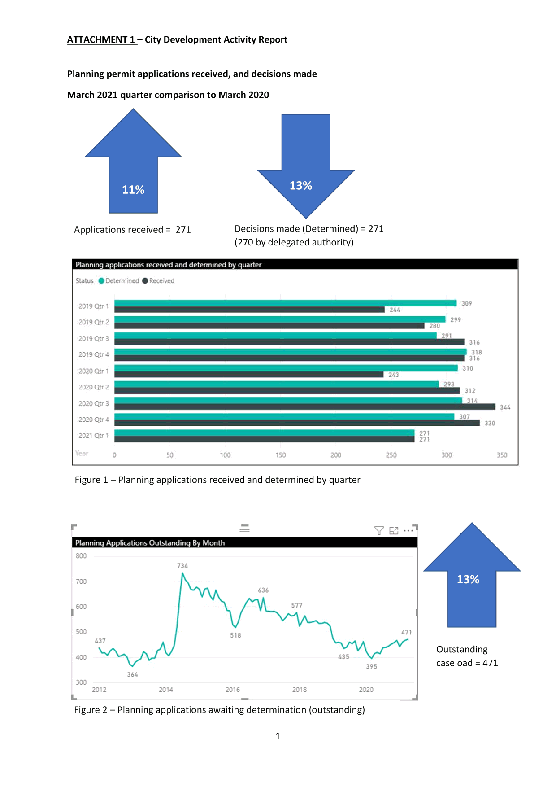

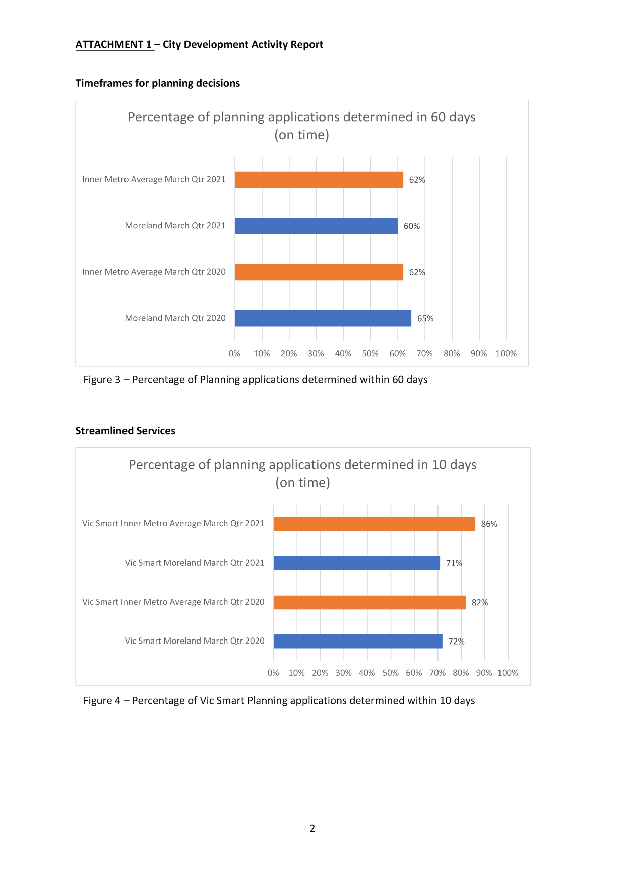

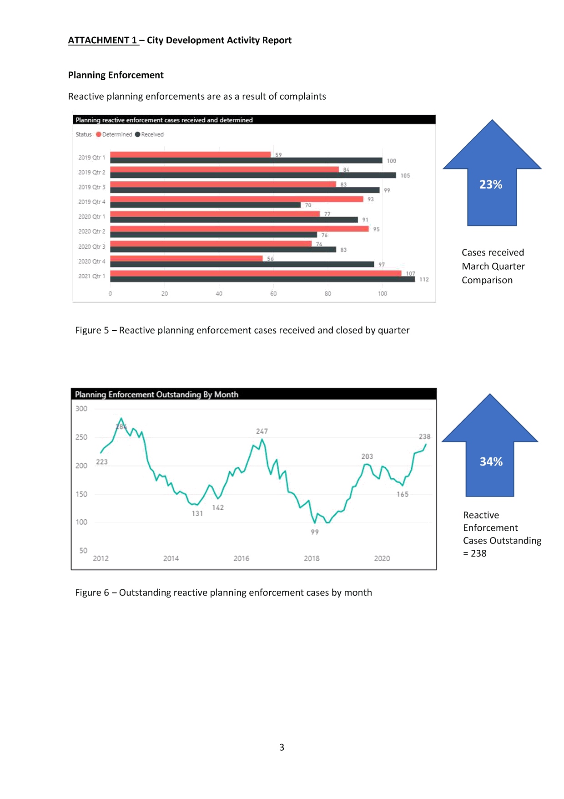

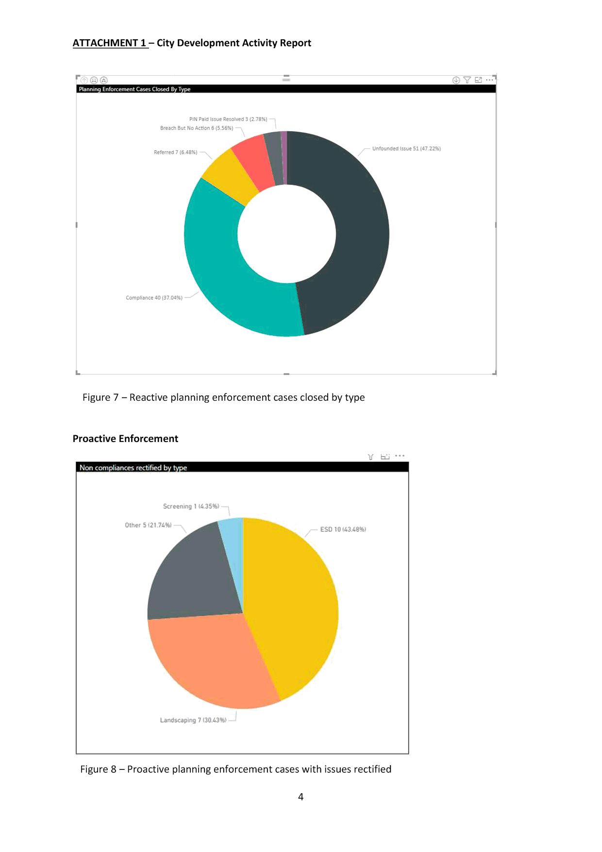

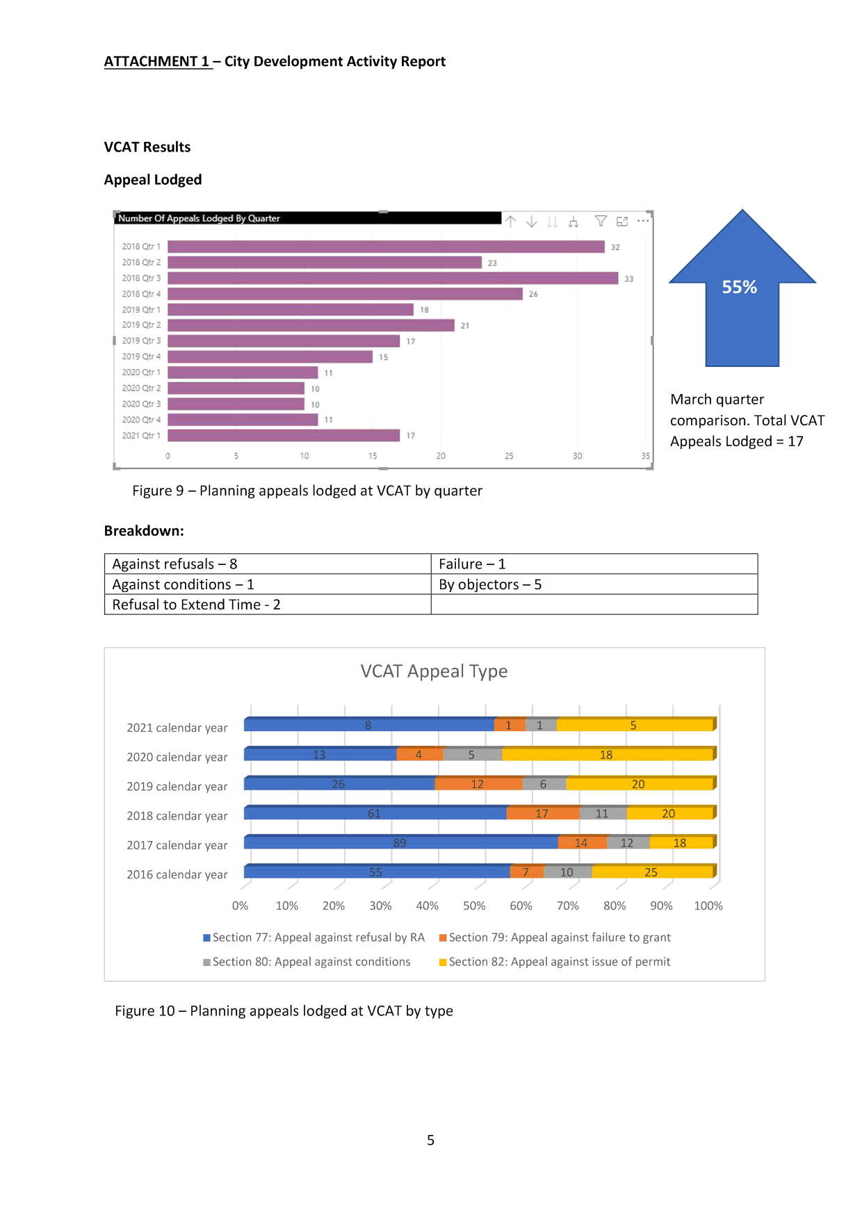

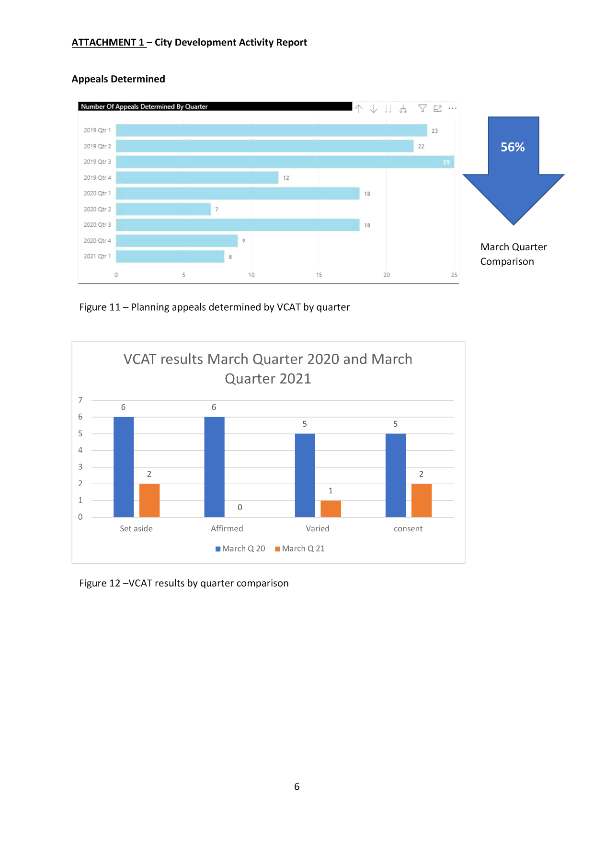

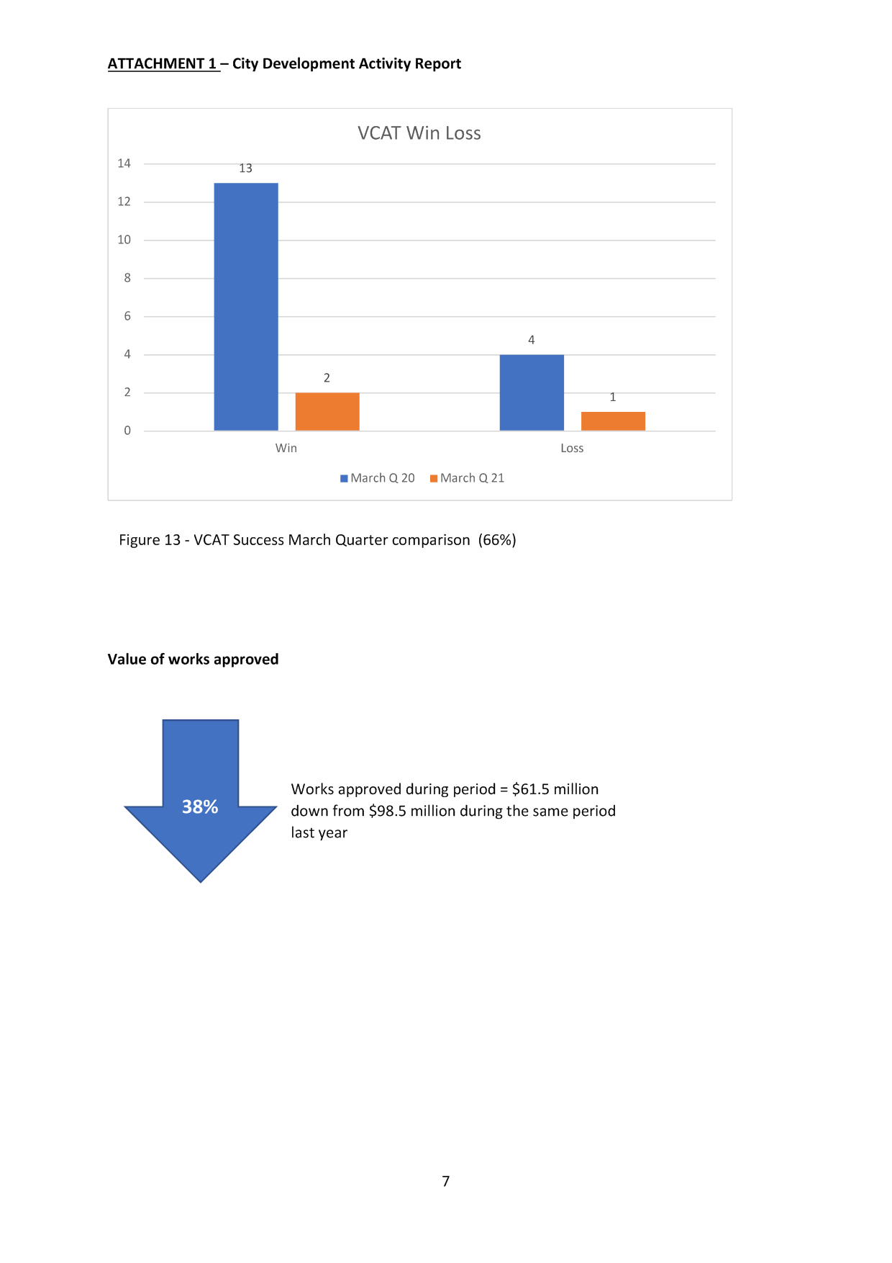
5.2 57 Melville Road, BRUNSWICK WEST, Planning Permit Application (MPS/2020/515)
Director City Futures Kirsten Coster
City Development

Executive Summary
Property: | 57 Melville Road, BRUNSWICK WEST VIC 3055
Proposal: | Development of the land for a five storey building, use of the land for dwellings and a reduction in the standard car parking requirement for the dwellings and a ground floor restaurant
Zoning and Overlays: | • Commercial 1 Zone  • Fronts a Road Zone Category 1 (Melville Road)  • Design and Development Overlay - Schedule 24  • Development Contributions Plan Overlay – Schedule 1  • Parking Overlay - Precinct 1
Strategic setting: | 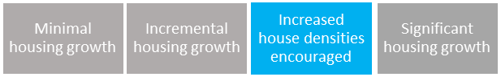
Objections: | • 9 objections  • Key issues:  ➢ Car Parking  ➢ Overlooking  ➢ Previous VCAT decision on the site
Objector consultation meeting: | • Date: 22 April 2021  • Attendees: 8 objectors, the applicant and 2 Council officers  • At this meeting the applicant agreed to increase car parking and provide more screening to reduce overlooking.
ESD: | • Minimum average NatHERS rating of 7.8 stars.  • BESS Score of 61%  • STORM Rating of 101%
Accessibility: | • All but one of the apartments are adaptable, which means the relevant accessibility requirement will be exceeded.
Key reasons for support: | • Adequately responds to previous VCAT decision on the site  • High quality materials and building design  • High level of compliance with the internal amenity requirements
Recommendation: | Notice of Decision to Grant a Planning Permit be issued for the proposal.

Officer Recommendation
That a Notice of Decision to Grant a Planning Permit No. MPS/2020/515 be issued for Development of the land for a five storey building, use of the land for dwellings and a reduction in the standard car parking requirement for the dwellings and a ground floor restaurant at 57 Melville Road, Brunswick West, subject to the following conditions:
Amended Plans Condition
1. Before the use and development commences, amended plans to the satisfaction of the Responsible Authority must be submitted to and approved by the Responsible Authority. When approved, the plans will be endorsed and will then form part of the permit. The plans must be drawn to scale with dimensions and must be generally in accordance with the plans advertised 12 February 2021 but modified to show:
a) The Environmentally Sustainable Design initiatives that are required to be shown on plans, as contained within Condition 3c of this permit.
b) The provision of an additional 3 car parking spaces, which will result in:
i. The provision of a car stacker system in the basement;
ii. Onsite car parking being a minimum of 12 spaces; and
iii. 1 car parking space for each dwelling and 3 spaces for the ground floor commercial tenancy.
c) The noise attenuation measures recommended in the advertised acoustic report completed by Acoustic Control (Report No. DL1602-1) reflected on the plans.
d) Any further acoustic attenuation measures to the proposed car stacker system, if required by the Acoustic Report in accordance with Condition 12 of this permit.
e) All west facing balconies with screening in the form of a metal shelf that is 500mm wide and at a height of 1320mm above finished floor level, in accordance with the Sectional Diagrams prepared by Map Architecture, referenced as TP250 Revision B dated 14/5/21.
f) The bicycle storage room designed to have either self-closing and self-locking doors or gates that are only accessible using keys, codes or swipe cards in accordance with the Australian Standard for Bicycle Parking (AS2890.3). Two spaces in the storage room are to be allocated to staff of the commercial use.
g) Details and notations implementing the Waste Management Plan in accordance with Condition 7 of this permit.
h) The verandah dimensioned and not projecting beyond the street alignment, unless it is setback not less than 750mm from the kerb and at a height less than 3m above the level of the footpath, in accordance with Clause 507 of the Building Regulations 2006.
i) Detailing of the ramp from the basement to the ROW. Any ramp from the car park to the ROW must be contained entirely within the site leaving the laneway levels unaltered.
j) Plans to demonstrate how each dwelling is provided with conveniently accessible, usable and secure storage in accordance with Standard D20 (Storage objective) of Clause 58.05-4.
k) The bathroom door design of Apartment 103 and shower designs of the accessible dwellings to meet the design requirements of Standard D17 (Accessibility objective) of Clause 58.05-1.
l) A notation on the basement plan that ‘no additional columns are to be placed in the car park’.
Compliance with Endorsed Plan Condition
2. The use and development as shown on the endorsed plans must not be altered without the written consent of the Responsible Authority. This does not apply to any exemption specified in Clauses 62.01, 62.02-1 and 62.02-2 of the Moreland Planning Scheme unless specifically noted as a permit condition.
Environmentally Sustainable Design Conditions
3. Prior to the endorsement of plans, an amended Sustainable Management Plan (SMP) and plans must be submitted to the satisfaction by the Responsible Authority. The Sustainable Management Plan must demonstrate a best practice standard of environmentally sustainable design and be generally in accordance with the SMP advertised 12/02/2021 by M3 Consulting but modified to include the following changes:
a) Amend the BESS report (and any other corresponding documentation) to:
i. No longer claim that 100% of dwellings are effectively Ventilated; and provide marked up ventilation pathways on plans (showing the length of the breeze path) as per BESS criteria for any dwellings for which natural ventilation has been claimed.
b) Provide updated NatHERS rating certificates for apartment 2.03 and 3.03 to demonstrate cooling loads less than 30Mj/m2
c) Show the following ESD initiatives on the development plans:
i. Location and type of all common area submeters
ii. External operable shading devices to west facing glazing of all bedrooms and living rooms, to block peak summer afternoon sun. A product diagram or section detail of the proposed device must be provided.
iii. The notation on plans specifying the rainwater re-use which is consistent with the SMP and STORM report
iv. The location of the designated electric vehicle parking bay and location of charging infrastructure
v. A Landscape plan showing the cross-sectional detail with dimensions of the planter box/raised planters and the proposed plant selection for all the vegetated areas together with substrate materials, drainage, irrigation and structural support required
vi. The glazing specifications (U-value/SHGC) in the window schedule as per the glazing specifications in the NatHERS ratings
Where alternative ESD initiatives are proposed to those specified in this condition, the Responsible Authority may vary the requirements of this condition at its discretion, subject to the development achieving equivalent (or greater) ESD outcomes in association with the development.
When submitted and approved to the satisfaction of the Responsible Authority, the amended SMP and associated notated plans will be endorsed to form part of this permit. No alterations to the SMP may occur without the written consent of the Responsible Authority.
4. Prior to the issue of an Occupancy Permit or issue of a Statement of Compliance, whichever comes first, all works must be undertaken in accordance with the endorsed Sustainability Management Plan report to the satisfaction of the Responsible Authority.
5. Prior to the issue of an Occupancy Permit or issue of a Statement of Compliance, whichever comes first, of any dwelling approved under this permit, a report from the author of the Sustainability Management Plan (SMP) approved pursuant to this permit, or similarly qualified person or company, must be submitted to the Responsible Authority. The report must be to the satisfaction of the Responsible Authority and must confirm (and include evidence) that all measures specified in the SMP have been implemented in accordance with the approved plan.
DCP Condition
6. Prior to the issue of a Building Permit in relation to the development approved by this permit, a Development Infrastructure Levy and Community Infrastructure Levy must be paid to Moreland City Council in accordance with the approved Development Contributions Plan. The Development Infrastructure Levy is charged per 100 square metres of leasable floor space and the Development and Community Infrastructure Levy is charged per dwelling.
If an application for subdivision of the land in accordance with the development approved by this permit is submitted to Council, payment of the Development Infrastructure Levy can be delayed to a date being whichever is the sooner of the following:
• For a maximum of 12 months from the date of issue of the Building Permit for the development hereby approved; or
• Prior to the issue of a Statement of Compliance for the subdivision;
When a staged subdivision is sought, the Development Infrastructure Levy must be paid prior to the issue of a Statement of Compliance for each stage of subdivision in accordance with a Schedule of Development Contributions approved as part of the subdivision.
Waste Management Plan Conditions
7. Prior to the endorsement of plans, an amended Waste Management Plan (WMP) must be submitted to the satisfaction of the Responsible Authority. The WMP must be generally in accordance with the WMP completed by M3 Consulting and advertised 12 February 2021 but modified to include:
a) Additional information about the management of hard waste from the site.
b) Provision for separate glass collection in preparation for a four-bin waste and recycling system for both the residential and commercial use.
When submitted and approved to the satisfaction of the Responsible Authority, the WMP will be endorsed to form part of this permit. No alterations to the WMP may occur without the written consent of the Responsible Authority.
8. The Waste Management Plan approved under this permit must be implemented and complied with at all times to the satisfaction of the Responsible Authority unless with the further written approval of the Responsible Authority.
Landscape Maintenance Condition
9. All landscaping and irrigation systems must be maintained to the satisfaction of the Responsible Authority in accordance with the endorsed landscape plans. Any dead, diseased or damaged plants must be replaced with a suitable species to the satisfaction of the Responsible Authority.
10. Prior to the issue of an Occupancy Permit or issue of a Statement of Compliance, whichever comes first, all boundary walls must be constructed, cleaned and finished to the satisfaction of the Responsible Authority.
11. Prior to the issue of an Occupancy Permit or issue of a Statement of Compliance, whichever comes first, all telecommunications and power connections (where by means of a cable) and associated infrastructure to the land (including all existing and new buildings) must be underground to the satisfaction of the Responsible Authority.
Acoustic Attenuation
12. Prior to the endorsement of plans, an amended Acoustic Assessment of the development, to the satisfaction of the Responsible Authority, must be submitted to the Responsible Authority. The assessment must be generally in accordance with the report prepared by Acoustic Control (Report No. DL1602-1 advertised by Council on 12 February 2021) but must detail recommended noise attenuation measures to ensure that:
a) Noise emissions from the operation of car stackers, roller doors and the use of the car park do not impact adversely on the amenity of dwellings within the development and neighbouring residential properties.
When submitted and approved to the satisfaction of the Responsible Authority, the Acoustic Report will be endorsed to form part of this permit. No alterations to the Acoustic Report may occur without the written consent of the Responsible Authority.
13. The building must be constructed and thereafter maintained in accordance with the recommendations contained within the approved Acoustic Report to the satisfaction of the Responsible Authority, unless with the further written approval of the Responsible Authority.
14. Prior to the issue of an Occupancy Permit or issue of a Statement of Compliance, whichever comes first, a report from the author of the Acoustic Report approved pursuant to this permit or similarly qualified person or company must be submitted to the Responsible Authority. The report must be to the satisfaction of the Responsible Authority and must confirm that all measures specified in the Acoustic Report have been implemented in accordance with the approved Acoustic Report.
Stormwater Conditions
15. All stormwater from the land, where it is not collected in rainwater tanks for re-use, must be collected by an underground pipe drain approved by and to the satisfaction of the Responsible Authority (Note: Please contact Moreland City Council, City Infrastructure Department).
16. Stormwater from the land must not be directed to the surface of the right-of-way to the satisfaction of the Responsible Authority
Balconies Conditions
17. The surface of all balconies are to be sloped to collect the stormwater run-off into stormwater drainage pipes that connect into the underground drainage system of the development to the satisfaction of the Responsible Authority.
18. Lighting on each balcony must be designed to not emit light direct onto adjoining property to the satisfaction of the Responsible Authority.
Expiry Condition
19. This permit will expire if one of the following circumstances applies:
a) the development is not commenced within two (2) years from the date of issue of this permit;
b) the development is not completed within four (4) years from the date of issue of this permit.
The Responsible Authority may extend the period referred to if a request is made in writing before the permit expires or;
• within six months after the permit expires to extend the commencement date.
• within 12 months after the permit expires to extend the completion date of the development if the development has lawfully commenced.
Notes: These notes are for information only and do not constitute part of this notice of decision or conditions of this notice of decision.
Note 1: Should Council impose car parking restrictions in this street, the owners and/or occupiers of the dwellings would not be eligible for resident parking permits to park on the street. Occupiers are eligible for the resident A parking permit which only permits parking in limited areas. The resident parking permits and Resident A parking permit are subject to future reviews and change. See Council’s website for more information: https://www.moreland.vic.gov.au/parking-roads/parking-permits/residential-parking-permits/.
Note 2: This permit contains a condition requiring payment of Development Contributions. The applicable development contribution levies are indexed annually. To calculate the approximate once off levy amount, please visit http://www.moreland.vic.gov.au/planning-building/ and click on ‘Moreland Development Contributions Plan (DCP)’. Alternatively, please contact Moreland City Council on 9240 1111 and ask to speak to the DCP Officer.

REPORT

1. Background

Subject site
The subject site is located at 57 Melville Road, Brunswick West. The overall site area is approximately 490.4 square metres and has a frontage to Melville Road and an abuttal to a bluestone ‘Right-of-Way’ (ROW) to the rear. The site is occupied by a single storey painted brick building which operates as a restaurant. Vehicle access is from the ROW and can be accessed from Victoria or Whitby Streets. Waste facilities are currently stored within the rear of the site.
The land has a cross fall of approximately 2.8 metres from east (47.969 AHD) to west (45.155 AHD).
The site is within the Melville Road/Albion Street/Victoria Street, Brunswick West Neighbourhood Activity Centre and is zoned Commercial 1 Zone (C1Z). Preferred built form outcomes within the Neighbourhood Centre are informed by Design and Development Overlay - Schedule 24 (DDO24).
The subject site is known as Lot 1 on Title Plan 548593Y. The title does not contain a restrictive covenant. The title indicates that the rear ROW is a ‘Road’. The site has legal access from the ROW.

Surrounds
The surrounds feature a mixed character of land uses, building typologies and planning controls. This part of Melville Road features a low to medium rise character of commercial and mixed use buildings. Buildings are mostly single or double storey except for a three storey building at 43 Melville Road (Estonian House) and a three storey apartment building on the corner of Melville Road and Whitby Street. Uses are diverse and include a Supermarket (52 Melville Road), Automotive Repairs (54 Melville Road), Post Office (51-53 Melville Road) and Take Away Food Premises (49 Melville Road). Melville Road is a Road Zone – Category 1 (RDZ1) and a tramway for Tram Route 58 (West Coburg to Toorak).
Land west of Melville Road, in Victoria and Whitby Streets, is residential and zoned Neighbourhood Residential – Schedule 1 (NRZ1). Whitby Street is contained within Heritage Overlay – Schedule 109 (HO109) (Marion Avenue Precinct, West Brunswick). The Marion Avenue Precinct is of local architectural significance as a consistently intact example of Inter-War Bungalow style housing. HO109 includes land at 61-71 Melville Road.
A location plan forms Attachment 1.

The proposal
The proposal is summarised as follows:
• Construction of a five storey building. The proposed building is four storeys to Melville Road (three residential floors above ground floor commercial tenancy). The basement is classified as a storey at the site’s rear, due to the basement projecting above ground level because of the slope of the land.
• Nine dwellings (eight x 2-bedroom and one x 3-bedroom).
• A 260 square metre restaurant containing 76 seats (no permit is required for this land use).
• Nine car parking spaces, accessed from the ROW.
The development plans form Attachment 2.

Planning Permit and site history
An application on the site (MPS/2018/668) proposing ‘use and development of a 5 storey apartment, including restaurant at ground floor and waiver of car parking (residential parking and restaurant parking)’ was determined at the Victorian Civil and Administrative Tribunal (VCAT) in January 2020 (the ‘VCAT decision’).
VCAT affirmed Council’s decision and directed the no permit should be granted because of non-compliances with DDO24 as it relates to building heights, rear setbacks and the overall massing and bulk of the building. The VCAT decision is relevant to the considerations of this application.
It is also relevant that the existing restaurant on the site has a planning permit (MPS/2007/92/A), allowing up to 76 patrons and service of liquor until 11pm Monday to Wednesday and 12am Friday and Saturday. A reduction of car parking of 9 spaces associated with this use has been granted. This permit includes 3 onsite car parking spaces for staff.

Statutory Controls – why is a planning permit required?
Control | Permit Requirement
Commercial 1 Zone | Clause 34.01-4: A permit is required to construct a building or construct or carry out works.  Clause 34.01-1: A permit is required for the use of the land for ‘Dwelling’ because the frontage at ground level exceeds 2 metres.  Restaurant is a Section 1 use in the zone, meaning that a permit is not required for this use.
Design and Development Overlay | Clause 43-02-2: A permit is required to construct a building or construct or carry out works.
Particular Provisions | Clause 52.06: A permit is required to reduce the car parking requirement from 15 spaces to 9 spaces.
The following Particular Provisions of the Moreland Planning Scheme are also relevant to the consideration of the proposal:
• Clause 45.06: Development Contributions Plan Overlay
• Clause 45.09: Parking Overlay
• Clause 52.34: Bicycle Facilities
• Clause 53.18: Stormwater Management in Urban Development

2. Internal/External Consultation

Public notification
Notification of the application has been undertaken pursuant to Section 52 of the Planning and Environment Act 1987 by:
• Sending notices to the owners and occupiers of adjoining land;
• Sending notices to objectors to MPS/2018/668; and
• Placing signs on site (to Melville Road and the ROW)
Council has received 9 objections to date. The key issues raised in objections are:
• Car Parking
• Traffic and accuracy of traffic report
• Functionality of the ROW
• Overlooking/privacy
• Noise (commercial and residential uses)
• Safety
• Visual bulk
• Active frontage
• Response to VCAT decision
• Emissions from the Restaurant
• Building Height
• Overshadowing
• Rubbish generation and collection
An objector consultation meeting was held on 22 April 2021 and was attended by Council Planning Officers, the applicant and 8 objectors. The meeting provided an opportunity to explain the application, for the objectors to elaborate on their concerns, and for the applicant to respond. During the consultation meeting discussions about potential strategies to address objector concerns about overlooking were undertaken.
Following the meeting, the applicant agreed to further limit views from the west facing balconies to residential land in Victoria and Whitby Streets. The applicant has also agreed to provide additional onsite parking, including spaces for the Restaurant. These matters are discussed in more detail in Section 4.

Internal/external referrals
The proposal did not require any external statutory referrals. The proposal was referred to the following internal branches/business units.

Internal Branch/Business Unit | Comments
Urban Design Unit | Council’s Urban Design Unit supports the proposal. Urban Design has positively commented on the proposed materials which are “derived from the site history and strengthens the overall architectural form”. Urban Design also remarked “The use of recycled brick, textured brick, black outlined soffit and timber, black metal is well thought-out. Urban Design is also supportive of the “medium rise mixed use apartment typology”.
Sustainable Built Environment - Development Engineering Team | Council’s Development Engineer supports the proposal subject to modifications, which are addressed by conditions details in the recommendation. Engineering are supportive of the proposed car parking reduction based on the site’s proximity to public transport and provision of bicycle parking spaces.
Sustainable Built Environment - ESD Team | Council’s ESD Team is mostly supportive of the proposed Sustainable Design features of the site. The ESD response is discussed in more detail in Section 4.

3. Policy Implications

Planning Policy Framework (PPF):
The following policies are of most relevance to this application:
• Municipal Planning Strategy (Clause 2), including:
− Vision (Clause 2.02)
− Settlement (Clause 2.03-1)
− Housing (Clause 2.03-5)
− Economic Development (Clause 2.03-6)
− Transport (Clause 2.03-7)
− Infrastructure (Clause 2.03-8)
• Settlement (Clause 11)
• Environmental Risks and Amenity (Clause 13):
− Noise Abatement (Clause 13.05-1S and 13.05-1L)
• Built Environment (Clause 15.01), including:
− Urban Design (Clause 15.01-1S, 15.01-1R & 15.01-1L)
− Vehicle Access Design in Moreland (Clause 15.01-1L)
− Building Design (Clause 15.01-2S & 15.01-2L)
− Apartment developments in Moreland (Clause 15.01-2L)
− Building Design in Neighbourhood and Local Centres (Clause 15.01-2L)
• Sustainable Development (Clause 15.02), including:
− Energy and resource efficiency (Clause 15.02-1S)
− Environmentally Sustainable Development (Clause 15.02-1L)
− Energy efficiency in Moreland (Clause 15.02-1L)
• Residential Development (Clause 16.01), including:
− Housing Supply (Clause 16.01-1S and 16.01-1R)
− Homes in Moreland (Clause 16.01-2L)
− Housing for People with Limited Mobility (Clause 16.01-1L)
• Economic Development (Clause 17), including:
− Business (Clause 17.02-1S)
• Transport (Clause 18), including:
− Sustainable Personal Transport (Clause 18.02-1S & 18.08-1R)
− Sustainable Transport in Moreland (Clause 18.02-1L)
− Car parking (Clause 18.02-4S & 18.02-4L)

Human Rights Consideration
This application has been processed in accordance with the requirements of the Planning and Environment Act 1987 (including the Moreland Planning Scheme) reviewed by the State Government and which complies with the Victorian Charter of Human Rights and Responsibilities Act 2006, including Section 18 (Taking part in public life). In addition, the assessment of the application has had particular regard to:
• Section 12: Freedom of movement - The proposed redevelopment of private land does not present any physical barrier preventing freedom of movement.
• Section 13: Privacy and Reputation - An assessment of whether there is any potential for unreasonable overlooking has been undertaken in Section 4 of this report
• Section 20: Property rights - The right of the landowner to develop and use their land has been considered in accordance with the Moreland Planning Scheme.

4. Issues
In considering this application, regard has been given to the State and Local Planning Policy frameworks, the provisions of the Moreland Planning Scheme, the VCAT decision, objections received and the merits of the application.

Does the proposal have strategic policy support?
Both State and local planning policies support increased residential densities with ground level commercial uses in Neighbourhood Activity Centres, to take advantage of the excellent access to public transport and other services within these locations.
The proposal meets the objectives and strategies of the Planning Policy Framework (PPF) by:
- Providing increased housing density in an area that is identified for ‘Significant Change’ within the Planning Scheme (Clause 16.01-1L: Homes in Moreland).
- Providing an appropriate transition to the rear residential zone through DDO24 compliant rear setbacks above 6.3 metres (Clause 15.01-2L: Building Design in Neighbourhood and Local Centres). Setbacks that do not comply with the DDO are consistent with the direction outlined in the previous VCAT decision on the site.
- Providing a restaurant at ground floor aligns with the Strategic Direction for land in Neighbourhood Centres outlined in Clause 02.03-1 and the purpose of the C1Z, which encourage a mix of uses to serve local shopping needs and to create a vibrant mixture of commercial uses.
The proposal enjoys strong strategic support at both State and local level.

Does the proposal respond to neighbourhood character, positively contribute to the local context and enhance the public realm?
The design response suitably achieves the relevant policy objectives of the Planning Policy Framework regarding neighbourhood character and building design. The current proposal also adequately addresses the issues raised in the VCAT decision.
Principally, a floor has been deleted in the current proposal reducing the overall maximum building height from 17.6 metres to 15.3 metres. Interface issues have also been resolved with the rear setback increased to address the VCAT decision. Key aspects of the design are discussed below.

DDO24 Built Form Requirements
Maximum building height and storeys
As outlined in Figure 5 to DDO24 the site is identified as a ‘Focus Area for Change’. Preferred maximum building heights of 13.5 metres and four storeys are sought by the DDO. The application proposes a maximum building height of 15.3 metres and five storeys. The proposal achieves the requirement of the DDO to Melville Road where three residentials levels are proposed above a ground level commercial tenancy, to a maximum building height of 13.5 metres. In comparison, the VCAT decision plans which proposed four storeys above a ground floor commercial use, with the uppermost level recessed behind the street wall. The VCAT decision supported a four storey street wall to Melville Road and suggested that a variation in building height could have been considered, if appropriately designed.
However, the VCAT decision found that the top section of the building, which exceeded the preferred building height by 5.4 metres, would be visible from longer range and oblique views above adjoining buildings throughout the Neighbourhood Centre and would contribute to visual bulk. The deletion of the uppermost storey and compliance with the preferred building height at the Melville Road frontage adequately addresses the massing and bulk concerns of the previously refused application.
Variation to the preferred height and storey requirements of the DDO are proposed towards the rear of the site. The basement level projects more than 1.2 metres above the ground level and is therefore considered as a storey. The suitability of this variation is a relevant consideration when considering interface treatment between the rear of the site and residential land to the west. This is discussed further below.
Rear setback
Land adjacent to the site and west of the ROW in Victoria Street is within the NRZ1. Rear setbacks should be provided as per the following requirements outlined in the DDO:
• 3 metres up to a height of 4 metres
• 6 metres above a height of 4 metres
• 8.6 metres above a height of 10.5 metres
Non-compliance to the rear setback requirement of the DDO and visual bulk impacts to the western residential interface was a central issue contested at the VCAT hearing. The VCAT decision plans had balconies and a part of the fourth level encroached into the setback area. The uppermost level was also considered to contribute to visual bulk concerns to the west. The VCAT decision was not supportive of the design and remarked the following on these issues:
62. I consider the upper level will be a prominent built form when viewed from the adjoining residential hinterland.
73. I acknowledge there are double storey buildings that face the laneway. I agree with Mr Blades that the height and setback of the basement and ground floor is satisfactory. However, I find it is the cumulative impact of the reduced setbacks of the upper levels and the building height that fails to provide adequate transition in built form to the NRZ.
The current application adequately addresses these issues. The previously proposed uppermost level has been deleted. Additionally, the height of the basement and ground level boundary walls are comparable to the previous proposal where a variation to rear setback was supported in the VCAT decision. Double storey is proposed to the ROW to a height of 6.31 metres. This is a slight increase of 250mm from the VCAT decision plans and is consistent with character of double storey form to the ROW. The rear setbacks comply with the DDO above this height in the current application.
A 1.83 metre variation to the overall height of the building is acceptable. Clause 15.01-2L encourages development to not exceed a building height of four storeys, unless the site is large enough to allow the visual impacts of the development to be mitigated through the design response, including the building height at the interface with adjoining properties not exceeding four storeys. The section of the building that exceeds the preferred maximum building height is setback between 8.6 and 10.85 metres from the boundary. This is further buffered by the 3.048 metre wide ROW, resulting in a minimum 11.64 metre setback from the nearest adjoining property boundary to the highest portion of the building. The rear interface strikes an acceptable balance between achieving the higher density built form objectives of the DDO and C1Z while preserving the amenity of adjoining properties.
The diagrams below depict the height of the current proposal as compared to the proposal that VCAT considered and upheld the refusal.

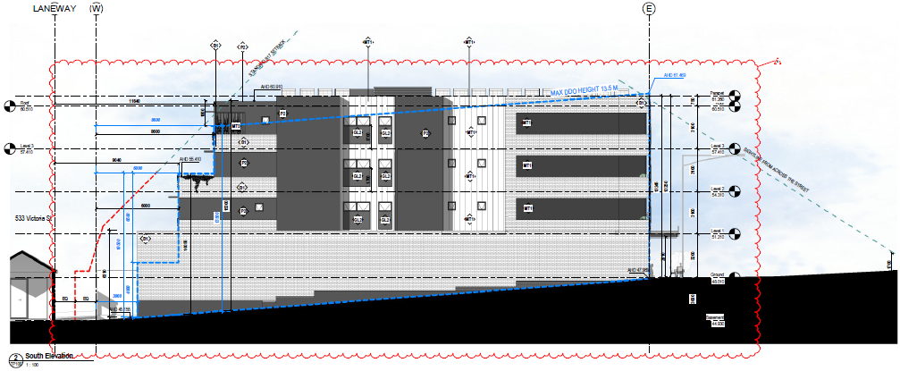
Proposed south elevation. Blue dashed line outlines preferred building envelope of DDO24.

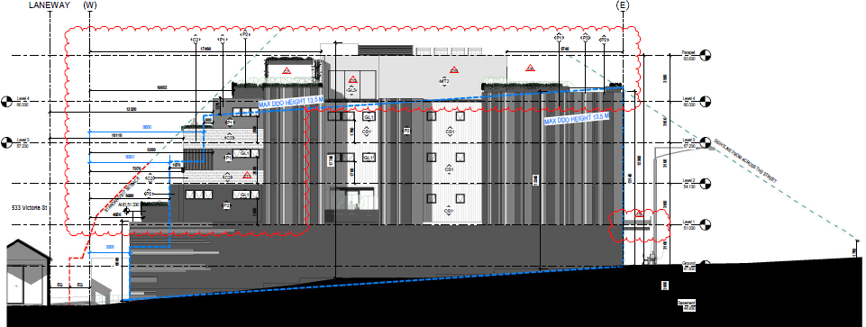
Substituted south elevation plan of MPS/2018/668 (as refused by VCAT). Blue dashed line outlines preferred building envelope of DDO24.
Active Frontages
The site is within the commercial core of the Neighbourhood Centre and should be designed with an active commercial frontage comprising the following:
A display window and/or entrance, measuring 65 - 80% of the width of the street frontage of each individual premise.
Non-compliance to this requirement was noted as an issue in the VCAT decision. The site has a 12.19 metre frontage to Melville Road. To achieve the requirement of the DDO a minimum of 7.92 metres of the frontage should contain a commercial display window and/or entrance. In the previous design the shopfront to the restaurant was 7.8 metres wide and the remainder of the frontage comprised of the dwelling entry and fire booster.
In discussing this issue, the VCAT decision concurred with the applicant’s Urban Design expert witness who recommended that the canopy over the pavement should be extended for the entire street frontage and not just over the commercial shopfront as an improved response to the DDO.
This has been implemented in the subject proposal. Additionally, the width of the booster to the street has been reduced by 500mm with landscaping introduced between the boosters and residential entry. The frontage of the commercial tenancy in the subject proposal is the same as in the previous application and accounts for approximately 59.9% of the site frontage to Melville Road.
Although this is a minor non-compliance to the numerical requirement of the DDO, the frontage is acceptable because the canopy has been extended, the booster’s width reduced, and landscaping has been introduced to soften views of the booster. Council’s Urban Design unit is also supportive of this response commenting that the “revised service cupboard is not considered dominant” and that the materials are made from high-quality panelling.
A permit is also required for the use of the dwellings because the frontage at ground level associated with the dwellings exceeds 2 metres. The frontage consideration of the residential use pursuant to the C1Z is acceptable for the same reasons described above. The diagrams below compare the elevation of the current proposal with the proposal considered by VCAT.
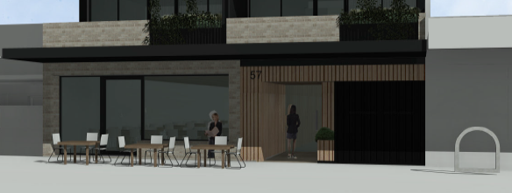
Proposed Melville Road frontage
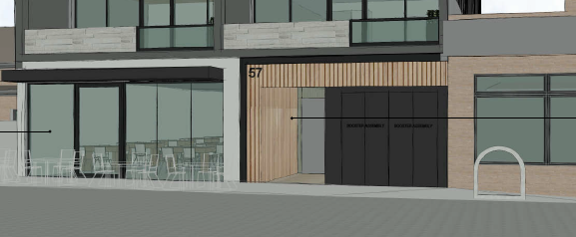
Melville Road frontage of VCAT decision plans.

Does the proposal result in any unreasonable off-site amenity impacts?
Multiple objections have raised concerns about overlooking and overshadowing. The decision guidelines of the C1Z requires consideration to be given to the overlooking and overshadowing as a result of building or works affecting adjoining land in the NRZ.
Although Standards B21 (Overshadowing open space objective) and B22 (Overlooking objective) of Clause 55 do not apply in this application, these Standards provide useful guidance on determining the reasonability of offsite amenity impacts.
Overshadowing
Shadow diagrams indicate that the proposal will not result in any additional overshadowing to land in the NRZ, including 533 Victoria Street which is the nearest residential lot to the site.
Increased shadowing will be created to the dwellings and a solar energy facility (i.e. solar panels) at 55 Melville Road. This site is within the C1Z and is not afforded the same amenity and solar energy facility protections as land within residential zones.
The rear of this site has been developed with a double storey dwelling with a first floor balcony and is known as 2/55 Melville Road. A planning permit (MPS/2017/392) has been issued for 1/55 Melville Road allowing ‘construction of a three storey building, consisting of a shop at ground floor and single dwelling above, and a reduction in the standard car parking and loading bay requirements’. Street facing balconies across two levels are introduced to 1/55 Melville Road in this permit.
Overshadowing to the south is acceptable due to the zoning of the land and provision of private open spaces above ground level to dwellings on this lot. Similarly, the planning considerations for existing residential rooftop solar energy facilities only apply to existing facilities in a residential zone and are not a consideration in relation to 2/55 Melville Road. It would be unreasonable to seek to protect the solar energy facility, because it would undermine the ability of the Centre to provide the desired increase in housing density.
Overlooking
A number of objections received from residents in Victoria and Whitby Streets have raised concerns about privacy and overlooking from west facing dwellings. Balconies, and bedrooms and living room windows are orientated to the west. This is encouraged by the Moreland Neighbourhood Centres Strategy, which supports orienting outlooks towards the rear of sites with the aim of minimising the requirement for screening. As designed, western outlooks from each vantage point (Balconies and Habitable Rooms in Levels 1-3) comply with Standard B22 as screening is not required for overlooking beyond 9 metres A minimum 9.048 metre setback to the east facing windows at 533 Victoria Street (constructed to the ROW) is provided.
Although the requirements of Standard B22 are met, the applicant has agreed to implement a horizontal shelf to each balcony, to further reduce the potential for downwards views from west facing balconies. This is depicted below and detailed further at Attachment 3. Implementation of this screening forms a condition of the recommendation.
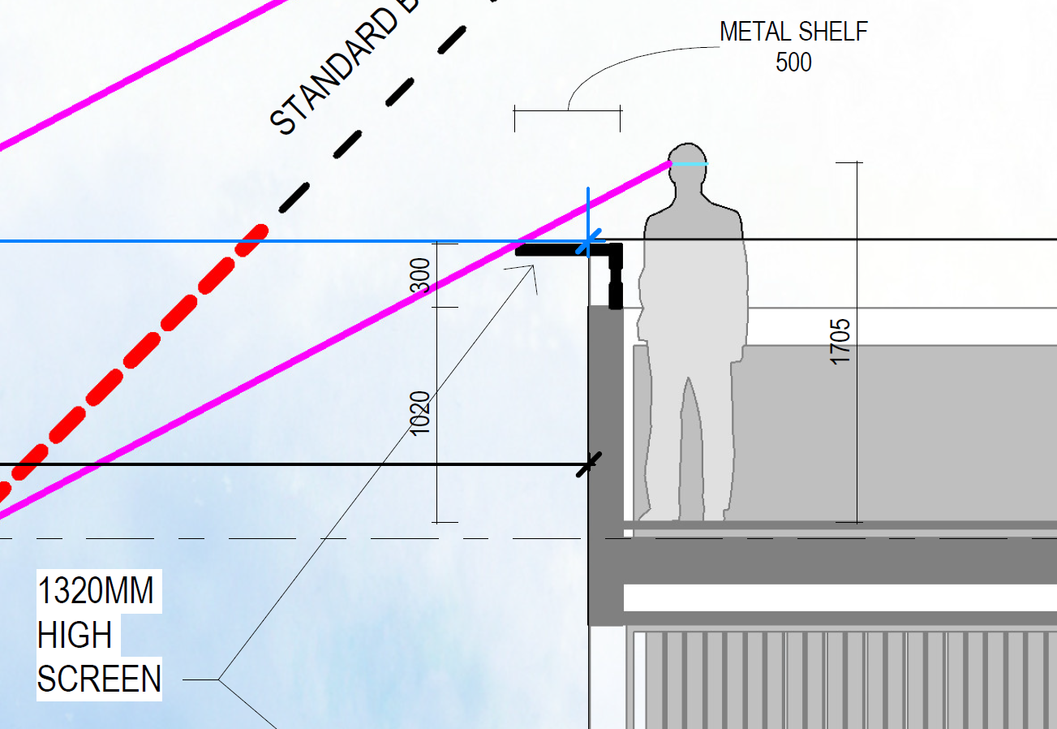
Excerpt of TP205 showing proposed metal shelf

Does the proposal provide appropriate onsite amenity and facilities?
Overall, the proposal provides appropriate internal amenity, in accordance with the Standards set out in Clause 58 of the Planning Scheme. Key considerations are detailed below.
Room Sizes
Functional layout requirements of Standard D24 have been met. All living areas are 3.6m x 3.6m and meet the minimum width requirement of the Standard and exceed the 12sqm minimum area requirement. These areas exclude kitchen and dining areas. Similarly, bedrooms meet the Standard and provide an area in addition to the requirements of the Standard for wardrobes.

Storage
It is unclear how the storage requirements of Standard D20 are met. The plans indicate that each dwelling is provided with a storage cage in the basement. However, the Standard sets minimum storage volumes to be provided within dwellings. A condition in the recommendation requires the plans to be updated to demonstrate how this requirement is met.
Noise
To ensure future residents of the dwellings are protected from noise from Melville Road (a tramway and RDZ1), a condition of the recommendation requires the recommendations from the advertised acoustic report to be reflected on the plans.

Has adequate car and bicycle parking been provided?
Clause 52.06 requires a total of 10 car spaces for the dwellings and 5 spaces for the restaurant to be provided. As the site is within a Parking Overlay and the Principal Public Transport Network, visitor spaces are not required to be provided. The advertised plans provided 9 on-site spaces, one for each dwelling.
It is noted that the VCAT decision commented that the provision of on-site car parking to be satisfactory which proposed a 9 space reduction.
Car parking concerns were raised in a number of objections and during the objector meeting. Following the objector meeting, the applicant agreed to introduce a pit car stacker system to increase the overall number of onsite spaces to 12.
The additional 3 spaces would be allocated to the staff of the restaurant. This is supported because it would decrease the non-compliance to Clause 52.06 and responds to objector concerns about parking opportunities for staff to the restaurant. A condition is included in the recommendation for an acoustic assessment of the stacker to be provided to ensure noise from the equipment does not unreasonably affect surrounding residential uses.
A 3-space reduction would still be required following this change. Council’s Development Engineers are satisfied that the statutory car parking requirement can be reduced for this application.
Clause 18.02-4L (Car parking in Moreland) supports reduced car parking rates in developments:
• Within and close to activity centres
• With excellent access based on frequency and location to a range of public transport options
• With increased provision of bicycle parking above the rates specified in Clause 52.34.
The proposal is located within the Melville Road/Albion Street/Victoria Street Neighbourhood Centre and has excellent access to public transport including trams opposite the site on Melville Road (Route 57 - West Coburg to Toorak) and buses (Alphington to Moonee Ponds) on Victoria Street; approximately 50 metres from the site.
The dwellings will not be eligible for parking permits in the event that parking restrictions are imposed by Council on the street. This is included as a note in the recommendation.
A total of 21 bicycle parking spaces are proposed within the site. This includes 17 enclosed spaces accessed from the residential entry and 3 visitor spaces adjacent to the lift. The provision of resident bicycle parking exceeds the requires of Clause 52.34 which only requires 1 space. Engineering have recommended conditions ensuring the security of the parking area. This includes the requirement for the parking area to be fitted with self-closing and self-locking doors or gates; that are only accessible using keys, codes or swipe cards. This is included in the recommendation.
The restaurant should provide 2 staff and 2 customer bike spaces. This can be provided in the parking area. Sufficient customer bicycle spaces are available on Melville Road. Between Victoria and Whitby Streets, on the west side of Melville Road, there is capacity for 14 bicycles to be parked.

What impact does the proposal have on car congestion and traffic in the local area?
Objections have raised concerns about the functionality of the ROW and accuracy of the applicant submitted traffic report. The traffic report includes swept path diagrams demonstrating the functionality of vehicle movements to the site. The traffic report includes a traffic study that was undertaken in May 2018 and is considered to provide an appropriate indication of on-street parking demand prior to COVID-19. Council Engineers have accepted the conclusions of this report.
In relation to traffic impacts, Council’s Development Engineers have assessed the proposal and consider that the proposal will result in 70 additional vehicle movements per day on Melville Road (a Road Zone) and Victoria Street (a Council main road). This remains within the design capacity of these streets and is not expected to cause traffic problems.
The use of the laneway for vehicle access is supported by Clause 15.01-1L (Vehicle Access Design in Moreland), because it allows street frontages to prioritise pedestrian movement and safety and to create active frontages.
Concerns about pedestrian and traffic safety have been raised by objectors. As discussed above Council’s Engineers have accepted the proposed vehicle access and traffic generation from the site and confirmed the functionality of vehicle movements in the ROW. Similarly, pedestrian movements in Melville Road are unchanged from existing conditions.

Are adequate loading/unloading facilities provided?
Clause 65.01 requires consideration of the adequacy of loading and unloading facilities. Council’s Engineers have commented that the one hour restricted parking fronting the site will allow deliveries during the hours of operation of the restrictions (8:00am and 6:00pm). This provides sufficient opportunities for deliveries to the commercial tenancy to be undertaken during business hours.

Does the proposal incorporate adequate Environmental Sustainable Design (ESD) features and daylight access?
ESD features of the development are adequate. However, ESD officers have identified concerns about the ‘Indoor Environmental Quality’ (IEQ) of bedrooms that are orientated to light wells. Clause 15.02-1L (Environmentally Sustainable Development) encourages the following IEQ considerations: “Achieve a healthy indoor environment quality, including thermal comfort and access to fresh air and daylight, prioritising passive design over mechanical heating, ventilation, cooling and lighting”.
All living rooms are orientated either to Melville Road or to the rear ROW and have windows to the building’s external walls. Where single aspect living rooms are proposed (1.01, 1.02, 2.01, 2.02, 3.01 and 3.02), the room depth meets the requirement of Standard D25.
Bedrooms orientated to light wells are designed in accordance with Clause 15.01-2L (Apartment developments in Moreland). Light well dimensions up to four storeys should have a minimum width of 2 metres and a minimum area of 9 square metres. The north and south light wells are 2 x 4.5 metres and meet this requirement
Council’s ESD Unit has commented that the bedrooms facing the light wells do not meet achieve a 0.5% Daylight Factor to 90% of the floor area of these rooms and that the only way of achieving the Daylight Factor requirement would be to increase the size of the light wells.
However, on balance this arrangement is acceptable because the light wells meet the size requirements of Clause 15.01-2L, the applicant has worked with Council to actively improve the daylight provision in these rooms by maximising window sizes and relocating wardrobes and because the light wells service bedrooms only.
Other conditions are contained in the recommendation and include the provision of shading devices to block peak summer afternoon sun.

Is the proposal accessible to people with limited mobility?
Clause 16.01-3L (Housing diversity in Moreland) encourages the provision of housing that can be lived in by people with limited mobility (or easily adapted to be lived in). Standard D17 (Accessibility objective) aims to ensure the design of dwellings meets the needs of people with limited mobility. At least 50% of dwellings should meet the design requirements of the Standard. The plans indicate that the proposal exceeds this requirement with all but one dwelling meeting Standard D17. Additional details are required to be shown on the plans to demonstrate that the Standard has been met. This relates to the bathroom door design of Apartment 103 and confirmation of shower designs in each dwelling. Subject to conditions confirming these design elements, the proposal will exceed the requirements of the Standard and Clause 16.01-3L.

Is the proposed waste management and collection appropriate?
An objection is concerned about additional rubbish in the ROW and heavy vehicle waste management and collection. A Waste Management Plan (WMP) has been submitted with the application. The WMP proposes private waste collection from the ROW for the residential and commercial tenancies in accordance with EPA and Council guidelines. These guidelines include collections times which seek to minimise disturbing residential areas. Council’s Development Engineer has accepted this approach and has recommended a condition requiring the applicant to provide a response to the management of hard waste.
Separate bin areas are provided for the commercial and residential uses. The restaurant will use the lift or staircase to dispose of rubbish in the basement. The location of the bin areas inside the basement will assist in the prevention of litter entering the ROW.
A condition is also recommended for the provision of separate glass collection in accordance with the State Government’s ‘four-bin waste and recycling system’ for the commercial and residential uses. When finalised, the WMP will form part of the endorsed documents and must be complied with.

5. Response to Objector Concerns
The following issues raised by objectors are addressed in section 4 of this report:
• Car Parking
• Traffic and accuracy of traffic report
• Functionality of the ROW
• Overlooking/privacy
• Safety to pedestrians and other road users
• Visual bulk
• Active frontage
• Response to VCAT decision
• Building Height
• Overshadowing
• Rubbish generation and collection
Other issues raised by objectors are addressed below.

Noise associated with dwellings
Concerns have been raised regarding the potential noise generated from the dwellings after occupancy. Higher density development and associated resident noise is expected within this setting. Residential noise associated with a dwelling is considered normal and reasonable in an urban setting and Neighbourhood Centre. Any future issues of noise disturbance, if they arise, should be pursued as a civil matter.

Use concerns
Under the provisions of the Moreland Planning Scheme, a planning permit is not required to use the land as a Restaurant in a C1Z. Therefore, issues resulting from the use of the land are beyond the scope of this application. However, it is noted that a restaurant of a similar scale to that proposed has been operating from this site for many years.

Emissions from the Restaurant
An objection is concerned about emissions from the restaurant and has questioned the location of flues. The applicant has since confirmed that the flue to the restaurant will be ducted to the main riser core and exhausted out the top of the building. The path of the ducting is currently shown on the ground floor plan.

6. Officer Declaration of Conflict of Interest
Council Officers involved in the preparation of this report do not have a conflict of interest in this matter.

7. Financial and Resources Implications
There are no financial or resource implications.

8. Conclusion
It is considered that the proposed development at 57 Melville Road, Brunswick West adequately addresses the VCAT decision on the site and achieves the built form objectives of DDO24. The proposed development will result in a built form outcome that appropriately responds to the western residential interface while also achieving the higher density built form objectives of DDO24 and C1Z.
On the balance of policies and controls within the Moreland Planning Scheme and objections received, it is considered that Notice of Decision to Grant a Planning Permit No MPS/2020/515 should be issued subject to the conditions included in the recommendation of this report.

Attachment/s
1 | 57 Melville Road Brunswick West - Location Plan | D21/197460
2 | 57 Melville Road, Brunswick West - Development Plans(2) | D21/204733
3 | 57 Melville Road, Brunswick West - Amended Overlooking Diagrams | D21/199421

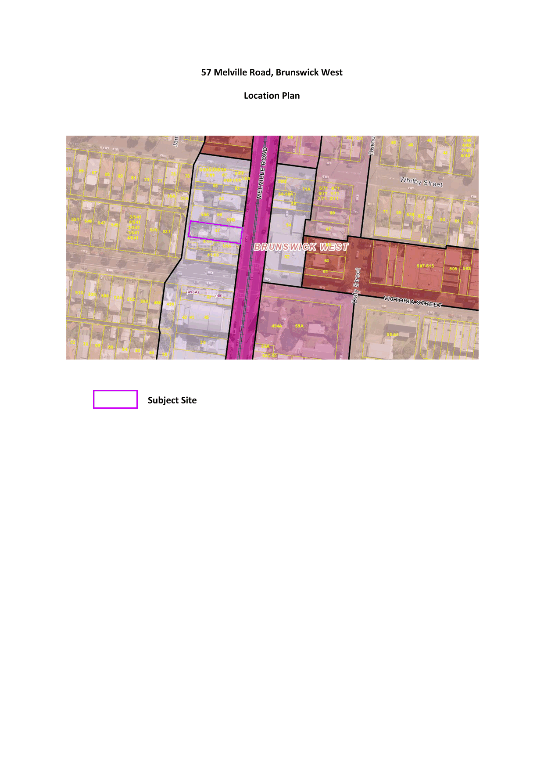
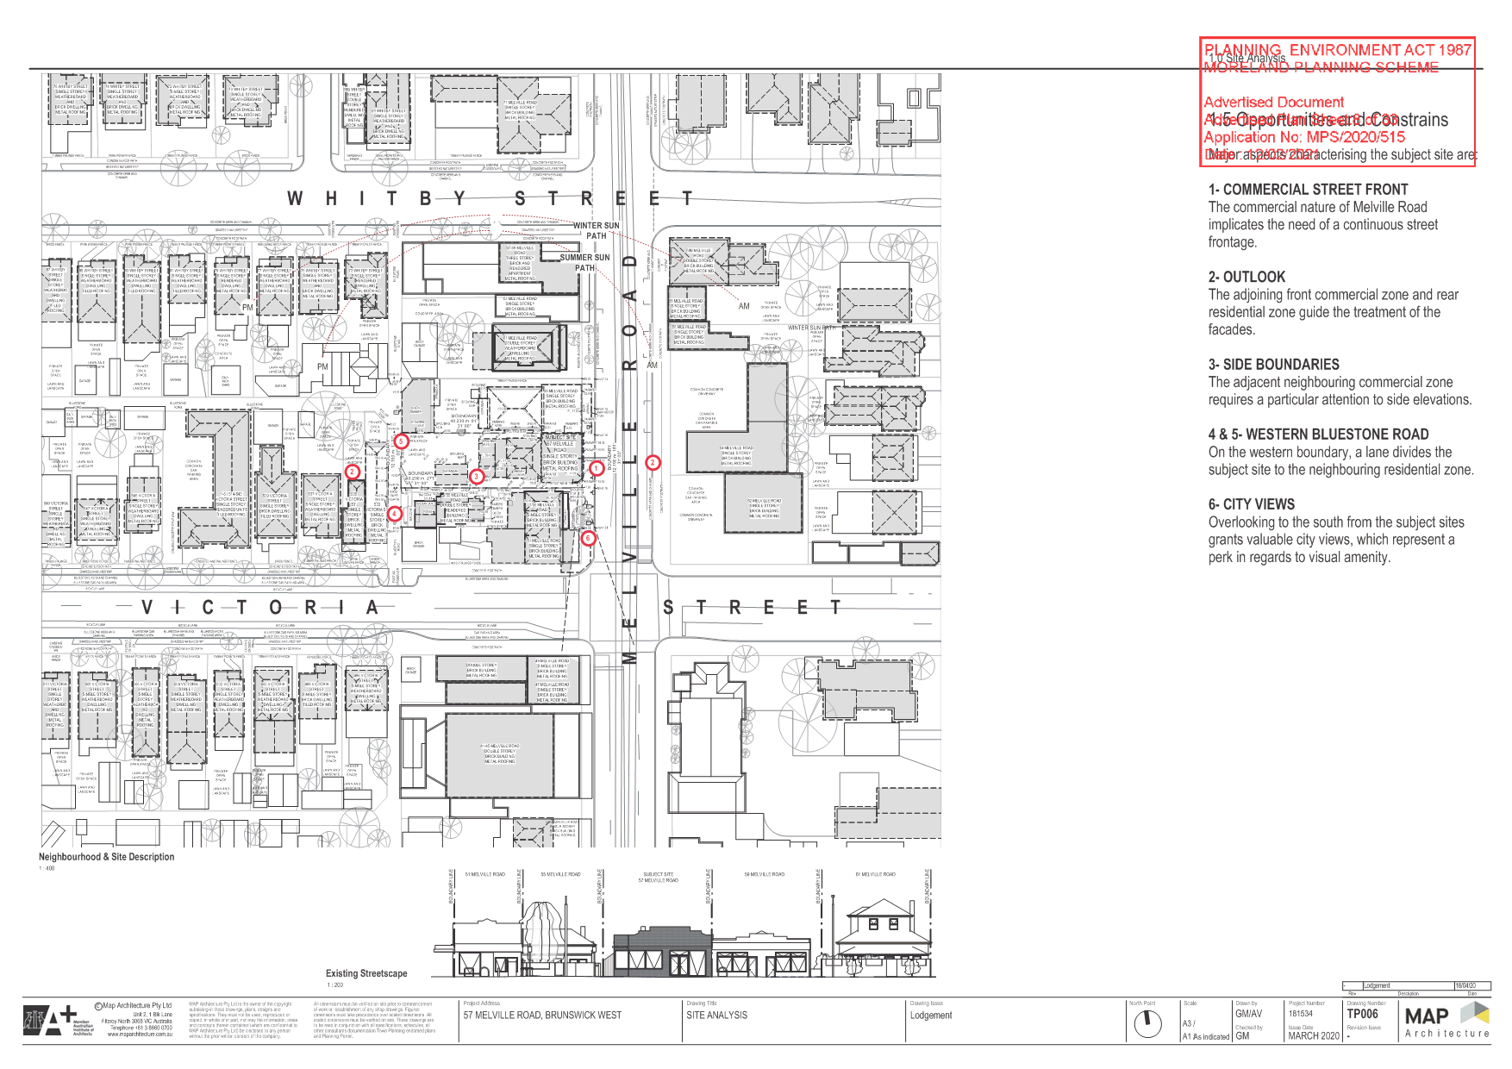

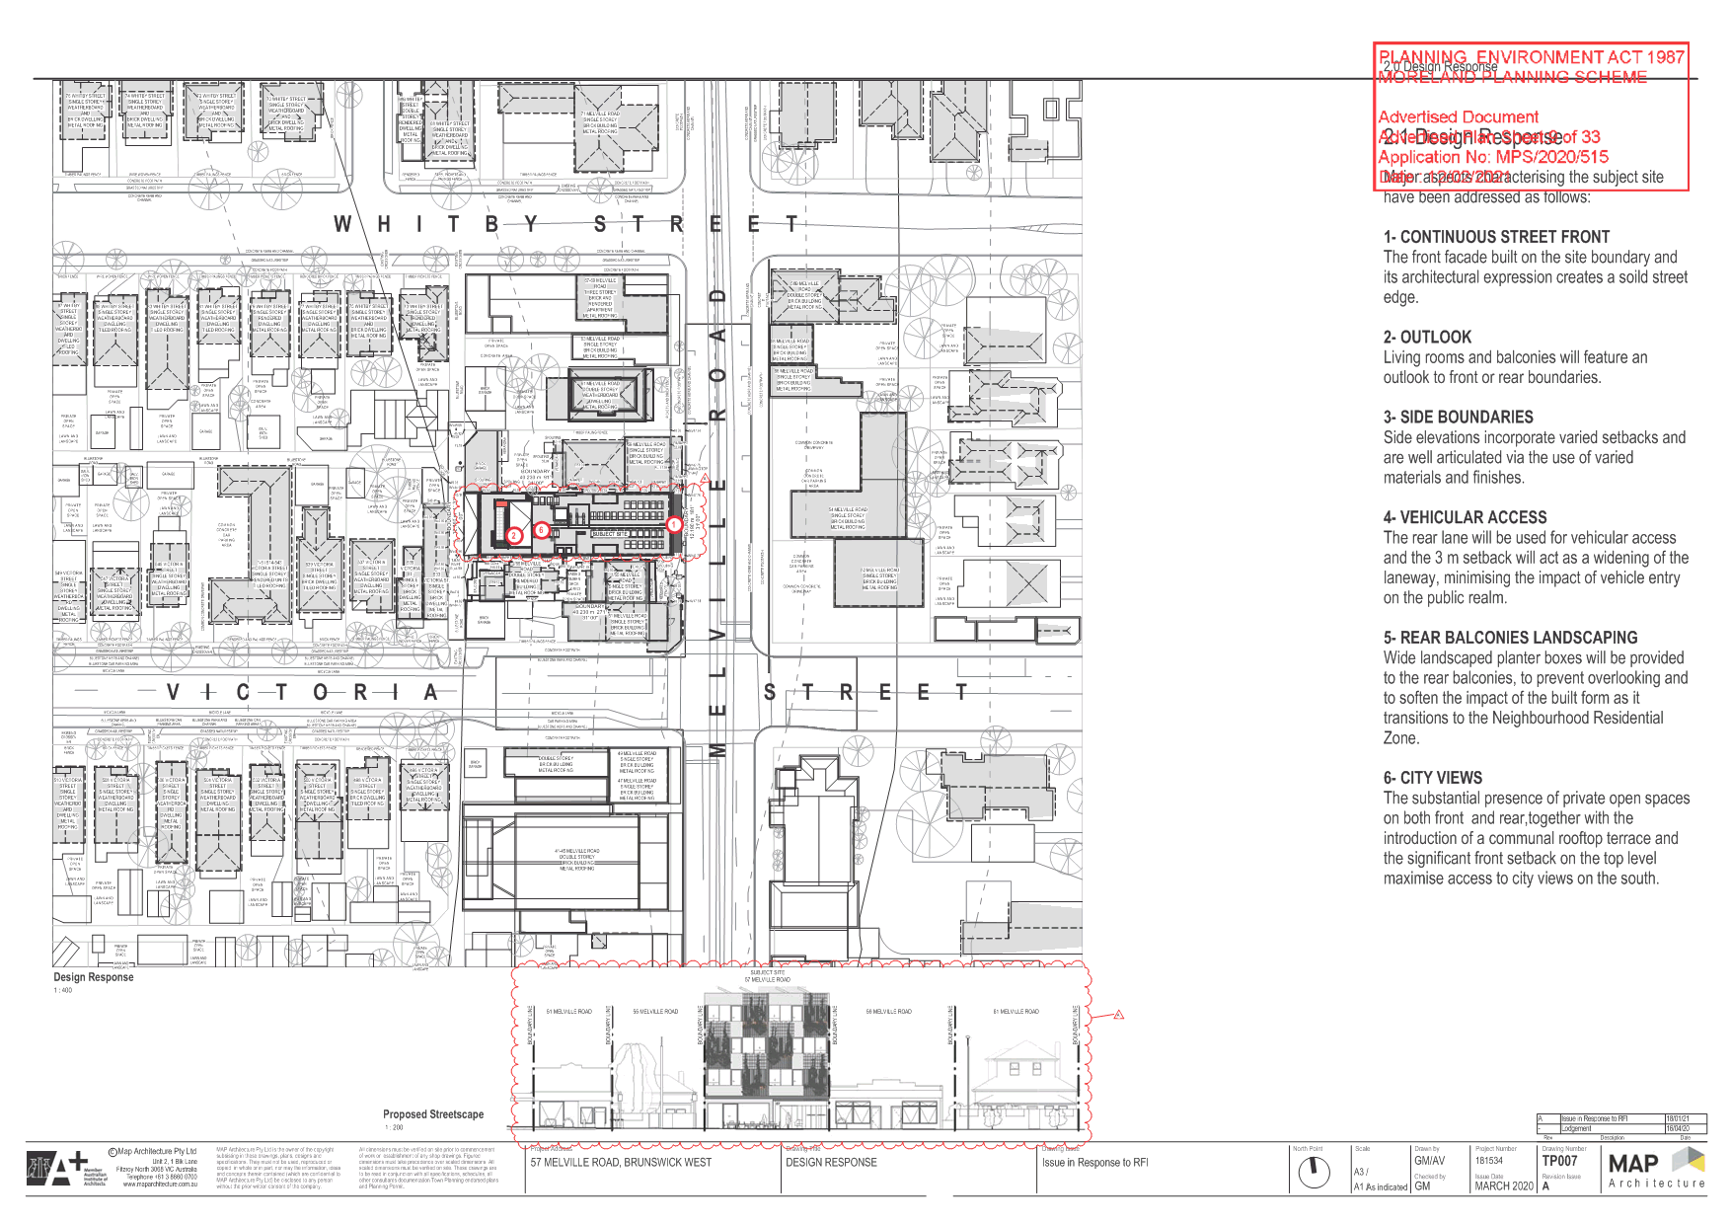

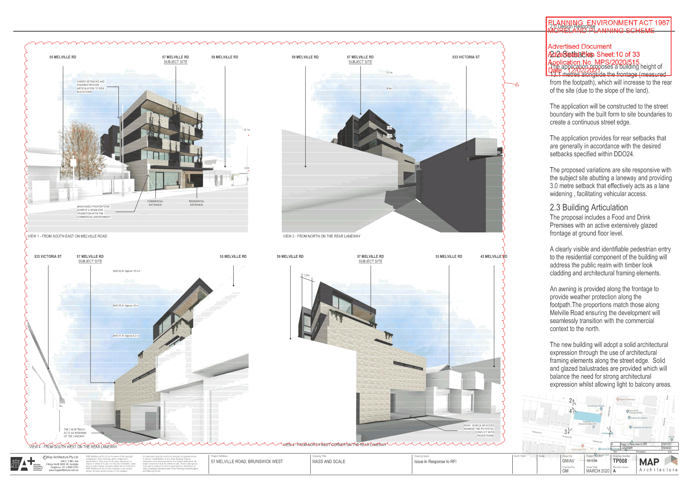

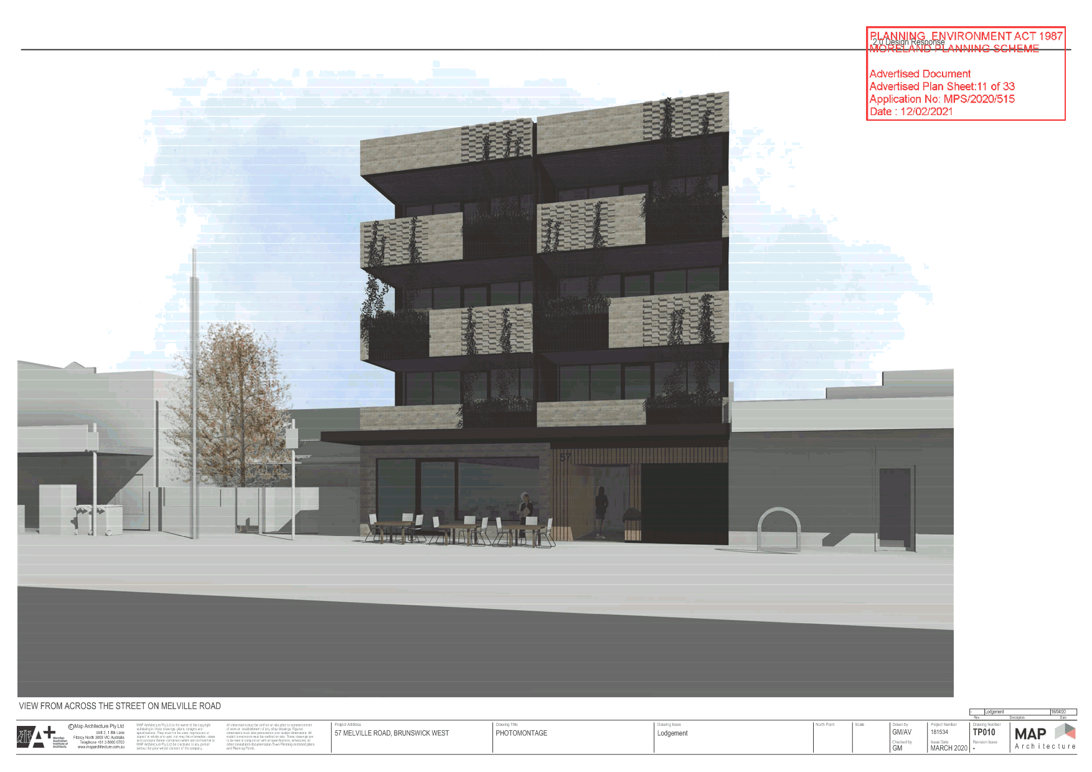

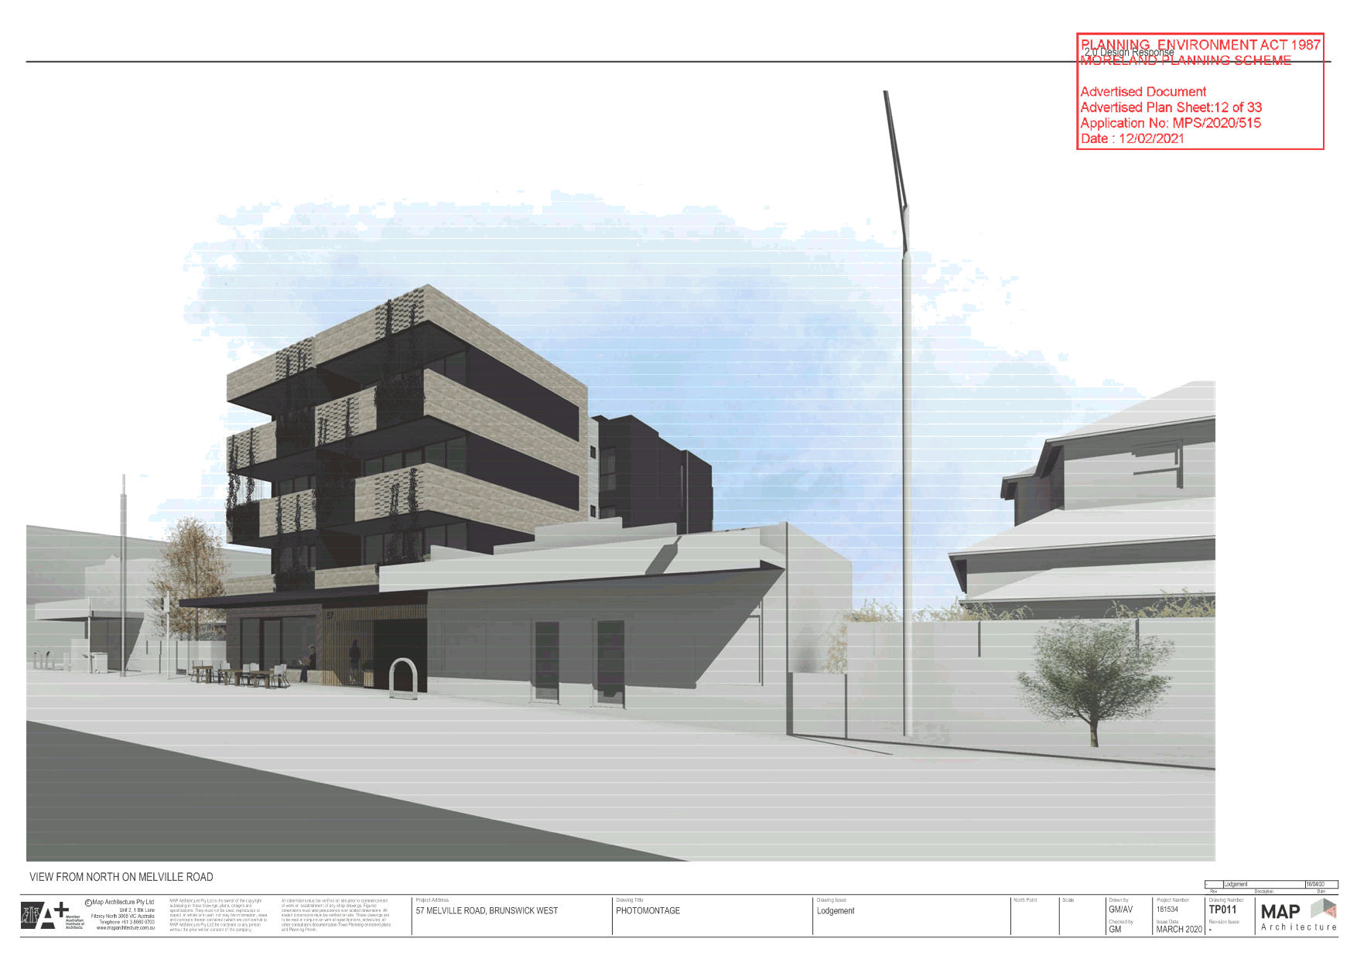

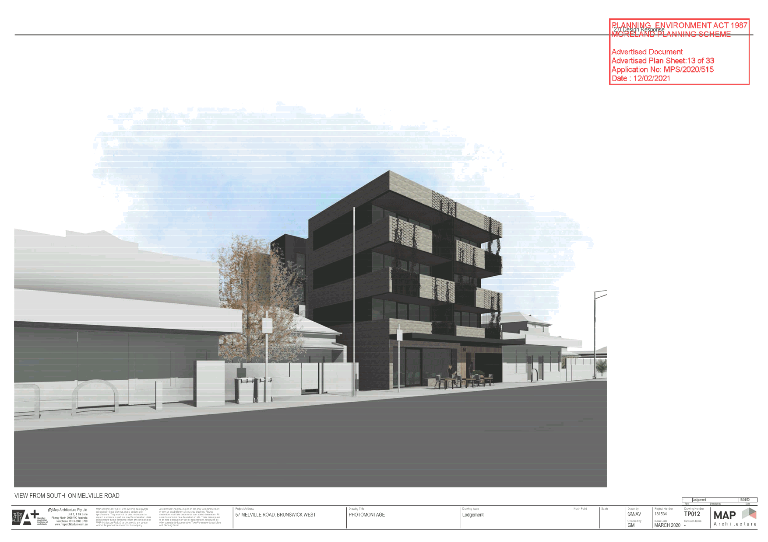

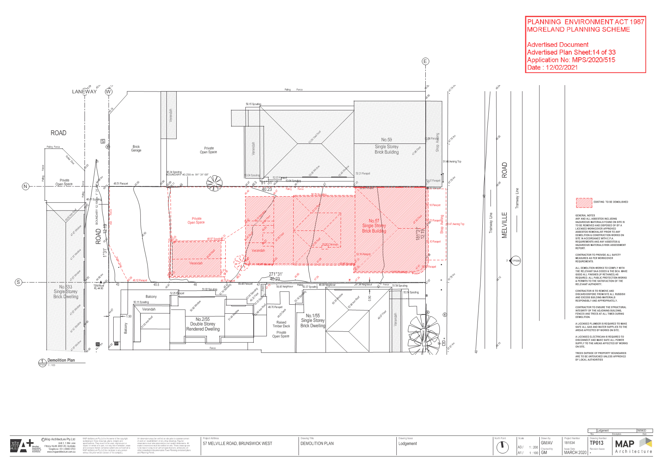

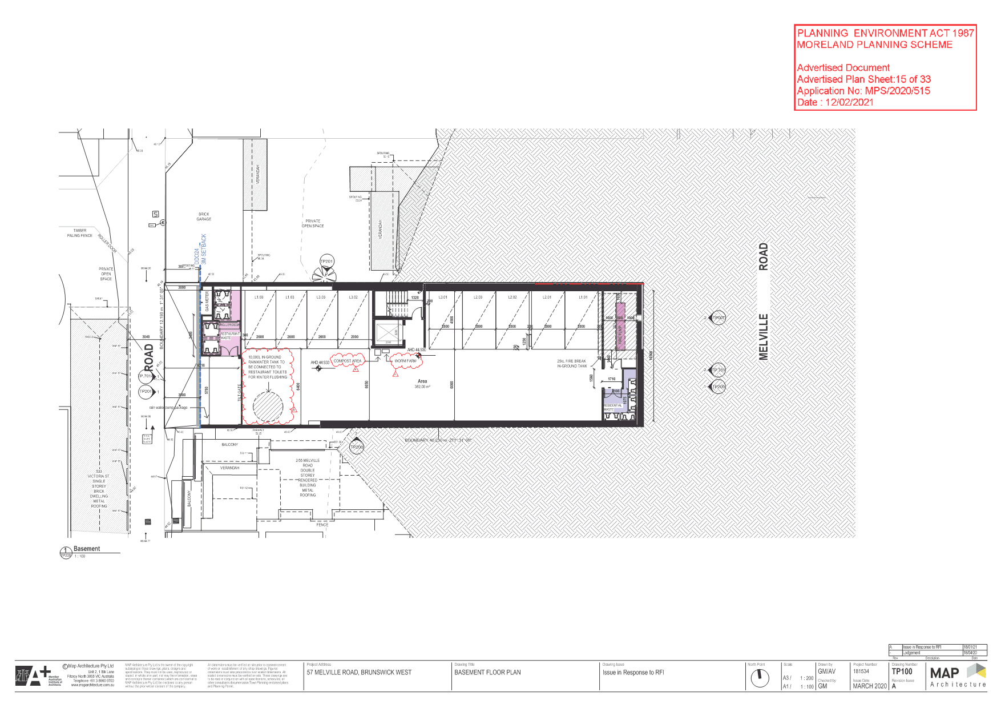

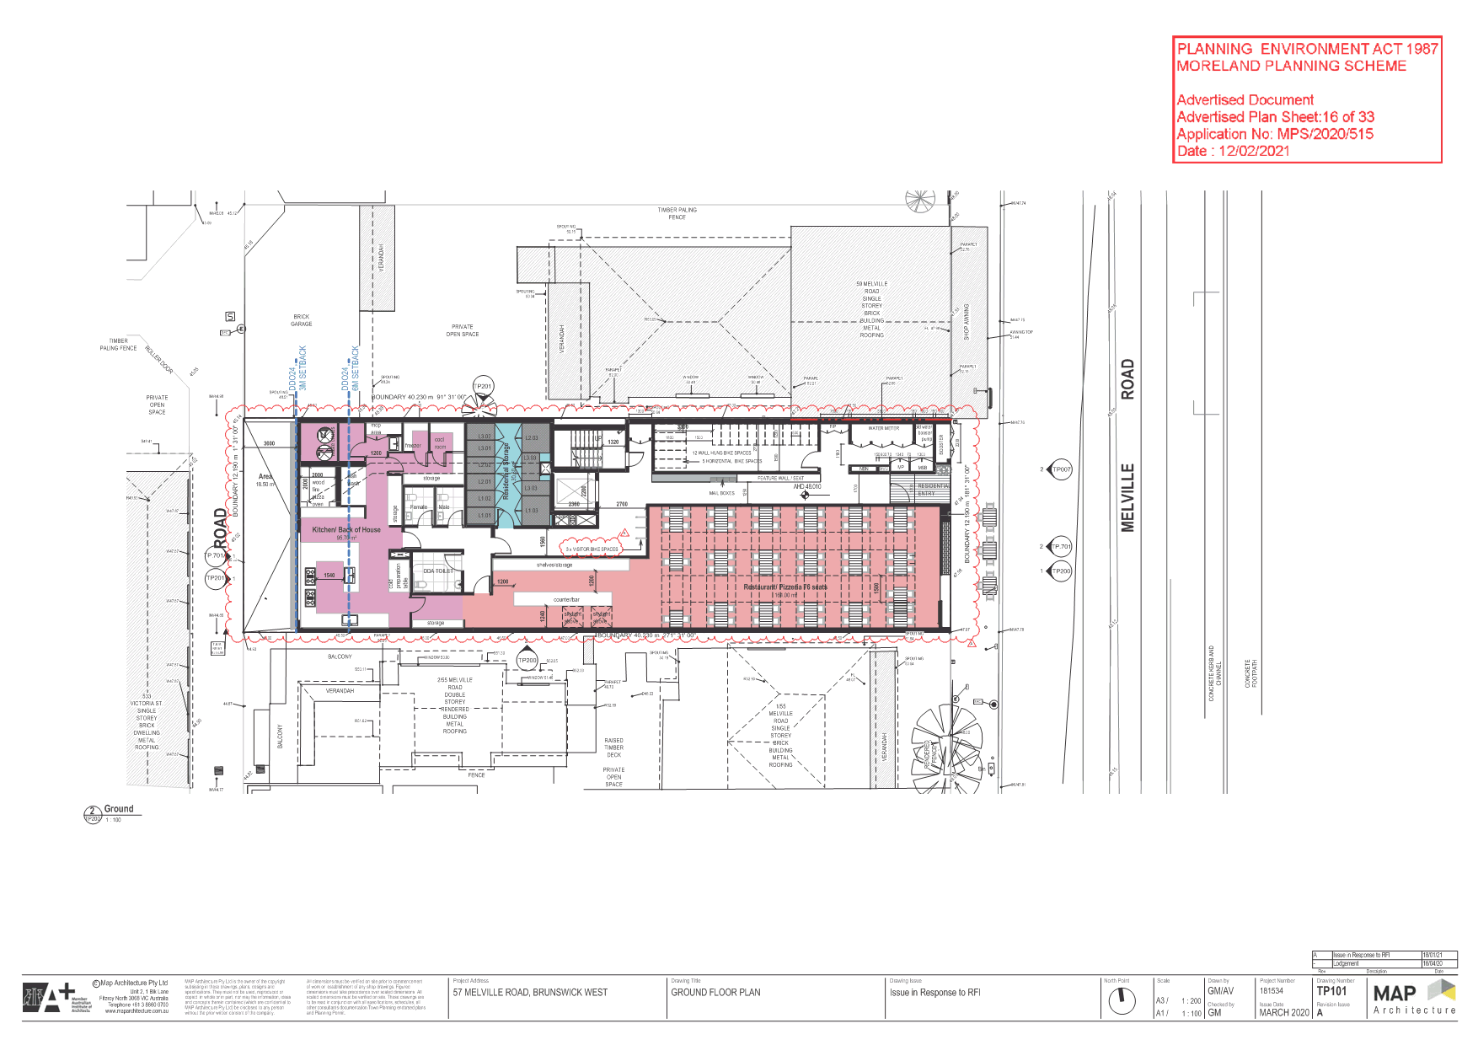

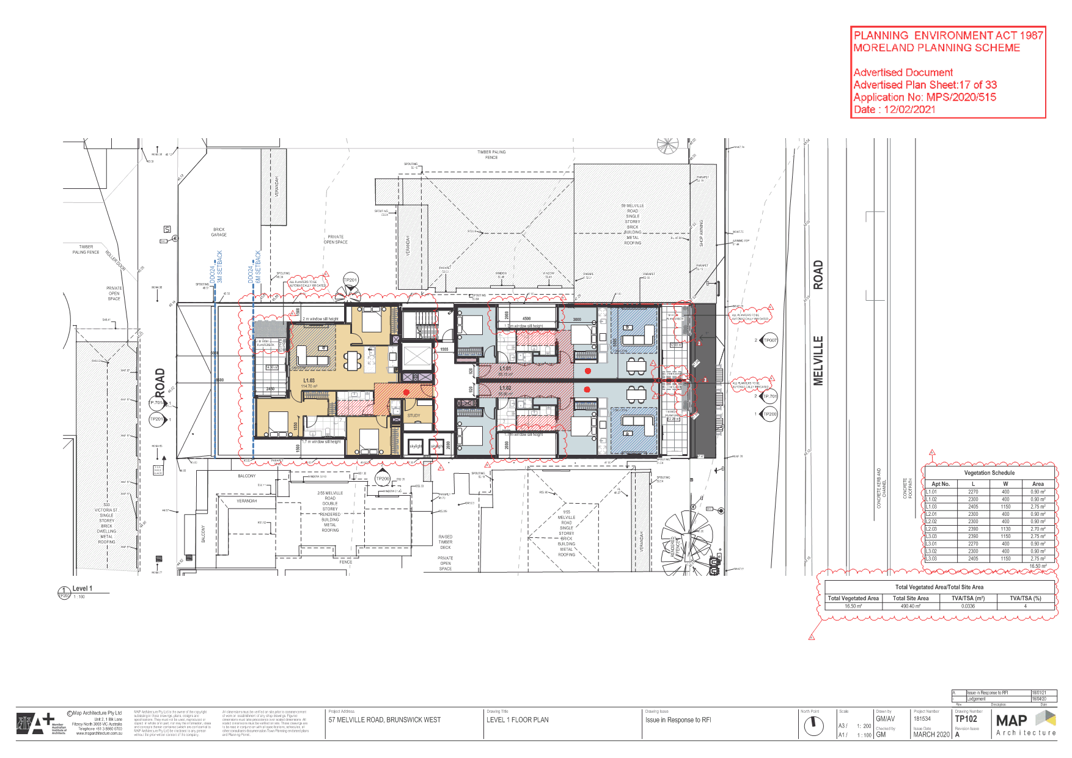

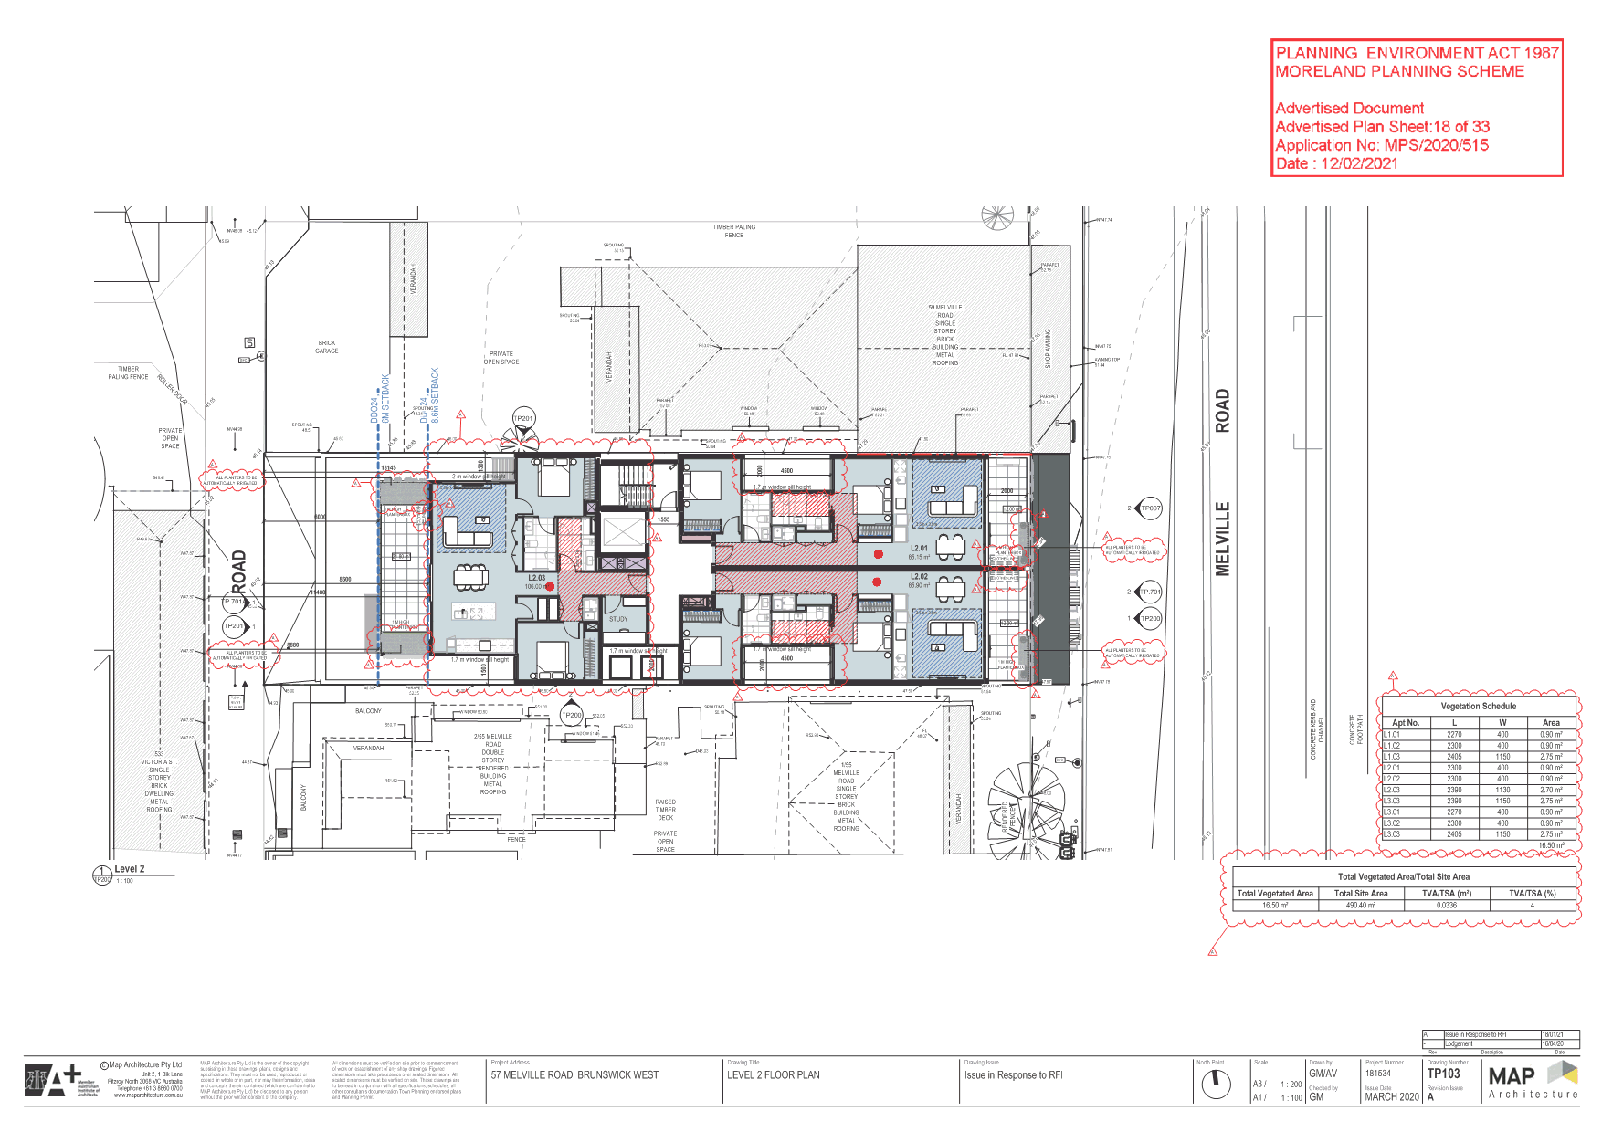

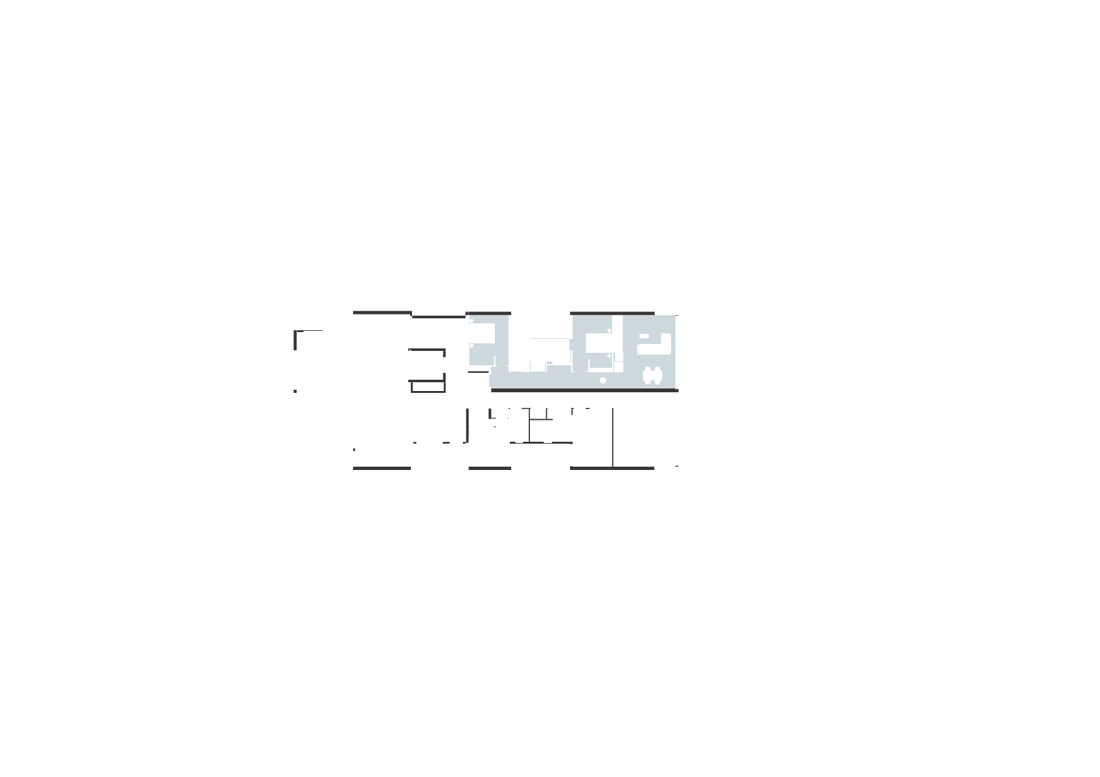
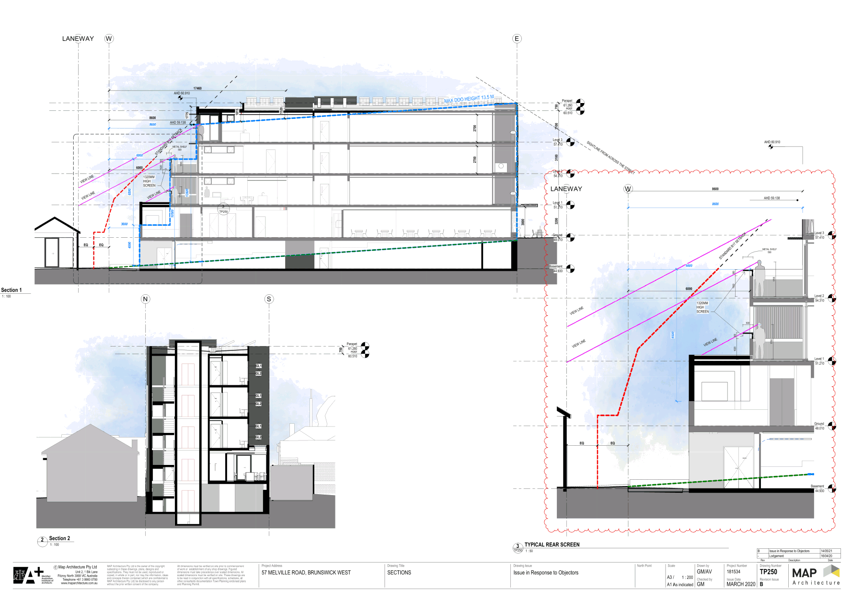
5.3 429 Albert Street, Brunswick - Planning Application MPS/2020/674
Director City Futures Kirsten Coster
City Development

Executive Summary
Property: | 429 Albert Street, Brunswick
Proposal: | Construction of two 8 storey buildings (with roof top terraces) containing dwellings and food and drink premise and 10 three storey dwellings over two basement levels and a reduction in the standard car parking requirements
Zoning and Overlays: | • Mixed Use Zone (MUZ)  • Design and Development Overlay (DDO26)  • Environmental Audit Overlay (EAO)  • Development Contributions Plan Overlay (DCPO)
Strategic setting:
Objections: | • 162 objections  • Key issues:  • Building height and visual bulk  • Setbacks to residential land, the park and Albert Street  • Parking and traffic
Planning Information and Discussion (PID) Meeting: | • Date: 29 April 2021  • Attendees: 43 objectors, the applicant and representatives, Council officers, and Deputy Mayor Cr Riley and Cr Conlan  • No changes were agreed to; however the meeting provided an opportunity for the objectors concerns to be discussed and helped inform the preparation of this report.
ESD: | • Minimum average NatHERS rating of 6.5 stars
Accessibility: | • Adaptable apartments comprise 65% of the proposal
Key reasons for refusal | • Unacceptable visual bulk to Clifton Park and the rear of properties fronting Albert and Pearson Streets  • Inconsistency with built form requirements and design objectives of DDO26  • On and off site amenity impacts
Recommendation: | It is recommended that Council’s submission to VCAT be that no planning permit should be issued for the proposal, based on the grounds outlined in the recommendation.

Officer Recommendation
That Council’s submission to the Victorian Civil and Administrative Tribunal be that no planning permit should be issued for application No. MPS/2020/674 which seeks permission for the construction of two 8 storey buildings (with roof top terraces) containing dwellings and food and drink premise and 10 three storey dwellings over two basement levels and a reduction in the standard car parking requirements at 429 Albert Street, Brunswick, based on the following grounds:
1. The proposal fails to comply with the design objectives, built form requirements and decision guidelines of the Design and Development Overlay (Schedule 26) of the Moreland Planning Scheme and will not adequately respond to the preferred future character for the area, including that:
a) The proposal fails to provide meaningful breaks between buildings, creating a continuous wall of built form along Clifton Park and rear of properties fronting Albert and Pearson Streets.
b) The siting and setbacks fail to ensure that height above 4 storeys is visually recessive when viewed from Clifton Park and the rear of properties fronting Albert and Pearson Streets.
c) The bulk, location and appearance of the western interface of Buildings A and B does not scale down to respond to the lower scale and heritage significance of existing dwellings. This includes siting and setbacks that fail to comply with the Clause 55 standards and objectives of Standards B17 (Side and rear setbacks), B21 (Overshadowing) and B22 (Overlooking).
d) The proposal fails to provide a 3 metre landscaped setback and 4 storey (15 metre) height at its interface to Clifton Park. This in combination with the setback of upper levels and lack of landscaping opportunities fails to achieve a pedestrian scale to the precinct edge and a quality landscape design to integrate with the parkland context.
e) The proposal fails to ensure that building massing, separation and orientation optimises park views for new dwellings with the inadequate separation distance between Buildings A and B.
f) The provision of high fencing, booster cabinet and substation to Albert Street fail to provide a quality public realm interface, by limiting activation to Albert Street and opportunities for passive surveillance at the street level.
g) The 2.5 metre setback to the eastern boundary fails to create an inviting and quality public realm connection between Albert Street and Clifton Park.
h) The single height void space for the east to west pedestrian accessway below Building B does not provide a quality public realm interface of an appropriate scale and proportion to visually strengthen this pedestrian link.
2. The design of buildings fails to meet the strategies and guidelines of Clause 15.01-2L Apartment Development in Moreland with respect to:
a) The building separation between Buildings A and B, which does not meet distances specified in Table 3 and does not allow adequate daylight to living rooms or provide a reasonable outlook from living areas.
b) The building separation between Building A and the eastern boundary does not meet distances specified in Table 1 and does not enable the reasonable future development opportunity at 427 Albert Street.
3. The proposal is not consistent with the following strategies contained at Clause 15.01-1L Urban Design in Moreland:
a) The siting and design of Building B fails to contribute to a fine grain urban structure reflecting an appropriate balance of open space to built-form which results in unacceptable bulk when viewed from Clifton Park and the rear of properties fronting Albert and Pearson Streets.
b) High fencing to ground level dwellings at Albert Street and the location of the booster and substation co-located with the vehicle accessway fails to maximise an active frontage.
c) The proposal fails to ensure that landscaping integrates development with the surrounding environment being Clifton Park.
4. The proposal is not consistent with the following strategies contained at Clause 15.01-2S Building Design and Clause 15.01-2L Building Design in Moreland and results in amenity impacts and unacceptable visual bulk as:
a) The design response including the stepped form of Building A does not minimise the detrimental impact of development on neighbouring properties, the public realm and the natural environment.
b) The form, scale and appearance of development does not enhance the amenity of the public realm.
c) The proposal does not provide sufficient space and conditions for planting new canopy and screening trees.
5. The proposal results in unacceptable off-site amenity impacts and fails to meet the following requirements of Clauses 55 required by the Mixed Use Zone at Clause 32.04-10 Buildings on lots that abut another residential zone, including:
a) The proposal unreasonably impacts the energy efficiency of the dwelling 437 Albert Street, Brunswick which does not meet the objective of Clause 55.03-5 - Energy efficiency.
b) Side and rear setbacks at levels 1 to 7 of Building A and part of level 7 of Building B are not setback to limit the impact on the amenity of existing dwellings. The objective of Clause 55.04-1- Side and rear setbacks is not met.
c) The height of the boundary wall of Building A located on the western boundary fails to limit the impact on the amenity of existing dwellings which does not meet the objective of Clause 55.04-2 - Walls on boundaries.
d) The siting of walls opposite the habitable room windows at 437 Albert Street fail to allow adequate daylight to this dwelling which does not meet the objective of Clause 55.04-3 - Daylight to existing windows.
e) Overshadowing impacts by virtue of shadows cast so that the adjoining residential land at 437 Albert Street, Brunswick would receive unacceptable shadowing at 10am which does not meet the objective of Clause 55.04-5 – Overshadowing.
6. The proposal fails to meet the following standards and objectives of Clause 58 Apartment Developments:
a) The high fencing and booster fail to integrate the dwellings with Albert Street which does not meet the objective of Clause 58.02-5 - Integration with the street.
b) Building A will impact the daylight access to 437 Albert Street and the layout between Buildings A and B do not make appropriate use of daylight. The objective of Clause 58.03-1- Energy efficiency is not met.
c) The proposal provides 10 per cent of deep soil planting where Standard D10 requires 15 per cent (603sqm) deep soil planting to accommodate 6 large trees or 12 medium trees per 90 square metres. This fails to meet Clause 58.03-5 Landscaping objectives, in a location that is adjacent to a parkland context.
d) The needs of residents and the objective of Clause 58.07-1 - Functional layout objective, are not met with the following dwelling layouts B2G and B2G-1 which do not achieve the 3.6 metre living area dimension required in both directions.
7. The proposal fails to demonstrate that it achieves best practice performance objectives for stormwater quality required by Standard D13 of Clause 58.03-8 and Clause 53.18 Stormwater Management in Urban Development.
8. The design response does not meet Standard D1, Clause 58.02-1 - Urban Context objectives as it fails to respond to the preferred future development of the area and is not appropriate to the urban context and the site.
9. The proposal fails to adequately demonstrate the car parking demand likely to be generated by the proposal and whether the reduction and allocation of on-site car parking is appropriate and that on street car parking is not unreasonably impacted.
10. The proposal fails to commit to contribute to public realm upgrades to Clifton Park and Albert Street proportionate to the scale of impact from the development on parkland by virtue of increased use from new residents and shadowing from the proposal, including infrastructure needed to manage conflicts from the ‘active use’ of the sports grounds in Clifton Park.

REPORT

1. Background

Subject site
The subject site is located at 429 Albert Street, Brunswick. The site is comprised of two lots forming an irregular shaped land parcel. The combined Albert Street frontage is approximately 49.40 metres, and the site has a western boundary depth of approximately 84.92 and an overall size of 4,013 square metres.
The site contains an industrial building occupying the rear half of the site and has been used as a timber yard. Several mature trees are located on-site. There are two vehicle accessways at the frontage of the site. The site has abuttal to a laneway connecting to Pearson Street.
There are no easement or restrictive covenants indicated on the Certificates of Titles.

Surrounds
The immediate context contains single storey dwellings with recent development ranging from double to five storey heights.
Land to the west contains single storey dwellings fronting Albert Street and Pearson Street which are within the Heritage Overlay (HO56 Daly Street Precinct). These are Victorian and Edwardian era housing associated with the former Hoffman Brickworks.
To the immediate north, land has been developed with part four and five storey apartment buildings at 460 Victoria Street.
The eastern boundary partially abuts both Clifton Park and 427 Albert Street Brunswick which contains an industrial building. A Council owned narrow strip of land adjoins the site to the west. It provides an open drain for water within the laneway to drain to Albert Street.
The subject site and lots at 395, 397-401, 403, 405, 407, 409, 411, 413, 417, 423 and 427 Albert Street, Brunswick comprise the ‘Albert Street Urban Renewal Precinct’ as defined in the Design and Development Overlay Schedule 26. The Precinct is bounded by Clifton Park to the north and east, Albert Street and Gilpin Park (across Albert Street) to the south.
The Precinct is currently occupied by a number of industrial businesses as well as residential dwellings, however by virtue of its designation in the planning scheme, this is anticipated to change in the future.
A location plan forms Attachment 1.

The proposal
The proposal is summarised as follows:
• Construction of two 8 storey buildings with roof top terraces, being Building A (27 metres) fronting Albert Street and Building B (27.86 metres) adjacent to the eastern boundary with Clifton Park.
• Ten three storey dwellings are proposed at the rear western boundary with laneway abuttal.
• Ground level contains a 94.59sqm food and drink premises and communal resident areas including bicycle workshop and co-working space.
• A total of 155 dwellings, comprising 54 one bedroom dwellings, 80 two bedroom dwellings and 21 three bedroom dwellings (including townhouses).
• Two basement levels accessed via a double crossover at Albert Street with 142 car parking spaces (12 in tandem arrangement).
• Construction of a north-south pedestrian path connecting Albert Street with Clifton Park.
• Provision of an east-west pedestrian link allowing access from Pearson Street to Clifton Park.
• The townhouses, podium levels (ground to third floor) of Building A and the park interface of Building B consist of brickwork. Upper level materials are generally pre-cast concrete in a white concrete finish with planter beds to provide façade vegetation.
Key development and landscaping plans form Attachment 2, the renders form Attachment 3 the shadowing plans form Attachment 4.

Planning Permit and site history
The Albert Street Urban Renewal Precinct forms an area of 1.74 hectares, previously in the Industrial 1 Zone. In 2015 Council received a request for a planning scheme amendment proposing to rezone the land to allow for residential development.
Amendment C161 was considered a significant opportunity to increase housing supply in Moreland, improve the safety and amenity of Clifton Park by activating a presently blank interface and improve the connectivity of key open space areas within Brunswick’s open space network and was broadly supported by State and Local planning policy.
While the applicant had sought an eight storey discretionary height limit, Council resolved to seek a six storey mandatory height control.
Amendment C161 was publicly exhibited in 2016 and 10 submissions were received. No objections were made to the proposed rezoning, however a range of concerns were raised including built form, height and car parking.
The findings of an independent planning panel were reported to the 9 August 2017 Council meeting (DED73/17) including that the mandatory six storey height limit be deleted and replaced with an eight storey discretionary height limit. At this meeting Council resolved to abandon the amendment.
Subsequently the Minister for Planning used his powers pursuant to section 20(4) of the Planning and Environment Act 1987 to rezone the land to the MUZ and apply DDO26 with a discretionary eight storey height limit, consistent with the recommendations of the independent planning panel.

Statutory Controls – why is a planning permit required?
Control | Permit Requirement
Mixed Use Zone | A permit is required to construct more than one dwelling on a lot pursuant to Clause 32.04-6.  Both the Dwellings and Food and Drink Premises (which does not exceed 150 square metres) are Section 1 uses in the zone, meaning that a permit is not required for the uses.
Design and Development Overlay Schedule 26 | A permit is required to construct a building or construct or carry out works pursuant to Clause 43.02-2.
Particular Provisions | A permit is required to reduce the car parking requirement from 179 spaces to 142 spaces pursuant to Clause 52.06.
The following Particular Provisions of the Moreland Planning Scheme are also relevant to the consideration of the proposal:
• Clause 45.03: Environmental Audit Overlay. Information accompanying this application identifies that contamination onsite can be suitably managed. If the proposal were supported, a condition would require a Certificate or Statement of Environmental Audit be issued before commencement of development.
• Clause 45.06: Development Contributions Plan Overlay
• Clause 45.09: Parking Overlay
• Clause 52.34: Bicycle Facilities
• Clause 53.18: Stormwater Management in Urban Development
• Clause 58: Apartment Developments

2. Internal/External Consultation

Public notification
Notification of the application has been undertaken pursuant to Section 52 of the Planning and Environment Act 1987 by:
• Sending notices to the owners and occupiers of adjoining and nearby land within approximately 70 metres of the site
• Placing two signs at the Albert Street frontage, one sign at the laneway and three signs at the interface with Clifton Park
Council has received 162 objections to date. The key issues raised in objections are:
• Excessive height and visual bulk
• Overdevelopment/overcrowding
• Out of character with the area
• Not in an activity centre
• Impact to residential heritage properties to the west
• DDO26 setbacks and objectives not met
• Loss of daylight and overshadowing
• Loss of privacy and overlooking
• Insufficient car parking
• Traffic and parking congestion and safety impacts on road network
• Traffic report accuracy during COVID-19 pandemic
• Insufficient public transport and infrastructure
• Impact on Gilpin and Clifton parks
• Level of ESD and urban heat island effect
• Insufficient developer contributions, street and public realm upgrades
• Substantially residential development in a MUZ
• Unlit laneway should not be used for pedestrian access
• Townhouse backyards too small
• Rendered images are inaccurate
• Construction and noise impacts
• Community and public benefits
• Lack of affordable or social housing
• Setting a precedent
• No demand for rentals and the site should be parkland
• Retain bluestone laneway
• Loss of property value
• Loss of views
• Loss of tv/radio signal
• Gates to Clifton Park
• Litter and graffiti
A Planning Information and Discussion meeting was held on 29 April 2021 and attended by Deputy Mayor Cr Riley and Cr Conlan, Council Planning Officers, the applicant and approximately 43 objectors. The meeting provided an opportunity to explain the application, for the objectors to elaborate on their concerns, and for the applicant to respond. No changes have been made to the application following the meeting.

Internal/external referrals
The proposal was referred to the following external agencies or internal branches/business units:
External Agency | Objection/No objection
Transport for Victoria | No objection and no conditions recommended.

Internal Branch/Business Unit | Comments
Urban Design Unit | Does not support the proposal.  • It results in bulk and massing that dominates Clifton Park. The podium has insufficient setbacks from the park. Upper levels have insufficient setbacks from the podium  • The physical break between the upper levels of Building B fails to reduce the visual bulk presenting to the park  • The stepped form to the western interface (facing Albert Street) should provide a single step transition and avoid a ‘wedding cake’ profile  This advice is considered further at Section 4 of this report.
Sustainable Built Environment - Development Engineering Team | Supports the proposal.  • That pedestrian movements onsite from the laneway are appropriate subject to:  − reconstruction of the drain on Council land  − providing secondary, not primary access, to the townhouses  • The site has good access to a range of transport options  • That supply of 142 on-site car parking spaces is accepted, though acknowledged that the independent traffic engineering advice has queried the allocation of onsite car parking to meet demand  The suitability of proposed car parking is discussed in section 4.  If the proposal were supported, recommended design changes would form conditions of approval.
Sustainable Built Environment - ESD Team | Does not support the proposal as the design fails to meet Standard W2 and best practice stormwater management as required by Clause 53.18 Stormwater Management.
Open Space Design and Development Unit | • Does not support the podium setback less than 3 metres from Clifton Park, where a lack of landscaping fails to soften the built form.  • Does not support the proposed level of upgrades, which is not proportionate to the impact of development on parkland from increased use and shadowing.  • Supports direct access from dwellings onto the park.  • Confirmed that protective nets are not required to manage the recreational use of the sports grounds.  If the proposal were supported recommended conditions of approval, would require contributions to public upgrades.
Property | Supports the proposal to allow:  • Pedestrian movement from dwellings fronting the park subject to the creation of a ‘paper road’ to avoid privatisation of public land  • Pedestrian movement over Council owned land abutting the west boundary subject to reconstruction of the drain  If the proposal were supported, these recommendations would form conditions of approval.

3. Policy Implications

Planning Policy Framework (PPF):
• Municipal Planning Strategy (Clause 2), including:
− Vision (Clause 2.02)
− Settlement (Clause 2.03-1)
− Environmental and Landscape Values (Clause 2.03-2)
− Environmental Risks and Amenity (Clause 2.03-3)
− Built Environment and Heritage (Clause 2.03-4)
− Housing (Clause 2.03-5)
− Economic Development (Clause 2.03-6)
− Transport (Clause 2.03-7)
− Infrastructure (Clause 2.03-8)
• Settlement (Clause 11)
• Environmental Risks and Amenity (Clause 13):
− Contaminated and Potentially Contaminated Land (Clause 13.04-1S)
− Noise Abatement (Clause 13.05-1S and 13.05-1L)
• Built Environment (Clause 15.01), including:
− Urban Design (Clause 15.01-1S, 15.01-1R & 15.01-1L)
− Vehicle Access Design in Moreland (Clause 15.01-1L)
− Building Design (Clause 15.01-2S & 15.01-2L)
− Apartment developments in Moreland (Clause 15.01-2L)
− Healthy Neighbourhoods (Clause 15.01-4S and 15.01-4R)
− Neighbourhood Character (Clause 15.01-5S)
• Sustainable Development (Clause 15.02), including:
− Energy and resource efficiency (Clause 15.02-1S)
− Environmentally Sustainable Development (Clause 15.02-1L)
− Energy efficiency in Moreland (Clause 15.02-1L)
• Residential Development (Clause 16.01), including:
− Housing Supply (Clause 16.01-1S and 16.01-1R)
− Homes in Moreland (Clause 16.01-2L)
− Housing for People with Limited Mobility (Clause 16.01-1L)
− Housing Affordability (Clause 16.01-2S & 16.01-2L)
• Transport (Clause 18), including:
− Sustainable Personal Transport (Clause 18.02-1S & 18.08-1R)
− Sustainable Transport in Moreland (Clause 18.02-1L)
− Car parking (Clause 18.02-4S & 18.02-4L)
• Infrastructure (Clause 19.02), including:
− Open Space (Clause 19.02-6L)
− Development infrastructure (Clause 19.03)

Human Rights Consideration
This application has been processed in accordance with the requirements of the Planning and Environment Act 1987 (including the Moreland Planning Scheme) reviewed by the State Government and which complies with the Victorian Charter of Human Rights and Responsibilities Act 2006, including Section 18 (Taking part in public life). In addition, the assessment of the application has had particular regard to:
• Section 12: Freedom of movement - The proposed redevelopment of private land does not present any physical barrier preventing freedom of movement, including in relation to the adjoining park.
• Section 13: Privacy and Reputation - An assessment of potential for unreasonable overlooking has been undertaken in Section 4 of this report.
• Section 20: Property rights - The right of the landowner to develop and use their land has been considered in accordance with the Moreland Planning Scheme.

4. Issues
In considering this application, regard has been given to the State and Local Planning Policy frameworks, the provisions of the Moreland Planning Scheme, objections received and the merits of the application.

Does the proposal have strategic policy support?
This site is not located in an Activity Centre, meaning this is not a location that the Planning Scheme identifies as an area for significant growth. Clause 02.04 identifies the site as being in a Transition-residential area. This classification comes from the Moreland Industrial Land Strategy and was the catalyst for the rezoning to the Mixed Use Zone (MUZ). The purposes of the MUZ includes providing for housing at higher densities. Planning policies support increased residential densities in appropriate locations with strong strategic support at both State and Local level for:
• Housing growth into areas with access to shops, services and public transport in accordance with a ‘20-minute neighbourhood principle’ where communities can access many of their daily needs within a 20-minute walk, cycle or public transport trip from their home (Clause 02.03-1 Settlement and Clause 16.01-1S Housing supply)
• Housing growth and change in accordance with the Strategic Framework Plan: Housing which identified this site as a Transition Residential Areas (Clause 02.03-5 Housing)
The site has policy support to accommodate increased residential densities, the commercial food and drink premises and change from the existing character.
However, the built form design response does not respond appropriately to its interfaces and the objectives of DDO26, as set out in this report.

Does the proposal respond to the built form requirements and design objectives of DDO26?
The Design and Development Overlay DDO26, that affects the site, outlines the preferred built form outcomes and objectives that are to be achieved within the Albert Street Urban Renewal Precinct.
Building Height and Scale
The height of Building A and B are 27 metres and 27.86 metres respectively. The roof top terraces increase the overall height to 30.67 metres. DDO26 allows a discretionary eight storey height of 28 metres. Design objectives of DDO26 include:
• To support quality medium density residential development that is mid-rise built form in character, with a pedestrian scale to the precinct edges and a western interface that is scaled down and provides a separation to respond to the lower scale and heritage significance of existing dwellings.
• To provide a quality public realm interface by including a visual and public pedestrian connection between Albert Street and Clifton Park, a high level of passive surveillance to external public spaces and internal communal areas, and quality landscape design to integrate into the parkland context
DDO26 provides built form guidance that:
• Development fronting Clifton Park should not exceed four (4) storeys
• Development within the precinct should not exceed eight (8) storeys
• Taller buildings above four (4) storeys in height should be set back from the four storey podium at the Albert Street and Clifton Park interfaces and from existing dwellings adjacent to the precinct, and be designed to be visually recessive when viewed from Clifton Park, Albert Street and the rear of properties fronting Albert and Pearson Streets. Balconies should not encroach into upper level setbacks
• Development should avoid creating a continuous wall of built form along the Clifton Park and Albert Street frontages by providing physical breaks between buildings
DDO26 anticipates height up to eight storeys at this site. The overall height generally accords with DDO26, except for the roof top terraces, which are small elements of each building and do not contribute to unreasonable additional bulk. However, key to consideration of this matter, is whether the siting and design of the top four levels is ‘visually recessive’ having regard to its interfaces to the west, Albert Street and Clifton Park.
The design locates three storey townhouses along the rear part of the west boundary with taller elements located towards Albert Street and the eastern edge of the site. This design results in unacceptable visual bulk to the residential interfaces to the west and to Clifton Park. The siting and design of Building B has an approximately 50 metre interface with the park. The upper levels (4-7) are setback approximately 2.8m from the lower levels. There is a break in the upper levels of Building B of 4.5 metres, which is readily apparent only when viewed from directly opposite the break. The proposal does not adequately respond to DDO26 because it is not designed to be visually recessive and fails to avoid creating a continuous wall of built form to the park.
The break provided between Building A and B of 7 metres separation is more apparent when viewing the development from the west. However, this does not ameliorate the visual bulk of the design, siting and continuous form at the upper levels of Building B.
The recommendation includes grounds to reflect these design and bulk concerns, noting the proposed materiality is considered acceptable.

Clifton Park interface
The built form requirements of DDO26 require a 3 metre setback from Clifton Park at ground and podium levels. Levels above the podium are to be designed to be visually recessive, however DDO26 does not specify a setback requirement.
A 3 metre setback to the eastern boundary is not provided for half the length of the site’s abuttal with the park. Proposed setbacks are between 1.1 and 6.33 metres (due to the angle of the boundary) at ground and podium levels.
The upper levels are setback from the podium by approximately 2.8 metres. At level four Building B contains pergola structures that increase the podium height to 16.5 metres. This design response seeks to balance proportions of the podium height and eight storey tower height. However, this results in the podium height exceeding the 15 metres guidance in DDO26. The render images of the development from Clifton Park identifies the proposed built form of level four aligning with the recent apartment development at 460 Victoria Street. However, the renders appear to be inaccurate. The podium of Building B will sit higher than the adjoining building by approximately 2.6 metres.
The lower and upper levels of Building B are located closer to Clifton Park than DDO26 anticipates. The design response fails to provide a pedestrian scale to Clifton Park and visually recessive upper levels. The proposal is too dominant when viewed from the park.
The render images illustrate mature trees in the setback to the park and Building B, where there is insufficient space to accommodate this planting. The proposal fails to achieve a landscaped interface to soften the visual impact and integrate development with its parkland context, as sought by DDO26.
These matters form grounds in the recommendation.
Albert Street interface
In contrast to the Clifton Park interface, the 3 metre setback of upper levels above the Albert Street podium is less dominating. This building composition is accepted as being visually recessive because the podium length is longer than the upper levels.
At ground level non-residential uses are located on the boundary and dwellings are setback between 3.6 to 4.65 metres. This is consistent with DDO26 which seeks a landscaped interface to dwellings accessed directly from Albert Street. However, there is 1.6 metre high fencing and a booster cabinet in front of these dwellings. The remainder of the ground floor accommodates a 6 metre wide vehicle accessway and 8.5 metre wide substation. The design therefore fails to promote an active frontage to Albert Street and passive surveillance as sought by DDO26. The design ‘steps’ down in scale at its interface to the west. However, the stepped form creates a ‘wedding cake’ appearance and encroaches into the setbacks anticipated by DDO26. A single ‘step’ and overall lower height at this interface is needed to respectfully transition down to respond to the single storey character and height.
These matters form grounds in the recommendation.
Pedestrian Paths
A 3 metre wide setback at ground level is provided along the eastern abuttal with 427 Albert Street. This provides the Primary Public Path requirements of DDO26. The 3 metre width is sufficient in the interim to allow passage for the public. When 427 Albert Street develops, a comparable setback should be sought to widen this connection and enhance visibility of the park from Albert Street. Activation of this space is achieved with the commercial and communal spaces fronting this path.
Level 1-3 encroach into this space, with a setback of 2.5 metres. This reduces the sense of openness and is insufficient to provide a quality public realm interface and primary connection between Albert Street and Clifton Park. A minimum setback of 3 metres should be provided. This matter forms a ground in the recommendation.
An east-west pedestrian accessway is provided from Clifton Park to the laneway connecting to Pearson Street. Building B partly projects over this space. Whilst objectors have raised concerns about the use of this unlit laneway to this site, the east-west link meets the intent of DDO26 to prioritise pedestrian, instead of vehicle access, to the precinct from this laneway. A double height void instead of single, should be provided as an appropriate scale and proportion to visually strengthen this link. This matter forms a ground of refusal in the recommendation.
If the proposal were supported, conditions of approval would require that a section 173 Agreement be entered into to ensure public access to both pedestrian links, maintenance, lighting and public liability.
Public Realm and Upgrade Works
DDO26 seeks that the developers of the Albert Street Urban Renewal Precinct contribute to the cost of upgrades to Albert Street and Clifton Park. This proposal commits to some public realm and upgrade works including undergrounding powerlines (subject to approval from the power authority), street tree planting and new footpath at the site’s frontage. A pedestrian crossing is proposed to align with the Primary Public Path. Upgrade works in Clifton Park include removal and realignment of a pedestrian path and the replacement of trees.
The extent of public realm works committed to by the applicant is not proportionate to the impact of the scale of development on parkland, due to increased use from new residents and shadowing from the proposal. Council considers that the following public realm infrastructure is needed and should be contributed to, in part, by this application: changes to the road reserve to accommodate new tree planting (not in the footpath where it conflicts with the awning), removal of redundant path lighting and new lighting in Clifton Park and upgrade of the pavilion change room and toilet block located east of the precinct edge.
This forms a ground of refusal in the recommendation.

Does the proposal result in any unreasonable off-site amenity impacts?
The MUZ and DDO26 require compliance with some Clause 55 amenity standards in order to mitigate impacts on residential land to the west and these are considered below.
Visual bulk and impact on daylight
The ‘stepped’ form of Building A does not comply with the standards relating to:
• Standard B17 seeking to setback the building from the side (western) boundary. The proposal fails to meet Standard B17 at all levels with encroachments ranging from 3.8 metres to 5.2 metres.
• Standard B18 seeking a boundary wall height that does not exceed 3.2 metres. The proposal has a 7.05 metre high wall on the western boundary.
• Standard B19 seeking to allow adequate daylight to existing windows by setting back walls at least 50 per cent of their height. This is not met at any level, with the non-compliance ranging from 0.43 metres to 1.5 metres.
Level 7 and the rooftop terrace of Building A and the southernmost tower of Building B are not setback the respective 21.6 metres and 22 metres from the western boundary as required by Standard B17.
The design response results in a reduction of daylight to 437 Albert Street which impacts energy efficiency and unreasonable visual bulk that fails to respond to the character of existing heritage properties to the west.
These matters form grounds of refusal in the recommendation.
Overshadowing
At 9am at the equinox shadowing from the proposal falls onto 437, 439 and 441 Albert Street, 44, 46 and 50-52 Pearson Street and the car park and bin store area at 376 Albert Street. The existing conditions of 437 and 439 Albert Street mean that the private open spaces do not achieve 30sqm and 37sqm respectively of sunlight at 9am. Compliance with Standard B21 requires that there is no additional shadowing to these rear yards. However, this would unreasonably impact development potential of the site. Therefore, shadowing impacts cast from the proposal at 9am are accepted.
In contrast, shadowing at 10am only affects 437 Albert Street and is cast from the southernmost townhouse. The site is large enough to ensure no shadowing to 437 Albert Street occurs at 10am. This impact is not accepted and forms a ground of refusal in the recommendation.
The rear of 44 Pearson Street has planning approval for the development of units, which will be impacted by shadows cast from the proposal at 9am. The overshadowing impact is acceptable as construction has not substantially commenced and the non-compliance is largely related to shadowing from the development itself.
Clause 55.04-5 Overshadowing open space objective requires assessment at the equinox (being 22 September) and does not require consideration of shadowing in winter months.
Shadowing to Clifton and Gilpin Parks is accepted. DDO26 anticipates heights up to eight storeys in this parkland setting. Both Clifton and Gilpin Parks are large parks which achieve adequate solar access throughout the day despite shadowing consistent with redevelopment of the precinct.
Overlooking
Some screening is proposed to the development where it interfaces with residential land to the west. If the proposal were supported conditions of approval would require compliance with Standard B22 to mitigate views within 9 metres including from the southernmost townhouse.
The eight storey buildings are setback 17 metres from the nearest residential property. Nine metres is the accepted standard for preventing unreasonable overlooking and views beyond this distance are not required to be screened.

Has adequate car parking and loading/unloading been provided?
Clause 52.06 requires a total of 179 car parking spaces, three spaces for the food and drink premises and 176 spaces for the dwellings. The site is within the Principal Public Transport Network Area with no statutory requirement to provide visitor parking onsite.
The applicant’s traffic report identifies that three spaces for the commercial tenancy and 139 spaces for the dwellings would be adequate to meet the anticipated demand at the site. A total of 99 spaces are to be allocated to one and two bedroom dwellings and 40 spaces to three bedroom dwellings. This results in 35 dwellings without any on-site car parking.
The site is located close to the Brunswick Activity Centre (780 metres distance) as well as other amenities located within the Grantham Street Neighbourhood Centre. The proposal provides 173 bicycle parking spaces, well above the 47 spaces required by Clause 52.34. The site has attributes for good walking and cycling connections as well as good access to frequent public transport options. This includes:
• Five different bus routes within 1.1 kilometres distance of the site, with two bus routes with bus stops located within 300 metres of the site
• Tram route 58 with the Dawson Street / Foden Street stop located 434 metres from the site
• Tram route 19 and the Brunswick Railway Station located near Sydney Road being 1030 to 900 metres distance respectively
Planning policy at Clause 52.06 Car Parking and Clause 18.02-4L Car parking in Moreland provide support for some reduction. Whilst the site does not have ‘excellent’ access to public transport, it has access to a range of public transport options. The reduction of 37 car parking spaces is not substantial and is supported in this location, if the car parking provided is appropriately allocated to meet demand.
To support Council’s Development Advice Engineer, a peer review of the applicant’s traffic report has been sought. This review concludes that the car parking demand is likely to be 135 spaces which is higher than the 120 spaces set out in the applicant’s report. The review identifies that the demand for two bedroom dwellings is anticipated to be 76 spaces where the proposal seeks to allocate 66 spaces and 35 spaces for one bedroom dwelling where 33 are allocated. The supply of 142 onsite car spaces may be appropriate, however the proposal fails to demonstrate the proposed manner of car parking allocation will satisfy the demand so as not to unreasonably impact unrestricted on street car parking. This forms a ground of refusal in the recommendation.
No on-site loading bay is proposed. The size of the commercial tenancy will not generate demand for deliveries requiring onsite loading. Vehicles can access basement level 1 with waste collection undertaken by a private company.

What impact does the proposal have on car congestion and traffic in the local area?
Up to 763 additional vehicle movements per day will occur on Albert Street as a result of the development. Objectors have raised concerns with the increased traffic from this proposal and the operation and safety of the road network.
Council’s Transport Engineers consider that the anticipated increase in traffic generation will not unreasonably affect the operation or safety of Albert or Pearson Streets. Albert Street is a local road and Pearson Street is a collector road that takes higher traffic volumes than local roads. Council recently undertook traffic counts in Albert Street and surrounding streets in March 2021 after the reduction in typical traffic volumes due to the COVID-19 pandemic. The existing volume of daily vehicle movements in combination with those from the proposed development do not exceed the capacity of the road network or pose unreasonable safety concerns to road users.
Whilst it is a local street, Albert Street can take volumes of traffic higher than a typical local road due to its width and layout. The recorded speeds in Council’s recent traffic count did not identify that the installation of traffic calming measures is required. Additional signage to make vehicles aware of cyclists on Albert Street is recommended, as part of public realm works undertaken by the developer. The peer review advice obtained by Council also confirms that the Albert and Pearson Street intersection and Albert, Gardiner and Fallon Street intersection will both operate under excellent conditions during peak hours with traffic generated from this development.

Does the proposal provide appropriate onsite amenity and facilities?
The standards of Clause 58 relating to onsite amenity are generally met or exceeded, noting that:
• Communal open space of approximately 900sqm substantially exceeds the 250sqm required by the standard D6.
• 44% of apartments achieve cross ventilation, in excess of the 40% required.
Dwelling layouts B2G and B2G-1 fail to meet the objective of Clause 58.07-1. The layouts are not functional for the needs of residents as the living area does not achieve the 3.6 metre dimension required in both directions. This relates to a total of six dwellings.
The townhouses generally accord with the on-site amenity standards and objectives of Clause 55.05. The secluded private open space of nine townhouses are less than the required 25sqm. Ranging from 16 to 18sqm the non-compliance is acceptable given the minimum 3 metre depth and excellent access to parkland.

Does the proposal comply with Clause 15.01-2L Apartment development in Moreland?
This policy sets out building setback standards for apartments. The objectives relate to daylight and outlook, future development opportunities of adjoining sites and amenity impacts. The proposal is not compliant with a number of the standards set out in this Clause. The following variations are acceptable:
• A 4.5 metre setback is required to level 3 up to level 7 at the north boundary. This increases to 6 metres at the top level. The non-compliances are 1.5 metres and 3 metres respectively. The adjacent site at 460 Victoria Street contains four and five storey buildings and will not develop to the same scale as the subject site. Therefore setbacks are not required to ensure adequate daylight access to lower levels, 460 Victoria Street achieves adequate daylight and outlook.
• From a daylight and outlook perspective, the break at upper levels of Building B is 4.5 metres where it should be 6 metres. This is appropriate for secondary windows to living spaces, bedrooms have adequate outlooks with oblique views to the park and sky and acceptable daylight.
• The separation between the townhouses and Building B generally exceeds the standard at ground and first level, with 8.2 metres, with exception to the 4.8 metre setback impacting only three dwellings (G08, 108 and 207). The 9 metre separation is not provided at level three, however the 8.2 metre distance provides adequate daylight and dwellings have long term access to oblique or upwards views.
The building separation between Building A and Building B required by Table 3 at Clause 15.01-2L is 9 metres up to level 3. This increases to 13.5 metres up to level 6 with the top floor separation increasing to 18 metres. This is not met with a uniform 7 metre setback provided. Adequate daylight is not achieved to dwellings at ground to level three in Building A with the proposed 7 metre separation. Furthermore, dwellings in the northern elevation of Building A do not have a reasonable outlook from living areas located adjacent to an eight storey building setback 7 metres. This design response also fails to optimise park views for new dwellings as sought by DDO26.
The setback of Building A from the eastern boundary does not meet the building separation distances of 3 metres up to level 3 and 4.5 metres at level 4. The 2.5 metre setback to the eastern boundary is not sufficiently setback to enable the reasonable future development at 427 Albert Street.
These matters form grounds of refusal in the recommendation.

Does the proposal result in appropriate landscaped outcomes?
Objections raised concerns with the loss of trees and impact to native wildlife from the development. Existing onsite trees are to be removed to facilitate development. The applicant’s arborist report advises that all trees, except one are of low or no arboricultural value. A Spotted Gum is of moderate value. A tree located at 437 Albert Street will be impacted with an encroachment of 29% into the tree protection zone. This Gossamer Wattle is in notable decline and not worthy of protection. These findings were reviewed by Council’s Open Space unit and are accepted.
Proposed works also include the removal of ten existing Melaleuca trees within Clifton Park to facilitate construction of the Primary Pedestrian Path. Council’s Open Space Planner is supportive of the removal of these trees providing an opportunity to gain a taller but more open tree canopy. The application proposes replacement trees within Clifton Park. If a permit were to issue this would form part of the public works plan.
Standard D10 requires 15 per cent (603sqm) of deep soil planting to accommodate 6 large trees or 12 medium trees per 90 square metres, where 10 per cent is proposed. Above ground planters have sought to provide extensive landscaping to the accessways, however non-compliance with Standard D10 impacts the ability to respect the landscape character of the area given its park abuttal. This matter forms a ground of refusal in the recommendation.

5. Response to Objector Concerns
The following issues raised by objectors are addressed in section 4 of this report:
• Excessive height, visual bulk and scale
• Out of character with the area
• Not in an Activity Centre
• Impact to residential heritage properties to the west
• DDO26 setbacks and objectives not met
• Loss of daylight and overshadowing
• Loss of privacy and overlooking
• Insufficient car parking
• Traffic and parking congestion and safety impacts on road network
• Level of ESD
• Insufficient developer contributions, street and public realm upgrades
• Unlit laneway should not be used for pedestrian access
• Townhouse backyards too small
• Rendered images are inaccurate
• Community and public benefits
Other issues raised by objectors are addressed below.
Overdevelopment/Overcrowding
The Victorian State Government has provided a clear policy imperative of urban consolidation as a way of providing housing for Melbourne’s growing population. DDO26 identifies mid-rise development to occur at this site. Density of the development is determined from a quantitative assessment of a development’s compliance with the Moreland Planning Scheme. As set out in this report the proposal fails to satisfy a number of policy objectives including the proposal’s ability to provide for the amenity of future residents, protect the amenity of existing residents and respond to the attributes and constraints of the site. Therefore the proposal is considered to be an overdevelopment of the site.
Substantially residential development in a MUZ
Objectors have concerns that the food and drink premise is tokenistic with development being substantially residential in a MUZ. The ground floor commercial tenancy seeks to benefit from DDO26 guidance that non-residential uses can provide a lesser setback than 3 metres to Albert Street. The provision of a commercial tenancy is a positive aspect of this proposal. The ground floor also provides a bicycle workshop and co-working space as communal facilities. On balance the mix of proposed uses is acceptable, noting the purpose of the MUZ is to provide for housing at higher densities. It is also noted that use of the land for dwellings does not require a planning permit in the MUZ so Council cannot restrict the amount of residential uses on the site.
Traffic report
Objectors have raised concerns that the applicant’s traffic report incorrectly states the distance to public transport options at section 1.6.3 and that the traffic movement counts were undertaken during the COVID-19 pandemic which are not representative of usual traffic conditions. The traffic report has factored a pre-COVID traffic movement rate into the traffic modelling to account for the reduction in typical volumes. Council’s Development Engineer and the peer review accept this methodology. The site’s distance from public transport options are set out in section 4 of this report.
Insufficient public transport and infrastructure
State Planning Policy supports an increase in development and land use activity in proximity to transport corridors and activity centres. The availability and frequency of public transport is a State Government responsibility. This report notes that the site has good access to public transport but concludes that the allocation of onsite car parking is not anticipated to meet demand for car parking from the proposal.
The site owner will be required to address infrastructure servicing demands of the development as stipulated by the various service agencies at the time of either subdivision or connection of the development including any service authority requirements to contribute to the cost of upgrading trunk infrastructure
Impact on Gilpin and Clifton parks
Objections have raised concerns about the impact of increased population close to and usage of Clifton and Gilpin Parks as well as shadowing impacts. Council is commencing work on a Development Plan to improve the Brunswick Central Parklands including Gillon Oval, Brunswick Park, Clifton Park, Reaburn Reserve and Gilpin Park. The Development Plan will set the strategic future direction for the open space and provide a framework for new works and future upgrades. Whilst developers are required to pay public open space contributions at subdivision, DDO26 also requires public realm upgrades specific to the Albert Street Urban Renewal Precinct. As detailed in section 4, the level of upgrades committed to as part of this proposal is not proportionate to the scale and impact of this proposal and this forms a ground of refusal in the recommendation. Shadowing impacts are discussed at section 4. Some trees within Gilpin Park will be shadowed from this proposal in winter months, however this is consistent with heights up to eight storeys sought by DDO26. Gilpin park is approximately 6.5 hectares with extensive tree coverage and there is the ability for additional works or tree planting to offset the impact from this proposal.
Urban heat island effect
The impacts of this proposal with respect to the urban heat island effect have been considered and are accepted. Aspects of the design such as the colour and materials of the roof and facades and shading reduce heat absorption. The loss of vegetation from the site and parkland will have an impact. Overtime this will be mitigated by new canopy tree planting, planting within the site and greening on the building, noting that deep soil planting and landscaping is insufficient and does not meet Clause 58.03-5, forming a ground of refusal in the recommendation.
Construction impacts
Construction techniques and effects – noise, dust, stability of existing foundations and damage to nearby dwellings - are dealt with under separate further permissions required should a planning permit be issued, including at the building permit stage.
Noise impacts
The proposed residential uses will have noise impacts consistent with that living in an urban area including speech, laughter, music and increased traffic. The permit applicant’s acoustic report confirms that plant and machinery including air conditioners will comply the relevant State Environmental Protection Policy, noting that future occupants must operate these at times which comply with the Environment Protection (Residential Noise) Regulations 2018.
Lack of affordable or social housing
As the site is privately owned, Council cannot require that social housing be provided. The permit applicant has advised that a $100,000 upfront donation to establish a specific fund for the Moreland City Council Local Government Area will be made to generate more social and affordable housing in Moreland as part of the Homes for Homes initiative. This initiative also donates 0.1 per cent of the subsequent sale price to Homes for Homes. If the proposal were supported, conditions of approval would require that a section 173 Agreement be entered into to confirm this commitment.
Setting a precedent
The Moreland Planning Scheme provides the strategic direction for increased residential densities and a changed character for this precinct. Future planning permit applications at nearby land will be assessed against this planning policy direction and site conditions, based on their own merits at the time of assessment.
No demand for rentals and the site should be parkland
The site is within private ownership and recently rezoned for mixed use to encourage increased residential densities in accordance with the strategic direction identified in the Moreland Planning Scheme. The apartment style housing that is provided in this development is responsive to the demographic trend of declining household sizes.
Retain bluestone laneway
The proposal does not seek changes to the bluestone laneway. As access via the laneway is secondary access for dwellings no changes are required which would remove bluestones from the laneway.
Loss of property value
VCAT has consistently found that property values are speculative and not a planning matter. Fluctuations in property prices are not a relevant consideration in assessing an application under the provisions of the Act or the Moreland Planning Scheme.
Loss of views
In relation to views, whilst it is recognised that views may form part of residential amenity, VCAT has consistently held that there is no legal entitlement to a view.
Loss of tv/radio signal
The potential impact of the proposal to tv or radio signals are outside the scope of the planning process and are not sufficient to warrant the refusal of the application.
Gates to Clifton Park
Objections have suggested that gates should be provided so that Clifton Park can be enclosed for use by dogs. The Primary Public Path is a key objective of DDO26 to provide an open and accessible pedestrian connection from Albert Street to the park. Restricting access with gates would not achieve this outcome.
Litter and graffiti
Matters concerning graffiti have been taken into account in the assessment of the application. The potential for occupants to litter does not warrant refusal of this application.

6. Officer Declaration of Conflict of Interest
Council Officers involved in the preparation of this report do not have a conflict of interest in this matter.

7. Financial and Resources Implications
There are no financial or resource implications.

8. Conclusion
On the balance of policies and controls within the Moreland Planning Scheme and objections received, it is considered that Council’s submission to VCAT be to not support application No. MPS/2020/674 for the reasons detailed in the recommendation.

Attachment/s
1 | 429 Albert Street Brunswick - Location Map | D21/198537
2 | 429 Albert Street Brunswick - Key Development and Landscape Plans | D21/199783
3 | 429 Albert Street Brunswick - Renders and sightlines | D21/199782
4 | 429 Albert Street Brunswick - Shadowing Plans | D21/199781



