Moreland City Council Annual Report
2013-2014

CONTENTS
OVERVIEW 2
MAYOR’S INTRODUCTION 3
CHIEF EXECUTIVE OFFICER’S REPORT 4
SNAPSHOT OF MORELAND 2013–2014 6
HIGHLIGHTS 9
COUNCIL PLAN 2013–2017 11
COUNCILLORS 18
CORPORATE STRUCTURE 21
FINANCIAL SNAPSHOT 22

OPERATIONS 24
GOVERNANCE 24
OPERATIONAL OUTPUTS 30
COMMUNITY SATISFACTION 32
HUMAN RESOURCES 33
OCCUPATIONAL HEALTH, SAFETY AND RISK 36
BEST VALUE 39

PERFORMANCE 41
PERFORMANCE REVIEW 41
PERFORMANCE STATEMENT 45
CERTIFICATION OF THE PERFORMANCE STATEMENT 54
INDEPENDENT AUDITOR’S REPORT 55
VICTORIAN GOVERNMENT PERFORMANCE INDICATORS 57

MORELAND CITY COUNCIL ANNUAL REPORT 2013–2014
This report outlines how the City of Moreland performed from 1 July 2013 to 30 June 2014.
The Council Plan 2013–2017 is the guiding document for this Annual Report. The Council Plan describes our strategic objectives in four focus areas and the key initiatives to be implemented to achieve them. The Annual Report provides an update on the highlights and achievements originating from this plan and addresses the challenges experienced throughout the year.
If you would like to view or order a copy of the Annual Report or the Council Plan, you can visit our Citizens Service Centres or contact us (03) 9240 1111. You can also view these documents at any of our libraries or on our website www.moreland.vic.gov.au.
We also welcome your feedback on this Annual Report. You can contact us on (03) 9240 1111, email us at info@moreland.vic.gov.au or write to us at Locked Bag 10, Moreland, 3058.

OVERVIEW
MAYOR’S INTRODUCTION
As someone who has lived my whole life in Moreland, I am proud of the way our Council served the local community in this financial year.
One of the key challenges that we faced during this year – and will continue to face in the future – is environmental sustainability. This is an area where we have taken strong action. We are one of only five Councils in Australia committed to becoming carbon neutral, which is reflected across a range of areas, including our promotion and support of environmentally sustainable design, the Moreland Watermap 2020 and the Zero Carbon Evolution Strategy.
A major focus for Council during this financial year was planning. We have improved the planning laws in our area with the introduction of the Moreland Local Planning Policy Framework, which includes the Municipal Strategic Statement, the Moreland Residential Zone Plan, the Structure Plan and the Design Code. Once approved and implemented, these planning protocols will improve the quality of developments and stop the overdevelopment in our residential streets.
Important infrastructure activity for Council included the completion of works at the Brunswick Library, Brunswick Baths and Brunswick Town Hall. The grandstand and grounds at CB Smith Reserve in Fawkner are now also near completion. Numerous commercial precincts were revitalised, including three areas in Glenroy. We continued to make significant progress with The Coburg Initiative, including plans for a new hospital and the renewal of the central commercial area.
As is the case every year, some of our most important work was performed on a daily basis through the efforts of Council staff in the areas of maternal and child health, home help, meals delivery and aged care. These key services that look after younger and older people are highly valued by all within our community.
The general cleanliness of our city continues to be a key challenge for Council. We make a concerted effort to maintain the amenity of the municipality, but more needs to be done to combat problems such as graffiti and dumped rubbish. Clearly these are areas where Council cannot operate alone. We require the help and cooperation of all residents to demonstrate civic pride and maintain well-presented residences, streets and suburbs.
I would also like to take this opportunity to acknowledge the ongoing efforts of our Chief Executive Officer, Peter Brown. Peter has instilled in his team an ethos of always putting the community first and a strong work ethic, and I thank him for his work on behalf of Council staff.
Cr Lambros Tapinos
Mayor

CHIEF EXECUTIVE OFFICER’S REPORT
This was a year of strong performance for Moreland Council as we worked to deliver the best possible outcomes for residents across the municipality. The underlying financial operating surplus for 2013–2014 was $4.789 million with a total budget expenditure of $154 million. Budget outcomes were in line with the Five Year Financial Plan, which outlines the Council medium-term blueprint for delivering services and maintaining assets.
We continued to build new infrastructure in areas of growing need while upgrading existing infrastructure. A Capital Works Program of $42.333 million was directed at a wide variety of projects, with the total capital spend being $19.364 million above the financial depreciation expense for the year. As the financial year ended, the trials of laying bluestones in Brunswick laneways commenced.
Streetscapes and shopping strips have been renewed with an emphasis on environmental sustainability and improved amenity, including the Jewell Station precinct (partnership with VicTrack); Anderson Road, Fawkner; Justin Avenue, Glenroy; Michael Street, Brunswick; Wheatsheaf Road, Glenroy; and Pascoe Vale Road, Glenroy.
Coburg continued to be a focal point via The Coburg Initiative. Heads of Agreement were signed with a provider for a new hospital and negotiations for construction progressed. A heritage building was purchased in Urquhart Street for a new co-located children’s centre and maternal and child health centre. Construction commenced on final stages of Pentridge Boulevard, linking Sydney Road to Bell Street.
Council’s ongoing commitment to sustainability was exemplified by the adoption of the Zero Carbon Evolution Strategy, a transformative implementation plan for local government and community leadership on climate change. This bold strategy aims to reduce carbon emissions across the entire Moreland community by 22 per cent by 2020, a reduction that would see the municipality living within its ‘carbon budget’ and on track to zero carbon. This was paired with a Carbon Management Strategy targeting Council’s corporate emissions. Council continued to implement National Carbon Offset Standard Accreditation, making Moreland the second Council in Victoria (and one of five nationally) to be carbon neutral for its corporate operations.
The Moreland Electric Vehicle Project was a finalist in the LGPro Sustainability Initiative awards (2014) and won a Keep Australia Beautiful National Energy Innovation Award (2013). Moreland is now the leading Council in Australia in terms of installed electric vehicle charge stations, including Victoria’s first public ‘fast charge’ point.
Moreland Watermap 2020 was endorsed by Council in June 2014, a clear implementation plan for us to become a Water Sensitive City. A major practical step towards this is the Stormwater Harvesting Project at Charles Mutton Reserve in Fawkner, which will deliver 13 millilitres per annum of treated stormwater to be used for irrigation at the reserve.
In the reporting period, 87 planning permit applications were assessed as part of the Sustainable Design Assessment in the Planning Process Program, with environmental savings calculated at 6,445 tonnes of greenhouse gas (CO2-e) and 119 millilitres of potable water. The Amendments Unit also contributed, working with five other councils to introduce Environmentally Efficient Design into local planning policy, incorporated into the Moreland Planning Scheme (still awaiting approval from the Minister for Planning).
Key policy frameworks that were endorsed by Council included the Moreland Local Planning Policy Framework including the Municipal Strategic Statement; new Residential Zones (awaiting Ministerial approval); and the Moreland Activity Centre Framework. Economic Development facilitated successful grants to two local businesses – KoKo Black and PMI Imageworks – through the Melbourne North Industry Innovation Fund, totalling $5.6 million in funding and 210 projected jobs.
Moreland continued to work at improving responsiveness to customer service requests. A total of 61,749 customer service requests were received, with 84 per cent completed on time, an improvement on the previous year (82 per cent). There was a 25 per cent increase in the proportion of online transactions for common processes, including animal registration renewals and infringement payments, as we encourage customers to take their service requests into the digital space. For example, Council now provides community members the ability to view planning applications undergoing public notice online at any time.
Council received 1,877 applications for planning permits, an increase of 28 per cent on the previous financial year, and reduced the backlog of planning compliance matters by 53 per cent. Council’s planning permit decision-making performance was the best in the state when benchmarked against other Councils, and is generally in the top three in monthly State Government Planning Permit Activity reporting, with 69 per cent of decisions made within statutory timeframes. The number of decisions appealed to VCAT dropped to an all-time low of 5 per cent.
It was another year of significant Home Support service, with 140,000 hours of support delivered through personal care, respite, home support, home maintenance and planned activity. Maternal and Child Health workers logged 2,585 Moreland births. Council’s Family Day Care service was accredited and received an ‘exceeding’ rating. Several key social strategies were endorsed by Council, including the Later Years Strategy, Affordable Housing Strategy and Recreation Strategy.
More than three750,000 visits were made to Moreland libraries, with an overall satisfaction rating of 91.7 per cent in the annual survey of members. The RFID (self-service) system was rolled out at all library branches.
Over 71,500 people attended Council festivals and events. Moreland became the second Council in Australia to receive White Ribbon Workplace Accreditation.
As ever, roads and rubbish remained crucial aspects of our service delivery. Approximately 10.83 kilometres of road were reconstructed or resurfaced, and 14 kilometres of footpath were replaced. Council workers handled 29,856 tonnes of waste, 15,529 tonnes of commingled recycling and 8,867 tonnes of green organics.
I am confident that we will build on our considerable achievements in all of these diverse areas in the coming year and the years ahead. In closing, I would especially like to thank our staff for their great work in bringing such a range of exemplary services, programs and strategies to our Moreland community.
Peter Brown
Chief Executive Officer
SNAPSHOT OF MORELAND 2013–2014
160,029 people
140 languages
2,586 new babies
One-third of residents born overseas
15 per cent population increase since 2001
Median house price $590,000
Median unit price $423,500
63,302 private dwellings
36 per cent of dwellings are medium or high density
5,094 hectares land area
31.41 persons per hectare
Moreland population will increase to approximately 188,500 by 2031
Location
The City of Moreland lies between 4 and 14 kilometres north of central Melbourne and covers the inner and mid-northern suburbs of Brunswick, Brunswick East, Brunswick West, Pascoe Vale, Pascoe Vale South, Coburg, Coburg North, Hadfield, Fawkner, Glenroy, Oak Park and Gowanbrae. Small sections Fitzroy North and Tullamarine are also part of Moreland.
Population
The estimated resident population of Moreland in June 2013 was 160,029 people. Between 1996 and 2001, the population of Moreland remained steady at around 136,000.
Since 2001, the population has increased by approximately 20,000 or 15 per cent since 2001.

Births
Moreland has seen a dramatic increase in births, with an average of 2,000 babies born in Moreland each year since 1995.
In this financial year 2,586 babies were born in Moreland. This is a 12.2 per cent increase since the 2008–2009 financial year, and a 36 per cent increase since 2000–2001.
Indigenous population
The total number of indigenous residents in Moreland increased to 703 people in 2011 from 627 in 2006.
Cultural diversity
The City of Moreland is a highly culturally and linguistically diverse municipality, with residents speaking approximately 140 different languages at home.
In 2011, more than one-third of Moreland residents were born overseas. Of those residents, 87 per cent were born in non-English-speaking countries and 13 per cent were born in English-speaking countries.
The main countries of birth of Moreland residents, apart from Australia, represent the traditional migrant groups from Europe, including Italy, Greece and the United Kingdom, along with India, Lebanon, China and New Zealand.
New arrivals to Moreland are changing Moreland’s cultural diversity and are now more likely to be born in India, China, Pakistan, Lebanon, Sri Lanka, the Philippines, Nepal and Iran.
Age profile
Moreland’s age profile is broadly similar to that of metropolitan Melbourne, with a median age of 35 years. However, Moreland has a larger proportion of older residents compared to the Melbourne Statistical Division (MSD). There are smaller proportions of 5 to 14 year olds and 55 to 64 year olds relative to the MSD. The number and proportion aged 35 to 54 years has increased substantially over the last decade and is now similar to the MSD.
Life expectancy
The life expectancy of residents living in Moreland is similar to the Victorian average and is increasing. Women in Moreland (and Victoria) live longer than males by approximately five years. The life expectancy of females born in Moreland between 2008 and 2010 is 84.2 years whereas the life expectancy of males is 78.7 years.
Education and occupation
Moreland has experienced a significant improvement in the retention of students from Year 10 to Year 12 over the past decade; however, there was a slight decrease between 2011 and 2013, from 90 per cent to 88 per cent.
The proportion of Moreland residents who have non-school qualifications has increased with 47 per cent more residents in 2011 having completed a non-school qualification than in 2001.
The proportion of managers and professionals in Moreland has increased from 19 per cent in 1996 to 29 per cent in 2011, while the proportion of technicians and trades workers, labourers and sales workers has decreased.
Housing and families
In 2011, Moreland had 63,302 private dwellings (including unoccupied dwellings), up from 59,231 in 2006.
Moreland has also witnessed substantial changes in households over the past decade. The proportion of families with children has decreased – with 59 per cent of all household types in 2011 compared to 63 per cent in metropolitan Melbourne.
The proportion of households comprised of couples without children has remained fairly stable over the past three census periods, while the proportion of lone person households has increased. Moreland has a higher proportion of these households in comparison to the metropolitan average, with 27 per cent of households lone people households compared to 23 per cent in metropolitan Melbourne in 2011.
Housing stock
Sixty-five per cent of occupied private dwellings in Moreland are separate houses, which is significantly below the metropolitan average of 73 per cent. The proportion of separate houses in Moreland has continued to fall with the growth of flats, units, apartments and semi-detached dwellings. Moreland has a significantly higher proportion of these dwellings (35 per cent) compared with the MSD (27 per cent). Between 2006 and 2011, the number of private dwellings in Moreland increased by 4,071 to a total of 63,302.
Residential property prices in Moreland over the past decade have risen at a relatively fast rate, especially between 2007 and 2010. Following the rapid rise in house and unit prices, the median price for both houses and units fell in 2011 and 2012. The median house price in Moreland in 2013 was $590,000 – the same median price as in 2010, but a recovery from the previous price decline. The median price for a unit in Moreland in 2013 was $417,500, decreasing by 1.3 per cent since 2012 when unit prices peaked at $423,500.
Community wellbeing
Council is committed to building and maintaining a vibrant and liveable city. Results from Council’s annual Community Indicators Survey 2012 indicate that the vast majority (81 per cent) of Moreland residents believe their local area has a positive sense of community and is a good place to live. The results show continuing high levels of perceived community wellbeing.
As in previous years, a high 89 per cent agreed that Moreland is a good place to raise a family. Eighty-eight per cent agreed that they were able to access a variety of recreation facilities and leisure activities, while 89 per cent of respondents agreed with the statement ‘You can get to know your neighbours’.
Ninety-two per cent of residents agreed with the statement ‘Cultural diversity enriches local community life’ and 90 per cent agreed that people from different ethnic backgrounds are made welcome in their neighbourhoods.
The only area showing a consistent decrease in agreement is the affordability of living in the area, dropping from 68 per cent in 2005 to 45 per cent in 2010. In 2012 this figure rose slightly to 52 per cent agreement, but is still low.

HIGHLIGHTS
Our Bluestone City
On 12 September 2013, Councillors unanimously voted for Moreland to become the ‘Bluestone City’ after much community debate regarding the preservation of the area’s bluestone laneways. Built between 1890 and 1950 and spanning 67 kilometres, Moreland has one of Victoria’s largest networks of bluestone laneways.
Laneways will now be reconstructed in the traditional manner (as far as possible) and sections that have already been concreted will be reconstructed in the original bluestone.
This decision recognises the laneways, together with bluestone bridges and other architecture, as an iconic feature of the local streetscape and urban identity and a highly regarded historical and cultural asset.
Supporting innovation
Ever year Moreland City Council offers grants ranging from $5,000 to $40,000 to the community. This year Council was proud to support some truly inspiring and worthy projects, ideas and initiatives that will make Moreland an even better place to live.
A photography project for vision impaired people, a home safety and wellbeing kit in Greek for seniors and carers, and street and digital artwork workshops for youth from indigenous, migrant and refugee backgrounds are just a few of the exciting projects to receive grants.
More substantial capital works grants include an accessible ramp at Gillon Oval in Brunswick; a kitchen and bar renovation at City Oval in Coburg and Raeburn Reserve in Pascoe Vale; and new sports field lighting at Hosken Reserve.
Safety first
Community safety was a big issue for Moreland residents in 2013–2014 and Council is committed to improving the safety of local streets with a focus on lighting, public transport and CCTV cameras.
Increased bike path lighting, illuminated late-night taxi ranks in four locations in Brunswick and recommendations for new lighting measures and upgrading to LED lights in some areas are just a few of the improvements already made.
A funding agreement with the Department of Justice Community Crime Prevention Unit saw the installation of CCTV cameras in the Sydney Road entertainment strip in Brunswick..
A Community Safety Leadership Group was endorsed in April 2013, and a one-off Community Safety Grant of $125,000 was introduced to help prevent family violence, including support for new parents and respectful relationship education for secondary students.
Trains Not Tolls
During this financial year Moreland City Council escalated its opposition to the state government’s proposed East West Link project – a stance that is in sync with Council’s decade-long record of advocating for better public transport options instead of large-scale spending on more roads.
The new road network has potential major impacts on Moreland residents, including loss of bike paths for up to four years, increased local traffic, loss of open spaces and sporting facilities, and cuts to budgets for roads, footpaths, transport, library and leisure centres.
As well as actively supporting the City of Yarra’s Trains Not Toll Roads campaign, Council continued to keep Moreland residents informed about the project’s potential environmental, social and technical impacts.
Council will continue to contest the road network in 2014–2015.

Oxygen Youth Centre
Launched in 2009, the Oxygen Project is all about improving and creating spaces and services for young people in Moreland. One the major successes of the project is the Oxygen Youth Centre – a dedicated space in Coburg North for young people to hang out and access support services.
The centre is also home to members of the Moreland Youth Service team who are committed to making the centre a welcoming place for young people in the local area.
The brand new building has a fully decked out band room, complete with drum kit, guitar and amps, and staff and partner organisations offer a range of free programs, including music, dance and song writing lessons, homework support, open studio art sessions and DJ workshops, along with regular barbecues and other events.
Sustainable City of the Year
In July 2013, Moreland City Council was named the 2013 Sustainable City of the Year at the Keep Australia Beautiful Victoria Sustainable Cities Awards ceremony for its efforts in addressing climate change.
Lead by Moreland Energy Foundation (MEFL), Council supports a range of innovative programs such as Zero Carbon Moreland; a behaviour change program with more than 4,000 local participants; Clean Energy Solutions; a bulk buying scheme for residents to buy affordable solar panels, hot water services and electric bikes; and Communities for Nature, which has seen 16,000 native seedlings planted by close to 200 households on their nature strips across Brunswick.
As well as taking out the top award, Council and MEFL won the Community Government Partnership award for the Moreland Energy Partnership. CERES also won the Cultural Heritage Award for their Indigenous Program – Living Heritage.
Future Moreland
During 2013, Council spoke with more than 1,700 community members in forums, workshops, public listening posts and surveys to find out their vision for Moreland. The information Council gathered formed the basis of the Moreland 2025 Community Plan.
An aspirational document that reflects what is important to residents, businesses and community groups, this long-term plan is about creating a better future for people living in Moreland and expresses the shared vision and values that will help guide planning and policy over the next 12 years.
Council endorsed the plan on 14 May 2014 and is now seeking community feedback on the draft document as part of a formal public submission process.
Brunswick Baths
In two stages over 2013 and 2014, Moreland City Council completed its largest ever infrastructure project – the new 50-metre outdoor pool and the redevelopment of the gym, cardio room, cycle room, occasional childcare and indoor aquatic facilities at the Brunswick Baths.
The $17.7 million project successfully maintained the historic character of this beautiful and iconic building, while transforming it into a state-of-the-art facility.
The indoor aquatics facility offers a 20-metre ‘program pool’ with an access ramp, new spa, sauna and steam room, and a new water-play pool with slide and water cannons, ideal for young swimmers becoming familiar with water. A new elevator also provides more access to the facilities on the upper level and ample bicycle parking will continue to meet the needs of Brunswick’s growing cycling community.

COUNCIL PLAN 2013–2017
At a Special Council Meeting on 24 June 2013, Council endorsed the Council Plan 2013–2017, including the Five-year Financial Plan.
Purpose
The Council Plan describes our strategic objectives in five themes and the key initiatives to be implemented to achieve them. Moreland City Council exists to care for and meet the changing needs of our community in a sustainable way.
Vision
By 2017, a sustainable Moreland will have a more resilient community, more attractive, accessible and safe places, a stronger local economy and services that meet the needs of our growing community.
Five Themes
- Moreland’s People
- Moreland’s Places and Spaces
- Environmentally Sustainable Moreland
- Moreland’s Sustainable Economy
- Civic Leadership
Values: How We Work
Customers and Community First
We acknowledge our main purpose is to work with our community and customers.
Respect
I will support and value others.
Personal Accountability
I take pride in my work and am responsible for doing it well.
Integrity
I will do what I say.
One Team
We will work within and across the organisation to achieve community outcomes.

STRATEGIC PLANNING FRAMEWORK
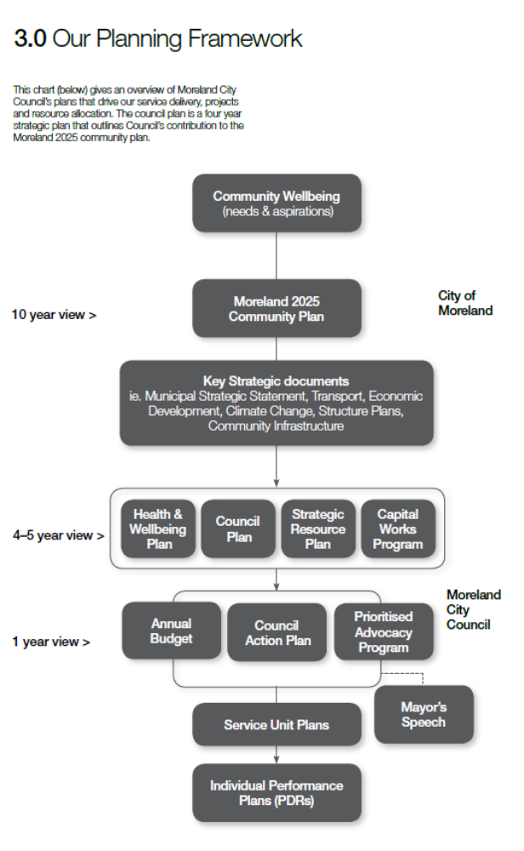
Council Plan performance monitor 2013–2014
This table provides a summary of Council’s progress under the priority themes in the Council Plan.
Theme | Measure | 2012-2013 | 2013-2014 | Source
Moreland’s People | Proportion of respondents satisfied with Council performance in the area of recreational facilities' | 91% | 90% | LGV satisfaction with local government survey
Moreland’s People | Immunisation rates per capita (for children aged 60–63 months) | 90% | 94% | Australian Childhood Immunisation Register
Moreland’s People | Proportion of actions in Health and Wellbeing Plan completed | - | 86% | Health and Wellbeing Action Plan 2013–14 Status Report
Moreland’s People | Attendance at aquatic and leisure facilities and Council-owned sports facilities – recreation services | 13,813 | 13,986 | Recreation services allocation applications
Moreland’s People | Attendance at aquatic and leisure facilities and Council-owned sports facilities – contracted services | 615,699 | 863,523 | Contracted service providers data reports
Moreland’s People | Proportion of respondents satisfied with Council performance in the area of family support services | 96% | 94% | LGV satisfaction with local government survey
Moreland’s People | Proportion of respondents satisfied with Council performance in the area of elderly support services | 88% | 90% | LGV satisfaction with local government survey
Moreland’s People | Proportion of advocacy program items relating to affordable housing achieved | 50% | 100% | Council report
Moreland’s Places and Spaces | Proportion of population / residences within 500 metres of a park | - | 99.32% | GIS report
Moreland’s Places and Spaces | Proportion of respondents satisfied with Council performance in the area of local Streets and footpaths | 59% | 70% | LGV satisfaction with local government survey
Moreland’s Places and Spaces | On road bike paths (formal and informal) | 0.43 metres per capita | 0.42 metres per capita | Capital Works Program records
Moreland’s Places and Spaces | Off-road shared paths | 0.40 metres per capita | 0.40 metres per capita | Capital Works Program records
Moreland’s Places and Spaces | Proportion of advocacy items relating to public transport achieved | 82% | 100% | Council report
Moreland’s Places and Spaces | Proportion of respondents satisfied with Council performance in the area of appearance of public areas | 85% | 84% | LGV satisfaction with local government survey
Moreland’s Places and Spaces | Proportion of respondents agree ‘There are good parks and open areas in your neighbourhood’ | 89% | - | Moreland Community Indicators Survey
Moreland’s Places and Spaces | Ministerial approval of Planning Scheme amendments that implement Council structure plans | - | C122 approved on 10/10/2013 | Victorian Government Gazette
Moreland’s Places and Spaces | Number of performances and other cultural activities at Mechanics Institute Performance Arts Centre (MIPAC) | - | 202 | Performing Arts Moreland report and Metanoia records for Mechanics Institute
Moreland’s Places and Spaces | Number of visits to Mechanics Institute Performance Arts Centre (MIPAC) | 4,848 | 8,166 | Performing Arts Moreland report and Metanoia records for Mechanics Institute
Moreland’s Places and Spaces | Retention of identified heritage sites and places | - | C145; C129; C155 | Victorian Government Gazette
Moreland’s Places and Spaces | Proportion of respondents satisfied with Council performance in the area of environmental sustainability | 89% | 89% | LGV satisfaction with local government survey
Moreland’s Places and Spaces | Increase in recycling tonnage per capita | 8.9 tonnes | 10.3 tonnes | Service records
Moreland’s Places and Spaces | Decrease in waste to landfill per capita | 20.2 tonnes | 20.4 tonnes | Service records
Moreland’s Places and Spaces | Perception of partners of Council’s performance as a partner |  |  | Survey of partners (new survey)
Moreland’s Places and Spaces | Open space land (m²) per capita | - | 35.9 m² | GIS report
Civic Leadership | Percentage of advocacy program items achieved | 82% | 100% | Council report
Civic Leadership | Proportion of respondents satisfied with Council performance in the area of community consultation and engagement | 81% | 76% | LGV satisfaction with local government survey
Civic Leadership | Sustainability index for road assets (including roads, carparks, footpaths / bikepaths, traffic management devices, bridges) | 49% | 77% | Capital Works Program records
Civic Leadership | Proportion of sealed local roads below the intervention level of 3.5 | 9.0% | 6.5% | Capital Works Program records
Civic Leadership | Proportion of footpaths ‘poor’ or ‘very Poor’ | 0.9% | 1.0% | Capital Works Program records
Civic Leadership | Median rate level as a proportion of median household annual income | 2.1% | 2.1% | Finance
Civic Leadership | Proportion of respondents satisfied with Council performance in the area of customer service | 89% | 86% | LGV satisfaction with local government survey
Civic Leadership | Proportion of payments conducted online | 72.5% | 73.9% | Pathway and supplier portal

COUNCILLORS
In 2013–2014 the Moreland community was represented by 11 Councillors elected from three wards across Moreland – North–West Ward (four Councillors), North–East Ward (four Councillors) and South Ward (three Councillors).
Voters in the Moreland community elect Councillors every four years. The last election was in 2012 and the next election is in 2016.
In addition to representing the interests of their wards, some Councillors are Portfolio Councillors with specific responsibility for a Council department. Responsibility for particular issues is also allocated to Councillors.

CURRENT COUNCILLORS
Cr Lambros Tapinos (Mayor)
Cr Meghan Hopper (Deputy Mayor)
Cr Sue Bolton
Cr Helen Davidson
Cr Lita Gillies
Cr John Kavanagh
Cr Samantha Ratnam
Cr Michael Teti
Cr Lenka Thompson
Cr Rob Thompson
Cr Oscar Yildiz, JP

South Ward
Councillor and Mayor Lambros Tapinos
First elected Mayor in 2008–2009 and re-elected in 2013
Councillor Responsible for East Timor and Friendship Cities and Member of the Audit Committee
Phone (03) 9018 5265
Mobile 0433 419 075
Email ltapinos@moreland.vic.gov.au

Councillor and Deputy Mayor Meghan Hopper
Elected in 2012
Portfolio Councillor for Planning and Economic Development (shared with Cr Davidson); Councillor Responsible for Status of Women; and Chair of the Urban Planning Committee
Phone (03) 9018 5291
Mobile 0409 694 937
Email mhopper@moreland.vic.gov.au

Cr Samantha Ratnam
Elected in 2012
Portfolio Councillor for Social Development (shared with Cr Gillies); Councillor Responsible for Social Diversity and Reconciliation; and Councillor Responsible for Youth
Phone (03) 9018 5324
Fax (03) 8672 6479
Mobile 0433 275 434
Email sratnam@moreland.vic.gov.au

North–East Ward
Cr Sue Bolton
Elected in 2012
Councillor Responsible for Accessible and Affordable Housing (shared with Cr Lenka Thompson) and Councillor Responsible for Sustainable Transport (shared with Cr Lenka Thompson)
Phone (03) 9018 5246
Mobile 0417 583 664
Email sbolton@moreland.vic.gov.au

Cr Michael Teti
Elected in 2008 and Deputy Mayor 2011–2012
Portfolio Councillor for City Infrastructure (shared with Cr Lenka Thompson); Councillor Responsible for Aged Services; Councillor Responsible for Recreation and Leisure (shared with Cr Yildiz); and Member of the Urban Planning Committee
Phone (03) 9018 5296
Mobile 0435 105 368
Email mteti@moreland.vic.gov.au

Cr Lenka Thompson
Elected in 2012
Portfolio Councillor for City Infrastructure (shared with Cr Teti); Councillor Responsible for Accessible and Affordable Housing (shared with Cr Bolton); Councillor Responsible for Sustainability, Climate Change and Water; Councillor Responsible for Sustainable Transport (shared with Cr Bolton); and Member of the Audit Committee
Phone (03) 9018 5261
Mobile 0417 353 020
Email lthompson@moreland.vic.gov.au

Cr Rob Thompson
Elected in 2012
Portfolio Councillor for Corporate Services; Councillor Responsible for Children; Member of the Urban Planning Committee; and Member of the Audit Committee
Phone (03) 9018 5310
Mobile 0409 760 436
Email rthompson@moreland.vic.gov.au

North–West Ward
Cr John Kavanagh
Elected in 2004 and Mayor from 2011–2012
Councillor Responsible for City Amenity and Improvement and Chairperson of the Audit Committee
Phone (03) 9018 5257
Mobile 0427 550 935
Email jkavanagh@moreland.vic.gov.au

Cr Helen Davidson
Elected in 2012
Portfolio Councillor for Planning and Economic Development (shared with Cr Hopper) and Member of the Urban Planning Committee
Phone (03) 9018 5308
Mobile 0403 709 948
Email hdavidson@moreland.vic.gov.au

Cr Oscar Yildiz JP
Elected in 2008 and Mayor from 2010–2011 and 2012-2013
Councillor Responsible for Recreation and Leisure (shared with Cr Teti)
Phone (03) 9018 5263
Mobile 0413 850 357
Email oyildiz@moreland.vic.gov.au

Cr Lita Gillies
Elected in 2012 and Deputy Mayor 2012–2013
Portfolio Councillor for Social Development (shared with Cr Ratnam) and Member of the Urban Planning Committee
Phone (03) 9018 5249
Mobile 0418 213 777
Email lgillies@moreland.vic.gov.au

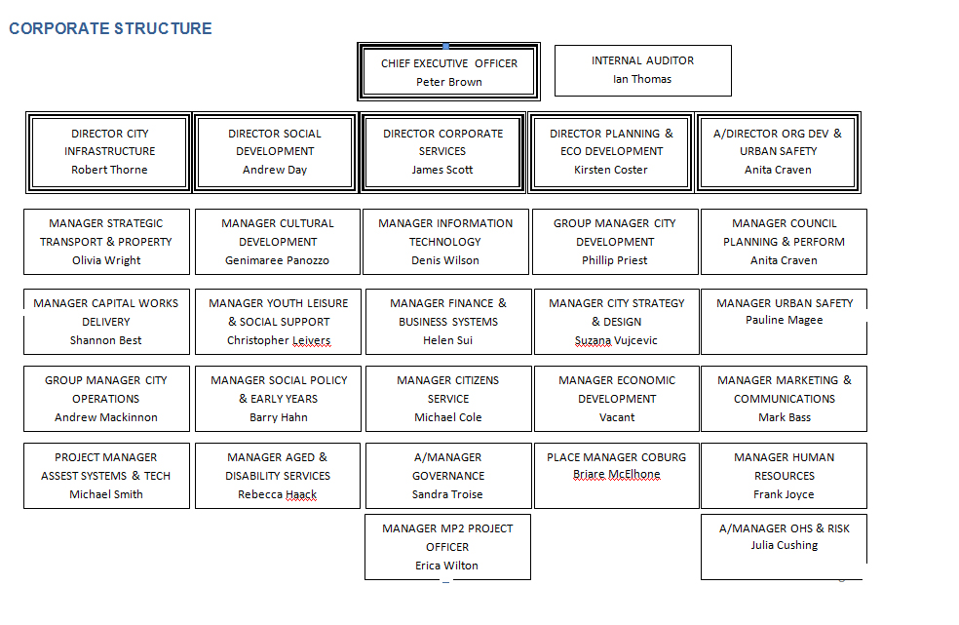

NOTE: Organisation structure as at 30th June 2013.
FINANCIAL SNAPSHOT
Five Year Financial Plan
Council is guided by the principles of the Five Year Financial Plan for the period 2011–2012 to 2015–2016. This plan was not intended to be static and has been reviewed annually as part of the Council planning process and updated to reflect changing circumstances.
The aim of the Five Year Financial Plan is to ensure that Council is able to undertake its strategic and governance role, and to maintain and repair its infrastructure assets at the level expected by the community while continuing to deliver essential services.
On pages 59–140 you will find the formally presented Council financial statements prepared in accordance with relevant accounting standards and legislative requirements. These reports are comprehensive and, as such, stakeholders and members of the community may find them difficult to interpret. This overview aims to simplify the pertinent information regarding Council’s financial performance for the year.
Income – where did the money come from?
Total income for the year was $162.5 million. There was an overall revenue increase of $2.6 million (or 1.6 per cent) compared to that of 2012–2013, primarily due to increased rates and charges and fair value adjustments for investment property. The majority of this revenue comes from rates and charges income of $114.27 million.
Other major sources of revenue were government grants of $17.7 million (10.9 per cent) and user charges and other fines of $20.88 million (12.8 per cent).
Expenses – how the money was spent?
Total expenses for the year were $147.3 million. Overall expenses increased in the year by approximately $4.5 million, which is primarily due to employee costs and depreciation. The majority of total expenses consist of employee costs of $71.8 million and contract payments, materials and services of $48.7 million. Council is reporting an accounting surplus of $15.2 million for the financial year. It is, however, important to note that this accounting profit includes items that are either one-off or committed for capital expenditure. After excluding non-cash developer contributions, capital grants and contributions and open space contributions, Council achieved a modest underlying surplus of $4.789 million. This is a modest result in the context of a total budget turnover of approximately $162 million where the surplus is necessary to meet debt redemption payment obligations and to complete carry forward projects.
Capital spending by Council programs
Total capital spending for the year was $42.333 million. Council continues to work at addressing its capital works program across a wide range of projects with the total capital spend being $19.364 million above the depreciation for the year. However, renewal works were $4.82 million below depreciation.

EXPENDITURE PROFILE 2013–2014
Category | Proportion of total expenditure (%)
Administration | 6.4%
Aged, disability and social services | 9.1%
Arts, culture and libraries | 4.0%
Asset maintenance | 4.1%
Asset management | 1.0%
Capital works | 26.1%
Youth and children’s services | 2.1%
Customer service | 1.9%
Governance | 2.6%
Health and immunisation | 2.2%
Local laws and regulations | 4.6%
Parks and street trees | 5.4%
Planning and economic development | 7.2%
Property services | 3.2%
Recreation and leisure | 2.0%
Roads and footpaths | 2.3%
Street cleansing | 2.2%
Systems and communications | 4.4%
Transport | 2.1%
Waste collection and recycling | 7.1%

OPERATIONS
GOVERNANCE
Moreland City Council derives its power, role, purpose and functions from the Local Government Act 1989.
Council meetings
Decisions on issues affecting Moreland residents are made at Council meetings, which are held once a month.
These meetings provide residents with an opportunity to participate in Council’s discussions and decision-making process. Outside of the formal agenda, residents have 30 minutes at each meeting to raise matters with Council at meetings.
Council met 14 times in during the reporting period. Two of those meetings were Special Council meetings.
Councillor attendance at 14 Council meetings 2013–2014
Cr Oscar Yildiz | 14
Cr Samantha Ratnam  Cr Sue Bolton  Cr Lenka Thompson  Cr John Kavanagh | 13
Cr Meghan Hopper  Cr Rob Thompson  Cr Helen Davidson  Cr Lita Gillies | 12
Cr Lambros Tapinos | 10
Cr Michael Teti | 6

Major committees
Council has two major committees: the Urban Planning Committee and the Audit Committee.
Urban Planning Committee
The Urban Planning Committee considers matters related to planning, building, environmental health, property, roads and traffic in accordance with Council’s obligations as outlined in the Council Plan and in accordance with the legislative framework. All affected parties have the opportunity to speak on applications and issues at the meetings.
The Urban Planning Committee has a pivotal role in developing the quality of life in Moreland.
The committee met 12 times and considered 33 reports in the reporting period.
Councillor attendance at 12 Urban Planning Committee meetings 2013–2014
Cr Meghan Hopper  Cr Helen Davidson | 11
Cr Lita Gillies | 8
Cr Rob Thompson | 8***
Cr Lenka Thompson  Cr John Kavanagh | 7**
Cr Lambros Tapinos  Cr Samantha Ratnam | 4*
Cr Michael Teti | 3

*Cr Tapinos and Cr Ratnam resigned from the Urban Planning Committee on 11 November 2013.
** Cr Kavanagh and Cr L Thompson resigned from the Urban Planning Committee on 12 March 2014.
*** Cr R Thompson joined the Urban Planning Committee on 11 November 2013.
Audit Committee
Consistent with the requirements of the Local Government Act 1989 and good corporate governance generally, Council has an Audit Committee. The Committee is an advisory committee to Council. The current Charter and Terms of Reference of the Audit and Committee were reviewed by the Committee and an updated Charter was adopted by Council in February 2014. The Moreland Council Audit Committee Charter is generally consistent with the February 2011 best practice guidelines for audit committees outlined in Audit Committees: A Guide to Good Practice in Local Government.
The overall purpose of the Committee is to provide a forum for communication between Council, management, and the internal and external auditors, and to assist Council in its oversight responsibilities by monitoring, reviewing and advising on:
- The external auditor’s performance
- The independence and performance of the internal audit function
- The truth and fairness of the view given by the annual financial, standard and performance statements of Council
- Council’s accounting policies and practices in accordance with current and emerging accounting standards
- Fraud risk mitigation and investigation
- The management and exercise of delegations
- Compliance with legal and regulatory requirements and policies
- Compliance with Council’s policy framework
- Internal controls, the control environment and the overall efficiency and effectiveness of financial operations, and
- Council’s overall risk management and business continuity policy and programs.
The Committee is presently chaired by Cr John Kavanagh, with two other Councillor members, Cr Rob Thompson and Cr Lenka Thompson, the Chief Executive Officer Peter Brown and three external representatives.
Council is fortunate to have the continuing services of Michael Francis (Managing Director of Pneuvay Engineering Pty Ltd, a local Moreland company), Kevin Quigley (local resident, chartered accountant and business consultant) and John Hoffmann (local chartered accountant).
The committee met four times in the reporting period.
Councillor attendance at four Audit Committee meetings 2013–2014
Cr John Kavanagh (Chair) | 4
Cr Lenka Thompson | 4
Cr Rob Thompson | 3
Michael Francis | 4
John Hoffmann | 4
Kevin Quigley | 4

State and federal government investigations
Moreland City Council was not the subject of any state or federal government investigations.
Documents containing prescribed matters open for public inspection
Council is committed to open and transparent governance and in accordance with the Local Government Act 1989 (the Act) and Section 11 of the Local Government (General) Regulations 2004. The following documents are available for public inspection at Moreland Civic Centre, 90 Bell Street, Coburg:
- Details of current allowances fixed for the Mayor, Lord Mayor (if any) and Councillors under section 74 or 74A of the Act
- The total annual remuneration for all senior officers in respect of the current financial year and the previous financial year, set out in a list that states:
- Ranges of remuneration of senior officers, where the difference between the lower amount and the high amount in each range must not exceed $10,000, and
- The number of senior officers whose total annual remuneration falls within the ranges referred to in subparagraph (i)
- Details of overseas or interstate travel (with the exception of interstate travel by land for less than three days) undertaken in an official capacity by Councillors or any member of Council staff in the previous 12 months
- Names of Council officers who were required to submit a return of interest during the financial year and the dates the returns were submitted
- Names of Councillors who submitted returns of interest during the financial year and the dates the returns were submitted
- Agendas for and minutes of ordinary and special meetings held in the previous 12 months kept under section 93 of the Act except if the minutes relate to parts of meetings which have been closed to members of the public under section 89 of the Act
- A list of all special committees established by Council and the purpose for which each committee was established
- A list of all special committees established by the Council which were abolished or ceased to function during the financial year
- Minutes of meetings of special committees established under section 86 of the Act and held in the previous 12 months except if the minutes relate to parts of meetings which have been closed to members of the public under section 89 of the Act
- Minutes of meetings of special committees established under section 86 of the Act and held in the previous 12 months except if the minutes relate to parts of meetings, which have been closed to members of the public under section 89 of the Act
- A register of delegations kept under sections 87, 88 and 98 of the Act, including the dates on which the last reviews under section 86(6) and 98(6) of the Act took place
- Submissions received in accordance with section 223 of the Act during the previous 12 months
- Agreements to establish regional libraries under section 196 of the Act
- Details of all property, finance and operating leases involving land, buildings, plant, computer equipment or vehicles entered into by the Council as lessor or lessee, including the name of the other party to the lease and the terms and the value of the lease
- A register of authorised officers appointed under section 224 of the Act
- A list of donations and grants made by the Council during the financial year, including the names of persons or bodies which have received a donation or grant and the amount of each donation or grant
- A list of the names of the organisations of which the Council was a member during the financial year and details of all membership fees and other amounts and services provided during that year to each organisation by the Council
- A list of contracts valued at $150,000 (or such higher amount as is fixed from time to time under section 186(1) of the Act) or more:
- which the Council entered into during the financial year without first engaging in a competitive process, and
- which are not contracts referred to in section 186(5) of the Act.
Note: The act provides that an amount higher than $150,000 may be fixed by Order in Council made under section 186(1) of the Act.
Inspection of these documents can be arranged by contacting the Manager Governance on 9240 1111.
Freedom of Information
The Freedom of Information (FOI) Act 1982 gives the community a legal right to access certain Council documents.
The FOI Act has four basic principles:
1. The public has a legal right of access to information
2. Local governments are required to publish information concerning the documents they hold
3. People may request that inaccurate, incomplete, out-of-date or misleading information in their personal records be amended, and
4. People may appeal against a decision not to give access to the information or not to amend a personal record.
Moreland City Council is subject to the FOI Act and responds to requests directly related to its operations.
There were 37 FOI requests processed in 2013–2014. There were seven requests granted in full, 26 in part and four requests denied in full. There was no internal review requested. Of the 37 requests received, 14 were planning or building related, eight health or personal information related and 15 requests for information about other areas of Council.
Of the requests that were partly denied, the most common exemption clause used was section 33(1), which relates to the unreasonable disclosure of information relating to the personal affairs of any person.
Accessing FOI
Requests to access FOI must be in writing and accompanied by an application fee of $26.50. Applicants should indicate in the form which access is required.
On receipt of a request, a decision must be made within 45 days. Where a decision is made to refuse or defer access, the applicant will be notified in writing of the reasons for the refusal and the procedures available to appeal the decision.

Local Laws
Council has the following local laws:
- Environmental and Civic Assets Local Law 2006
- Moreland City Council General Local Law 2007
- Meeting Procedure Local Law 2010
Whistleblower legislation
The Whistleblowers Protection Act 2001 (the Act) commenced operation on 1 January 2002. With the introduction of the Victorian Government Independent Broad-Based Anti-Corruption Commission (IBAC) it was replaced by the Protected Disclosure Act 2012 in February 2013. The purpose of the current (and previous) Act is to encourage and facilitate the making of disclosures of improper conduct by Council officers or Councillors. The Act provides protection to whistleblowers that make disclosures in accordance with the Act, and establishes a system for the matters disclosed to be investigated and rectifying action to be taken.
As required by section 58 of the Protected Disclosure Act, Moreland City Council has developed disclosure procedures to facilitate the making of disclosures under the Act. The procedures can be found on Council’s website. During the period the reporting period there were no complaints referred to Council by the Ombudsman or IBAC.
All correspondence, phone calls or emails from internal or external whistleblowers should be addressed to Moreland City Council’s Protected Disclosure Coordinator on phone 9240 1111 or email info@moreland.vic.gov.au.
Information Privacy Policy
Moreland City Council believes that the responsible handling of personal information is a key aspect of good democratic governance, and is strongly committed to protecting every individual’s right to privacy. Accordingly, Council is committed to full compliance with its obligations under the Information Privacy Act 2000 (Vic) and the Health Records Act 2001 (the Acts). In particular, Council will comply with the Information Privacy Principles (IPPs) and Health Privacy Principles (HPPs) contained in the Acts. Council’s policy applies to all personal information held by Council.
For example, Council holds personal (and in some cases sensitive) information on its local citizens and ratepayers (for example, names and addresses) in order to carry out its functions (for example, planning, valuation and property services). It may also request personal information in order to provide education, welfare and other community services (for example, child care services). In some instances, personal information may be contained on a public register (for example, register of building permits, food premises and animal registration details).
The Information Privacy Policy applies to all Council employees, Councillors and contractors of Moreland City Council. Training and awareness sessions, local procedures and a policy manual have been set in place to best ensure the protection of personal information and to provide strong security frameworks around its use and disclosure.
Any person wishing to access their personal information should contact Council’s Privacy Officer (phone 9240 1111). If any citizen believes that their personal information is inaccurate, incomplete or out of date, they may request Council to correct the information. If any citizen feels aggrieved by Council’s handling of their personal information, the individual may make a complaint to Council’s Privacy Officer. The complaint will be investigated as soon as possible and a written response will be provided. Alternatively, any person may make a complaint to the Privacy Commissioner.
During the period to 30 June 2014 there were no complaints referred to Council by the Privacy Commissioner.

AWARDS and CITATIONS
- Annual Report 2013 – Australasian Reporting Awards (Bronze)
- Aquatics Recreation Victoria Annual Awards – Online Communications Finalist
- Keep Australia Beautiful – Community Government Partnerships Award Winner: Moreland Energy Partnership, the road map to carbon neutrality
- Keep Australia Beautiful - National Energy Innovation Sustainable Cities Award Winner
- Keep Australia Beautiful - Sustainable City of the Year: City of Moreland (Victoria) Award Winner
- LGPro Awards – Community Infrastructure Under $1.5 million Finalist - Oxygen
- LGPro Awards - Sustainability Initiative Finalist 2014 for the ‘Moreland Electric Vehicle Project’
- Place Leaders Asia Pacific - Place Practice Category Award Winner 2014 for the ‘Fighting Crime with Placemaking, Better Block Brunswick initiative’
- Stormwater Australia – Highly Commended Excellence in Infrastructure 2014 for the ‘Charles Mutton Reserve 13ML/a Stormwater Harvesting System’
- Vicsport Award Winner - Best Sports Development Initiative by an Industry Associate/Corporate Supporter – ALLPLAY
- Victorian Health Promotion Foundation Awards Finalist – ALLPLAY

OPERATIONAL OUTPUTS

SERVICE DELIVERY 2013–2014
Operational and service activity:
Measure | Quantity
Waste sent to landfill (total tonnes) | 29,856 tonnes
Landfill (average rubbish per dwelling) | 466 kilograms
Paper and bottle recycling | 16,529 tonnes
Tonnes of green waste collected | 8,867 tonnes
Delivered meals total:  - Meals delivered to Moreland residents  - Whittlesea / Nillumbik Contract (meals)  - Whittlesea / Nillumbik Contract (sandwiches) | 202,202  136,686  48,644  16,872
Total Home Support hours delivered | 144,000
Trees and shrubs planted | 17,985
Number of library loans | 1,317,147
Planning permit applications received | 1,513
Planning permit applications received for subdivision | 363
Dogs and cats registered | 9,293 dogs  4,274 cats
Kilometres of streets cleaned | 35,790.5

CAPITAL WORKS 2013–2014
Capital works projects delivered in the 2013–2014 budget included:

Land assets | $12,650,791
Roads and carparks | $5,131,295
Parks and reserves | $3,761,848
Footpaths and bikepaths | $2,826,950
Libraries and cultural buildings | $2,216,467
Climate change | $2,176,419
Aquatic and leisure centres | $2,157,493
Council fleet | $1,909,923
Pavilion and sports clubs | $1,810,429
Information technology | $1,267,595
Transport management | $1,173,137
Library collection | $919,515
Business centre renewal | $668,961
Drainage | $597,200
Early years facilities | $490,189
Coburg 2020 | $482,221

COMMUNITY SATISFACTION
Each year Moreland participates in a survey of local government services administered by the Department of Planning, Transport and Local Infrastructure. The survey aims to provide data so individual councils can track the views of their residents over time.
In 2014, Moreland scored 87 per cent for overall performance compared with 83 per cent in 2013, showing an increase in satisfaction.
Twenty-one Council services were surveyed, with four of these receiving ratings above 90 per cent. The areas of Council that received the highest rating were community and cultural activities, and arts centres and libraries (both on 95 per cent). This was followed by family support services (94 per cent), waste management (93 per cent), recreational facilities (90 per cent), elderly support services, and environmental sustainability (89 per cent).
The lowest levels of satisfaction were for planning and building permits at 55 per cent, planning for population growth in the area and general town planning policy (both at 65 per cent).
HUMAN RESOURCES

Workforce data
As at 30 June 2014, Council had 1,075 employees. The profile of Council’s workforce by gender, department and status (full-time, part-time or casual) is shown below.
 | Full time |  |  | Part time |  |  | Casual |  |  | TOTAL
Department | Female | Male | Total | Female | Male | Total | Female | Male | Total | Female | Male | Total
CEO Group | 1 | 2 | 3 | 1 | 0 | 1 | 0 | 0 | 0 | 2 | 2 | 4
City Infrastructure | 27 | 187 | 214 | 3 | 3 | 6 | 0 | 2 | 2 | 30 | 192 | 222
Corporate Services | 37 | 31 | 68 | 28 | 3 | 31 | 5 | 0 | 5 | 70 | 34 | 104
Planning and Economic Development | 41 | 24 | 65 | 16 | 3 | 19 | 0 | 0 | 0 | 57 | 27 | 84
Organisational Development and Urban Safety | 33 | 38 | 71 | 44 | 20 | 64 | 2 | 4 | 6 | 79 | 62 | 141
Social Development | 84 | 39 | 123 | 238 | 32 | 270 | 101 | 26 | 127 | 423 | 97 | 520
Totals | 223 | 321 | 544 | 330 | 61 | 391 | 115 | 40 | 155 | 681 | 424 | 1075

Indigenous employment
Council has the capacity to offer two traineeships per year for Indigenous residents in the Moreland and adjacent areas. This financial year, one full-time indigenous trainee graduated from her certificate course and found work elsewhere after graduating. A previous trainee graduate was offered an extension as an employee in the Records Unit, and a new full-time trainee was appointed working in the Information Technology and Home Support areas. Council engaged Apprenticeships Plus to facilitate the successful placement of the Indigenous trainee.
Workplace relations
The Moreland City Council Enterprise Agreement 2012 (the Agreement) will expire 30 June 2015. Council’s Joint Consultative Committee, which comprises a number of workplace and management representatives, remains in place to facilitate discussion and consultation between Council and the unions on matters arising out of the Agreement.
The revised Council Employee Code of Conduct incorporating the organisational values was implemented across the organisation.
Throughout the year, workplace relations within Council remained largely harmonious. A number of minor restructures have occurred to improve service delivery in areas such as Marketing and Communications and Environmental Health. An organisational restructure was implemented 1 July 2014, following consultation with unions and staff during June 2014. This restructure resulted in the reduction of five departments to four departments and the creation of a new Property Branch.
Number of days lost due to industrial dispute
2009–2010 | 2010–2011 | 2011–2012 | 2012–2013 | 2013–2014
0 | 18 | 0 | 1 | 0

Building workplace culture
During 2013, there was an ongoing focus to embed the organisational values that were adopted in 2012. This work has included embedding training and awareness of the values through the employee induction process.
The use and implementation of annual service unit planning has continued with an emphasis on measuring and improving performance. Each service unit has a number of measures and actions in place that link to organisational priorities in the Council Plan. Service Unit Plans have been developed for all services using the RBA methodology. These actions were the focus for service delivery in 2013. Additionally, every year organisational KPIs are put in place for all supervisor staff to ensure that their areas and staff they have responsibility for are being managed consistently across the organisation. These KPIs include financial and project management, human resources, occupational health and safety, risk, procurement and delivery against the Council Plan.
The Organisational Culture Inventory (OCI) measures the operating culture and employee experience within an organisation. This survey was run in early 2014 and was the third such survey the organisation has completed. In late 2014, line Managers will participate in result debriefings and will design and implement action plans with their units.
Learning and development

Developing our leaders: Aim for Blue Program
The Aim for Blue leadership development program supports the move towards a more constructive and higher performing workplace culture through a combination of tailored workshops and development activities designed to build existing leadership capability and to enhance the confidence of leaders when interacting with staff.
The programs are aimed at continuing to support the development of our leaders at all levels. Aim for Blue explicitly links these programs to our Human Synergistics culture measurement tools: Organisational Culture Inventory and Life Styles Inventory.
The Aim for Blue Program continued to focus on contributing to a positive culture at Moreland City Council by investing in its leaders with a particular focus on coaching and managing for performance. These programs were designed to support the organisation’s shift towards a coaching culture.
The 2014–2015 Aim for Blue Program will continue to focus on coaching and will introduce the notion of mentoring. The program will focus on providing practical and interactive development opportunities for supervisors and managers.

e-Learning
Moreland City Council has continued to use e-learning as a training delivery tool for staff. This web based e-Learning system delivers compliance, induction and various personal development training online with a course library of over 400 different courses to choose from.
Throughout the financial year, 21 different e-learning courses were assigned to staff with a total of 132 staff undertaking online courses.

Corporate Training Program (including OHS)
Council is committed to investing in its staff through development and training opportunities and recognises that building internal capacity of staff contributes to improving the performance of the organisation. Throughout the year, 143 separate training programs were run, with 1,445 staff undertaking corporate training (including OHS training). The programs conducted under the Corporate Training Program are shown below:
Corporate training 2013–2014 (including OHS)
Training category | Number of courses run | Number of attendees (instances)
Occupational health and safety | 45 | 510
Business and workplace effectiveness | 29 | 286
Leadership and management | 24 | 264
Diversity and social awareness | 3 | 49
Lifestyle, wellbeing and self-development | 5 | 57
Compliance | 15 | 198
Systems training | 21 | 72
Overall Total | 142 | 1445
OCCUPATIONAL HEALTH, SAFETY AND RISK
Occupational health and safety
Council is committed to ensuring a safe and healthy environment for its employees, contractors, visitors and members of the public affected by our workplace activities. Council’s commitment is stated within our Occupational Health and Safety (OHS) Policy. The Policy states that Council’s overall workplace safety objective is to eliminate all work-related incidents, illnesses and injuries, so far as is reasonably practicable and to provide a safe, productive workplace that promotes and enhances the quality of working life, and enhances Council’s ability to provide quality services to the community.
Council strives, through a process of continuous improvement, to fully integrate health and safety into all aspects of its activities. Council has committed to ensuring that all legislative requirements are being met and that a safety management system is in place to provide a preventative and systematic approach to OHS. To facilitate compliance, and to continually improve on the management of OHS, Council has developed an OHS Strategic Plan 2011–2014 containing six key strategic objectives to be actioned over a three year period.
Actions undertaken during the financial year include:
- Three units achieved accreditation; Property Services, City Strategy and Design and Recreation Services. Additionally, eight units successfully participated in the annual surveillance audit. Twenty-six units have now achieved SafetyMAP accreditation across Council.
- Three defibrillator units were deployed across Council at Campbell Turnbull Library, Fawkner Library and Walter Street Depot. This completes the rollout of these potential life saving devices across Council. There are a total of nine defibrillator units deployed across Council.
- There has been a continued focus on raising awareness of OHS throughout the organisation, with a strong focus on improving incident reporting timeframes.
- Council’s consultation processes continue to operate effectively with all OHS Committees functioning and meeting regularly.
- The OHS and Risk team continues to work with high risk areas to undertake risk assessments, mitigate risks and identify areas for improvement.
Corporate Training Program – OHS training
Throughout the year, 74 OHS training programs were run with 973 staff undertaking OHS training. The OHS programs conducted (including the Corporate Training Program and unit-specific OHS training) are outlined below.
OHS training 2013–2014
Course | Number of courses run | Number of attendees (instances)
CPR | 10 | 96
Critical incident and debriefing | 1 | 11
SMART driver training | 1 | 12
First aid level 2 | 7 | 61
Heavy Vehicle driver training | 3 | 76
Infection control | 1 | 15
JSA | 1 | 5
Manual handling | 20 | 316
Occupational violence prevention | 1 | 18
Asbestos awareness | 1 | 10
Dangerous goods and hazardous substances | 1 | 16
OHS rep five-day training | 1 | 1
Sun smart | 5 | 94
OHS rep refresher training | 3 | 32
Work-life balance | 1 | 12
Work safe at heights | 1 | 8
OHS, risk and injury management training | 3 | 23
Return to work | 6 | 94
Staff safety | 1 | 14
Traffic management | 2 | 45
Plant safety training | 1 | 9
Overall Total | 71 | 667

MoreCare – injury management
There was a slight increase in the number of incidents and injuries reported by 10.6 per cent when compared to the previous year. Due to the nature of the reported injuries, the number of workers compensation claims has increased slightly when compared to last year.
Council has implemented a range of initiatives to assist in preventing injuries and, if an injury is sustained, to assist employees to return to their pre-injury work and life as soon as possible:
- The Early Intervention Program continues to be successful, with the majority of injuries being musculoskeletal in nature, accounting for 57 per cent of all injuries this year. Council has found the Early Intervention Program to be extremely effective in managing minor injuries by reducing recovery times and in turn the impact on the employee and their workplace.
- Sprains and strains continue to be a major type of injuries. Due to this, an ergonomic sweep was conducted to all desk-based staff to raise awareness on workstation ergonomics. There was also an awareness session on the vehicle ergonomics. This program mainly assisted to identify potential problem areas, and determine suitable amendments.
- Injury management and return to work training has been rolled out to all supervisory staff this year to improve their knowledge and awareness.
- The majority of claims were sustained within our high risk areas in Social Development and City Infrastructure, namely: Home Support, Social Support, Waste Services, Roads and Street Cleansing. Of all employees who lodged a claim during the year, four employees still remain unfit for any work.

Injury management results
 | 2008–2009 | 2009–2010 | 2010–2011 | 2011–2012 | 2012–2013 | 2013–2014
No. of incidents reported (inc. injuries) | 272 | 269 | 295 | 385 | 361 | 404
No. of injuries reported | 175 | 181 | 190 | 241 | 217 | 224
No. of claims | 34 | 28 | 26 | 18 | 21 | 24
Average claim cost | $35,276 | $23,702 | $16,295 | $42,574 | $44,314 | $57,377
No. of days lost | 1,545 | 324 | 214 | 601 | 529 | 1,229
Employees returned to work | 22 | 15 | 15 | 14 | 17 | 17
No. return to work | 3 | 0 | 1 | 0 | 4 | 2
*For return to work information, only time lost claims have been included in the above count.
MoreHealth – employee health and wellbeing
The Health and Wellbeing Program is designed to support employees in managing their own health and wellbeing through education and by providing employees with the tools to enable them to make better decisions. During the year, employees participated in self-funded pilates and meditation, skin checks, ergonomic sweeps of work stations as well as seminars covering topics such as Heal Program presented by Merri Community Health, D’Accord sessions, diabetes and a number of other relevant initiatives.
Risk management
Risk management continues to be a strong focus at Council. Risk has been integrated into Council’s business planning and also continues to be reinforced through Projects and Procurement.
The Service Unit Risk Registers are regularly reviewed and the Corporate Risk Register reviewed and updated every six months with high and extreme risks identified and treatment plans established to manage those risks. The Corporate Risk Register has been endorsed by the Audit Committee.
Risk management is integral to Council operations and, as such, OHS and risk management workshops are regularly held for supervisors and leaders across the organisation as part of the corporate training calendar.
The MAV Risk Management Audit was held on the 28 February 2013. Council received an overall score for the 2012–2014 Audit of 94 per cent, which is a significant improvement on the 2010–2012 score of 69 per cent (review in 2012 was 73 per cent). The Audit assesses Council’s risk management processes for organisational risk management, reactive risk management, asset facilities management, special committees and building services and town planning.
BEST VALUE
The MoreValue Program is Council’s chosen vehicle to delivery on the Best Value principles outlined in Section 208A of the Local Government Act. The Act requires that:
All services must:
- Meet quality and cost standards
- Be responsive to community needs
- Be accessible to those for whom it is intended.
A council must:
- Achieve continuous improvement in its provision of services
- Develop a program of regular consultation with its community in relation to the services it provides
- Report regularly, at least once a year, on its achievements to its community in relation to the Best Value principles.
Following a review of the MoreValue Program in 2011, two Council services were piloted for review using the revised MoreValue methodology during 2012–2013. Reviews of Council’s Civic Facilities Service (incorporating Bookings and Events Management and Council Facilities Management) and Community Transport Service were conducted.
These piloted reviews have been evaluated for their effectiveness in delivering on the Best Value principles. The findings from the evaluation have enabled the further improvement of the MoreValue Program.
For instance in October 2013 Council adopted Lean Thinking as its Continuous Improvement methodology, to further strengthen the MoreValue Program. Lean Thinking will provide a uniform approach to continuous improvement across Council services. In February 2014, a significant Lean proof of concept project on Council’s parking infringement internal review process commenced. This project has identified significant financial and customer improvements. These include:
- Projected year on year savings of $38,500 per annum from avoided PIN revenue write-offs and reduced overtime
- Improved customer response times from 90 days at project commencement to 44 days at 30 June and projected to achieve a new service standard of less than 10 business days in August 2014.
Other initiatives recently implemented across the organisation to drive service improvement and deliver best value outcomes, include:
- A Maternal and Child Health (MCH) administration review has identified improvement opportunities to increase nurse direct care from 50 per cent to 60 per cent, by:
- Centralising client appointments, bookings and SMS reminders within the MCH service administration team
- Installing a new bookings software capability
- Reducing nurse travel for administration purposes
- Reducing the client ‘did not attend’ appointment rate.
- A review was conducted of the Mayor and CEO correspondence process within Council’s City Operations Branch. The review was designed to improve the process for responding to written correspondence. The review has streamlined the Mayor and CEO correspondence process, and has significantly reduced customer response times. The review has also resulted in improved software enhancements which will assist the reduction in response times for Mayor and CEO correspondence across all Council departments.
- Council recently launched an e-recruit system which provides benefits of having electronic management of end to end recruitment. e-recruit makes the recruiting process more transparent, simplified and efficient for recruiting staff. It also increases responsiveness to candidates to effectively recruit for and fill vacant positions. It is expected to significantly reduce paper use and increase data and reporting capacity.
- The backlog of planning compliance matters has been reduced by 53 per cent over the last 2 financial years from a peak of 273 to 144 at the end of June 2014.
- Council’s planning permit decision-making performance was the best in the state when benchmarked against other Council’s for a number of months in 2014 and is generally in the top three in monthly State Government Planning Permit Activity reporting, with 69 per cent of decisions made within statutory timeframes. Council also went live with the ability for the community to view planning applications undergoing public notice online at any time.
- A program to monitor and improve phone standards across Council commenced in February 2014. The first round revealed a very good result with 74 per cent of Council staff responding to standard. This was second highest compared to seven benchmarked councils. This program will assist to target continuous improvement initiatives related to phone standards and responsiveness.
- Process and efficiency improvements to the accounts payable function were achieved in with the implementation of a new invoice management software system.
- Online lodgement enhancements for three more business processes were provided during the year. Options added in include:
- Residential and commercial planning applications, including a request to seek a pre-application meeting
- Legal point of discharge (LPOD)
- email receipting.
- Council has improved its process and customer service for both road openings and road closures permit applications. A permit and invoice with specific conditions is now generated in a timelier manner.

PERFORMANCE
PERFORMANCE REVIEW
Moreland’s People
Focus Area | Achievements | Challenges
Moreland community members are mentally and physically healthy and active | - Completed the Brunswick Baths  - Adopted a new Health and Wellbeing Plan  - Commenced work to cost the removal of the fence around Coburg Oval to improve accessibility for the broader community  - Commenced construction of the multipurpose courts in Gowanbrae  - Endorsed the Sport and Physical Activity Strategy  - Developed and adopted the Moreland Domestic Animal Management Plan  - Upgraded playgrounds in Shore Reserve South and Parker Reserve  - Continued to campaign for the installation of noise walls on the M80 | - Ongoing work to finalise business case and feasibility of the Oak Park Aquatic Centre redevelopment  - Finalising works at CB Smith Reserve providing better facilities, sporting fields and open space
Moreland community members feel connected to others and have access to the necessary services | - Competed design and prepared tender for the new Pascoe Vale Community Facility (incorporating Sussex Neighbour House)  - Opened the Oxygen Youth Centre in Coburg with regular programs running  - Developed and adopted a new Ageing Well Strategy  - Completed the rollout of self-serve loan systems in Moreland libraries | - Finalising construction to expand facilities at Barry Beckett and Anne Sgro children’s centres  - Ongoing work to address challenges associated with legislative and funding changes in the aged and disability sector  - Work in partnership with Department of Human Services and Neighbourhood Houses to ensure their ongoing sustainability  - Continue to progress the extensive work necessary to finalise the Development Contributions Plan
Moreland community is educated | - Implemented the Moreland Digital Strategy and Plan  - Implemented webinars and video calls for the community to connect with Moreland staff | - Construction completed with reoccupation and collection reinstatement scheduled for completion in August 2014
Moreland community feels safe and is safe | - Established the Community Safety Reference Group to action safety initiatives throughout the community  - Continued graffiti removal to keep the city clean | - Ongoing work to install CCTV cameras and the activation of Wilson Avenue in Brunswick
Moreland community has access to affordable housing | - Adopted the Moreland Affordable Housing Strategy  - Adopted the Moreland Activity Centres and Housing Strategy  - Made a submission to Senate inquiry into affordable housing
The human rights of Moreland’s diverse community are upheld | - Implemented the ‘White Ribbon’ action plan to support, action and highlight the need to prevent family violence  - Held the Honouring Women in Moreland Awards as part of International Women Day celebrations  - Adopted the Reconciliation Policy and action plan | - Continue streamlining policy through the inclusion of Human Rights and Inclusion Framework into the current Access and Inclusion Policy

Moreland’s Places and Spaces
Focus Area | Achievements | Challenges
People have access to local places, spaces and public transport | - Finalised and adopted the master plan for Fleming Park  - Adopted a funding strategy to redevelop the Brunswick Civic and Arts Precinct  - Adopted the Coburg Streetscape Masterplan  - Continued campaign to secure funding for improvements to the Upfield bike path  - Gained state government approval for the Craigieburn bike path | - Continue the work to finalise the concept plans and business case for the ongoing usage of the former Glenroy Primary School  - Continue work to renew public spaces, including Coburg streetscapes
People can access a variety of mobility options | - Implemented ongoing work to improve pedestrian accessibility, including footpath works and addressing disability access | - Ongoing work to improve transport and traffic in the Brunswick Activity Centre
Attractive and well maintained built environment, streetscapes and landscapes | - Planted 4000 new street trees throughout the municipality  - Continued to implement the waste services review based on results reported to Council in October 2013  - Made a submission to state government for Plan Melbourne, including addressing community concerns on state legislated notification frameworks | - Ongoing work with the state government and community to address new residential codes and development across the municipality
Cultural and artistic focus on the City of Moreland continues to thrive | - Successfully facilitated a transition of Mechanics Institute Performing Arts Centre (MIPAC) management from Performing Arts Moreland (PAM) to Council  - Completed and installed new public art for Coburg
The historical places of the City of Moreland continue to be enhanced | - Completed the panel hearing process for an amendment to the Lygon Street Heritage Study Stage 2 through key milestones, including authorisation, exhibition and consideration of submissions  - Endorsed the development of walking maps

Environmentally Sustainable Moreland
Focus Area | Achievements | Challenges
Reduction of non-renewable energy, fresh water usage and carbon emissions | - Adopted the Carbon Management Strategy  - Achieved National Carbon Offset Standard accreditation for Moreland  - Adopted a new Watermark Strategy to implement improvements for water and stormwater management  - Adopted the Moreland Community Climate Action Plan
Moreland community is focused on reducing consumption | - Adopted the Waste and Litter Strategy
The City of Moreland’s natural environment is preserved and enhanced | - Completed Bush Reserve new community park  - Endorswd new Edgars Creek Conservation and Development Plan  - Continued support of Creek Committees | - Bush Reserve construction underway and due for completion late 2014  - Drafting commenced for the Open Space Shared Use Policy

Moreland’s Sustainable Economy
Focus Area | Achievements | Challenges
The City of Moreland has a growing local economy | - Prepared report endorsing Coburg Planning Scheme amendment package for state government seeking authorisation  - Continued to support the Brunswick Business Incubator | - Ongoing work to develop Coburg Central to provide improved employment opportunities for the community

Civic Leadership
Focus Area | Achievements | Challenges
Partnerships are used to delivery community outcomes | - Successfully launched the Northern Infrastructure Study, through the partnership of seven northern Councils  - Continued work to action grade separation work for Coburg and Glenroy | - Continue to engage with community members, groups and partner organisations to develop and implement the Moreland 2025 Community Plan
Moreland community has access to information, opportunities to participate in decision making and access to decision makers | - Endorsed the Engagement Strategy and utilised to inform major community engagement efforts by Council  - Improved communication through the use of social media activity with Facebook likes growing to over 3000  - Supported the MAV campaign for constitutional recognition of local government | - Ongoing work to progress new software to support improved web technology and capacity
Moreland City Council is financially responsible taking account of current and future needs | - External consultant completed an organisational review  - Continued to implement a new asset management system to improve the maintenance and improvement of assets | - Review of pilot programs completed  - Preliminary discussion paper written on way forward pending outcomes of organisational review
Moreland community has access to responsive services | - Continued actions to improve Customer Service responsiveness, through both systems improvements and staff training

PERFORMANCE STATEMENT

Theme: Moreland’s People
Outcome | Key Strategies | Strategic Action | Measure | Target | Result | Comment
KSO 1: Moreland community members are mentally and physically healthy and active | Enhance and support health and wellbeing outcomes for the Moreland community through the implementation of the Health and Wellbeing Plan | Adopt a new Health and Wellbeing Plan | Adopt the Health and Wellbeing Plan and annual action plan | October  2013 | Achieved | Council adopted the Health and Wellbeing Plan on 11 September 2013
KSO 3: Moreland community members are mentally and physically healthy and active | Deliver infrastructure to meet the health and wellbeing needs of the community | Finalise business case and feasibility for Oak Park Aquatic Centre redevelopment | Adopt implementation action plan | December  2013 | Not Achieved | The business case and feasibility for the redevelopment of Oak Park Aquatic Centre has not been formally adopted by Council, but was presented to Councillors in December 2013 at an information session
KSO 15: Moreland community members are mentally and physically healthy and active | Deliver infrastructure to meet the health and wellbeing needs of the community | Complete detailed design for new Pascoe Vale Community Facility (incorporating Sussex Neighbour House), and prepare tender documentation | Completed design and prepared tender | April 2014 | Achieved | The detailed design and tender documentation has been prepared for the new Pascoe Value Community Facility
KSO 18: Moreland community members feel connected to others and have access to the necessary services | Deliver Council facilities, services and programs that are inclusive and accessible across all lifecycle stages | Deliver programs and events for young people at the Oxygen Youth Centre in Coburg | Youth centre operational and running programs | September 2013 | Achieved | The Oxygen Youth Centre was officially launched in July 2013 and opened to the public in September 2013.  Since opening, Oxygen has attracted over 3000 young people, hosted art exhibitions and is offering a range of services and activities including music, DJ and drumming workshops, homework support groups, games and movie nights, workshops, music events and weekly barbecues. Outer Urban Projects are permanently based at Oxygen and a number of partner agencies are offering services and programs from the centre.
KSO 22: Moreland community members feel connected to others and have access to the necessary services | Support libraries and community facilities, such as neighbourhood houses, to facilitate access to a range of services and programs that promote social connectedness | Complete structural and remediation works at the Brunswick Library | Reopen library to community | January  2014 | Not Achieved | Delays to this project have resulted in timeline overruns, with construction complete and the library open to the public in August 2014
KSO 26: Moreland community is educated | Provide access to a range of lifelong learning opportunities | Implement Moreland Digital Strategy and Plan | Number of webinars delivered per month | One per month until project completion | Achieved | This project was completed in December 2014 and achieved the key outcomes of the project, including delivering in excess of one webinar per month, multiple video calls per month. This was made possible due to the refinement of the technology platform.
KSO 26: Moreland community is educated | Provide access to a range of lifelong learning opportunities | Implement Moreland Digital Strategy and Plan | Number of video calls per month | Five per month | Achieved
KSO 26: Moreland community is educated | Provide access to a range of lifelong learning opportunities | Implement Moreland Digital Strategy and Plan | Refine technology platform | Completed by January 2014 | Achieved
KSO 27: Moreland community feels safe and is safe | Support the improvement of community safety through the implementation of community safety initiatives | Implement community safety initiatives | Successfully implement community safety initiatives | June  2014 | Achieved | There were a number of initiatives driven by the leadership group relating to community safety. The key project was installation of CCTV in Brunswick. This project is currently on track to be operational in August 2014, which is consistent with project timelines.
KSO 31: Moreland community has access to affordable housing | Support the improvement of affordable housing options to accommodate the diverse Moreland community | Adopt Moreland Affordable Housing Strategy | Adopt Strategy and implementation plan | August  2013 | Not Achieved | The Moreland Affordable Housing Strategy was adopted by Council in December 2013
KSO 38: The human rights of Moreland’s diverse community are upheld | Deliver Council services that support and promote the diversity of Moreland community | Evaluate the Access and Inclusion Policy 2010–14 | Complete evaluation and endorse revised direction | June  2014 | Not Achieved | Evaluation of the access and inclusion policy was completed and a revised direction is being worked on to integrate this into a Human Rights and Inclusion Framework. This has not yet been endorsed by Council.
KSO 39: The human rights of Moreland’s diverse community are upheld | Support the prevention of family violence | Implement White Ribbon action plan | Achieve 100 per cent of 2013/14 actions | June  2014 | Achieved | All actions from the White Ribbon action plan were completed during 2013/14, which included accreditation as a White Ribbon workplace in December 2013

Moreland’s Places and Spaces
KSO 41: People have access to local places, spaces and public transport | Deliver projects and initiatives to improve access of local spaces and places to meet the needs of Moreland’s growing community | Undertake scoping and detailed design for Glenroy Primary School ‘Early Years and Learning Hub’ | Adopt action plan | June  2014 | Not  Achieved | Glenroy Primary School Draft Concept plans and business case have been finalised, but have not yet been adopted by Council
KSO 50: People can access a variety of mobility options | Deliver projects and initiatives to induce a shift towards more environmentally sustainable travel modes of walking, cycling and public transport | Implement Brunswick Integrated Transport Strategy | Deliver the CAPEX projects that have been funded in the program | June  2014 | Not Achieved | CAPEX program for the Brunswick Integrated Transport Strategy is under way and is due for completion in August 2014
KSO 54: Attractive and well maintained built environment, streetscapes and landscapes | Deliver services, projects and initiatives that focus on improving the appearance of streetscapes and landscapes | Develop program of works to implement adopted Moreland Street Landscape Strategy and continue street tree planting program in residential streets | Develop program of works and plant 4000 street trees | June  2014 | Achieved | A total of 4,144 street trees were planted during 2013/14
KSO 57: Attractive and well maintained built environment, streetscapes and landscapes | Support the development of high quality buildings that meet the needs of Moreland’s changing city | Continue to progress the amendment (C142) through key milestones including consideration of submissions and panels process | Complete panel hearing process | June  2014 | Not Achieved | This project was not achieved due to a change in State government policy, when they announced that they are preparing a design code at a state level. Moreland Officers are supporting this process by working with Office of Victorian Government Architects. Council will still progress Amendment C142 concurrently with work at the State level to introduce a Design Code. Council approved commencement of the panel process in July 2014.
KSO 58: Attractive and well maintained built environment, streetscapes and landscapes | Delivery of services, projects and initiatives that focus on improving the appearance of streetscapes and landscapes | Implement and report on outcomes of waste services review as per Council resolution. | Achieve planned outcomes of the review, and report the results to Council | October  2013 | Achieved | The results and progress on implementing the waste services review were reported to Council in September 2013
KSO 61: Cultural and artistic focus of the City of Moreland continues to thrive | Present, facilitate and partner a range of arts and cultural experiences | Facilitate a successful transition of Mechanics Institute Performing Arts Centre (MIPAC) management from Performing Arts Moreland (PAM) to Council | Signe contract and put a new program in place for 2014 | December  2013 | Achieved | Council Funding Agreement with Metanoia was signed for management of the Mechanics Institute in June 2013 and transition was successful
KSO 64: The historical places of the City of Moreland continue to be enhanced | Continue to identify and protect places of identified heritage places through the Heritage Overlay in the Moreland Planning Scheme and the planning permit process | Prepare and progress an amendment for Lygon Street Heritage Study Stage 2 through key milestones including authorisation, exhibition, consideration of submissions and panel process | Completion of Panel hearing process | June  2014 | Achieved | Panel hearing for Amendment C149 was conducted 8–10 April 2014. Council considered the panel recommendations on 9 July 2014.
Environmentally Sustainable Moreland
KSO 66: Reduction of non-renewable energy, fresh water usage and carbon emissions | Deliver projects and initiatives that contribute to waste-sensitive urban design, improving water quality and water efficiency | Adopt updated Moreland Community Climate Action Plan | Adopt implementation plan | June  2014 | Achieved | Zero Carbon Evolution 2020 was endorsed by Council at its meeting on 11 June 2014
KSO 70: Moreland community is focused on reducing consumption | Promote reduction in consumption by the community | Adopt Waste and Litter Strategy | Adopt Waste and Litter Strategy | June  2014 | Achieved | Council adopted the Waste and Litter Strategy at the June 2014 Council meeting
KSO 74: The City of Moreland’s natural environment is preserved and enhanced | Implement Moreland Open Space Strategy | 1. Complete Edgars Creek Conservation and Development Plan | 1. Endorse plan | June  2014 | Not Achieved | Council has endorsed the Edgars Creek Plan. The Bush Reserve construction is underway, but is behind schedule. Council is working with Jemena to complete the works by late 2014. The Shared Use Policy has also been drafted and continues progress.
 | Implement Moreland Open Space Strategy | 2. Complete Bush Reserve redevelopment to new community park | 2. Complete construction | June  2014 | Not Achieved
 | Implement Moreland Open Space Strategy | 3. Develop open space shared use policy | 3. Endorse policy | June  2014 | Not Achieved
Moreland’s Economy
KSO 78: The City of Moreland has a growing local economy | The Coburg Initiative (TCI) | Complete business case for Development Cluster 2 and execute contracts by provider, make final decision | Complete hospital provider's feasibility study for the project, prepare contract documentation and commence 223 Submission process if proceeding | April  2014 | Not Achieved | A Heads of Agreement has been executed and the hospital business case is being undertaken with a decision expected in late 2014
KSO 34: The City of Moreland has a growing local economy | Support and facilitate a growing local economy through activity centre and land use planning strategies | Develop a Moreland Municipal Strategic Statement (MSS) amendment package for Council's consideration prior to seeking state government authorisation to amend the scheme | Council report endorsing amendment package to state government seeking authorisation | June  2014 | Achieved | New Local Planning Policy Framework (including MSS), also incorporating the Moreland Activity Centre Framework was endorsed by Council at its meeting on 12 March 2014

Civic Leadership
KSO 88: Partnerships are used to deliver community outcomes | Build, maintain and participate in key community partnership initiatives | Adopt Moreland 2025 Community Plan and commence implementation of action plan | 1. Adopt | September  2013 | Not Achieved | Timelines for Council adoption of the plan were extended in late 2013, with a revised adoption date of September 2014. Council endorsed the Community Plan for public consultation in May 2014 and the Section 223 process was completed on 27 June 2014.
KSO 88: Partnerships are used to deliver community outcomes |  |  | 2. Progress against action plan | June  2014 | Not Achieved
KSO 91: Moreland community has access to information, opportunities to participate in decision making and access to decision makers | Improve opportunities for community members to engage with Council | Endorse Engagement Strategy and utilise to inform major community engagement efforts by Council | Report to Council | June  2014 | Achieved | The Engagement Strategy was reported to Council at information session in April 2014
KSO 94: Moreland City Council is financially responsible taking account of current and future needs | Maintain the financial sustainability of the organisation | Implement Asset Management Information System | 1. Implement Roads Assets | December  2013 | Not Achieved | The road assets were imported in the new Asset Management System in July 2013. Building assets have been delayed due to resourcing issues and are expected to be imported in by the end of 2014.
 | Maintain the financial sustainability of the organisation | Implement Asset Management Information System | 2. Implement Building Assets | March  2014 | Not Achieved
KSO 96: Moreland City Council is financially responsible taking account of current and future needs | Increase organisational productivity through MoreValue Program and continuous improvement initiatives | Adopt and implement revised MoreValue program | Report to Council on achievement of 2 per cent productivity dividend for each Service Review | June  2014 | Not Achieved | The adoption of a revised MoreValue Program was delayed to allow for the outcomes of the organisational review. A draft program was completed by June 2014 and scheduled for a discussion with the Moreland executive in August 2014.
KSO 98: Moreland City Council is financially responsible taking account of current and future needs | Maintain the financial sustainability of the organisation | 1) Implement Five-year Financial Plan | 1) Adopt 2014/15 budget | June  2014 | Not  Achieved | The 2014-2015 budget was adopted by Council on 9 July
 | Maintain the financial sustainability of the organisation | 2) Increase renewal expenditure | 2) Renewal / upgrade expenditure for 2013-2014 is no less than depreciation | June  2014 | Achieved | The Renewal/upgrade figure for 13/14 is slightly higher than depreciation (1.01:1)
KSO 99: Moreland community has access to responsive services | Improve customer interactions and opportunities for Moreland community | Implement new software system to improve the functionality of Council public website | New system operational | June  2014 | Not Achieved | Design and useability of the new system is on target, but overall timelines have been delayed due to the CMS provider going into administration in January 2014

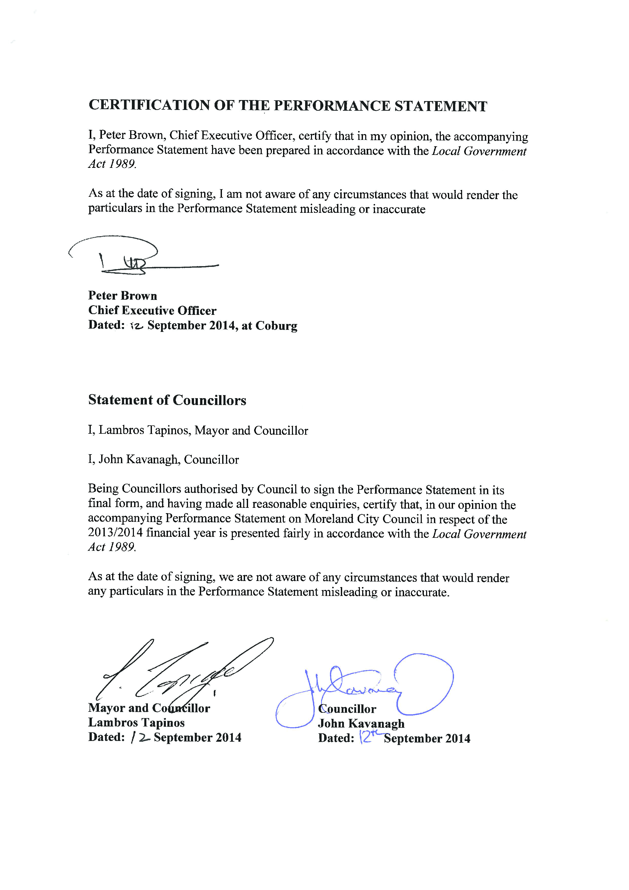

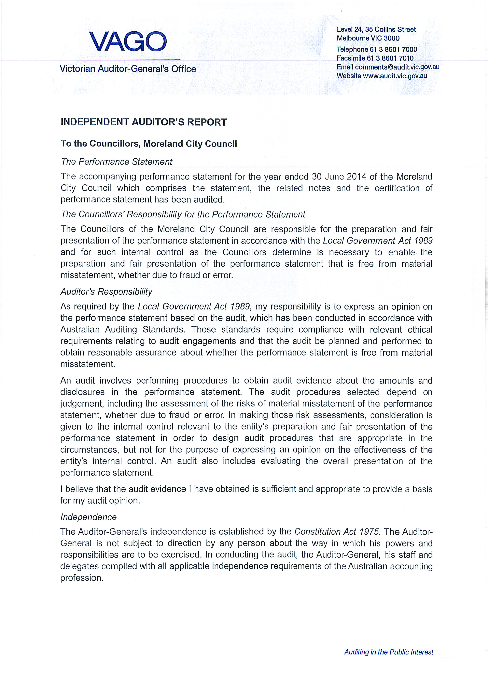

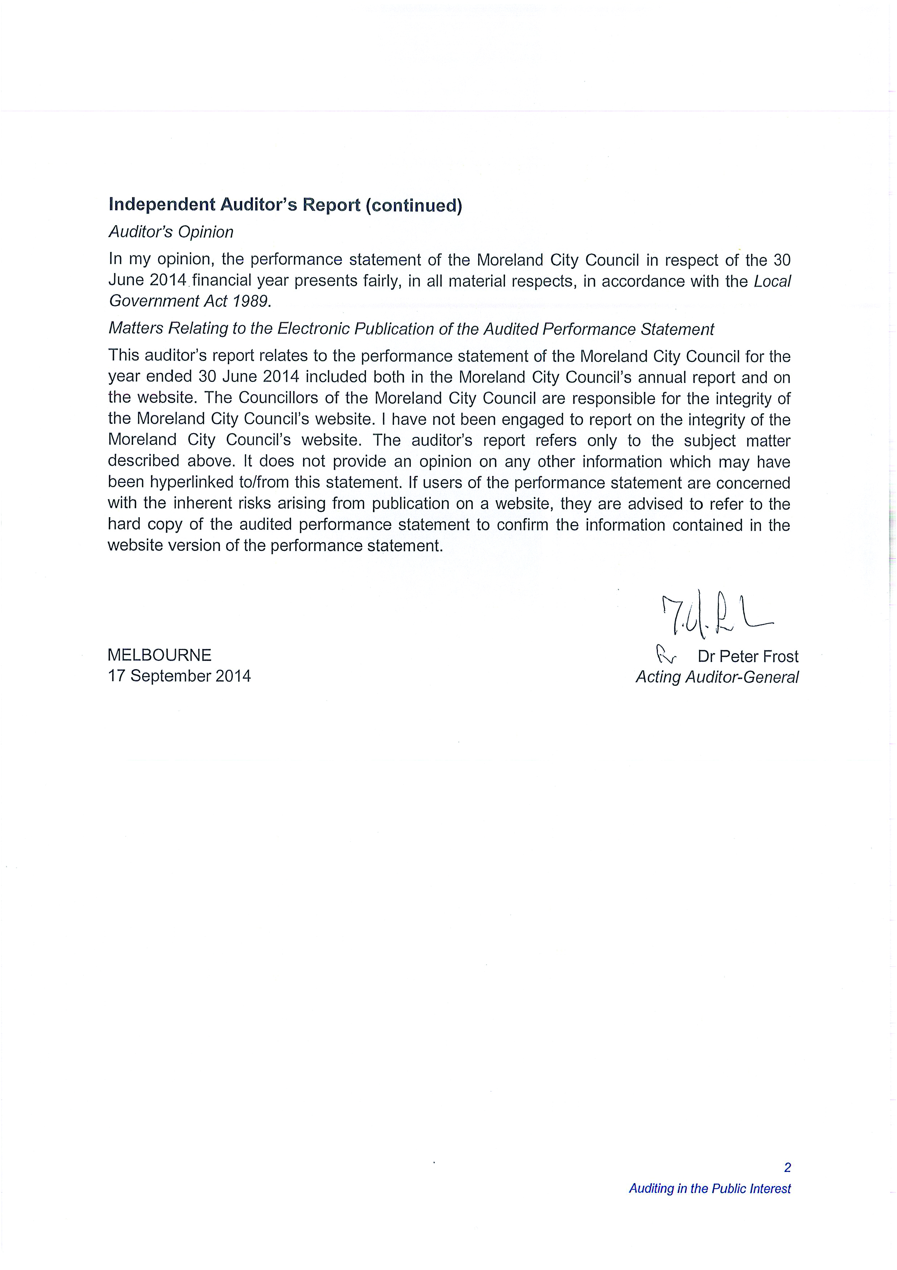

VICTORIAN GOVERNMENT PERFORMANCE INDICATORS
Category | Proposed Indicator |  | Indicator definitions and comments | 2012 | 2013 | 2014
 | 1. Average rates and charges per assessment |  | Rates and charges declared as being receivable, in the calculations for the adopted rates, at the beginning of the year, including:  general rates and charges declared under SS. 160, 161, 161A of the Local Government Act 1989; municipal charges and services rates and charges (i.e. garbage services) levied under SS. 159 and 162 respectively; and supplementary rates declared divided by the number of assessments used in the calculation of the adopted rate (i.e. when the rate is struck). | $1,451.58 | $1,550.18 | $1,582.63
 | 2. Average rates and charges per residential assessment |  | Rates and charges declared for all residential assessments (as per the definition in 1. above, except for assessments only) divided by the number of residential assessments. | $1,354.65 | $1,442.70 | $1,360.90
Sustainability | 1. Average liabilities per assessment |  | Total liabilities as per the published financial statements (i.e. AAS27); less items held in trust (reflected in assets also held); divided by the number of assessments used in the calculation of the adopted rate (i.e. when the rate is struck). | $1,242.66 | $1,216.49 | 1,146.79
Sustainability | 2. Operating result per assessment |  | Operating result per financial statements (i.e. AAS27); divided by the number of assessments used in the calculation of the adopted rate (i.e. when the rate is struck). | $-21.16 | $242.61 | $210.22
Services | 1. Average operating expenditure per assessment. |  | Operating expenditure per the financial statements (i.e. AAS27) (including asset sales and depreciation); divided by the number of assessments used in the calculation of the adopted rate (i.e. when the rate is struck). | $2,230.83 | $2,027.19 | $2,040.31
Services | 2. Community satisfaction rating for overall performance generally of Council |  | Council result from the Annual Community Satisfaction Survey for Local Governments (Chart One: Summary of Results – Result No. 1) coordinated by the Local Government Division. | 62 | 60 | 61
 | 1. Average capital expenditure per assessment | Amount capitalised to the balance sheet and contributions by a local government to major assets not owned by the local government, including expenditure on:  capital renewal of existing assets which returns the service potential or the life of the asset to that which it had originally;  capital expansion which extends an existing asset at the same standard as currently enjoyed by residents to a new group of users;  capital upgrade which upgrades an existing asset to provide a higher level of service or expenditure that will increase the life of the asset beyond that which it had originally;  divided by the number of assessments used in the calculation of the adopted rate (i.e. when the rate is struck).  Note: Exactly what is included, as capital expenditure will vary according to the local government’s policy in defining the ‘asset’ and its ‘life’. |  | $433.42 | $485.90 | $586.32
 | 2. Renewal gap. Renewal and maintenance gap | Ratio of current spending on renewal to the long-term Average Annual Asset Consumption (AAAC) 26%.  Ratio of current spending on renewal plus maintenance to AAAC plus maintenance 35%. The AAAC is the amount of a local government’s asset base consumed during a year based on current replacement cost (i.e. cost or fair value) divided by useful life; and totalled for each and every infrastructure asset. |  | 60%  78% | 95%  117% | 82%  84%
Governance | - Community satisfaction rating for Council’s advocacy and community representation on key local issues (indexed mean) | Council result from the Annual Community Satisfaction Survey for Local Governments (Chart 1: Summary of Results – Result No 2) coordinated by the Local Government Division. |  | 55 | 57 | 54
Governance | 2. Community satisfaction rating for Council’s engagement in decision-making on key local issues | Council result from the Annual Community Satisfaction Survey for Local Governments (Chart 1: Summary of Results – Result No 3) coordinated by the Local Government Division. (indexed mean) |  | 56 | 57 | 55

Australian Bureau of Statistics, 2011 Census of Population and Housing
Moreland Maternal and Child Health database
Australian Bureau of Statistics, 2011 Census of Population and Housing
Australian Bureau of Statistics, 2011 Census of Population and Housing
Department of Immigration and Citizenship Settlement database
Australian Bureau of Statistics, 2011 Census of Population and Housing
Department of Human Services, Life Expectancy Estimates
Department of Education and Early Childhood Development, Summary Statistics Victorian Schools
Australian Bureau of Statistics, 2011 Census of Population and Housing
Australian Bureau of Statistics, 2011 Census of Population and Housing
Australian Bureau of Statistics, 2011 Census of Population and Housing
A Guide to Property Values, Department of Sustainability and Environment, 2013

